Median Filtering

Chaithanya Gadiyam

Abstract
This lab exercise performs 3 x 3 median filtering on a bitmap image, implemented on both CPU and GPU (with and without shared memory) to clean up a gray scale bitmap image. The program is tested on three images of different sizes and CPU and GPU execution times, computation error and speedup against CPU are measured to analyze the performance of CPU and GPU.

Design Methodology
A 3 x 3 median filtering algorithm is implemented to clean up a grayscale bitmap image. Implementation is done with CPU, GPU using global memory and GPU using shared memory. The provided Bitmap header file is used to perform load and save operations on bmp images and also to get and set pixel values of the image. For CPU implementation, median filtering is performed by capturing neighboring pixels around the current pixel, i.e. 9 pixel elements including the current pixel element. Median of these 9 elements is calculated by sorting them and picking the middle element, which is used to set value of the current pixel in output image. This operation is carried out on all pixels in the image. For border conditions, missing neighboring pixels of the current pixel are replicated with a pixel of value 0. For GPU implementation (both with global memory and with shared memory), a 2D block with tile width as 16 is chosen (i.e. 16 x 16 block) for optimal utilization of all threads in a stream multiprocessor. Dimensions of the input image are used to determine the size of 2D grid, i.e. total number of blocks. For GPU implementation with global memory, all 9 elements required to perform 3 x 3 median filtering on each pixel are loaded from global memory, i.e. each pixel is accessed 9 times from global memory. For GPU implementation with shared memory, an 18 x 18 block of shared memory is used for each block in which all 16 x 16 pixel elements corresponding to the current block of the input image are copied from global memory, along with the border elements around the 16 x 16 tile. These outlier elements are used to calculate median for the bordering elements of the 16 x 16 tile. Neighboring elements of each pixel are accessed from shared memory for all pixel elements in the block. For both GPU implementation with global memory and shared memory, sorting is implemented using bubble sort algorithm and the median value is calculated by picking the middle element in the sorted array of 9 elements. Computation times of all three implementations are measured along computation error and speedup of GPU implementations with global memory and with shared memory, against CPU implementation.

Results

This program is tested on 3 images (Lenna.bmp, RIT.bmp, milkyway.bmp) of different sizes and the corresponding results are tabulated as below. From the results, it can be observed that both GPU implementations give better performance than the CPU implementation and also from the plot shown in the following page, it can be seen that speedup of both GPU implementations increases as the image size increases.

Image | Width x Height | CPU Time (ms) | GPU Global Time (ms) | GPU Global Speedup | GPU Shared Time (ms) | GPU Shared Speedup
Lenna.bmp | 252 x 205 | 26 | 0 | 26 | 0 | 26
RIT.bmp | 946 x 532 | 265.333 | 4 | 66.33325 | 5 | 53.0666
milkyway.bmp | 4000 x 2000 | 4410.67 | 57 | 77.38017544 | 68 | 64.86279412
Table 1. Results Summary

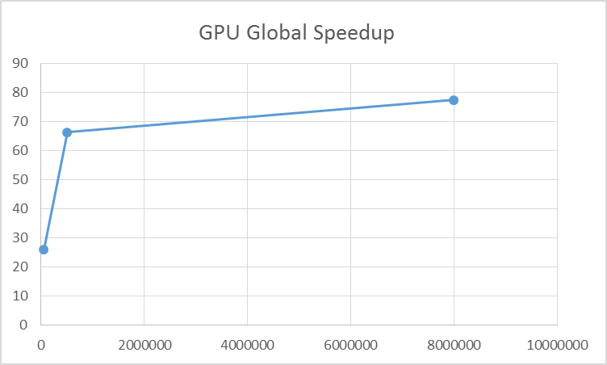
Figure 1. GPU global memory speedup as a function of number of elements
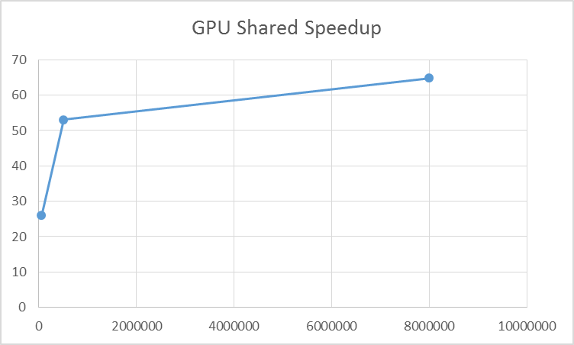
Figure 2. GPU shared memeory speedup as a function of number of elements

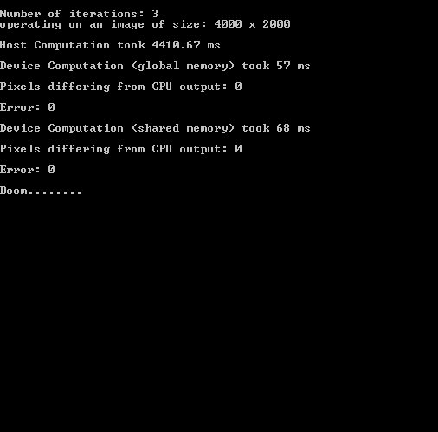
Figure 3: sample console ouput


Figure 4 Output image of GPU shared memory implemenation

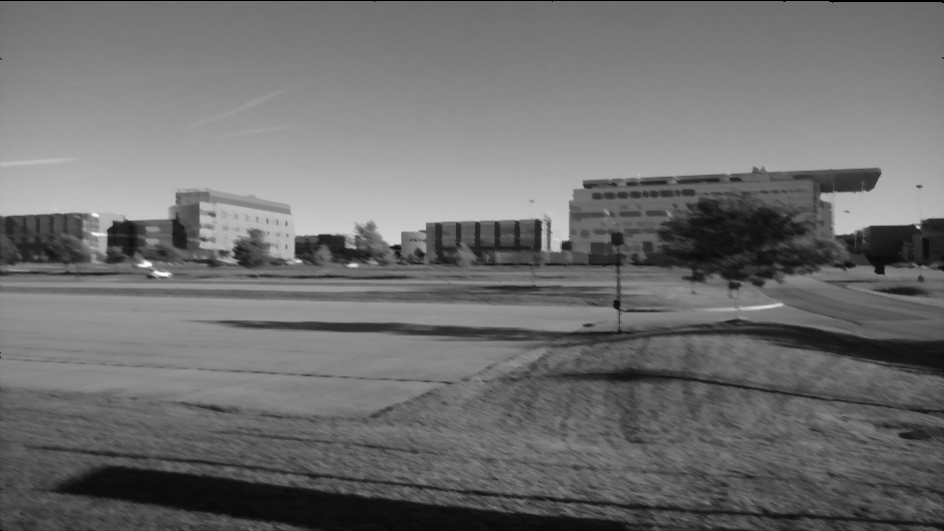
Figure 5 Output image of GPU shared memory implemenation


Figure 6 Output image of GPU shared memory implemenation

Conclusion
This lab exercise helps in understanding the usage of shared memory through the implementation of median filtering algorithm on GPU using shared memory. It can inferred from the results that speedup of both GPU implementations improve as image size increases. Also there is difference in the execution times of GPU implementations using global memory and shared memory.

Questions
- Median filtering is defined for any window size; in this exercise, you implemented a 3x3 filter, but 5x5, 7x7, or 99x99 are all conceivable. If you wanted to extend your implementation to handle a large, but still fixed, radius, what problems would you have?
- . As the window size increases, sorting should be done on more and more numbers, which affects the performance. Also shared memory implementation performs better than remaining two implementations for larger window sizes, because more elements would copied to shared memory per block and elements would be accessed more number of times from shared memory.

- As it was previously mentioned, using shared memory can result in unused threads because they are only used for loading the needed values. For your implementation using shared memory, determine the percentage of a block that is utilized. This should be a generic answer using the following assumptions:
- Two dimensional square blocks are used with a two dimensional grid.
- A block is α x α threads.
- A windows size of β x β is used. β is an odd number.
- All values have infinite precision.
- For the current implementation using shared memory, for a block of α x α threads, shared memory of size α+ β-1 x α+ β-1 is used, so that median can be found for all elements in the α x α block. For the case of 16 x 16 block and window size of 3 x 3, shared memory of size 18 x 18 is used, so that median can be found for border elements in the 16 x 16 as well. Hence the percentage of a block utilized is 100%, as all threads in 16 x 16 block are used to compute output element. Copying the bordering elements of 18 x 18 shared memory is done by bordering threads of 16 x 16 block, i.e. threads of first and last row and first and last column in 16 x 16 block are used to copy bordering elements of 18 x 18 shared memory.

- You used shared memory to implement the median filtering algorithm in the GPU. Could you use Texture or Constant memory instead of, or in addition to, shared memory. Justify your answer with concrete numbers is your explanation.
- Accessing texture memory and constant memory would be faster when compared access to global memory. But shared memory access is much faster than access to texture memory or constant memory. Also texture memory is useful in the cases where memory access are localized. But input array can be copied to constant memory instead of copying to global memory at host, so that access from constant memory at kernel would be faster than access to global memory as constant memory of 64 kB is cached.

