
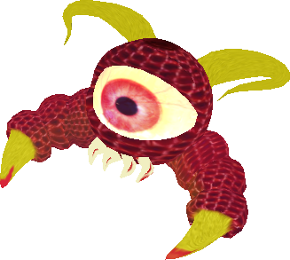
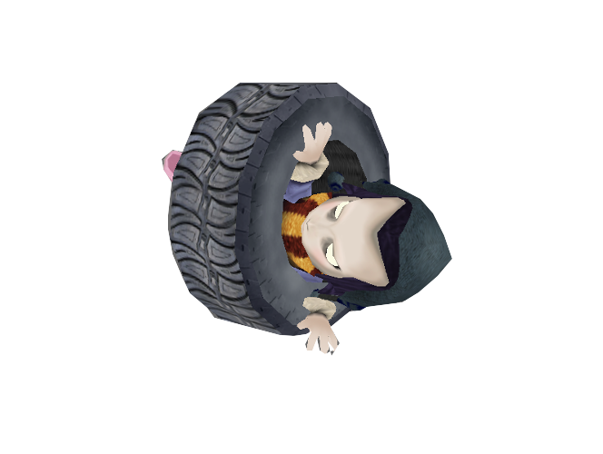
x

AUTHOR: Carlos M. Galdamez
Spring 2016

I. GENERAL INFORMATION

This is a platform game about Eve that has to participate in an obstacle course to escape from the land of the cyclopes

II. DETAILED GAME DESCRIPTION
- Basic Concept
Eve has to run obstacle courses. These obstacle courses will contain tires/tokens that will enable the character to attack the enemies as well as increase the score of the player. The player has to get to the end of the stage
and collect the big tire to complete the stage in the allotted amount of time.

- Background Story
Eve was abducted by a huge cyclops at a young age. Now she is old enough to escape. Eve will have to go through various obstacles to escape the land of the cyclops and in the way will encounter the kyklopes which are the minions of the cyclops. She will have to defeat her foes and beat time if she wants to get back home.

- Objective
Survive the obstacle on each stage and reach the big collectible tire to finish each stage.

- Gameplay
The player will be allowed to walk, run, and roll onto platforms in each level. However certain platforms are only accessible by going at very high speeds. Each level will have tire tokens placed in the map. Eve will have to collect these tokens in order to attack any enemies that might get in her way. To clear large gaps eve can go into ‘rolling’ mode. In order to clear each level Eve has to reach the last floating platform and collect the last large tire token.

- AI component
Enemy AI will be rudimentary. They will guard a specified area of the map. When the player is at a certain distance from the enemies, the enemies will charge at the player and start attacking the player.

- What is the planned interface?
Keyboard will be used for basic user movements such as moving forward, jumping, and changing between the different character modes. Additionally the user will be able to toggle between different camera modes using the keyboard, enable and disable music and sound effect and lastly display the help menu.

- What is the planned perspective (1st person vs. 3rd person)?
The planned perspective is 3rd person. The default camera placement will be behind and slightly above the character. The player will have the option to toggle between different camera modes such as top view, right side view, left side view, top view, and if the player really wants to there is also 1st person perspective in which the user can look up and down by pressing the up and down arrows. First person perspective however is not recommended , it is much harder to pass a level using first person perspective.

- What are the Software and the Hardware platforms?
Software - Panda3D game engine with Python programming
Hardware – PC

- What is the basic interactive structure?
Levels with level transition effects

- What is the "heart" of the gameplay? (e.g. speed, actions, style, continuous, turnbased, etc.?
Rolling Eve is a continuous platform game with the various obstacles such as moving platforms, falling platforms, tiny platforms, ramps, and enemies.

- Does multi-player work?
Only single-player.

- How difficult is the game? How long will it take the average player to complete?
Easy for novice game player. The game doesn’t have the functionality of letting users select the difficulty levels. The game consists of 2 levels. All levels are easy. The first level will roughly take the player 4 minutes to complete. The second level is slightly more challenging than the first level and contains more enemies than the first. The second level will take the average player roughly 7 minutes to complete.

III. OTHER ASPECTS OF THE PRODUCT DESIGN

- Characters --
Eve - This is the player character
- Default Properties: Eve starts in an idle position in the furthest corner of the stage.
- Winning: Eve wins by reaching the last platform which contains the big token
- Losing: Eve loses if health goes down to 0 or if Eve runs out of time to complete the stage.
- Player starts out with 100 health points
- The player has ‘rolling’ mode and ‘regular’ mode. ‘Rolling’ mode will be used to clear large gaps by rolling at high speed up a ramp. It is recommended ‘rolling’ mode only only be used to go fast up ramps. Using it else where will make the character extremely hard to control.
- The player can jump,run,and roll
- Player will pick up tire tokens which will increase the players score as well enable the player attacking capabilities.

Kyklops– This is the enemy type 1.
- Normal State: Enemy will be guarding a part of the map
- Detection State: Enemy will detect player at a specified distance
- Reaction State: Enemy will charge at player and attack player if the player is detected.
- End State: If the player destroys the enemy, enemy will disappear otherwise it will go back to scouting an area.

- Controls --
Control table
Action | Control | Context
Forward | W | All levels
Right | D | All levels
Left | A | All levels
Back | S | All levels
Jump | Space Bar | All levels (only in regular mode)
Attack | Enter | All levels(only in regular mode)
Switch Modes | M | All levels
Toggle Music On/Off | Q | All levels
Toggle SFX On/Off | X | All levels
Toggle Help Menu | H | All levels
Toggle Camera | C | All levels

- World --
Each stage is an obstacle course which will contain fixed and moving platforms, ramps and enemies that will make the task of getting through the obstacle course complex. Each stage will have a time limit as well.

- The onscreen interface contains a health gauge, a timer and counter which keeps track of tires collected. The health gauge decreases when an enemy attacks the player or if the player falls off the map. The count of tires collected increases every time a tire is collected and decreases every time the player attacks. The count is used to keep track of how many attacks the player can do.

- Describe all menus in detail, and chart out the "shell" structure.
Main menu consists of four buttons ‘Controls’, ‘Level Select’, ‘Leaderboard’ and ‘Quit’. The controls button will allow the player to see all player controls as well as the non player controls. The level select button will display all levels for the game and will allow player to got to a different stage if it is not locked. The leaderboard button will show another menu with links for each stage. When a stage is chosen the scores for that specific stage will be shown. Finally the quit button will exit the game.

- The only on screen messages are for the completion of each stage and when the player loses. If the player wins, then there will be a message shown saying the stage has been completed and it will display number of token collected. It will also give the player the option to continue to the next stage. If the user loses then it will show that the game is over and will give the user the option to retry the current level.

- Graphics -- Describe the general style of the graphics.
Low poly models.
All models provided by the instructor or from the Internet.
Environment models (obstacle courses) will be procedurally constructed in Panda3D by using simple building blocks such as cubes and spheres/disks.

- Sounds and Music -- Describe at least the general manner in which sound effects will be used in the game.
Eve has sound effects for running,rolling,jumping, and landing. Additionally each stage will contain a unique soundtrack. Sounds and music were downloaded from the following sites:
http://www.freesound.org
http://incompetech.com
http://soundbible.com

- License Exploitation --
None, original universe. Music will be credit to their respect artists.

