# 1. Given the provided data, what are three conclusions we can draw about Kickstarter campaigns?

1. Projects with larger goals have a higher rate of failure or cancelation. Projects with lower goals have a higher success rate.

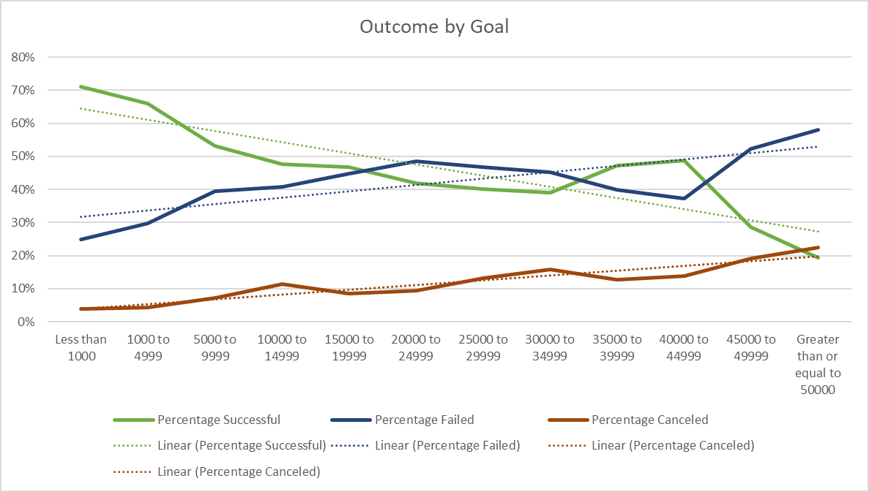

1. Projects in the following sub-categories have had a 100% success rate since the start of this data set. New projects in these categories should do well.

|  |  |
| --- | --- |
| Category | Sub-Category |
| film & video | documentary |
| film & video | shorts |
| film & video | television |
| food | small batch |
| games | tabletop games |
| music | classical music |
| music | electronic music |
| music | metal |
| music | pop |
| music | rock |
| publishing | nonfiction |
| publishing | radio & podcasts |
| technology | hardware |

1. Projects in the following sub-categories have had a 0% success rate since the start of this data set. New projects in these categories are a high risk.

|  |  |
| --- | --- |
| Category | Sub-Category |
| film & video | animation |
| film & video | drama |
| film & video | science fiction |
| food | food trucks |
| food | restaurants |
| games | mobile games |
| games | video games |
| journalism | audio |
| music | faith |
| music | jazz |
| music | world music |
| photography | nature |
| photography | people |
| photography | places |
| publishing | art books |
| publishing | children's books |
| publishing | fiction |
| publishing | translations |
| technology | gadgets |
| technology | web |

# 2. What are some limitations of this dataset?

* The data does not show information about how well a project was marketed. How often was the project was visited? How often was it visited but not backed? Were successful projects shared on social media more often than unsuccessful projects?
* The goal and pledge amounts are not all in the same currency. In order to properly analyze the impact of a goal amount has on the project outcome, these values should all be converted to the same currency.

# 3. What are some other possible tables and/or graphs that we could create?

1. A table showing the success rate, average percent funded, and count of completed projects by category & subcategory.
2. A table showing the success rate, average percent funded, and count of completed projects flagged as “staff_pick” vs those that were not.
3. A table showing the success rate, average percent funded, and count of completed projects flagged as “spotlight” vs those that were not.
4. A bar graph showing the success rate by subcategory filtered by parent category.
5. A bar graph showing percent funded by category and/or subcategory.