Warehouse Inventory Management

Final Project Report

CMSC 495 - 7983

David Kirkman, Charles Garnette, Emily Chiou, Eric Bridges

Table of Contents

Overview 4

Individual Contributions 4

Project Lead – David Kirkman 4

Front-End Developer – Charles Garnette 4

Back-End (Database) Developer – Emily Chiou 4

Technical Writer – Eric Bridges 4

Requirements Specification 5

Warehouse Inventory Overview 5

Item Detail and History 5

Incoming Shipment 5

Outgoing Shipment 5

Project Plan 6

Planning Phase 6

Development Phase 6

Conclusion Phase 6

System Specification 7

User’s Guide 7

Warehouse Inventory Overview 7

Inventory Table 8

Search Bar 8

Function Buttons 8

Item Details and History 8

Item Details Screen 8

Incoming Shipment 10

Add a New Item to the Database 10

Outgoing Shipment 11

Test Plan and Results 12

Design and Alternate Designs 13

Original Design 13

Storyboard Design 13

System Screen Design 13

UML Design 20

Final Design 21

Front-End UML Design 21

Back-End UML Design 22

Development History 23

Conclusion 23

Lessons Learned 23

Design Strengths and Limitations 23

Future Improvement 23

# Overview

The Warehouse Inventory Management (WIM) system is a stand-alone warehouse management package with a user-friendly interface and a stable database foundation. Created to be intuitive, it requires minimal training. Designed with minimal overhead in mind, it can be installed on any modern Windows based computer.

The WIM system allows a user to manage all on-hand inventory and incoming or outgoing orders. It provides a quick, low-impact transition from older spreadsheet or traditional paper record keeping. With a list of all items, their location, and quantity on the main screen, complete inventory oversight is simple. This list can be sorted at the users request and provides a method for searching for an item. Each item in inventory has a complete details pane which includes the order history of incoming and outgoing shipments, as well as an updatable location to be used when physical warehouse reorganization becomes necessary. Shipments, incoming or outgoing, can be managed from the main screen. With a simple interface for all shipments, items can be added as incoming or outgoing and have their on-hand quantities adjusted accordingly.

By leveraging the strengths of each member of the team, the project was completed on time and with few changes to the initial design concept.

## Individual Contributions

### Project Lead – David Kirkman

David created the initial project requirements and milestones for this project. He continued to support the team by guiding weekly discussions and maintaining a Trello board with weekly tasks. Working with the front-end and back-end developers and the technical writer, David ensured the team continued to meet milestones and documented any challenges or changes.

### Front-End Developer – Charles Garnette

Charles developed the front-end user interface and worked directly with the back-end developer to ensure proper interaction between the front-end structure and back-end foundation. Working with the team’s Test Plan and collaborative inputs, Charles created an optimized and straightforward user interface.

### Back-End (Database) Developer – Emily Chiou

Emily had the initial concept for the project and developed the back-end database to ensure proper data management within the system. Working with the front-end developer, she helped ensure proper integration with the Java based front-end structure and the Oracle 11g XE back-end foundation.

### Technical Writer – Eric Bridges

Eric created the Test Plan and User Guide, ensuring the inclusion of all project functional requirements. Working with the front-end and back-end developers he created the UML design diagrams and, working with the project lead, compiled the final project report.

# Requirements Specification

The Warehouse Inventory Management system includes these major features with their supporting minor features.

## Warehouse Inventory Overview

The user will be able to see an overview table of all items currently on hand, their location and current quantity.

* Each item will reside in its own row.
* Columns for each: inventory ID, item name, UPC, aisle-bay-shelf location, and quantity.
* The table will be sortable by column header in ascending or descending order.

## Item Detail and History

The user will be able to view an item’s details, history, and adjust the items location.

* An item can be chosen from the overview table.
* An item’s detail area will show the following information: item ID, item name, UPC, quantity on hand, and current location
* The detail area will show the item’s history including incoming and outgoing shipments, shipment date, quantity change, and associated vendor ID.
* An item’s location can be changed by adjusting the aisle, bay, or shelf.

## Incoming Shipment

The user will be able to add an incoming shipment, the items it contains, shipment date, order number, truck number, and vendor ID.

* The incoming shipment area will contain inputs for the order number, truck number, vendor ID, shipment date, and items within the shipment.
* An item not currently in the database may be added.
  + The new item area will provide inputs for all categories of item details, matching those of items already in the database.
* An item already in the database will have its quantity adjusted to include the incoming quantity.

## Outgoing Shipment

The user will be able to add an outgoing shipment, the items it contains, shipment date, order number, truck number, and vendor ID.

* The outgoing shipment area will contain inputs for the order number, truck number, vendor ID, shipment date, and items within the shipment.
* An item will have its quantity adjusted to remove the outgoing quantity.

# Project Plan

## Planning Phase

Week 1

* Project inception
* Form team

Week 2

* Define requirements and team member roles
* Determine necessary technologies
* Define project milestones
* Establish team coordination plan and tasks

Week 3

* Complete Test Plan & User’s Guide
* Setup code repository

Week 4

* Complete Program Design

## Development Phase

Week 5

* Develop database table structure
* Develop the Inventory Overview module
* Connect the Front-End and Back-End
* Prepare the Phase 1 Report

Week 6

* Develop the Item Detail module
* Create database test data
* Conduct any quality assurance adjustments
* Prepare the Phase 2 Report

Week 7

* Develop the Incoming and Outgoing Shipment modules
* Conduct any quality assurance adjustments
* Prepare the Phase 3 Report

## Conclusion Phase

Week 8

* Perform final testing
* Create the Project Report
* Compile and submit the final project package

# System Specification

The Warehouse Inventory Management system was designed and tested on Microsoft Windows based machines. Any system which meets the hardware requirements for the installed Windows operating system will support the WIM system with the addition of at least 2 GB available hard disk space.

Software Requirements:

* Microsoft Windows Operating System Version 7 or higher
* Java Developers Kit (JDK) version 8 or higher
* Oracle Database 11g Express Edition

# User’s Guide

This user’s guide to the Warehouse Inventory Management system provides step-by-step instructions for completing all tasks within the system. This guide makes two assumptions. First, that the WIM system and database have been installed. Second, that there are no issues with the connection between the interface and the database.

## Warehouse Inventory Overview

Upon opening the WIM software, it will default to the Overview screen shown below.

This window can be separated into three major sections:

1. Inventory Table
2. Search Bar
3. 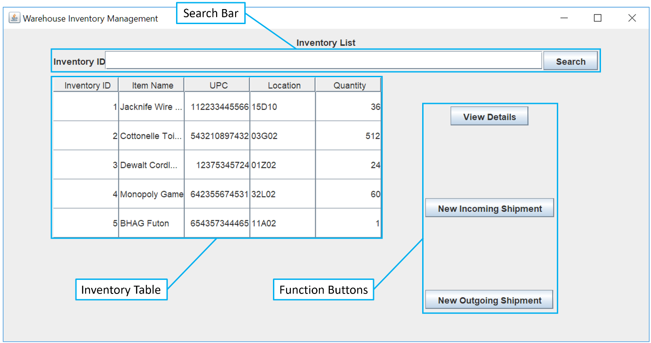Function Buttons

*Figure 1. WIM Main Screen with Inventory Table, Search Bar, and Function Buttons highlighted.*

### Inventory Table

When the WIM software is first opened, the Inventory Table will display a list of all items current in inventory. This table can be sorted in ascending or descending order by clicking on any of the headers.

### Search Bar

The search bar can be used to filter the inventory table and show only the item that you are looking for. Search by entering the Inventory ID then clicking the “Search” button. The Inventory Table will update with the results. If there are no results, the table will return blank.

### Function Buttons

View Details: After selecting an item in the Inventory List, use this button to view its details.

New Incoming Shipment: Initiates a new incoming shipment.

New Outgoing Shipment: Initiates a new outgoing shipment.

## Item Details and History

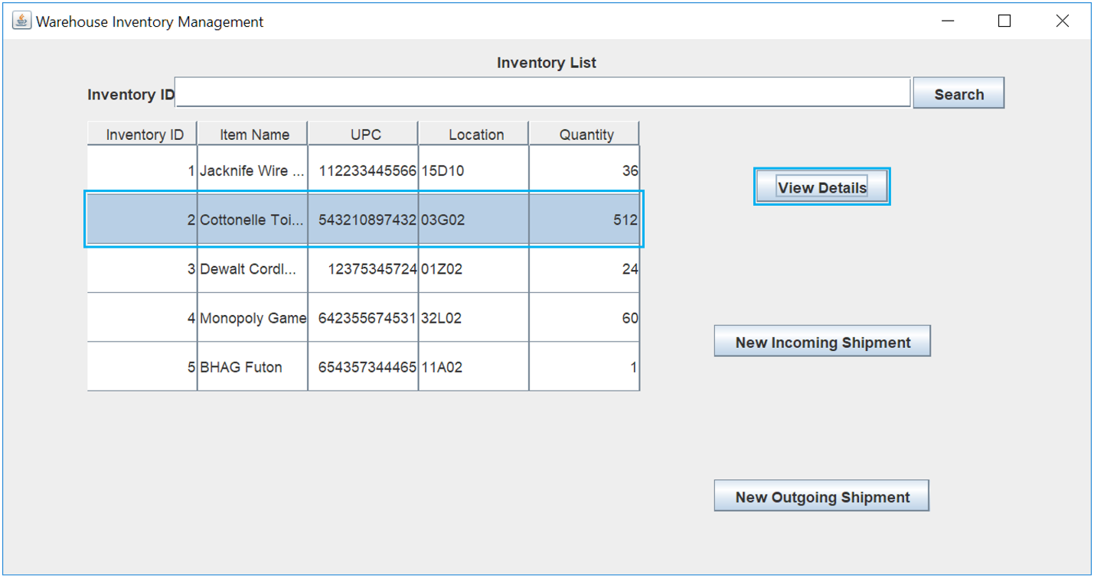 To view an item’s history, select it from the Inventory List, then click the “View Details” button.

*Figure 2. WIM Main Screen with View Details button and a listed item highlighted.*

### Item Details Screen

The item details screen provides the same five properties as the Inventory List in addition to the item’s history, and an option to update the item’s location.

#### Item History

An item’s history is displayed in the lower half of the window. The history includes an Order ID number, Date, Truck number, Quantity, and Vendor ID number. A positive quantity indicates an incoming shipment, and a negative quantity an outgoing shipment.

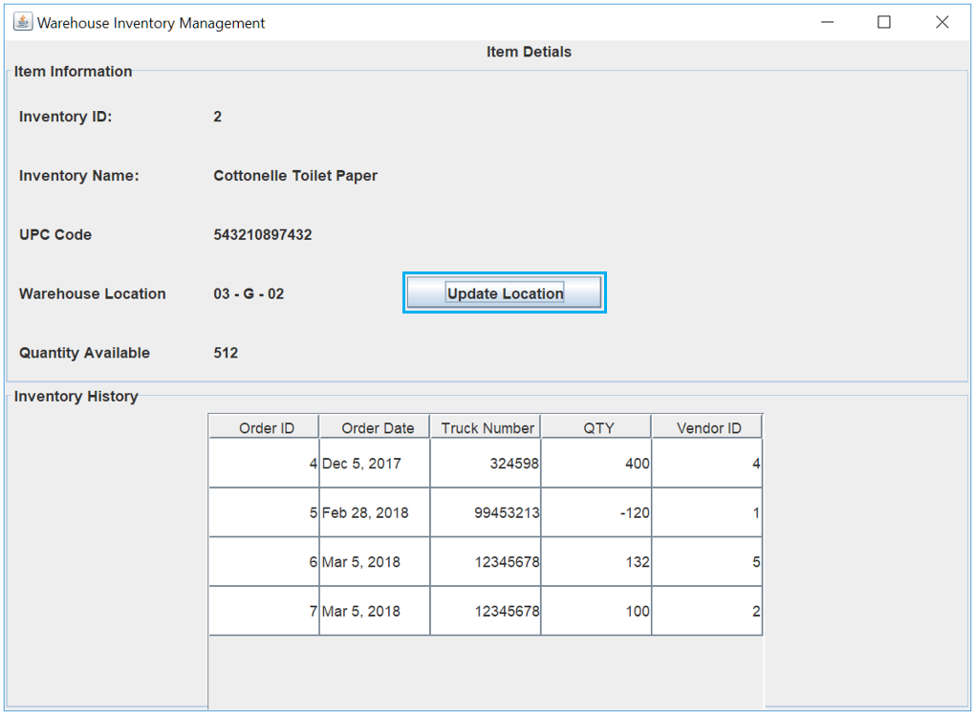

*Figure 3. Item Detail window with the Update Location button highlighted.*

#### Update Item Location

To update an item’s location, click the “Update Location” button in the Item Detail window.

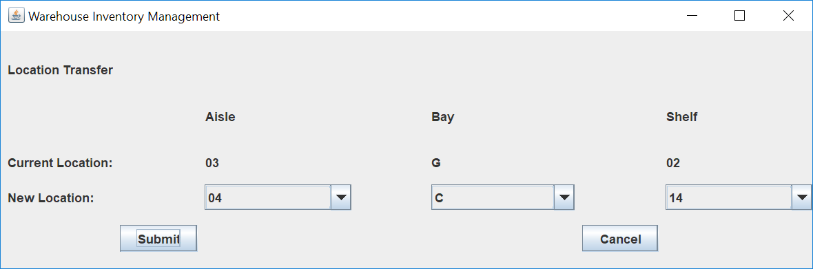

*Figure 4. Item Location Update window.*

An item’s location can be updated by adjusting any or all of the drop-down lists to the new location. Once the changes have been made, click the “Submit” button to save and return to the Item Detail screen.

To return to the Main Screen close the Item Detail window by clicking the “X” in the upper right.

## Incoming Shipment

To initiate a new Incoming Shipment, click the “New Incoming Shipment” button on the Main Screen.

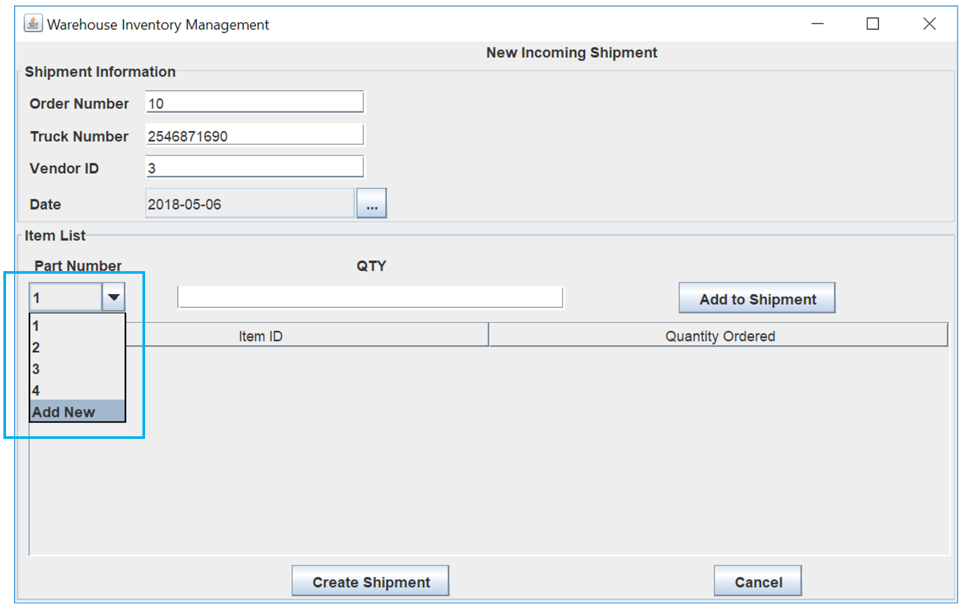*Figure 5. New Incoming Shipment window with “Add New” highlighted in the Part Number list.*

Within the New Incoming Shipment window, enter the Order Number, Truck Number, Vendor ID, and select the order date. To add a new item to the order, select its Inventory ID from the Part Number drop down list. If the item is not currently in the inventory database, select “Add New”

### Add a New Item to the Database

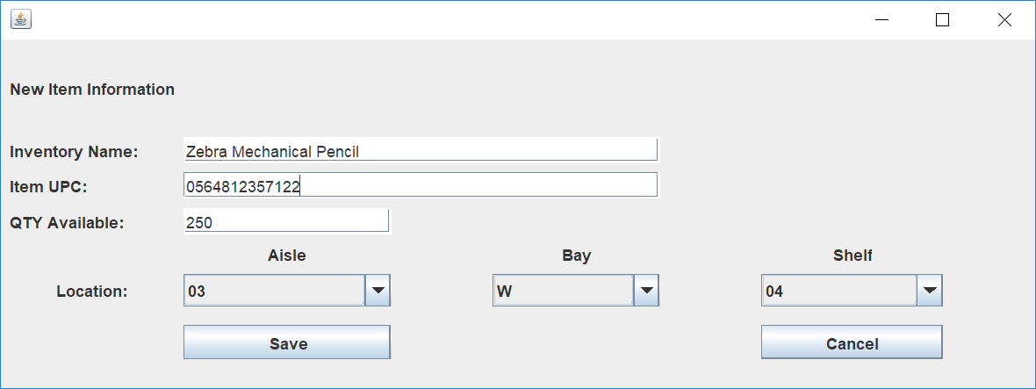 After selecting “Add New” in the New Incoming Shipment window, the New Item window will open.

*Figure 6. New Item window.*

Within the New Item window, enter the items Name, UPC, and incoming Quantity. The Location will default to 00-A-00 and can be changed in this window or later in the Item Details window. When complete, click the “Save” button to save the new item and return to the New Incoming Shipment window.

After adding all items to the new shipment, click “Create Shipment” to add the incoming items to the inventory, save the order, and return to the Main Screen.

## Outgoing Shipment

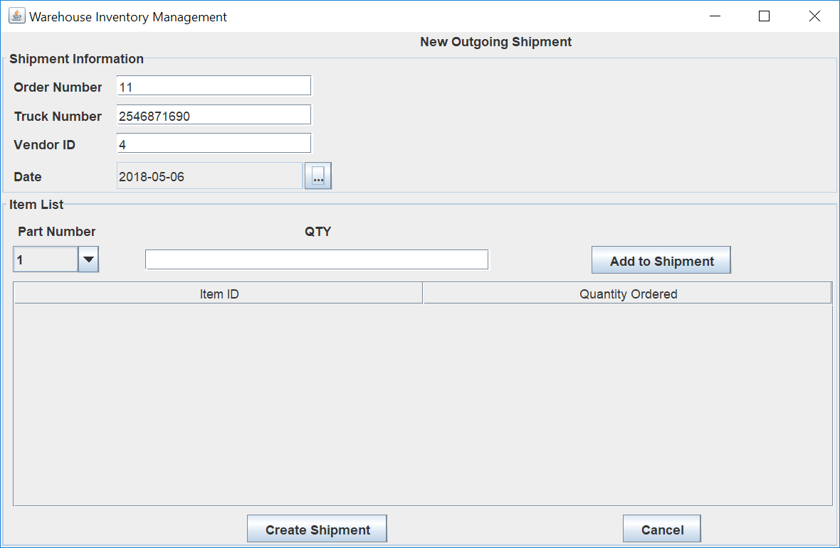 To initiate a new Outgoing Shipment, click the “New Outgoing Shipment button on the Main Screen.

*Figure 7. New Outgoing Shipment window.*

Within the New Incoming Shipment window, enter the Order Number, Truck Number, Vendor ID, and select the order date. To add a new item to the order, select its Inventory ID from the Part Number drop down list. After adding all items to the new shipment, click “Create Shipment” to remove the outgoing quantity from inventory, save the order, and return to the Main Screen.

# Test Plan and Results

The test plan was based on the requirement specifications and overall functionality of the software and underlying database. After validating each requirement individually, the WIM system was determined to be functional and meet all requirements.

|  |  |  |
| --- | --- | --- |
| **Req.** | **Description** | **Result** |
| **1** | **Warehouse Inventory Overview** | |
| 1a | The user will be able to view a table of all on-hand items. | Pass |
| 1b | Each item in the table will reside in its own row | Pass |
| 1c | The table will feature columns for Inventory ID, Item Name, UPC, Location, and Quantity | Pass |
| 1d | The columns will be sortable in ascending and descending orders | Pass |
|  | | |
| **2** | **Item Detail and History** | |
| 2a | The user will be able to view an Item’s Details and edit the location | Pass |
| 2b | An item can be chosen from the overview table | Pass |
| 2c | An item’s detail view will show its Item ID, Name, UPC, Quantity, and Location | Pass |
| 2d | An item’s detail view will show its incoming and outgoing shipment history | Pass |
| 2e | An item’s location can be changed by its aisle, bay, or shelf | Pass |
|  | | |
| **3** | **Incoming Shipment** | |
| 3a | The user will be able to create an incoming shipment | Pass |
| 3b | The incoming shipment view will include an Order Number, Truck Number, Vendor ID, Shipment Date, and list of items within the shipment | Pass |
| 3c | Items not currently in the database may be added | Pass |
| 3d | Items currently in the database will have their quantity increased by the incoming amount | Pass |
|  | | |
| **4** | **Outgoing Shipment** | |
| 4a | The user will be able to create an outgoing shipment | Pass |
| 4b | The outgoing shipment view will include an Order Number, Truck Number, Vendor ID, Shipment Date, and list of items within the shipment | Pass |
| 4c | Items currently in the database will have their quantity decreased by the outgoing amount | Pass |

# Design and Alternate Designs

During the development process, there were few changes made to the original designs. The following line-graphics and descriptions represent the original design plan and overall intent for the front-end interface. Following the original user interface design are the initial and final versions of the UML representations for the Java front-end and database back-end.

## Original Design

### Storyboard Design

The below storyboard design is meant to show the general flow of the system. The initial view will be the Items Overview screen. From here, a user will be able to access all other screens. The Items Detail screen is specific to the items in the Items Overview screen and will not be accessible from the incoming or outgoing shipment screens. From the Items Detail screen, the user will be able to open the inventory transfer popup which will allow the user to change the item’s location in the warehouse.

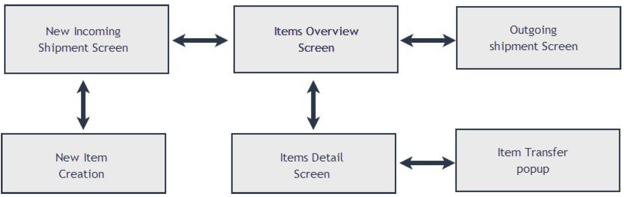

*Figure 8. Storyboard chart showing program behavior.*

### System Screen Design

#### Items Overview

##### Synopsis

The Items Overview screen is the main dashboard of the application. This screen is the landing screen after a user logs in, all other screens are launched from here, with the exception of the of the New Item screen. The grid in the center of the screen shows all items in the inventory with the current quantity on hand as well as the location.

##### User Actions

Inventory ID Search: The user will be able to enter an inventory ID, then click search, and the system will update the grid showing the item.

View Details: The user will select an item or items in the grid by using the checkboxes on the left, then click the View Details button. The Item Details screen will launch showing the details of the selected items.

New Incoming Shipment: The user can open the New Incoming Shipment screen by clicking this button.

New Outgoing Shipment: The user can open the New Outgoing Shipment screen by clicking this button.

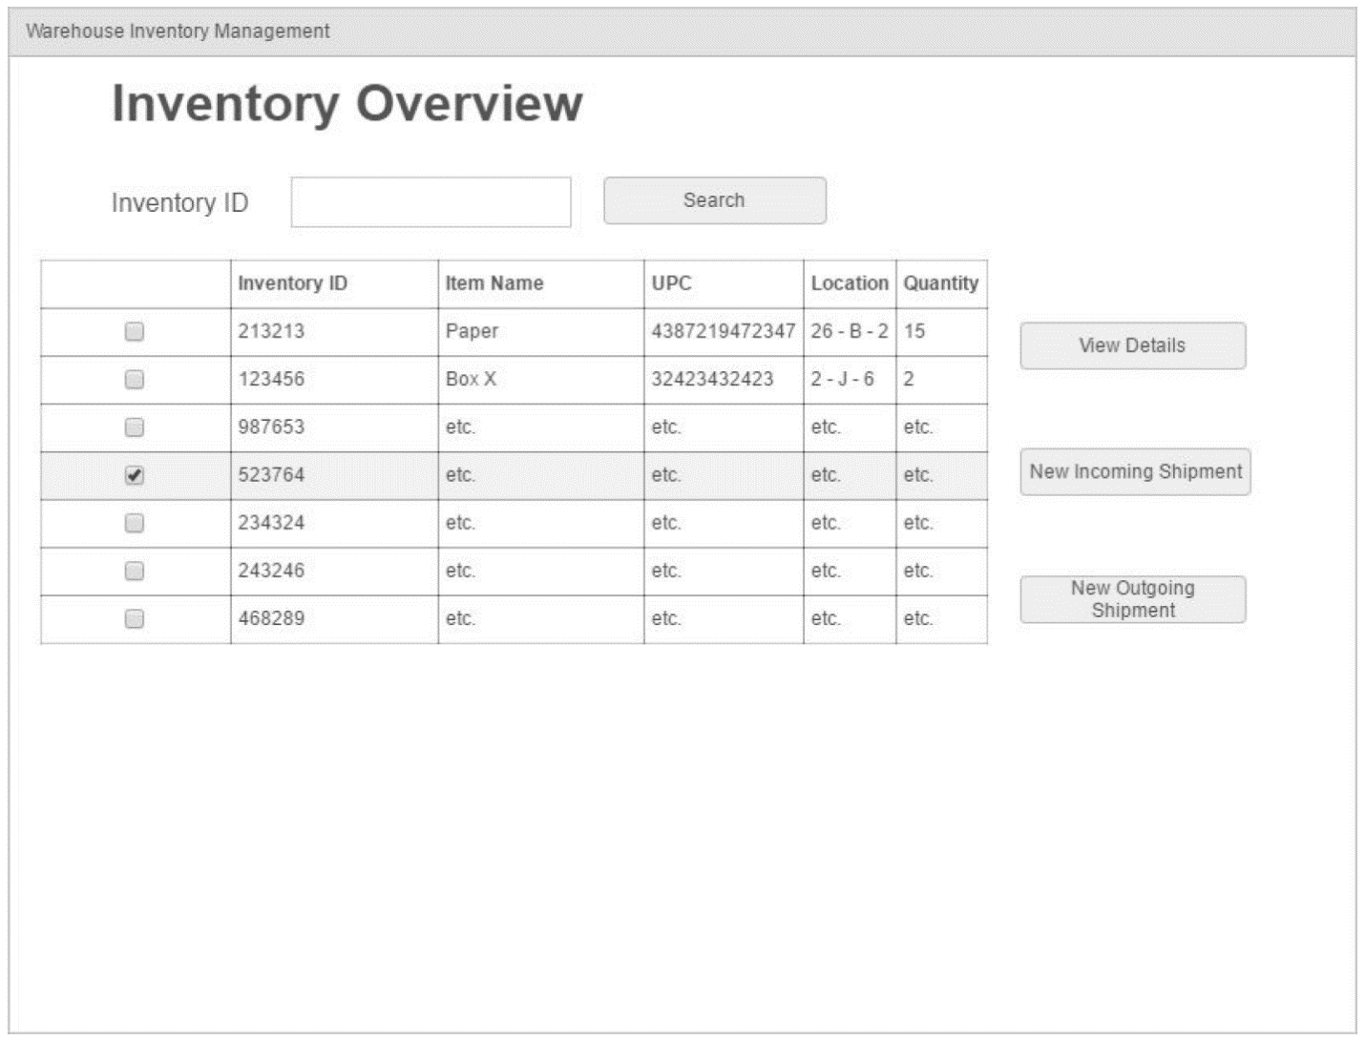*Figure 9. Original Inventory Overview screen design.*

#### Items Detail

##### Synopsis

The Item Detail screen allows the user to see the selected item’s details including the incoming and outgoing shipment history, truck numbers, order numbers, and quantity changes. This screen also allows the user to open the Update Location screen. The inventory ID is the identifier assigned by the system at the time of item creation.

##### User Actions

Change Inventory Name: The Inventory Name is an editable field that will allow the user to update the name of the item when the Save button is clicked.

Change UPC code: The UPC Code is an editable field that will allow the user to change the UPC entered when the Save button is clicked.

Update Location: This button will open the Item Transfer screen which allows the user to change the item’s location.

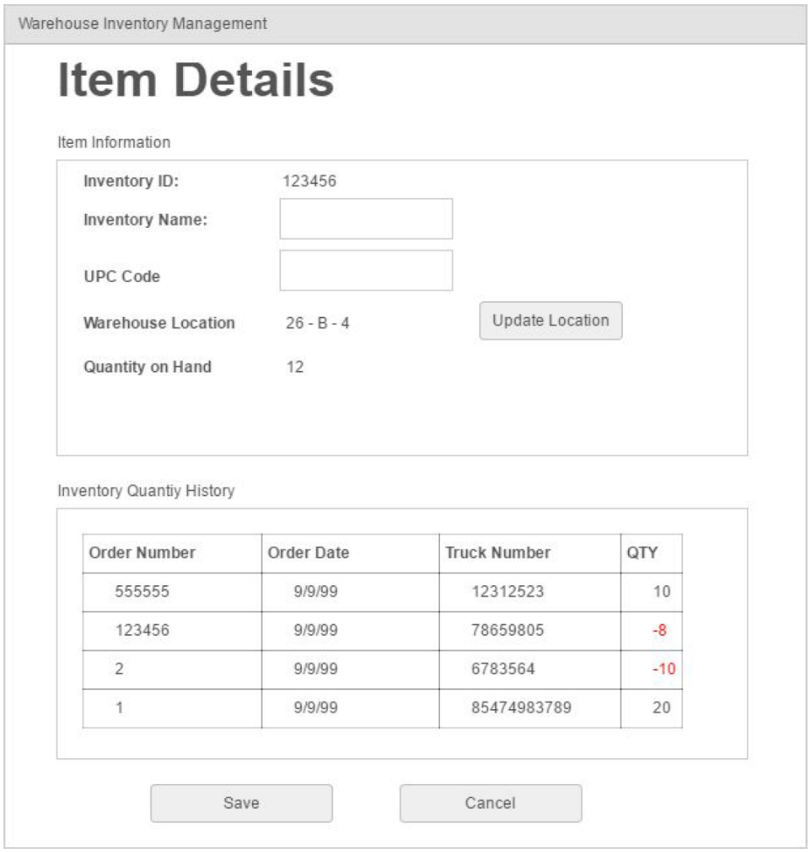

*Figure 10. Original Item Details screen design.*

#### Item Transfer Pop - Up

##### Synopsis

The Item Transfer screen allows the user to change an item’s location. This is done by selecting the values from the drop downs, all three must be selected to save. When the user clicks Save, the system will check if that location is in use, if it is, it will show an error to the user stating that the location is already in use.

##### User Actions

Aisle Dropdown: Allows the user to select the aisle.

Bay Dropdown: Allows the user to select the bay.

Shelf Dropdown: Allows the user to select the shelf.

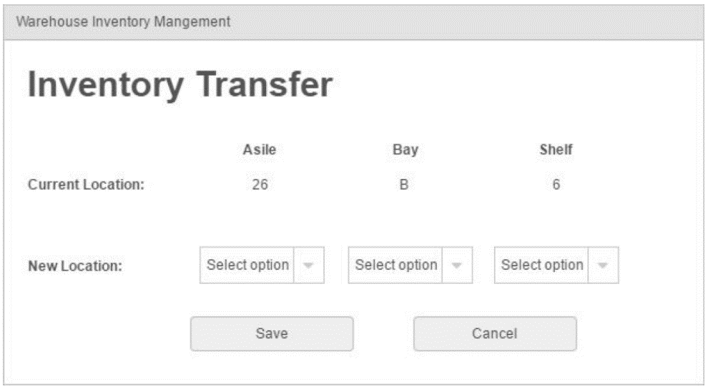

*Figure 11. Original Inventory Transfer screen design.*

#### New Incoming Shipment

##### Synopsis

The New Incoming Shipment screen is where the user will go to create a new shipment. The purpose of this screen is to allow the user to receive a shipment into the system, which will update the quantity on hand for the items in the shipment. The items list is where the user can add items to the shipment with the incoming quantity. The part number is selected through the dropdown, which is a list of all available inventory items currently in the system. Also in the dropdown list, is an Add New option. When this is selected and Add to Shipment is clicked, it will take the user to the New Item Creation window.

##### User Actions

Order Number: The Order Number is an editable field that allows the user to enter the Order Number.

Truck Number: The Truck Number is an editable field that allows the user to enter the Truck Number.

Date field: The Date field allows the user to select the date of the order.

Part Number: Is a dropdown list of all items currently in the system. It will also contain an extra line item for Add New which is used for New Item creation.

QTY: The QTY is an editable field that allows the user to enter the QTY in the shipment.

Add to Shipment: Adds the selected item to the table of all items being added to the shipment. If Add New is selected in the dropdown, the user will be directed to the New Item Creation screen.

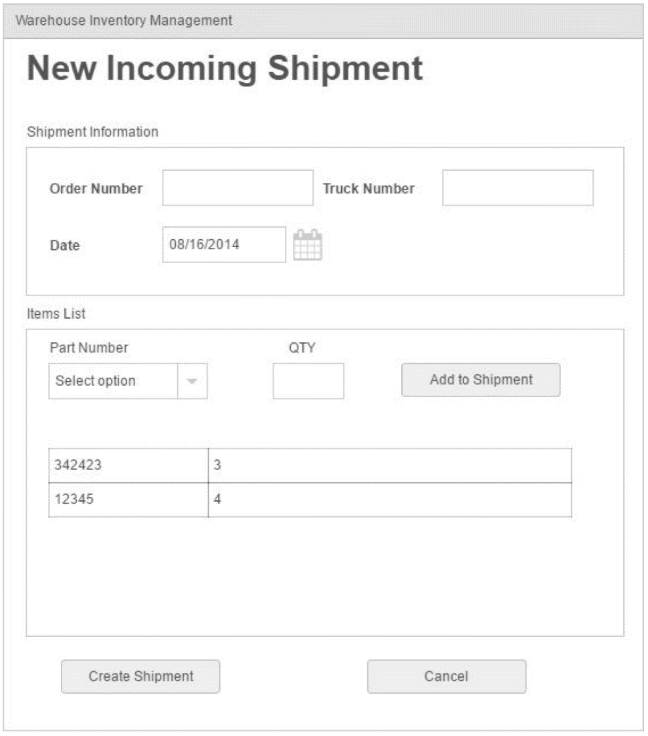

*Figure 12. Original New Incoming Shipment screen design.*

#### New Item Creation

##### Synopsis

The purpose of the New Item Creation screen is to allow the user to add new items to the system. The Name and UPC fields are required, while the Location and Quantity on Hand fields can be left blank. If these fields are left blank, a default quantity of 0, and a default location of 0 - A - 0 will be used.

##### User Actions

Inventory Name: The Inventory Name is an editable field that allows the user to enter the Name of an item. This field is required.

UPC Code: The UPC Code is an editable field that allows the user to enter the UPC Code. This field is required.

Quantity on Hand: The Quantity on Hand is a numeric field that allows the user to enter the initial quantity.

Aisle Dropdown: Allows the user to select the aisle.

Bay Dropdown: Allows the user to select the bay.

Shelf Dropdown: Allows the user to select the shelf.

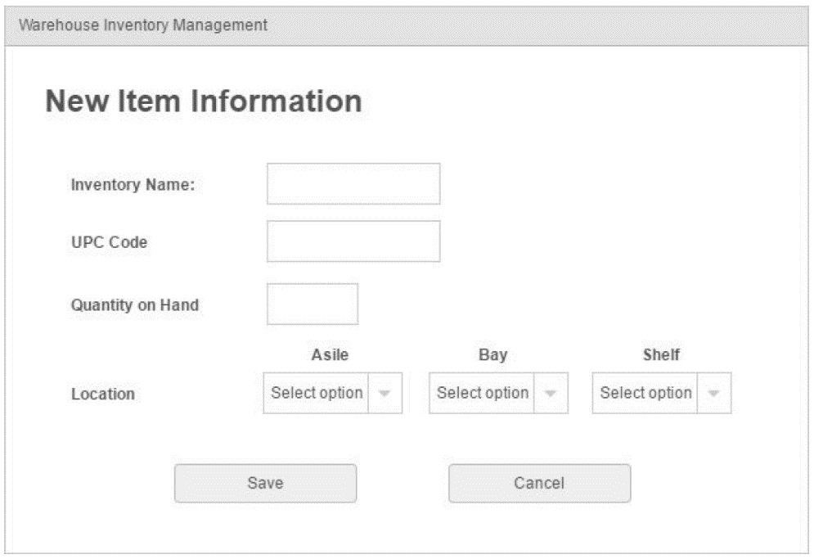

*Figure 13. Original New Item Information screen design.*

#### Outgoing Shipment Screen

##### Synopsis

The Outgoing Shipment works much in the same way as the Incoming Shipment screen, where a new shipment is created, and the quantity on hand is deducted from the inventory.

##### User Actions

Order Number: The Order Number is an editable field that allows the user to enter the Order Number.

Truck Number: The Truck Number is an editable field that allows the user to enter the Truck Number.

Date: The Date field allows the user to select the date of the order.

Part Number: Is a dropdown list of all items currently in the system.

QTY: Is an editable field that allows the user to enter the outgoing quantity.

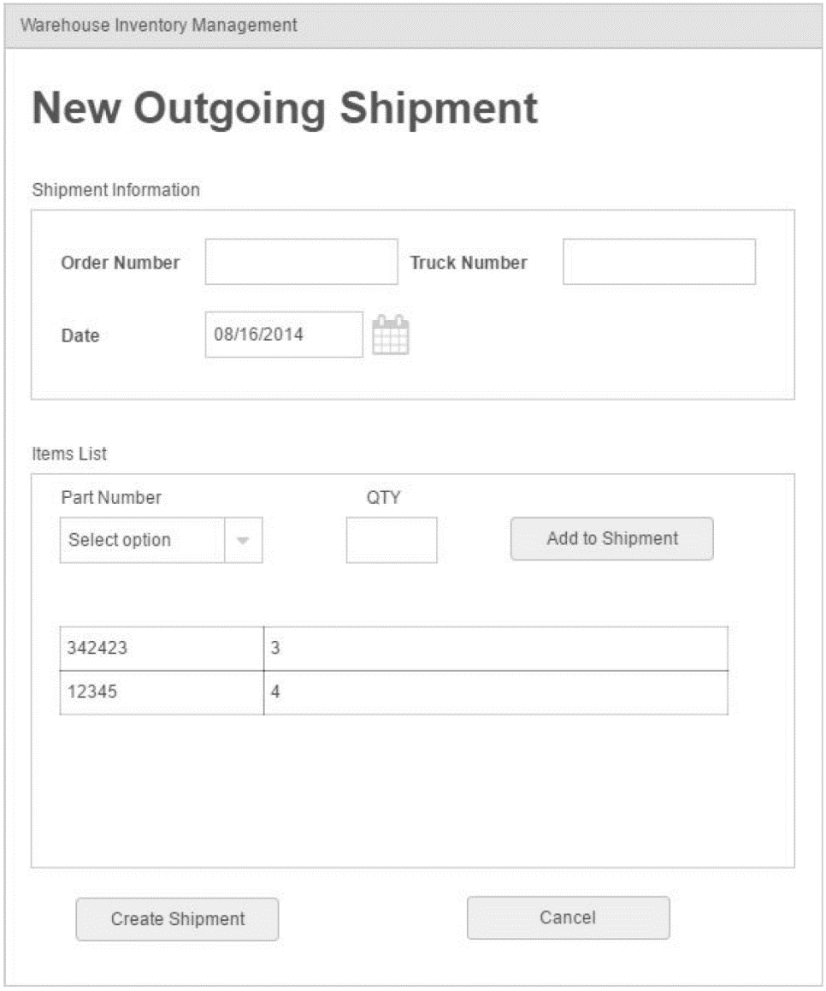

*Figure 14. Original New Outgoing Shipment screen design.*

### Original UML Design

#### Front-End UML Design

#### Back-End UML Design

## Final Design

The majority of the system remained the way it was originally designed with minimal changes to the layout of certain screens. Change details can be found in the Development History section. There were no substantial changes to the UML design for the back-end tables. The front-end UML design has expanded noticeably, however, the original features remain with the addition of additional classes to support the user interface.

### Front-End UML Design

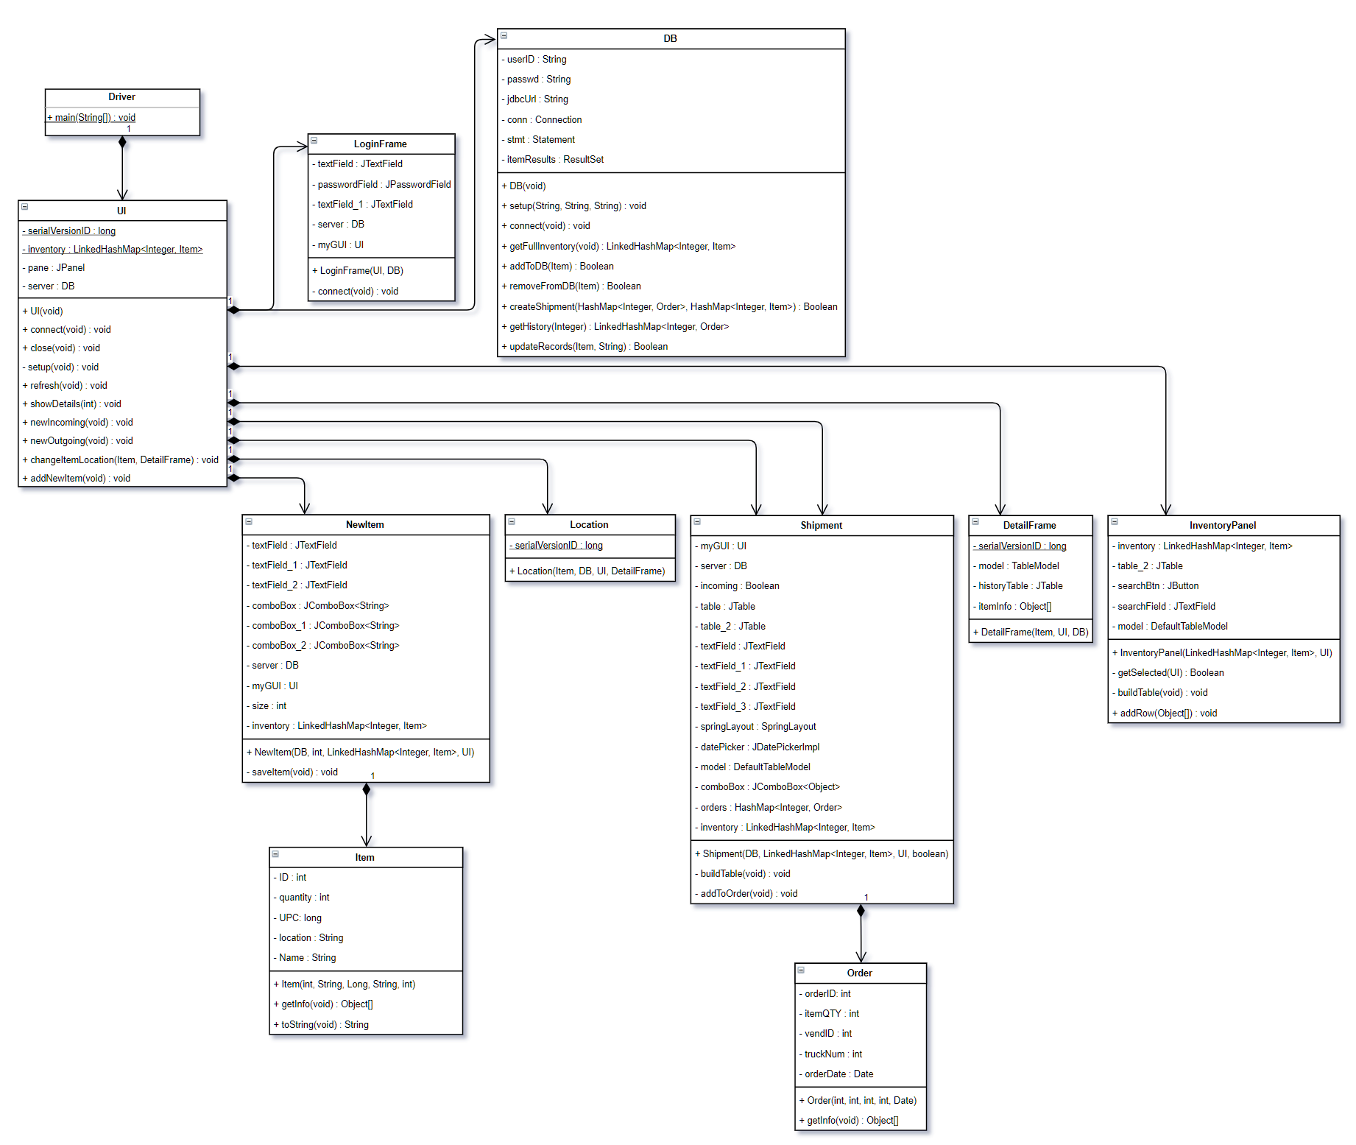

### Back-End UML Design

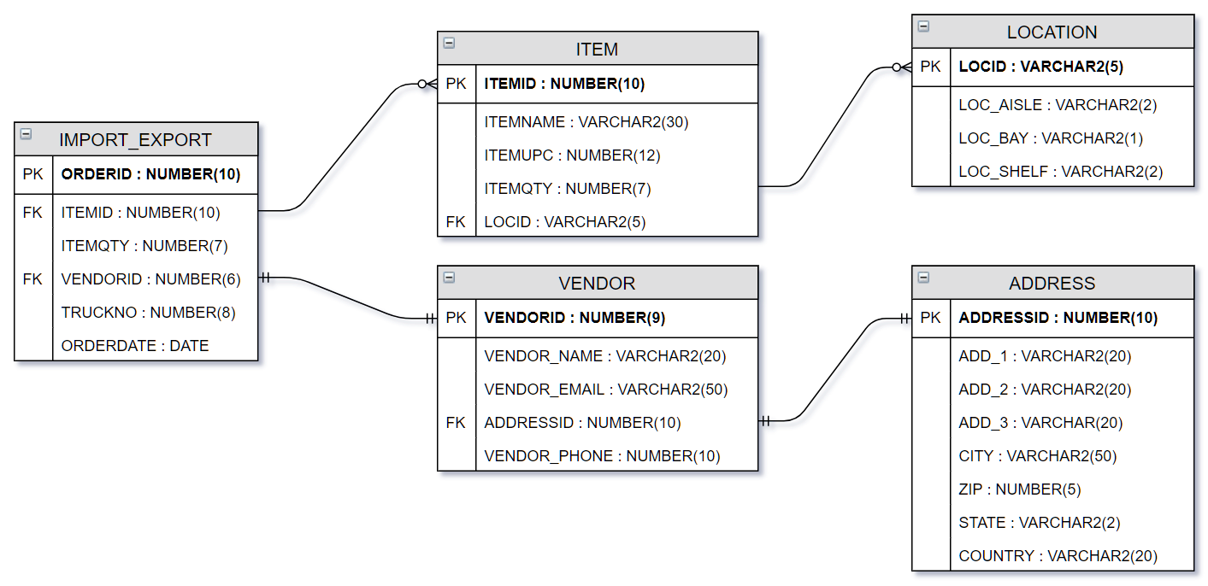

# Development History

In the Inventory Overview window, the checkboxes were removed to limit the selection to a single item when viewing the Item Details.

The Item Detail module was initially planned for completion during Week 5. This was reevaluated, and the Inventory Overview module was completed instead, pushing the Item Detail module to Week 6. The Inventory Overview module also performs the database connection and allows testing of the system earlier.

The Outgoing Shipment module was initially scheduled for completion during Week 8. Due to its similarity with the Incoming shipment module, they were completed concurrently during Week 7.

# Conclusion

The Warehouse Inventory Management system project was a success. With only minor deviations from the original plan and design documents, and without bottlenecks, the system was completed on schedule and as intended.

## Lessons Learned

Creating this project as a group was a new experience for all of us. We were all aware of the importance of communication when working in a group, but this project helped prove a working concept when face-to-face meetings were not an option. We were able to take this knowledge and apply it effectively by using Git, Slack, and Trello to coordinate our efforts.

On the development side, we learned the importance of creating a design document before beginning development. By having this completed, the development stages could be better planned and coordinated across the team. It also ensures that the final product will remain user-centric, not designed by a developer.

## Design Strengths and Limitations

Our design was based on using Java to develop the front-end and the Oracle 11g XE database as the back-end. These two components, both free and developed and maintained by Oracle, enabled a quick and seamless integration between the two ends. Although the seamless integration is especially important in a tailored database management system, using Java as the front end gives it a minimalist look unlike other modern systems.

## Future Improvement

Going forward, the WIM system would benefit from minor usability features such as a reset button on the Main Screen to restore the full inventory list after performing a search and overall U/I refinement adjustments. Designed to be a database and front-end package, the next release could include remote access. While running on a stand-alone machine is effective, a multi-user system would enable proper management, oversight, and delegation as necessary. Because both Java and Oracle 11g XE were developed to function on Linux machines as well as Windows machines, after testing, the next iteration of the WIM system could include Linux support.