# Stash/bitbucket

# Data driven framework:

* Framework which is driven by data. It can be used when **one test case** is executed with **different sets of data.**
* Example. 20 credentials to test single application.
* **Data Provider** is used to provide data to the test case using 2-Dimentional Object array.

# Execute Failed Test Cases:

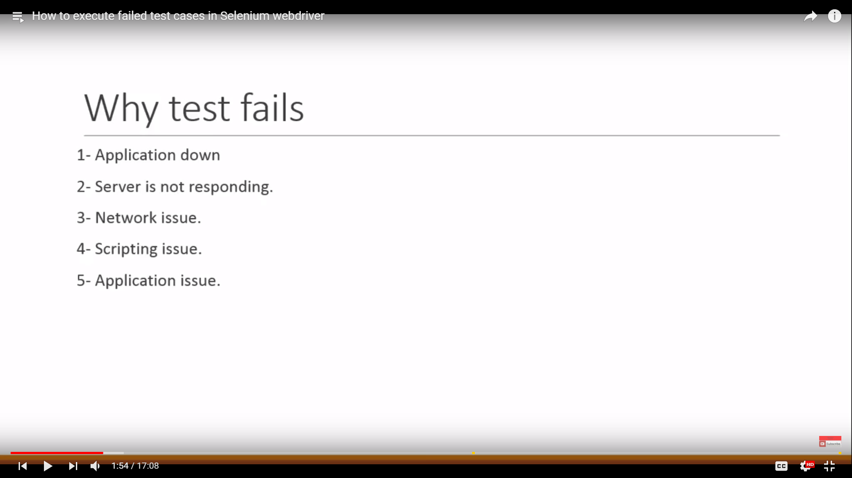

For failed test cases, we need to create different xml to run failed ones, but **TestNG** automatically **generates failed test cases XML file**.

We can now directly run failed test cases by right clicking **tetsng-failed.xml** file.

If we run **failed testng xml file**, it will generate failed test cases folder where we **have only failed test cases reports** only.

**Steps:**

* Create object of testng class
* Add failed test cases into lists
* **SetTestSuites** is used to run the failed test cases.

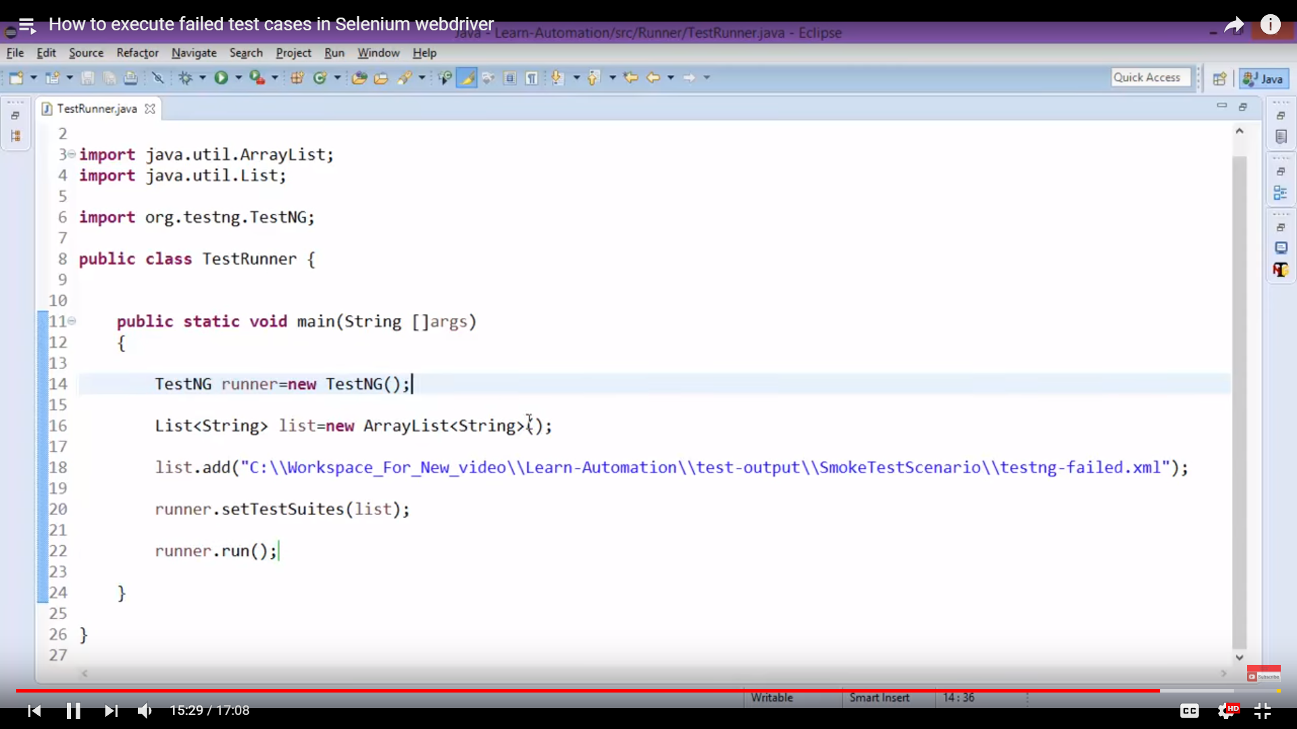

# XSLT Report

* XML stylesheet report for transformation