**Performance Testing Using Jmeter**

What is Performance Testing?

Performance testing is non functional testing. It determines the speed, effectiveness, reliability, scalability and interoperability of the system, computer, network, program or application

Performance testing tools:

* Apache Jmeter
* Load Runner
* SmartMeter.io etc.,

Advantages of performance Testing:

* Validate Features
* Measure the speed, accuracy and stability
* Keeps your user happy
* Improve optimization and load capacity

Types of Performance Testing:

* **Load testing** - Load Testing is performed to determine a system behaviour under both normal and at peak load.
* **Stress testing** - Stress testing is a activity that determines the robustness of software by testing beyond the limits of normal operation
* **Endurance testing** - It involves in testing a system with a significant load extended over a significant period of time.
* **Spike testing** - It is to determine the behaviour of a software application when it receives extreme variations in traffic.
* **Volume testing** - Volume testing is done to analyze the system performance by increasing the volume of data in the database.
* **Scalability testing** - It is used to measure its capability to scale up or scale out in terms of any of its non-functional capability.

Why we go for Jmeter for performance testing?

Jmeter is open source tool and user friendly. It used for performance and load testing for analyzing and measuring the performance of a variety of services. This tools mainly used for web and API/ Web Services applications.

* It is platform – independent tool.
* Highly support and portable for all java bases apps.
* Less scripting efforts because it is user-friendly GUI.
* Supports multiple load injectors managed by a single controller.
* It is highly extensible.
* It stores test plan in XML format, which means you can generate a test plan using a text editor.
* Protocols like HTTP, HTTPS, XML, SOAP, Java-Based protocols and FTP.

Jmeter:

* In Jmeter can record our scripts by using “Non-test Elements – HTTP(s) test script recorder” and “Logic Controller – Recording controller” or using “Blaze Meter” also we can record scripts.
* **Test Plan** - A test plan defines series of steps Jmeter will execute when we run.
* **Elements** - It is a building blocks for test plans. Elements of a test plan can be added by right clicking on the Test Plan node and we can choose a new element from the “add” list.

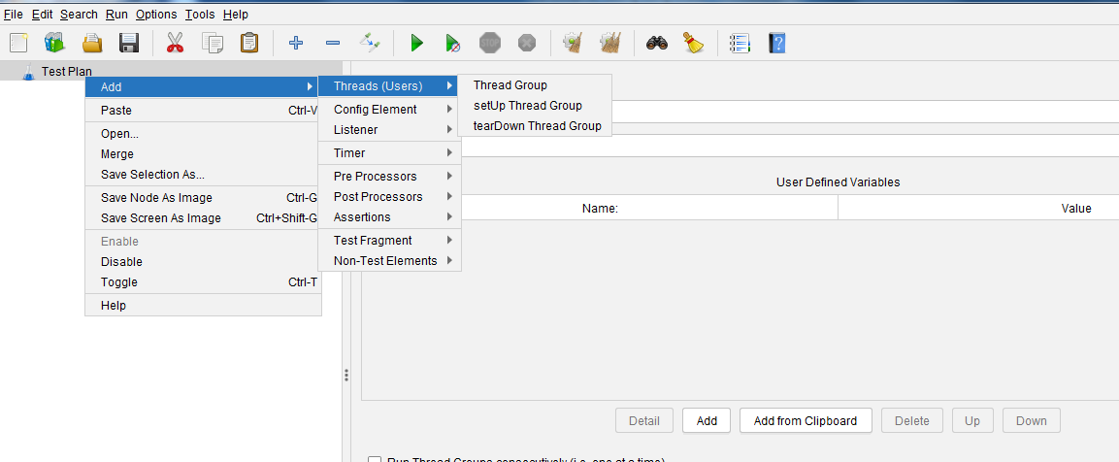

* **Thread Groups** - It is beginner for test plan. It controls the number of threads Jmeter will use during the test.

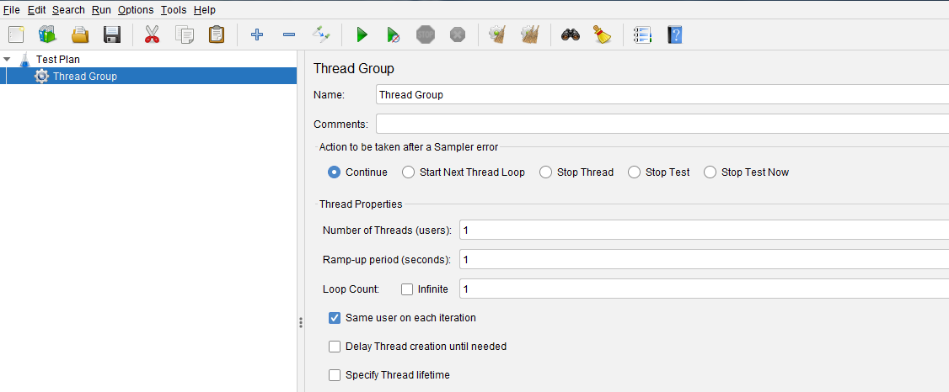

* **Samplers -** It allow JMeter to send specific types of requests to a server. It simulate a user’s request to the target server. For example, we can add a HTTP Request sampler if you need to perform a POST, GET, DELETE on a HTTP service.

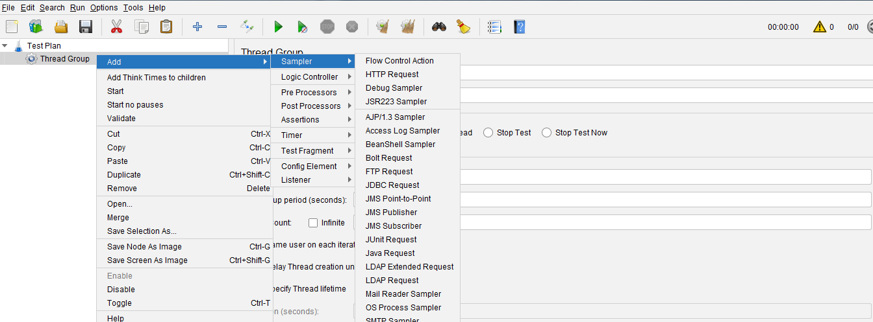

* **Listeners -** It let you view the results of Samplers in the form of tables, graphs, trees or simple text in some log files. It provide visual access to the data gathered by JMeter about the test cases as a Sampler component of JMeter is executed when we start the test plan .

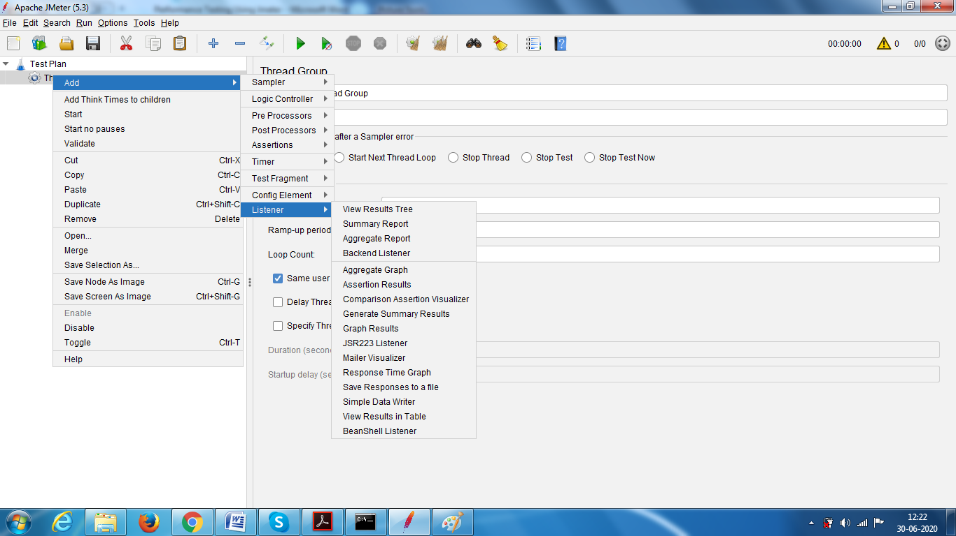

* **Correlation** - It is process of extracting some valuefrom the reponse of one step into the request of another step. It takes and store the dynamic response from the server and passes it on to subsequent request.
  + To handle session variables, they are passed to the subsequent requests and help validation & authentication of the actions performed.
  + If we don’t send the dynamic values by correlation the web request may fail.
  + To perform correlation, we need use “Regular Expression Extractor”.

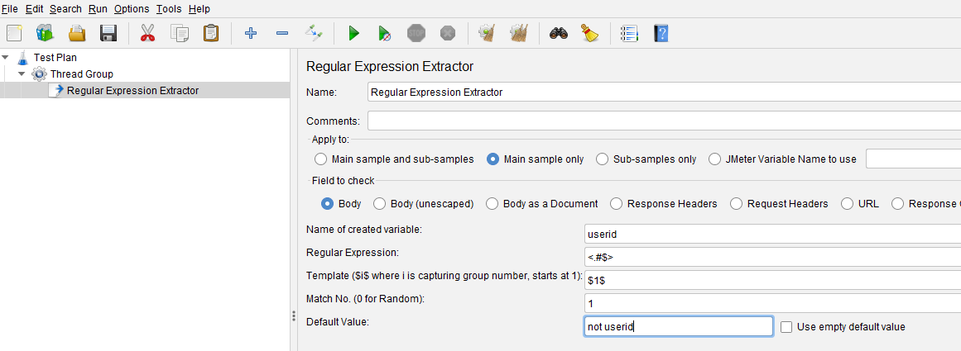

* **Distribution Testing** - It enables having a local JMeter (master) that handles the test execution, together with multiple remote JMeter instances (slaves) that will send the request to our target server.
  + To perform distribution we need to configure some settings like we need to add slaves ip address in jmeter properties file.
  + Now you can execute multiple users at a time.

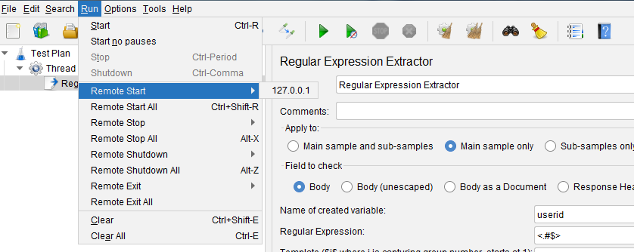

* **CSV Data Set Config** - It allows you to extract external data sets in a CSV format. It is used to read the data from a file and split them into variables.

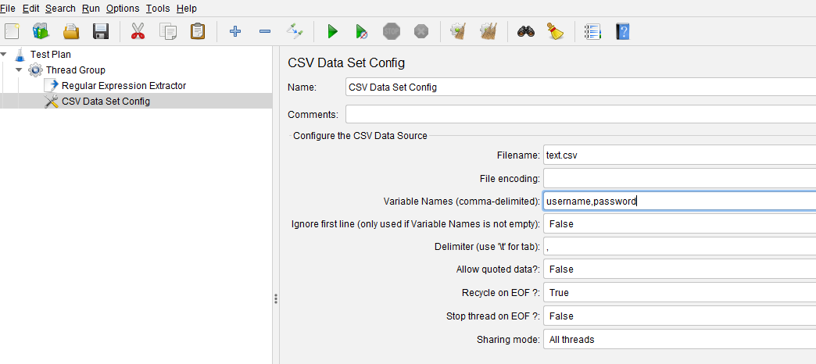

* **Functions and Variables** - Functions are special values that can populate fields any sampler or elements. It helps you to make your test plan flexible and maintainable.

