# Initial Setup – Server Side

1. Request a GIT account
2. Log in with your GIT account on <https://s415vmmt156.detss.corpintra.net>
   1. If you did not receive a password, use the “Forgotten your password?” button below the login screen. Use the capgemini email address.
3. Navigate to your home profile by clicking “Dashboard” on the top right
4. Press “Manage SSH Keys”

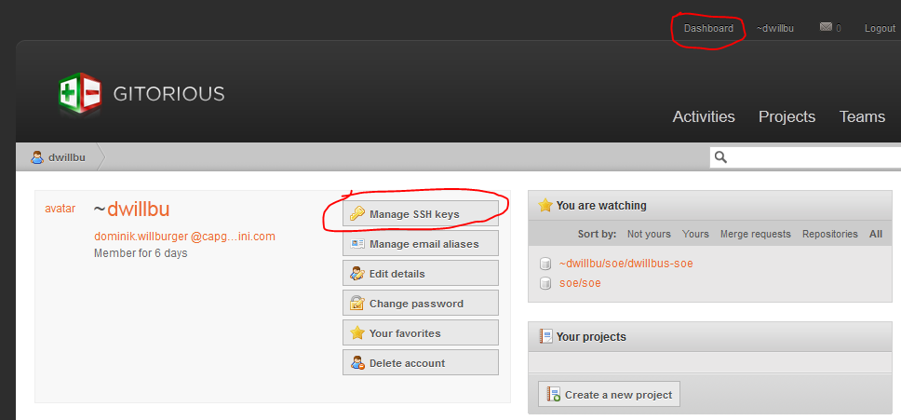

1. Press “Add SSH Key”

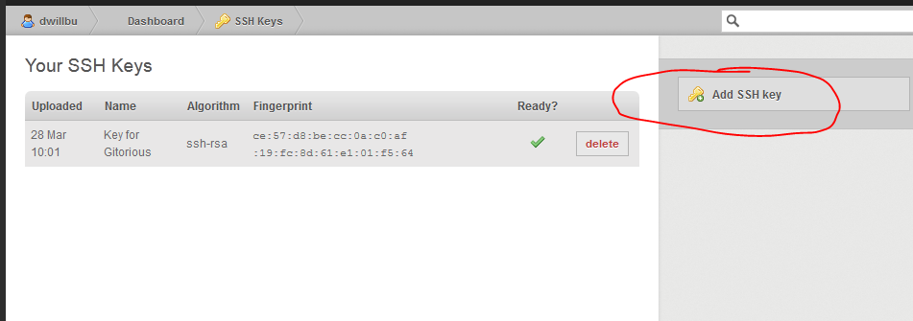

1. Paste the content of a locally generated SSH key.

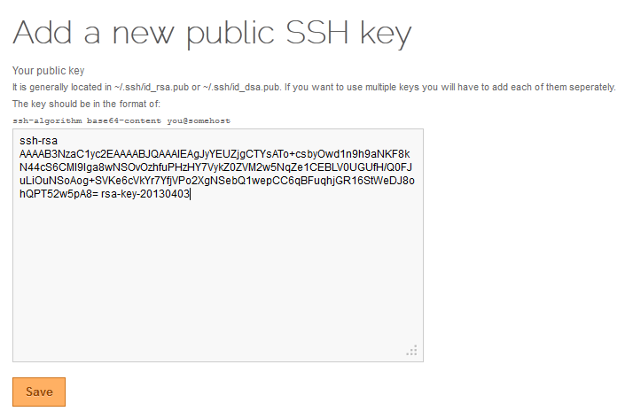

* 1. The key can be generated using PuTTYGen, which is available on the WWW: 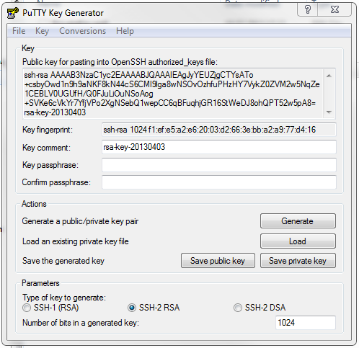
  2. Make sure to 1. Use SSH-2 RSA 2. The pasted text needs to be in the format as displayed above. 3. Save the private and public key locally for later use. For security please provide a passphrase. The text can be copied directly from PuTTYGen to the Gitorious screen via Copy&Paste.

# Initial Setup – Client Side

1. Use the installation file from the starter package or download GitExtensions from <http://code.google.com/p/gitextensions/>
2. Run the installer
3. 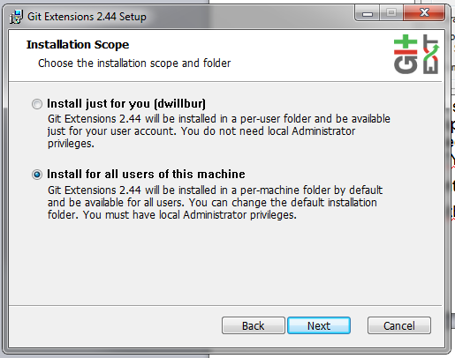
4. 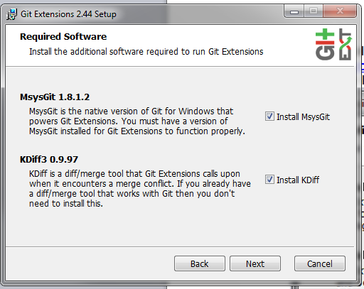
5. 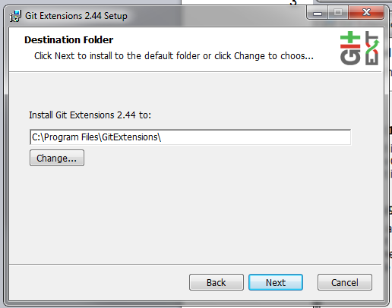
6. 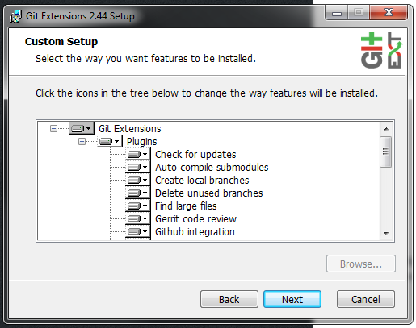
7. 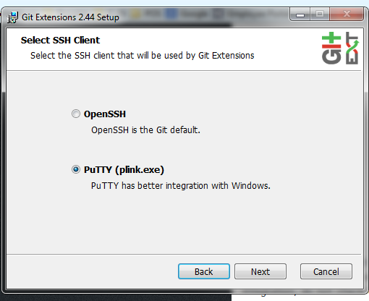
8. Accept all windows regarding the installation of KDiff
9. In the GIT setup check “Windows Explorer integration”
10. 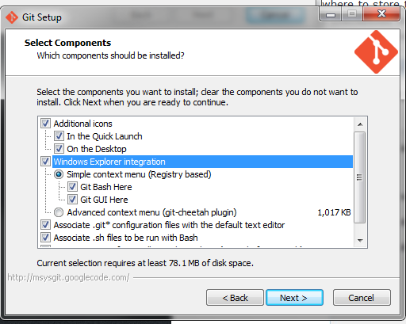
11. 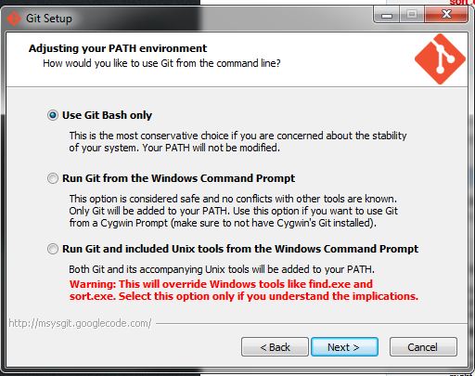
12. 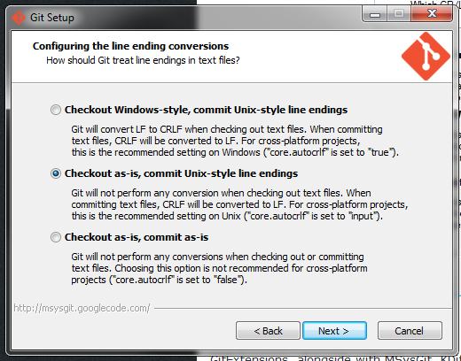
13. Accept the subsequent screens.
14. Installation done.
15. Configure your personal user by right-clicking a random folder in the windows explorer. In the context menu select Git Extensions -> Settings.
16. Hit the repair button and enter your data:
17. 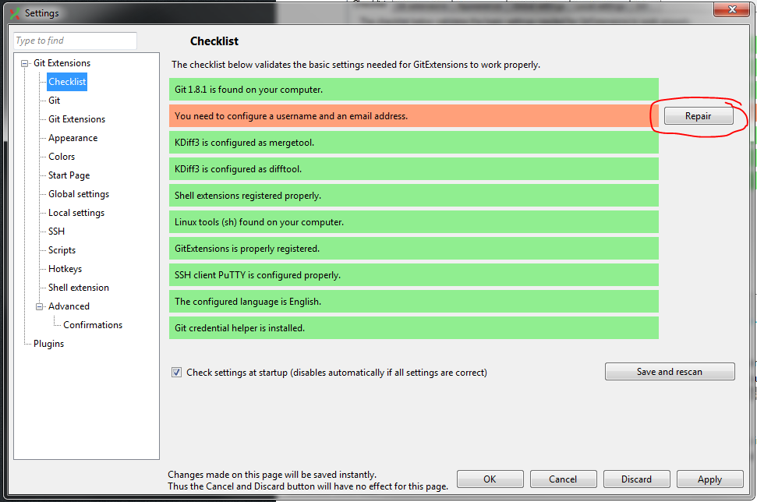
18. Provide the required information. Use the username from Gitorious.
19. 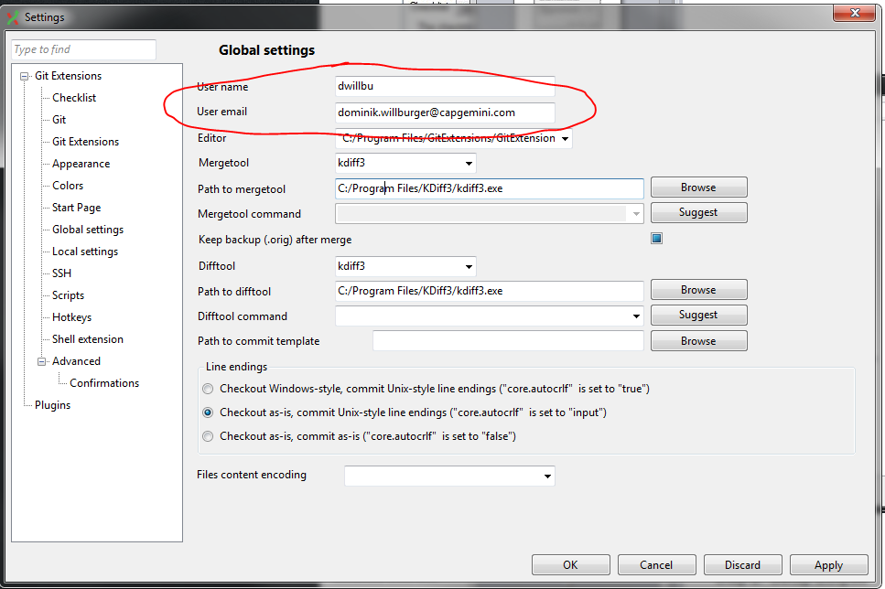

# Initial Setup – Setting up the clones

1. Create a remote CLONE on Gitorious:
   1. Log in to Gitorious
   2. Switch to the soe project site
   3. Press the “clone repository” button
   4. 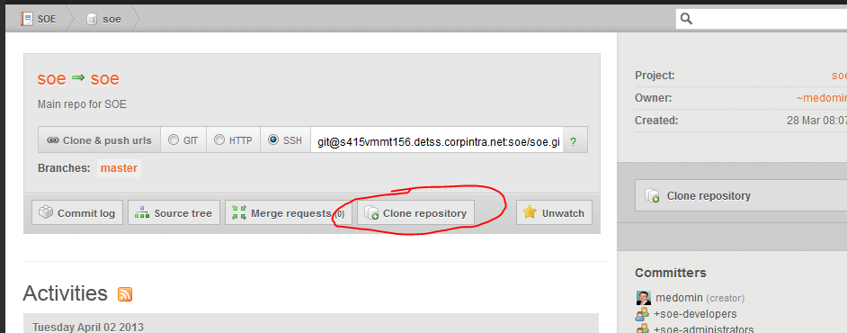
   5. Give a name to the clone:
   6. 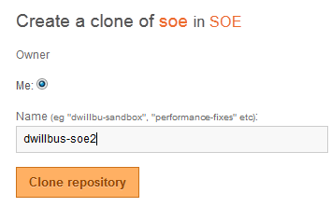
   7. The clone will be displayed. You can copy the path from the screen.
   8. 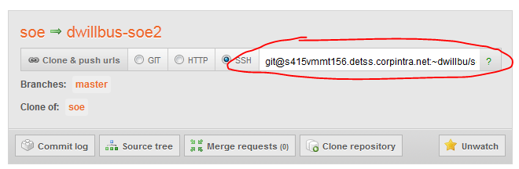
2. Create a local CLONE: In the windows explorer right-click->GIT Ex Clone
   1. Paste the URL in the “repository to clone” field
   2. Select the branch “master”
   3. When doing this for the first time: press “Load SSH Key” and select your private Key as generated during the GIT initial setup.
   4. Press “clone”
   5. 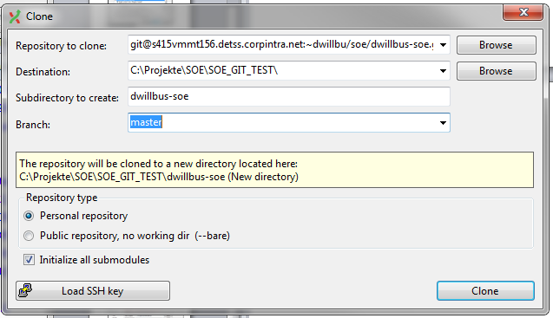
   6. The contens are now cloned to the local repository