Steps to create new branch and check files to GIT repository
Go to C:\MBConnect\SOE\git\central folder . Right click on central folder->git browser
1. Pull changes from Master to Master
Update your local with master branch .
2.Create a branch with your service name /task name as shown below
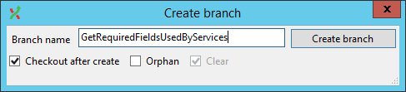

3. Pull the changes from master branch to local branch
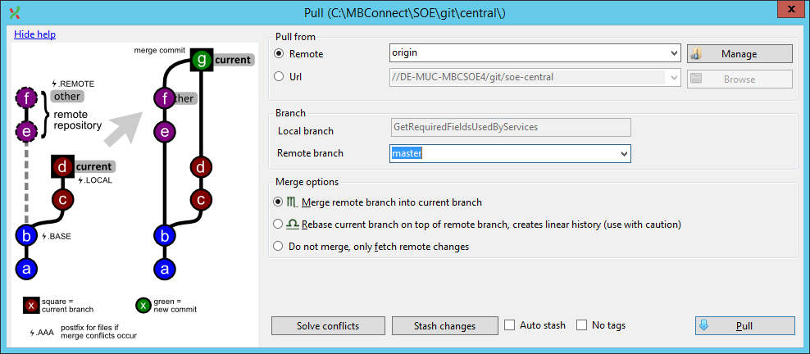
4. Commit changes locally
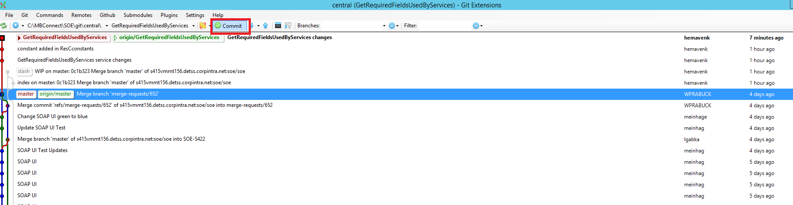

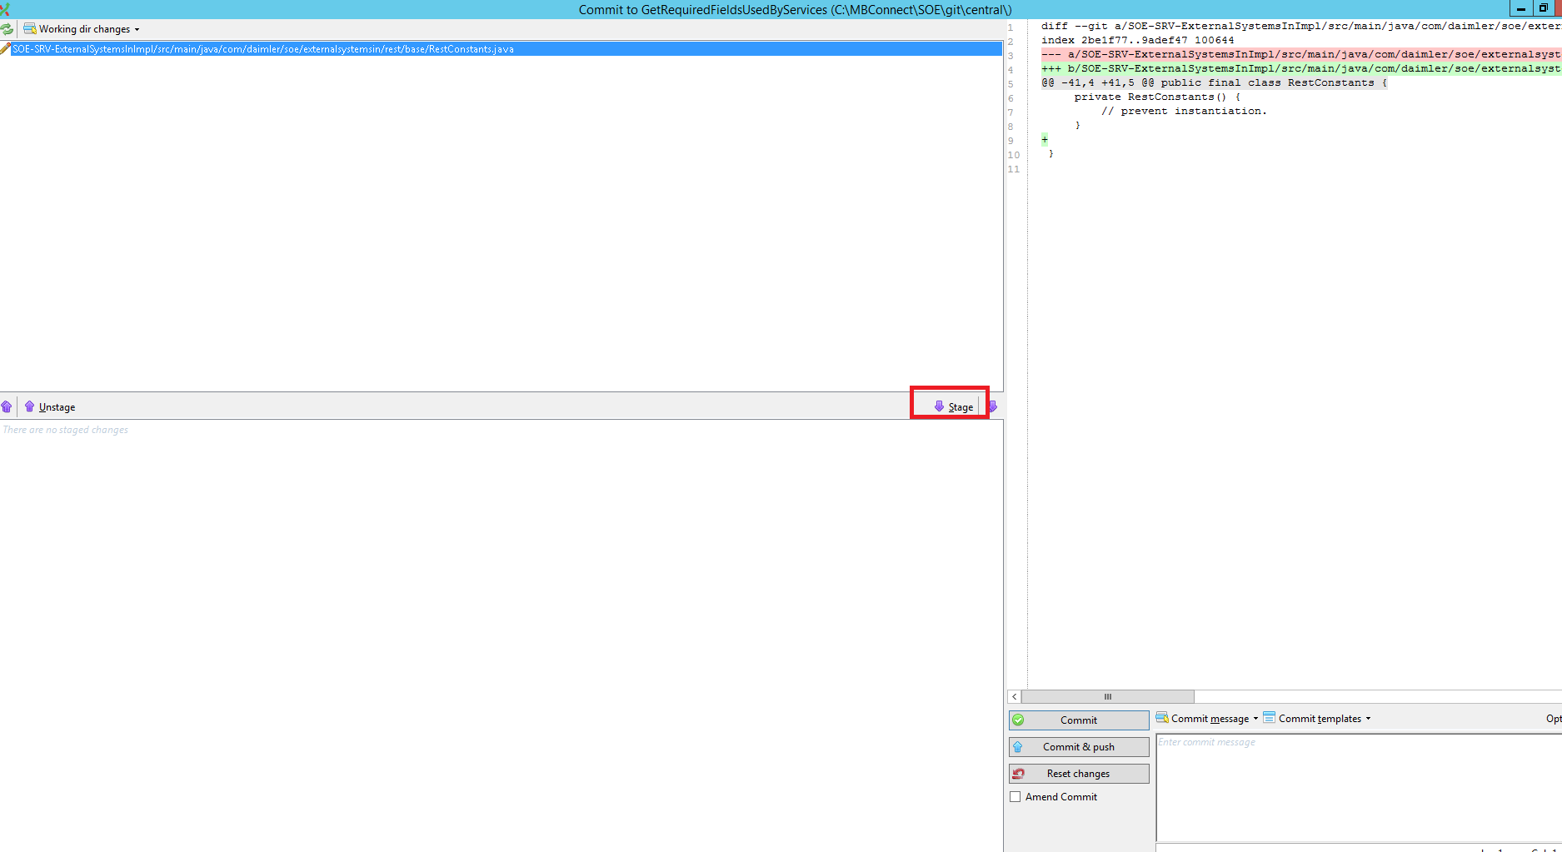
Stage down the files which are changed and enter the comments . Click commit

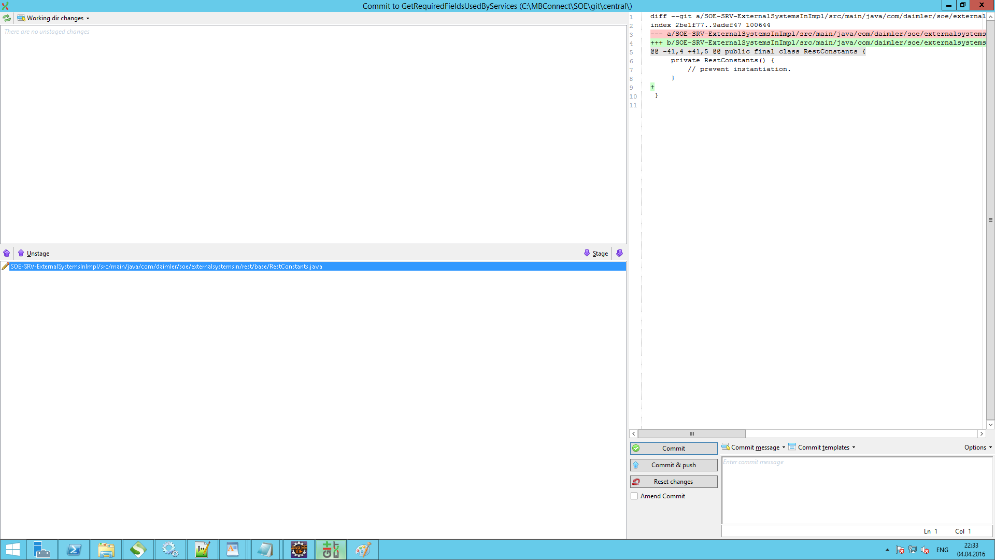

5. Push the changes local to local branch
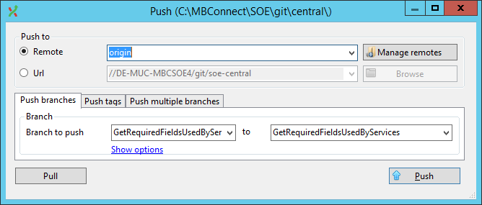

6.when pulled , if any conflicts ,click on stash changes
Or go to eclipse , right click on the folder/file ,right click->Team->stashes ......resets the changed files which you do not want to commit.
Files which you want to commit and if it has conflicts , merge the files carefully . It should have the latest changes of master and then merge your changes .

