SOAP UI test file generation
Rest Service whose method type is GET
1. Copy the existing any of the service xml file whose method type is GET as mentioned below. Rename the file to your service name.

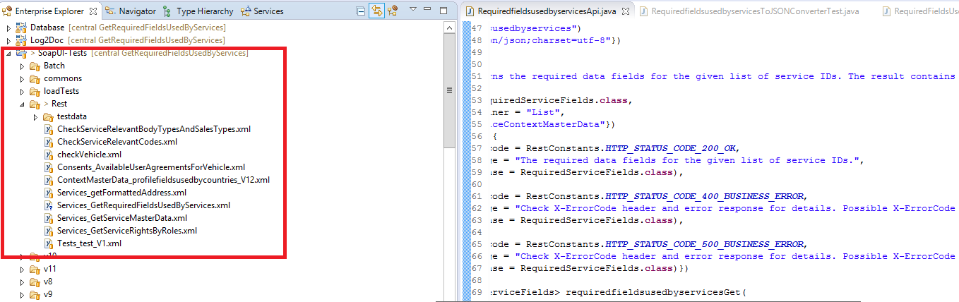

2. In SOAP tool, switch workspace to REST-Worspace.xml file

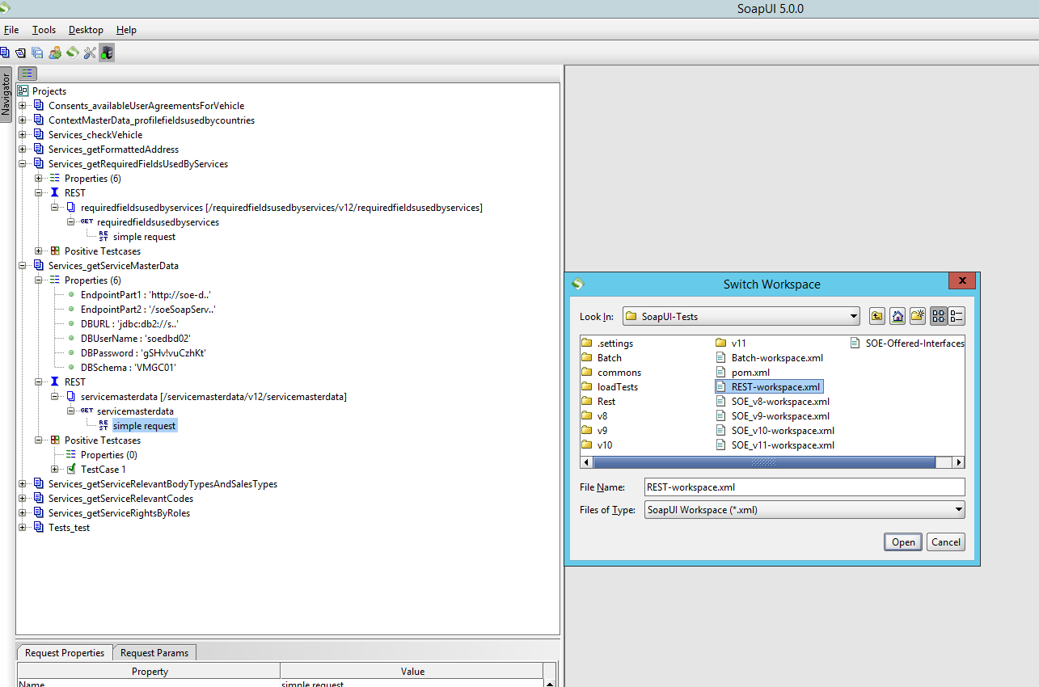

3. File -> Import project -> Select the create file in step 1
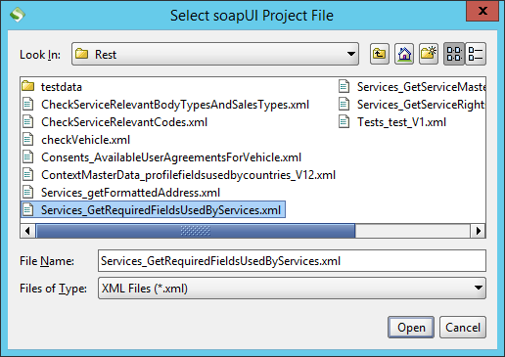
4.
Change the highlighted folder names as per your service name and path in API

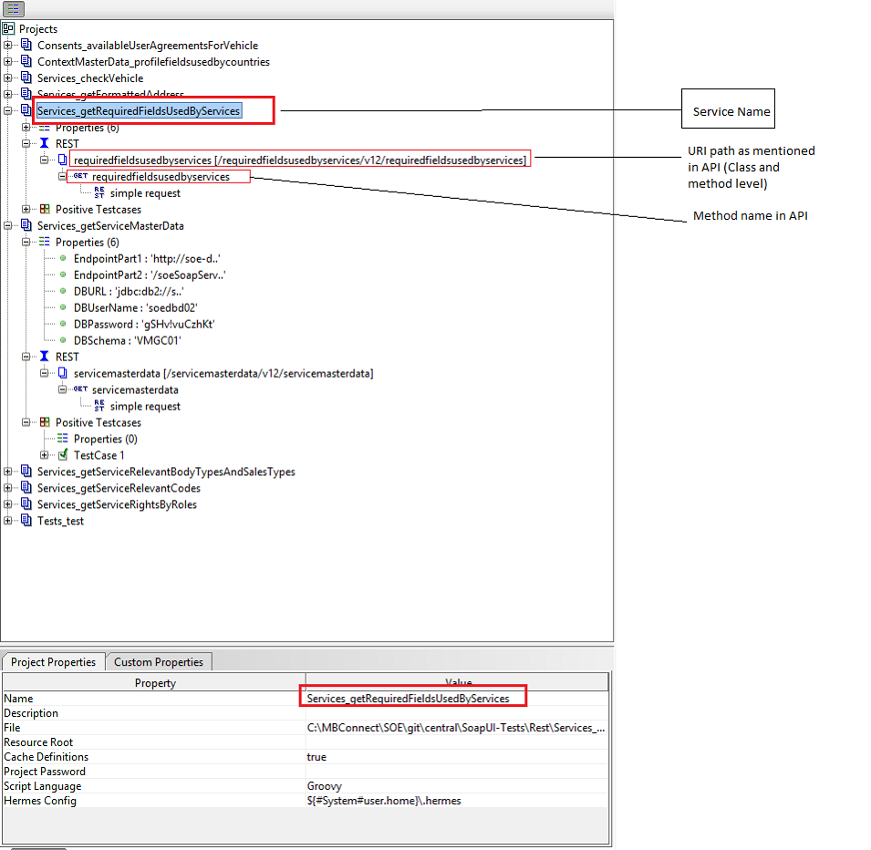

5. Select the service as shown below and add query params referring to your API method in eclipse
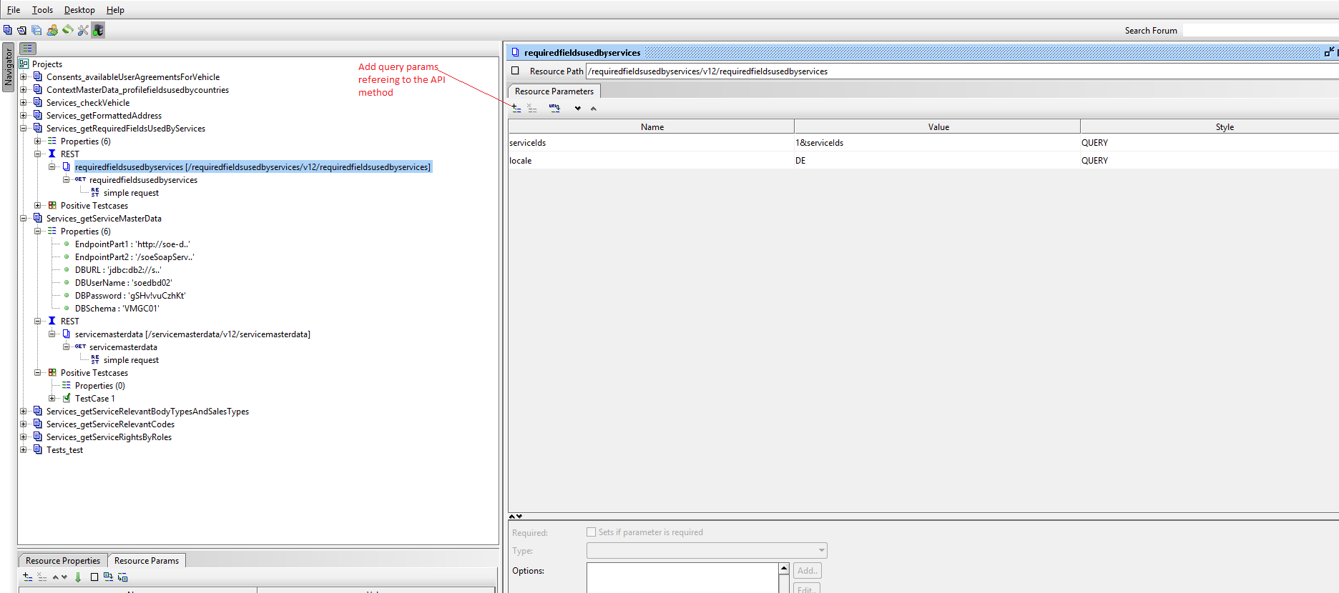
6. load properties
select the project and load the properties as shown below
C:\MBConnect\SOE\git\central\SoapUI-Tests\commons\ci_properties\dev1.properties
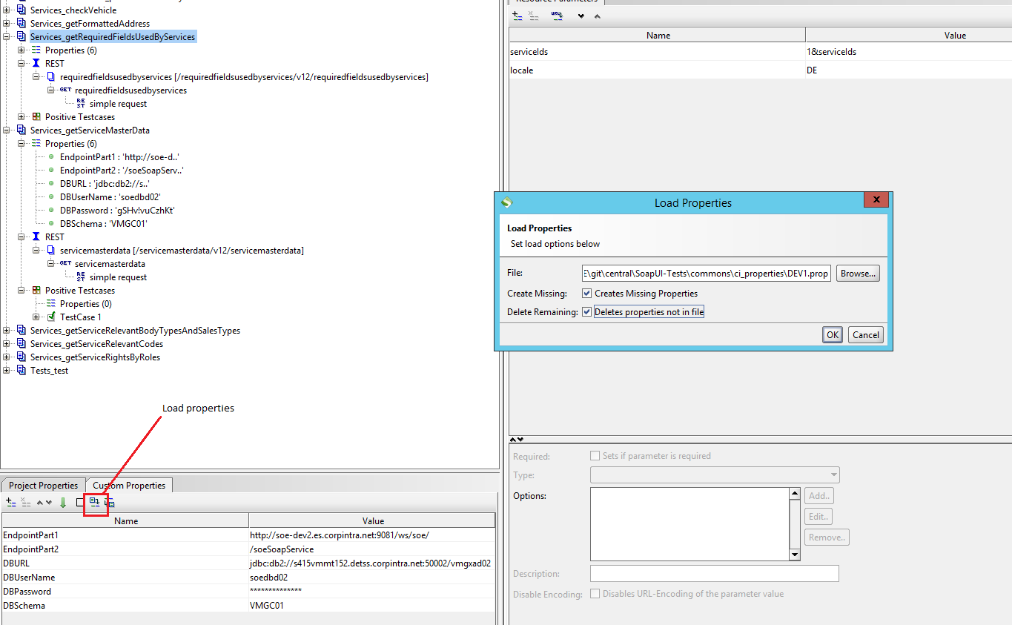

7.Double click on simple request in navigator .
Check for query params refering to the API method in eclipse.
Check for headerparams refering to the API method in eclipse and update the same in SOAPUI tool as shown below

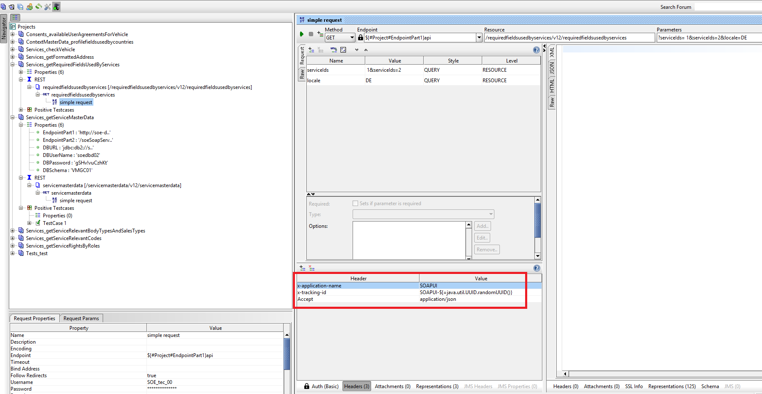
8. Double click on the method name and check for method type which should be GET
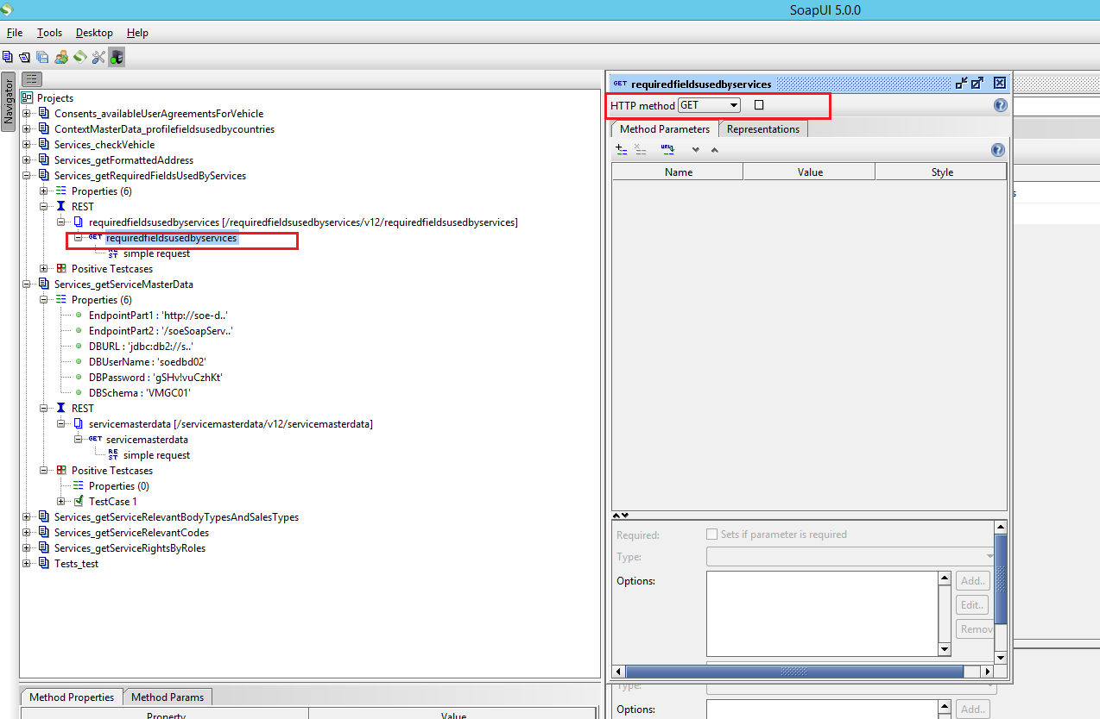

9.

Right click on project and save as “servicName.xml “ file(In following path C:\MBConnect\SOE\git\central\SoapUI-Tests\Rest) as shown below

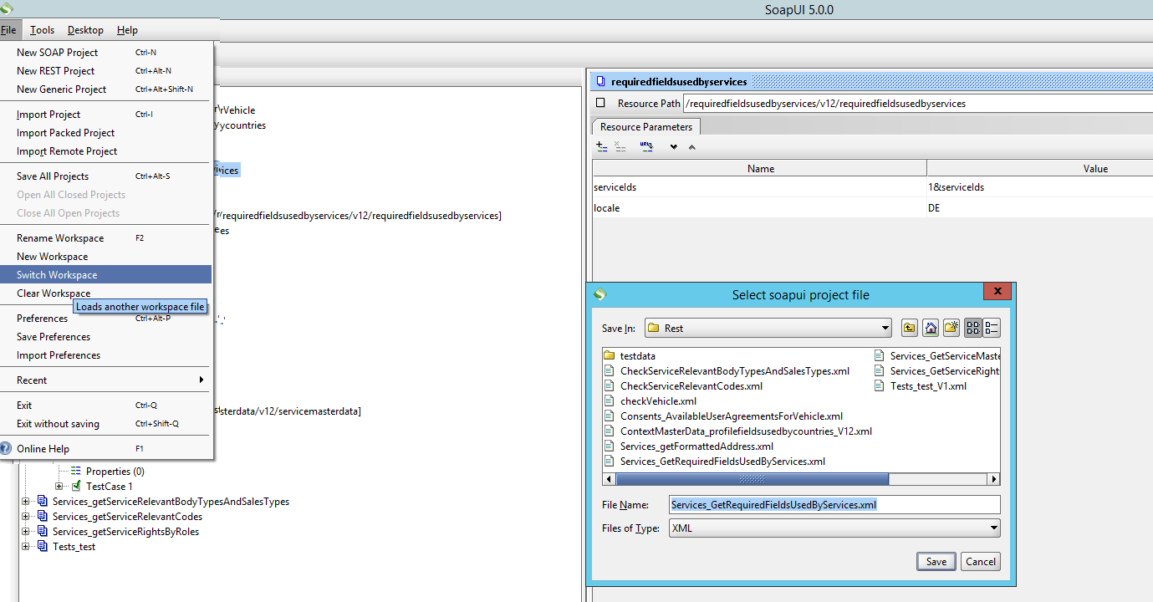

10. Rest-worspace.xml file will automatically be updated with new service configuration. Check your service name update in rest-workspace.xml file in eclipse
11. Finally two files will be changed
Rest-Workspace.xml(Existing file)
Services_Servicename.xml file(New file)

