Flask Templates!!

Adding in **‘render_template’** - to the import list

And

Adding **render_template(‘html name’)** to the return tag from the route on **server.py**

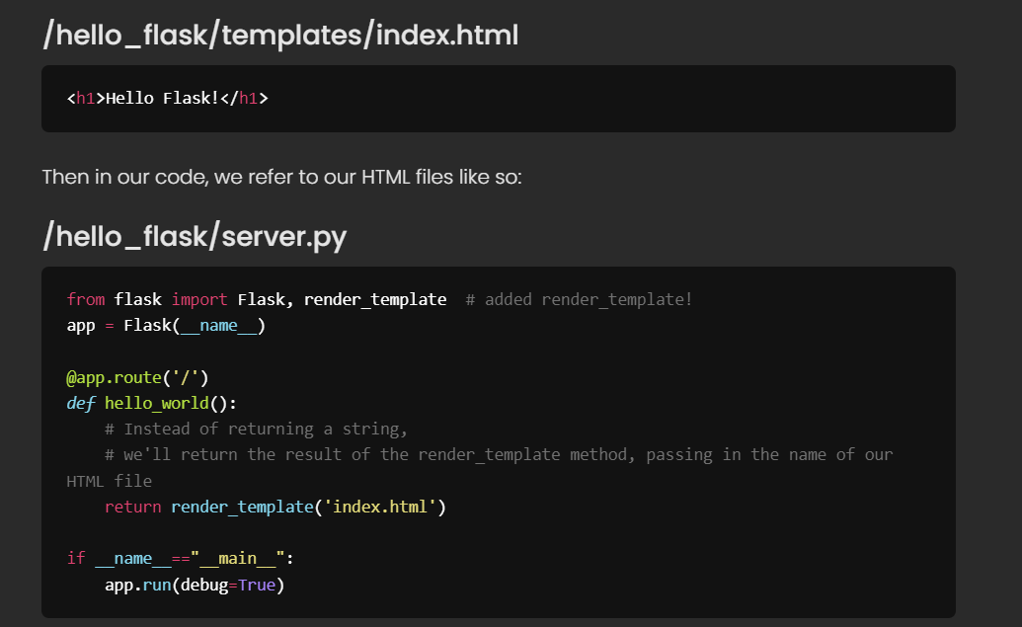

Passing data

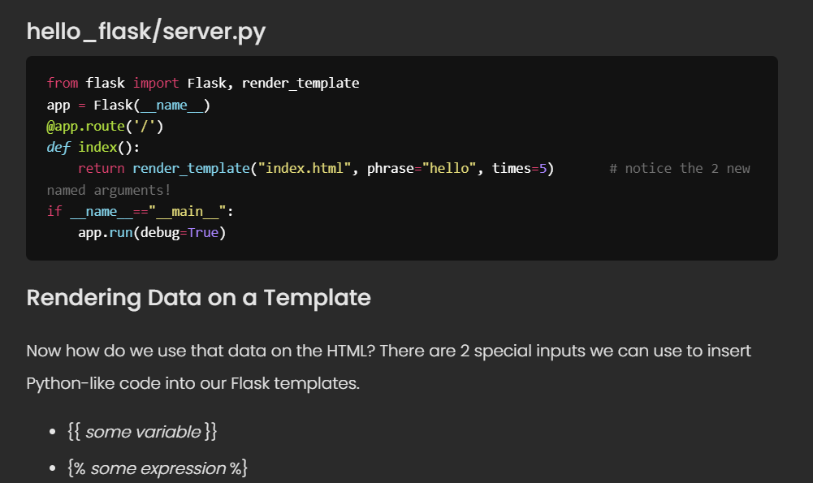

Pay attention to the indexing keys

Use **{{ }}** to add a variable

Use **{% %}** to add an expression such as a **‘for loop’**

**‘For loops’** must use **{% endfor %}**

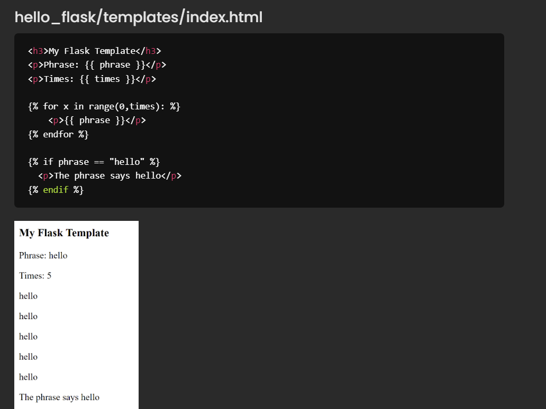

Jinja template documents

https://jinja.palletsprojects.com/en/3.1.x/

* {% ... %} for [Statements](https://jinja.palletsprojects.com/en/3.1.x/templates/#list-of-control-structures)
* {{ ... }} for [Expressions](https://jinja.palletsprojects.com/en/3.1.x/templates/#expressions) to print to the template output
* {# ... #} for [Comments](https://jinja.palletsprojects.com/en/3.1.x/templates/#comments) not included in the template output