**Rudachenko Dmitriy**

Age: 26

Phone: +380680209780

E-mail: rudachenko.dmitriy@gmail.com

**Full Stack Web Developer**

Programmer over than 10 years, 8 year of commercial development.

For the years of work, I get experience and skills in all directions of web-development, which allow me to handle tasks of any difficulty level.

Skills:

- PHP - Frameworks Yii2, CodeIgniter

- JS - JQuery, JQuery UI, AngularJS, TypeScript

- Databases MySQL, MsSQL, PostgreSQL, SQLite

- HTML5, CSS3, Flex

- WordPress plugins and themes

- Composer

- Version Control Systems - Git, SVN

- Linux administration skills

- Intermediate English level

Additional skills:

- C# Knowledge - Linq, Ninject, Nuget, NHibernate

- ASP.NET – basic skills

- Experience with MS Reporting Service

- Experience with WooCommerce, Magento, Google AdWords API

Education:

2008 – 2014 - Zaporozhye Engineering Academy(ZGIA), System Programming

2005 – 2008 - «It-Step» Computer Academy, Programming

Experience:

2016 – 2017 mysoul.help – Lead Developer

Online consultations project based on video calls and text chats (in-browser Skype analog).

Use WebRtc technology, with capability of call recording, text chats, consultation schedule interfaces.

Site based on Yii2 framework, calls based on Kurento media server, app. server - Node.js

Used technologies:

-PHP + Yii2, JS \ jQuery, CSS, etc

-PostgreSQL

-WebRtc

-Kurento Media Server, Linux Administration

-Node.js

-LiqPay API

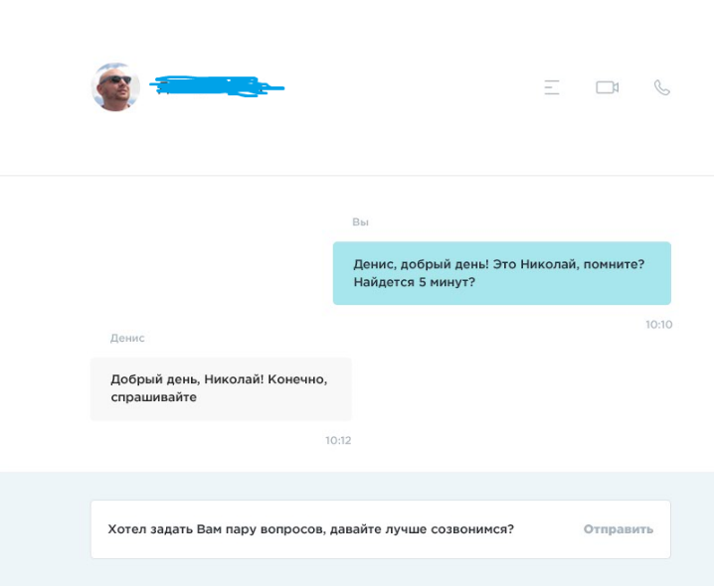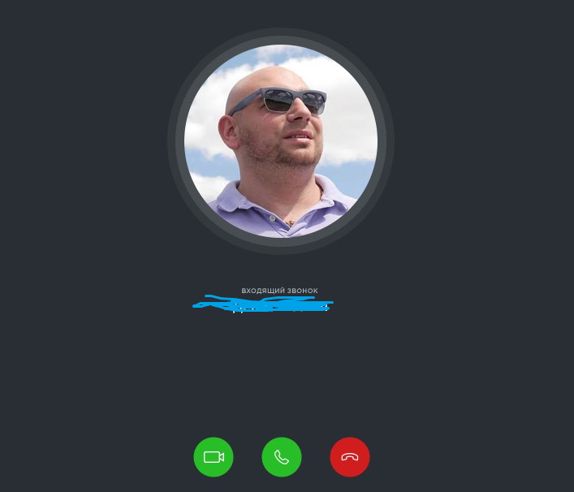

2016 – Eloplay, Web Developer

Development of system that allows to track progress of gamers in different games, tournament management. Integration with RiotGames API, Steam API and Blizzard API.

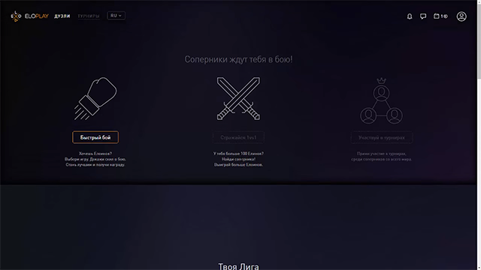

Used technologies:

C# +, nHibernate, PHP + Yii2, TypeScript, AngularJS

2014 – 2016 ClickandSell Inc. - Lead Developer

Big project about Site-Builder and CRM development, integration with each other and other services.

Also WordPress integration, Linux servers management.

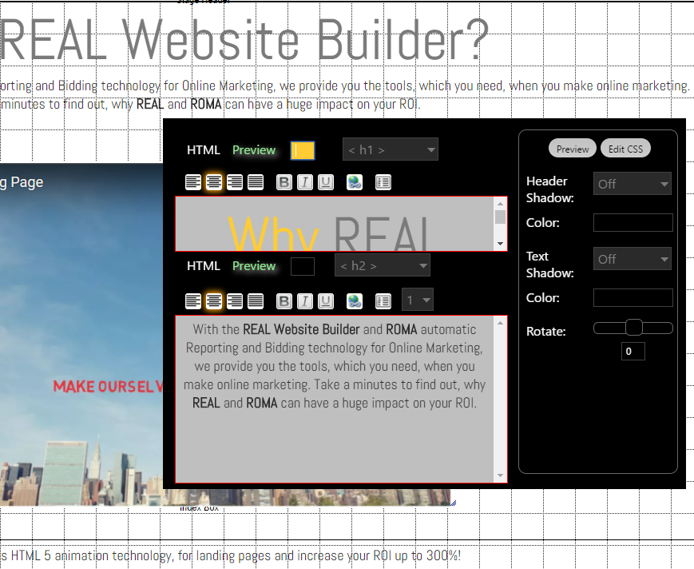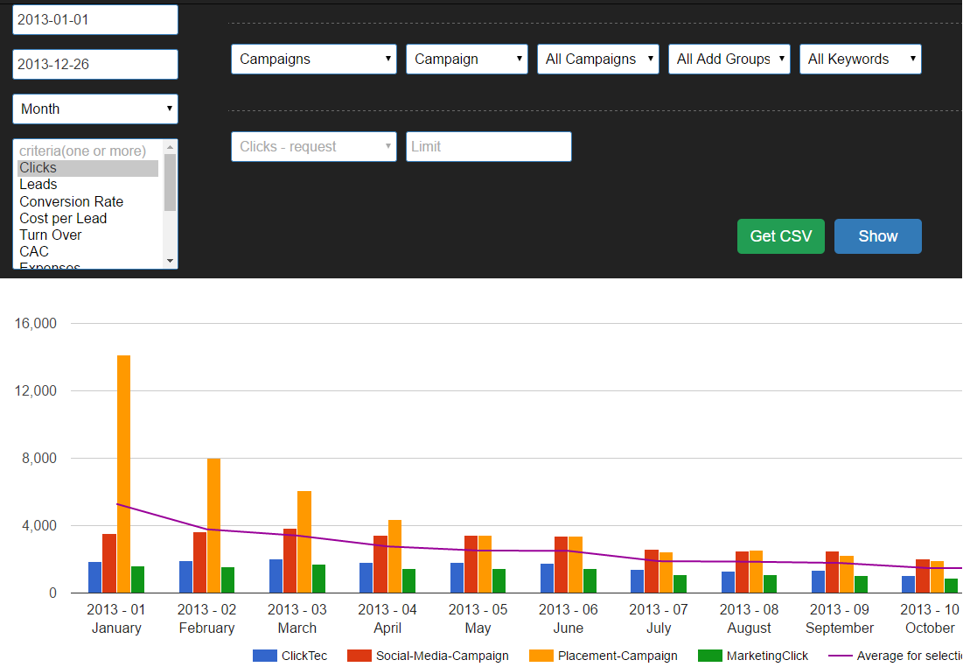

Analytic system effectivity of sales and advertisement, integration with с Google Adwords, Magento, WooCommerce.

Used technologies:

PHP, MySQL, CSS, JS, Frameworks, Google API, WordPress etc.

2013 – 2014 Freelance, PHP based web projects and C# for desktop apps.

Different web projects including WordPress tasks, custom themes, plugins, short-codes generators etc. For example, icon generator with saving as short-code.

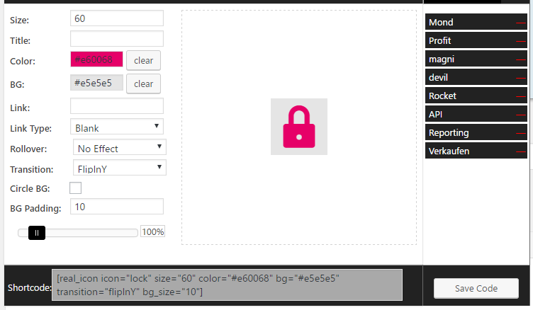

Used technologies:

PHP/JS/Databases. Wordpress Themes and plugins

2012 – 2013 SMK Vision, Web developer

Different small and mid-sized web-projects, including parsers, submitters, calculation systems.

Used technologies:

- PHP / CodeIgniter, JQuery/CSS3/HTML5, C#

2009 – 2012 JSCB «Industrialbank», Programming Engineer

Was a part of the team of developers internet-banking system. Experience with big, high-loaded databases and its optimization.

Used technologies:

PHP \ Smarty \ JS, DataBases MS SQL\MySQL, C#, MS Reporting Services