Description of Database Features

Step 1: “Annotation Data” – The annotation of Affymetrix probesets is derived from GeneChip® Mouse Genome 430 version 2.0 arrays.

Step 1: “Statistics” – Statistics for each of 531 ANOVA models to test for gene expression differences and for correlations between phenotype measurements and gene expression values are available for all 45,101 probesets on the array. ANOVA models were used to decompose gene expression estimates for each probeset (Y) into a sum of effects <model terms> and random error (ε). GROUP refers to STRAIN-SEX-DIET groups in OverallModel. STRAIN is treated as a random effect in Model 2. The subject headers include the following:

Gene Expression:
ANOVA Model Used
OverallModel: Y = μ + GROUP + ε
Model1: Y = μ + SEX + DIET + STRAIN + ε
Model2: Y = μ + SEX + DIET + ~STRAIN + ε
Model3: Y = μ + SEX + DIET + STRAIN + DIET:STRAIN + ε
Model4: Y = μ + SEX + DIET + STRAIN + DIET:STRAIN + SEX:DIET + SEX:STRAIN + SEX:DIET:STRAIN + ε

Term tested
Group, Sex, Diet, Strain, StrainByDiet, StrainByDietBySex

Sex Used in Model
Female, Male

Diet Used in Model
LowFat, HighFat

Comparison Tested (for pairwise tests)
e.g., LowFat vs HighFat

“FoldChange” (for pairwise tests)
e.g., fold change in gene expression between LowFat and HighFat

“Fs_values”
Calculated values of modified F-statistic incorporating shrinkage variance components

“Ptab”
Tabulated permutation p-value (based on 1000 permutations of group labels)

“Qvalue”
Calculated false discovery rate (“q-value”) derived from Ptab distribution

Correlation:
cor_<phenotype>
Correlation between gene expression and phenotype

absolute_cor_<phenotype>
Absolute value of correlation between gene expression and phenotype
Step 1: “Data Columns” – Normalized microarray experiment data to be included in query results (Step 2) and plotted (Step 3).

Microarray Experiment Data:
Strain
Strain identifier (129, A, B6, BALB, C3H, CAST, DBA, I, MRL, NZB, PERA, SM)

Sex
Female or Male

Diet
LowFat or HighFat

Biological Replicate
Replicate1, Replicate2, Replicate3

Example Queries

EXAMPLE 1: Find the genes that are differentially expressed (false discovery rate < 0.05) between low-fat and high-fat diets for females in strain NZB.

Gene Expression Step 1:
- Select “Gene Symbol” in “Annotation Data” tab

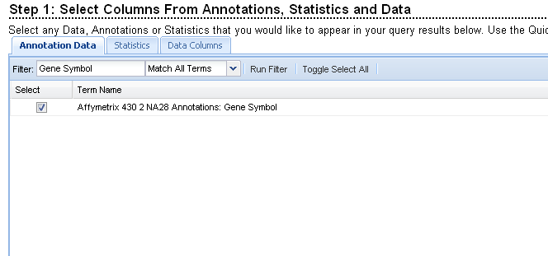

- Enter search terms as “Model1 Diet Female NZB” (separate each term by a space) in “Statistics” tab and select all available statistics.

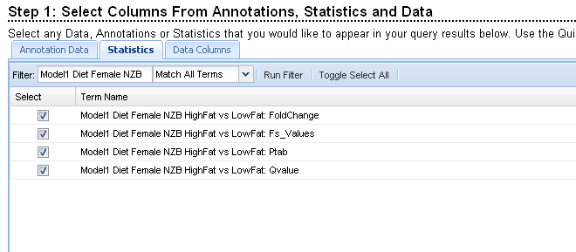

- Enter search terms as “Female NZB” in “Data Columns” tab and select all biological replicates.

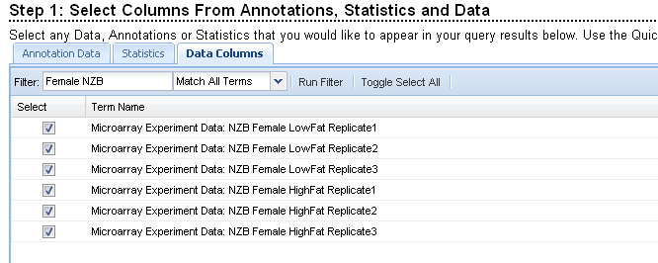

Gene Expression Step 2:

- Click the “Add a Filter” tab and find all “q-values” less than 0.05. Order the query results by “Fs_values” to find probesets with the largest F-statistics. All results may be downloaded to a CSV file by clicking the tab below the query output. Select a probeset to view the expression levels in a plot (Step 3).

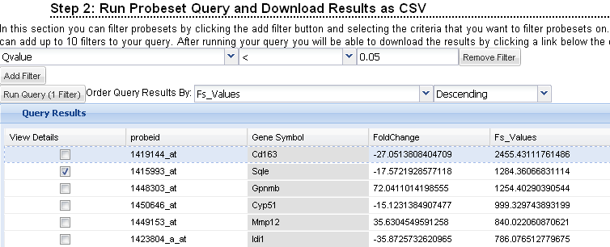

Gene Expression Step 3:

5. The probe set can be visualized in numerous formats. To view the boxplot format, order the arrays by Group. Click the “Group Arrays” button and group using Box Plot. The plot below shows that NZB mice (females) have a much higher expression for the selected probeset when fed the low-fat (6% chow) diet than the high-fat diet.

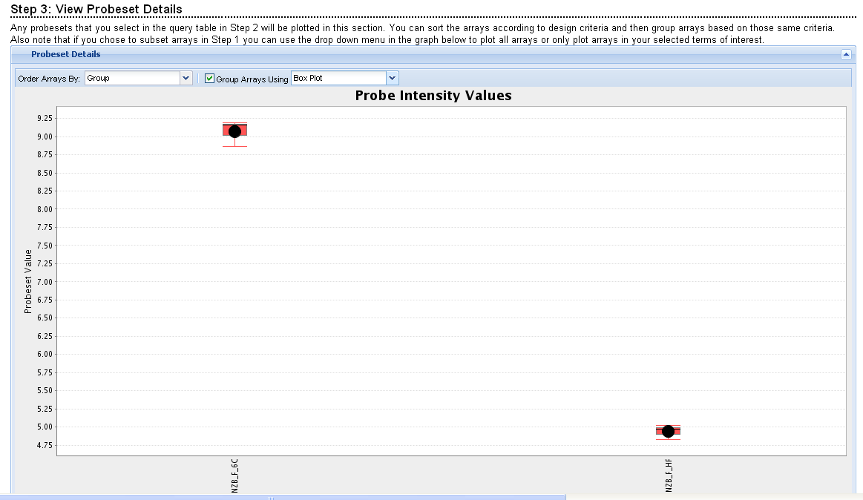
EXAMPLE 2: Find probesets for which gene expression and cholesterol correlation levels are correlated (cor > 0.8).

Correlation Step 1:

- Select “Gene Symbol” and “Chromosomal Location” in “Annotation Data” tab

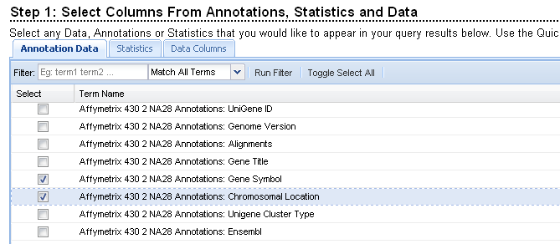

- Enter search term as “cor_chol” in “Statistics” tab.

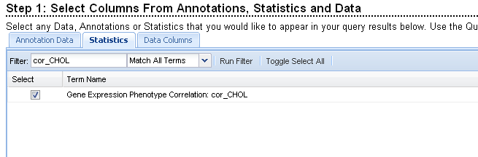

- Click “Toggle Select All” in “Data Columns” tab to select all biological replicates for each strain.

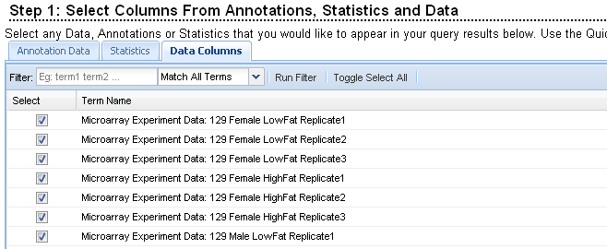

Correlation Step 2:

- Click the “Add a Filter” tab and find all correlation coefficients greater than 0.8. Order the query results by correlation values. All results may be downloaded to a CSV file by clicking the tab below the query output. Select a probeset to view the expression levels in a plot (Step 3). The top two probesets correspond to the gene “Akr1b3”.

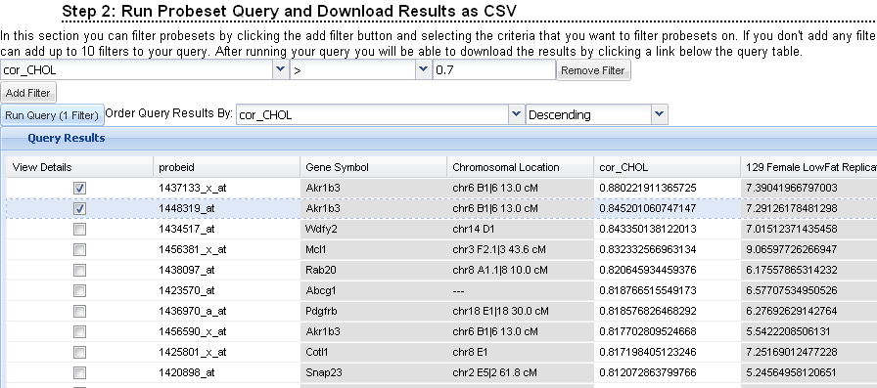

Correlation Step 3:

5. To view the boxplots, order the arrays by Group. Click the “Group Arrays” button and group using Box Plot. The plot below shows the results for all 48 STRAIN-SEX-DIET groups.

