Visual Monocular Odometry

Camera
Microsoft Lifecam Cinema
73.5° diagonal field of view

Disable Autofocus:
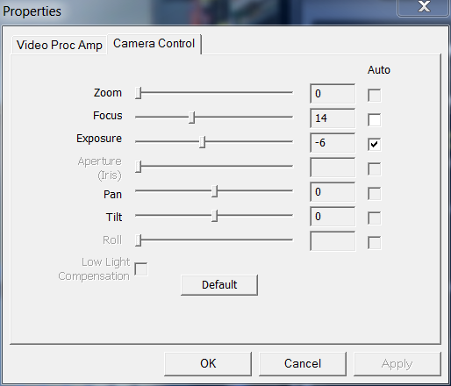
Good compromise between sharp focus near / far: 14
See http://www.wfu.edu/~yipcw/atg/microsoft/lifecam/ for detailed instructions

Camera Calibration

Optical Flow

Visual Odometry

CalcPitchRoll doesn't work, and CalcNetDistanceTravelled is obsolete.

