Christopher Geleta

2 December 2015

CS301.01

Dr. Isaacman

PA5, Phase one

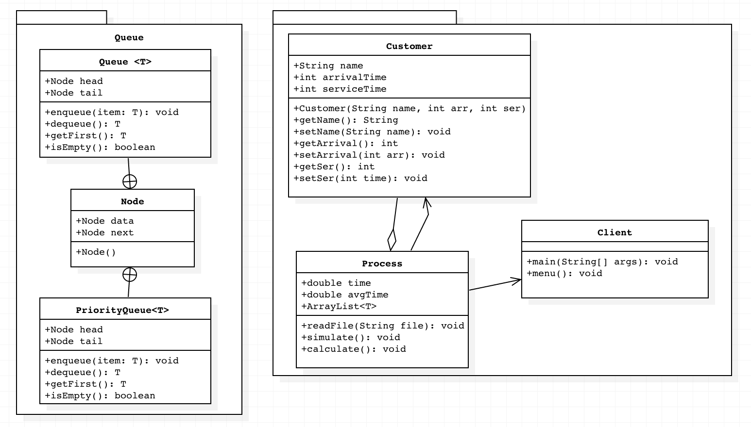**UML:**

**Algorithm:**

While the Queue has a customer in it

remove that customer from the Queue

set the clock to the arrival time of customer

if the customer is valid

if server is available

do process

depart Customer

else

place customer in Queue to wait

if the Queue still has customers

replace for the arrival

count customer

else

if the waiting Queue is not empty

remove the next customer

compute wait time

depart customer

else

mark the server free

Print stats after the loop ends