Creating an R-ArcGIS Script Tool

In order to build an R-ArcGIS script tool, you must first create an ArcGIS script tool user interface component. This tutorial will cover how to create the user interface component for the *R Summarize Tool*, but you can follow this general workflow to create any R-ArcGIS script tool so long as the parameters match those included in your R script file (e.g., summarize-tool.R).

1. Creating the R Summarize Tool

Add the R Summarize Tool to the **r-arcgis-pro-project** toolbox in ArcGIS Pro.

1. Double click **arcgis-r-pro-project.aprx** to open the project in ArcGIS Pro.
2. From ArcGIS, click on the **VIEW** tab, and then in the *Windows* group, select **Project**.
3. In the *Project* pane on the right side of ArcGIS Pro, click the **Toolboxes** dropdown menu. Right-click the **r-arcgis-pro-project** toolbox, and select **New** > **Script**.
4. Fill in the fields of the *General* section of the *Script Tool* wizard to match the following image:

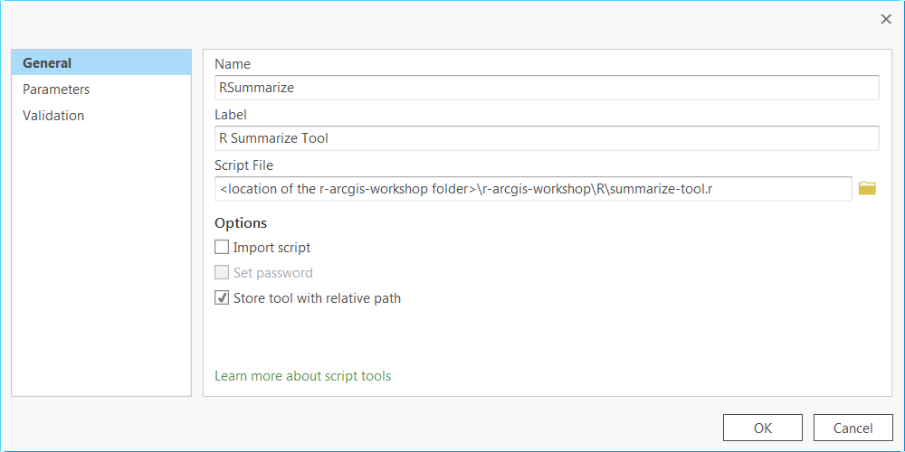

**Note**: For the *Script File***,** browse to the *r-arcgis-workshop/tools/R* folder, and select the **basic-summarize-tool.R** file. Do not copy exactly what is displayed in the image above.

1. Select the *Parameters* section of the *Script Tool* wizard, and fill in the pane to match the following image:

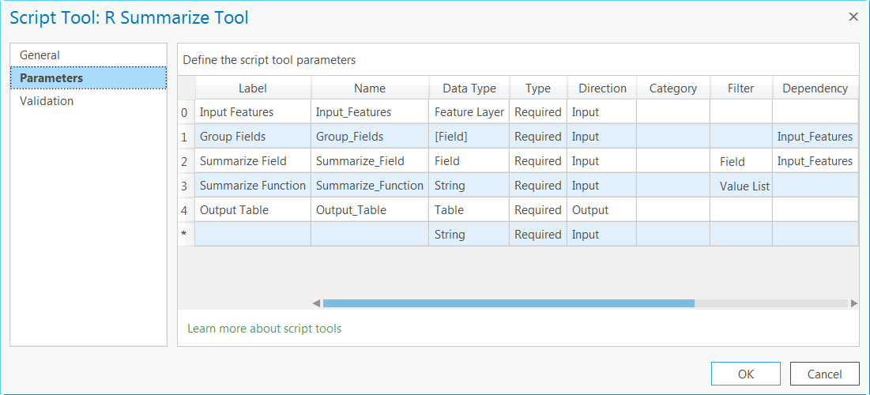

* 1. For the *Group Fields* parameters, when specifying the *Data Type*, make sure to check the **Multiple Values** checkbox:  
       
     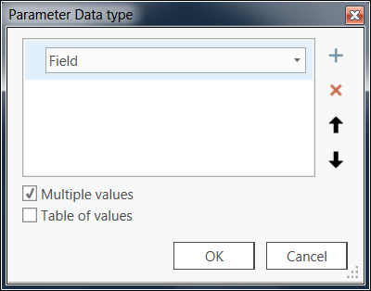
  2. For the *Summarize Field* parameter, when specifying the *Filter*, fill in the *Field Filter* dialog to match the following image:  
       
     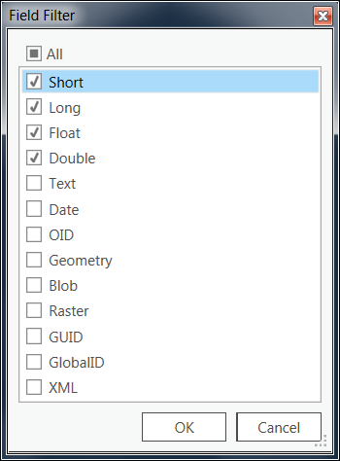
  3. For the *Summarize Function* parameter, when specifying the *Filter*, fill in the *Value List Filter* dialog to match the following image:  
       
     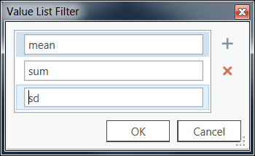

1. Once you are finished setting tool parameters, click **OK**.

**Note:** Make sure the tool parameters are provided in the same order as above or the tool will not function properly.

Now that the R-ArcGIS script tool has been constructed, you can test it with the Toronto crime data to ensure it works properly.

1. Select the **R Summarize Tool** from the *r-arcgis-pro-project* toolbox.
2. Fill in the fields however you want, but be sure to select the 'toronto_crime_groups' feature class for the *Input Features* field. Click **OK**.

Once the tool has finished executing, you should see an output standalone table added to your Table of Contents. Right-click the standalone table and select **Open** to view the summarized data set.

If you received any errors in the output, they will most likely be related to the R script. Make sure that all of your variables were set correctly, and run the script again using the test data set to ensure all the functions are working properly.

# Future Considerations

R is a powerful tool with an abundance of resources that can be drawn from to extend the functionality of ArcGIS. This tutorial has outlined the process of building a basic R tool within ArcGIS, but you should continue to experiment and create your own R tools for ArcGIS using the procedures you have learned in this tutorial.

© 2015 Esri Canada All rights reserved. Trademarks provided under license from Environmental Systems Research Institute Inc. Other product and company names mentioned herein may be trademarks or registered trademarks of their respective owners. Errors and omissions excepted.