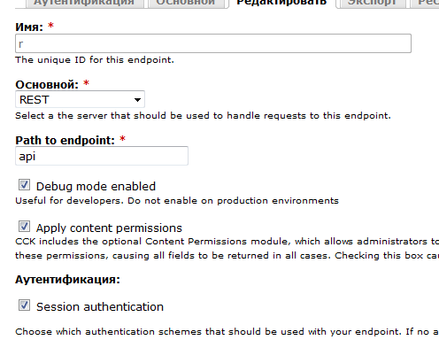

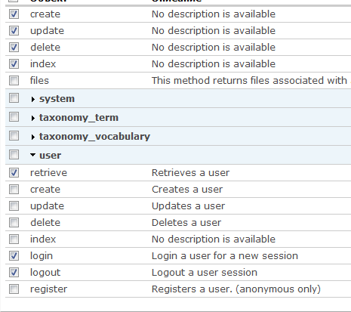

<?php

$API_URL = 'http://localhost:85/d6s/api/';

// Server REST - user.login

$user_data = array(

'username' => 'xmlrpc',

'password' => '5340940',

);

$curl = curl_init($API_URL . 'user/login.json');

curl_setopt($curl, CURLOPT_POST, 1); // Do a regular HTTP POST

curl_setopt($curl, CURLOPT_POSTFIELDS, http_build_query($user_data)); // Set POST data

curl_setopt($curl, CURLOPT_HEADER, FALSE); // Ask to not return Header

curl_setopt($curl, CURLOPT_RETURNTRANSFER, TRUE);

curl_setopt($curl, CURLOPT_FAILONERROR, TRUE);

$response = curl_exec($curl);

$http_code = curl_getinfo($curl, CURLINFO_HTTP_CODE);

if ($http_code == 200) { $logged_user = json_decode($response); }

else {

$http_message = curl_error($curl);

die($http_message);

}

// Server REST - node.create

$node_data = array(

'title' => 'car 1',

'type' => 'car',

'field_code[0][value]' => 'C1',

'field_year[0][value]' => '2010',

'field_manufacturer[0][value]' => 'VAZ',

'taxonomy[1]' => '1',

'language' => 'ru',

);

// Define cookie session

$cookie_session = $logged_user->session_name . '=' . $logged_user->sessid;

// cURL

$curl = curl_init($API_URL . 'node.json');

curl_setopt($curl, CURLOPT_POST, 1); // Do a regular HTTP POST

curl_setopt($curl, CURLOPT_POSTFIELDS, http_build_query($node_data)); // Set POST data

curl_setopt($curl, CURLOPT_HEADER, FALSE); // Ask to not return Header

curl_setopt($curl, CURLOPT_COOKIE, "$cookie_session"); // use the previously saved session

curl_setopt($curl, CURLOPT_RETURNTRANSFER, TRUE);

curl_setopt($curl, CURLOPT_FAILONERROR, TRUE);

$response = curl_exec($curl);

$http_code = curl_getinfo($curl, CURLINFO_HTTP_CODE);

if ($http_code == 200) {

$node = json_decode($response);

}

else {

$http_message = curl_error($curl);

die($http_message);

}

print_r($node);

<http://drupal.org/node/783460>

using System;

using System.Collections.Generic;

using System.ComponentModel;

using System.Data;

using System.Drawing;

using System.Linq;

using System.Text;

using System.Windows.Forms;

using System.Net;

using System.IO;

using System.Collections.Specialized;

using RestSharp;

namespace d6s

{

public partial class Form1 : Form

{

public string nl = Environment.NewLine;

public Form1()

{

InitializeComponent();

}

private void Form1_Load(object sender, EventArgs e)

{

d6sApi a = new d6sApi("xmlrpc", "5340940");

/*d6sApiSession s = a.Login();

textBox1.Text += "Login" + nl + nl;

textBox1.Text += "sessid: " + s.sessid + nl;

textBox1.Text += "session_name: " + s.session_name + nl + nl;

d6sApiNodeCreate n = a.CreateCar("car from c#", ".net", 2005, "ZAZ");

textBox1.Text += "Node creation" + nl + nl;

textBox1.Text += "nid: " + n.nid + nl;

textBox1.Text += "uri: " + n.uri + nl + nl;*/

string ci = a.CarIndex();

textBox1.Text += "Car index: " + ci + nl + nl;

string cc = a.CarCode("aaa");

textBox1.Text += "Car code: " + cc + nl + nl;

string ce = a.CarEcho();

textBox1.Text += "Car echo: " + ce + nl + nl;

}

}

//https://github.com/restsharp/RestSharp/wiki

public class d6sApi

{

const string BaseUrl = "http://localhost:85/d6s/api";

readonly string _username;

readonly string _password;

string _sessid;

string _session_name;

public d6sApi(string username, string password)

{

_username = username;

_password = password;

}

public T Execute<T>(RestRequest request) where T : new()

{

var client = new RestClient();

client.BaseUrl = BaseUrl;

var response = client.Execute<T>(request);

//TODO: if response is ok

return response.Data;

}

public d6sApiSession Login()

{

RestRequest request = new RestRequest();

request.Resource = "user/login.json";

request.Method = Method.POST;

request.AddParameter("username", _username);

request.AddParameter("password", _password);

d6sApiSession session = Execute<d6sApiSession>(request);

_sessid = session.sessid;

_session_name = session.session_name;

return Execute<d6sApiSession>(request);

}

public d6sApiNodeCreate CreateCar(string title, string code, int year, string manufacturer) {

RestRequest request = new RestRequest();

request.Resource = "node.json";

request.AddCookie(_session_name, _sessid);

request.Method = Method.POST;

request.AddParameter("title", title);

request.AddParameter("type", "car");

request.AddParameter("field_code[0][value]", code);

request.AddParameter("field_year[0][value]", year);

request.AddParameter("field_manufacturer[0][value]", manufacturer);

request.AddParameter("taxonomy[1]", "1");

request.AddParameter("language", "ru");

return Execute<d6sApiNodeCreate>(request);

}

public string CarIndex()

{

RestRequest request = new RestRequest();

request.Resource = "car.json";

RestClient client = new RestClient();

client.BaseUrl = BaseUrl;

RestResponse response = client.Execute(request);

return response.Content;

}

public string CarCode(string code)

{

RestRequest request = new RestRequest();

request.Resource = "car/{code}.json";

request.AddParameter("code", code, ParameterType.UrlSegment);

RestClient client = new RestClient();

client.BaseUrl = BaseUrl;

RestResponse response = client.Execute(request);

return response.Content;

}

public string CarEcho()

{

RestRequest request = new RestRequest();

request.Resource = "car/echo.json";

RestClient client = new RestClient();

client.BaseUrl = BaseUrl;

RestResponse response = client.Execute(request);

return response.Content;

}

}

public class d6sApiSession {

public string sessid { get; set; }

public string session_name { get; set; }

}

public class d6sApiNodeCreate {

public string nid { get; set; }

public string uri { get; set; }

}

}

<?php

function car_service_services_resources() {

return array(

'car' => array(

'retrieve' => array(

'callback' => '_car_service_retrieve',

'access callback' => 'user_access',

'access arguments' => array('access content'),

'access arguments append' => FALSE,

'args' => array(

array(

'name' => 'code',

'type' => 'string',

'description' => 'The code of the car to get',

'source' => array('path' => '0'),

'optional' => FALSE,

),

),

),

'index' => array(

'callback' => '_car_service_index',

'access callback' => 'user_access',

'access arguments' => array('access content'),

'access arguments append' => FALSE,

),

'actions' => array(

'echo' => array(

'callback' => '_car_service_echo',

'access callback' => 'user_access',

'access arguments' => array('access content'),

'access arguments append' => FALSE,

),

),

),

);

}

function _car_service_retrieve($code) {

return array('_car_service_retrieve: ' . $code);

}

function _car_service_index() {

return '_car_service_index';

}

function _car_service_echo() {

return '_car_service_echo';

}

/*

function noteresource_perm() {

return array(

'note resource create',

'note resource view any note',

'note resource view own notes',

'note resource edit any note',

'note resource edit own notes',

'note resource delete any note',

'note resource delete own notes',

);

}

function car_service_services_resources() {

return array(

'car' => array(

'retrieve' => array(

'help' => 'Simple retrieve',

'callback' => '_tmp_service_retrieve',

'access callback' => '_tmp_service_access',

'access arguments' => array('view'),

'access arguments append' => TRUE,

'args' => array(

array(

'name' => 'code',

'type' => 'string',

'description' => 'The code of the car to get',

'source' => array('path' => '0'),

'optional' => FALSE,

),

),

),

'create' => array(

'help' => 'Simple create',

'callback' => '_tmp_service_create',

'access arguments' => array('note resource create'),

'access arguments append' => FALSE,

'args' => array(

array(

'name' => 'data',

'type' => 'struct',

'description' => 'The car object',

'source' => 'data',

'optional' => FALSE,

),

),

),

'update' => array(

'help' => 'Simple update',

'callback' => '_tmp_service_update',

'access callback' => '_tmp_service_access',

'access arguments' => array('update'),

'access arguments append' => TRUE,

'args' => array(

array(

'name' => 'id',

'type' => 'int',

'description' => 'The id of car to update',

'source' => array('path' => 0),

'optional' => FALSE,

),

array(

'name' => 'data',

'type' => 'struct',

'description' => 'The car object',

'source' => 'data',

'optional' => FALSE,

),

),

),

'delete' => array(

'help' => 'Simple delete',

'callback' => '_tmp_service_delete',

'access callback' => '_tmp_service_access',

'access arguments' => array('delete'),

'access arguments append' => TRUE,

'args' => array(

array(

'name' => 'id',

'type' => 'int',

'description' => 'The id of car to delete',

'source' => array('path' => 0),

'optional' => FALSE,

),

),

),

'index' => array(

'help' => 'Simple index',

'callback' => '_car_service_index',

'args' => array(

array(

'name' => 'page',

'type' => 'int',

'description' => '',

'source' => array('param' => 'page'),

'optional' => TRUE,

'default value' => 0,

),

array(

'name' => 'parameters',

'type' => 'array',

'description' => '',

'source' => 'param',

'optional' => TRUE,

'default value' => array(),

),

),

),

),

);

}

function _car_service_retrieve($code) {

return '_car_service_retrieve_' . $code;

}

function _car_service_create($data) {

return '_car_service_create_' . print_r($data, true);

}

function _car_service_update($id, $data) {

return '_car_service_update_' . $id . '_' . print_r($data, true);

}

function _car_service_delete($id) {

return '_car_service_delete_' . $code;

}

function _car_service_index($page, $parameters) {

return array(

'hello' => 'world'

);

}*/