Hello World!

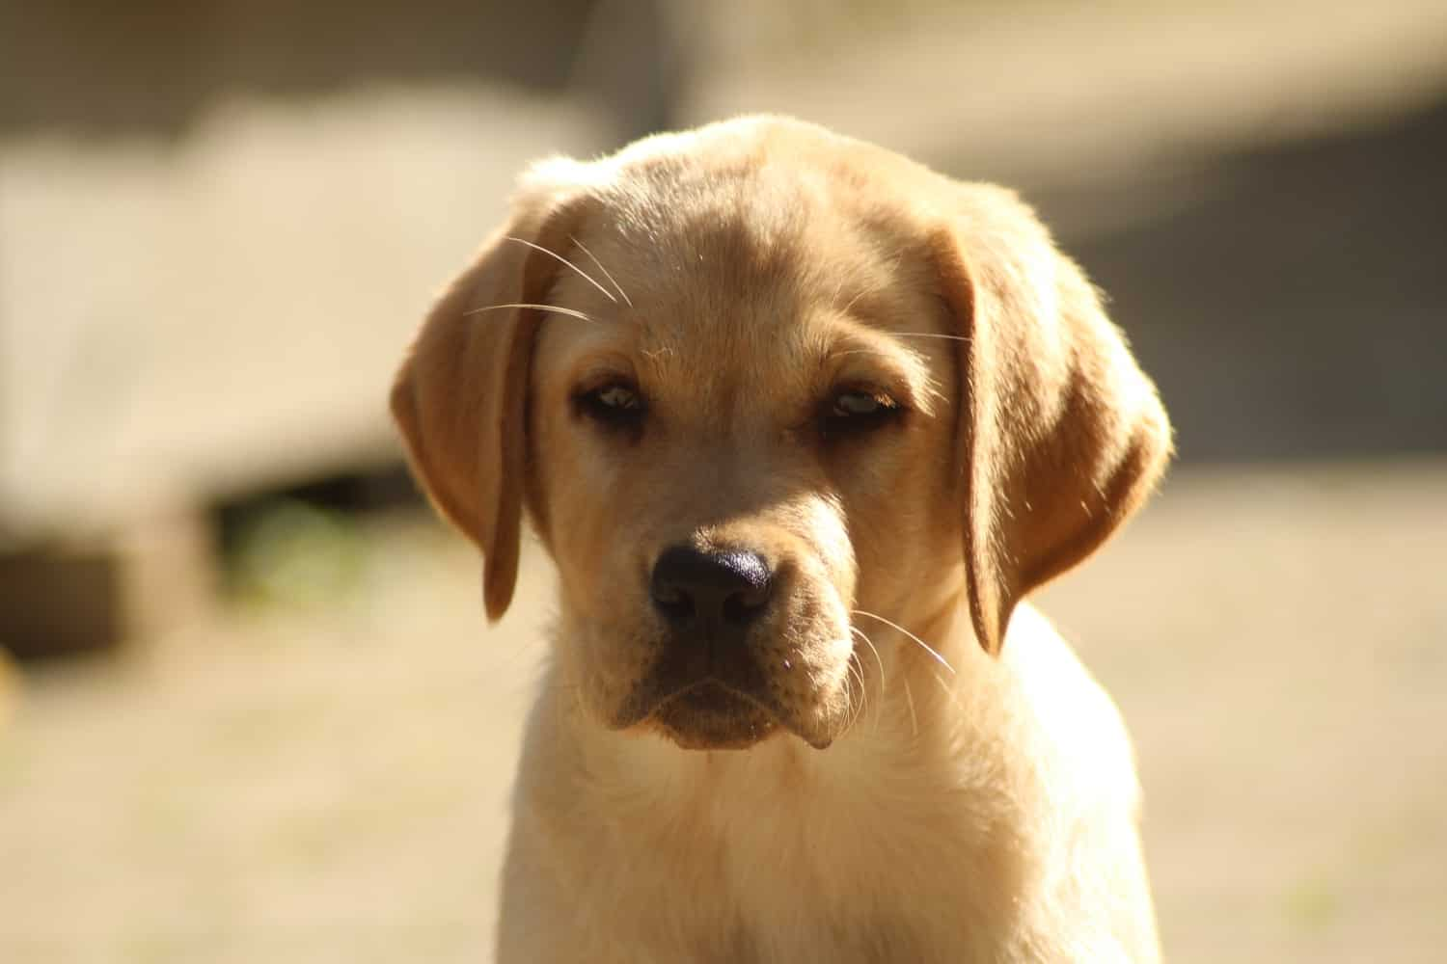

|  |  |  |
| --- | --- | --- |
| **Name** | **Surname** | **%** |
| John | Blue | 30 |
| Sam | Red | 20 |
| Scott | Yellow | 10 |