**Pandas-Challenge Report**

The dataset consisted of 15 schools with a total of 39,170 students. The total budget for the school district was $24,649,428. The average math score across all the 15 schools was 78.98 and the reading score was 81.88. The percentage of students who passed math and reading respectively were 74.98 and 85.81. The percentage of students who passed both was 65.17. A score above 70 was considered passing grade in both math and reading.

The results from the analysis are shown in Table 1.

|  |  |  |  |  |  |  |  |
| --- | --- | --- | --- | --- | --- | --- | --- |
| Total Schools | Total Students | Total Budget | Average Math Score | Average Reading Score | % Passing Math | % Passing Reading | % Overall Passing |
| 15 | 39,170 | $24,649,428 | 78.98 | 81.88 | 74.98 | 85.81 | 65.17 |

Table 1

As we can observe from the analysis that average reading score was higher than the average math score. Similarly, percentage of students who score above 70 (passing grade) was higher in reading compared to math.

Then we analyzed at individual school level. The data is presented in the following table 2.

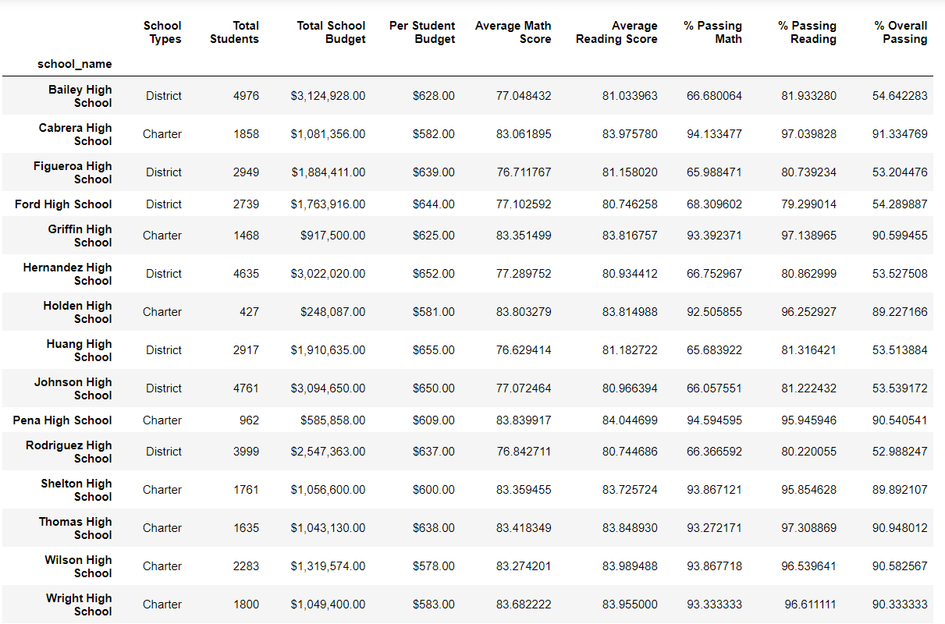

Table 2

The total number of students in each school range from 427 (Holden High School) to 4976 (Bailey High School). There were two different categories of schools represented in the dataset – District and Charter schools. We can observe from the dataset that the district schools have a greater number of students enrolled than charter schools.

The total school budget for each of the school ranged from $248,087 (Holden High School) to $3124,928 (Bailey High School) while the per capita budget ranged from $581(Holden High School) to $655 (Huang High School). In terms of budget, we see that the district schools had more money available than the charter schools.

The average math score ranged from 76.63 (Huang High school) to 83.84 (Pena High school). The average reading score ranged from 80.74 (Rodriguez High school) to 84.04 (Pena High school). Pena High schools had the highest average math and reading scores. The average reading score was higher across all schools compared to the average math score.

The percent of students passing math was highest for Pena High school (94.59%). The school with the lowest percent of student passing in math was Huang High school (65.68%). Thomas High school had the highest percentage of students passing in reading (97.31%) compared to Ford High school (79.3%) with the lowest percentage. The school with the highest overall passing percentage was Cabrera High School (91.33%). While Rodriguez High school (52.3%) had the lowest overall passing percentage.

The top 5 performing schools are shown in table 3. All the best performing schools are charter schools.

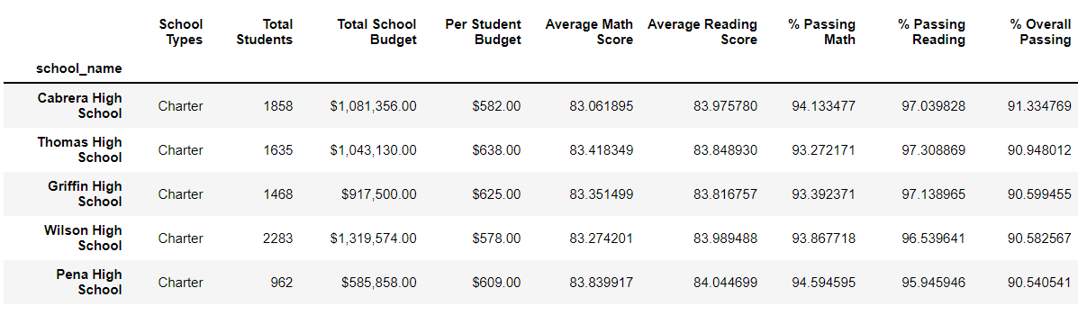

Table 3

The bottom 5 performing schools are shown table 4.

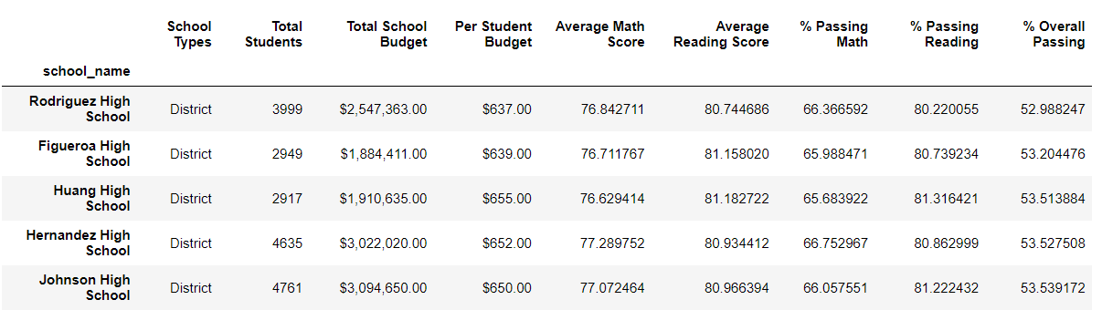

Table 4

Math score across grades - Grade 11 students at Holden High School had the highest average Math score (85)

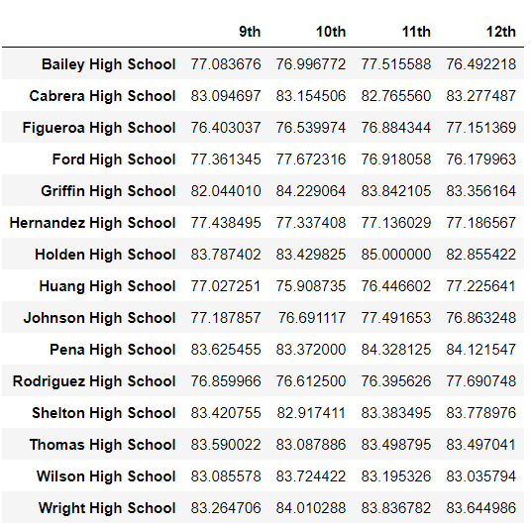

Table 5

Reading score across grades – Grade 12 students at Holden High School had the highest average score (84.7)

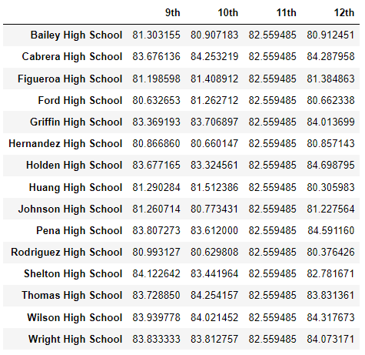

Table 6

Test scores and passing percentages compared against per student spending (Table 7)

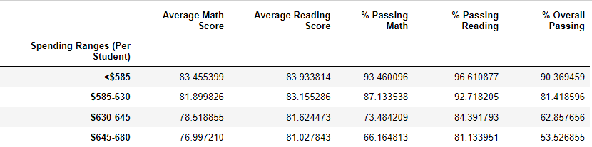

Table 8

From analyses we can summarize that spending per student seems to have negative correlation to test scores and passing percentages.

Test scores and passing percentages compared across school size (Table 8)

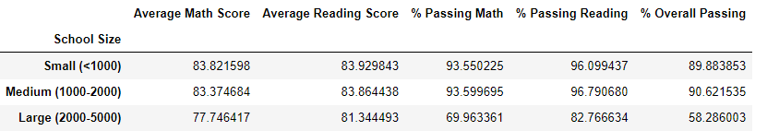

Table 8

We can summarize that smaller schools tends to do better at tests compared to larger schools.

Comparison of Scores by School Type (table 9).

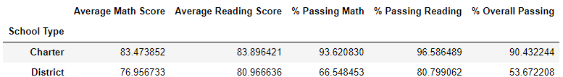

Table 9

We can clearly summarize that charter schools are doing better in tests and passing percentages compared to the district schools.

Conclusions –

* Spending per student seems to have negative correlation to test scores and passing percentages.
* Smaller sized schools are doin better at tests compared to larger schools
* The charter schools are doing better in both math and reading tests and passing percentages compared to the district schools.