Computer Assisted Verbal Autopsy: Comparing

Large Language Models to Physicians for

Assigning Causes to 6939 Deaths in Sierra Leone

from 2019-2022
Richard Wen¹, Anteneh Tesfaye Assalif^{1,2}, Andy Sze-Heng Lee¹,
Rajeev Kamadod¹, Asha Behdinan¹, Ronald Carshon-Marsh¹,
Catherine Meh¹, Thomas Kai Sze Ng¹, Patrick Brown¹,
Prabhat Jha^{1*}, Rashid Ansumana²
^{1*}Centre for Global Health Research, St. Michael’s Hospital, Unity Health Toronto and University of Toronto, 30 Bond St, Toronto, M5B 1W8, Ontario, Canada.
²College of Medical Sciences, Njala University, Bo, Sierra Leone.
*Corresponding author(s). E-mail(s): prabhat.jha@utoronto.ca;
Contributing authors: rwen@torontomu.ca; antenehta@gmail.com; andylee.dee@gmail.com; rajeevk@kentropy.com; asha.behdinan@mail.utoronto.ca; ronald.carshonmarsh@mail.utoronto.ca; catherine.meh@unityhealth.to; kaisze.ng@unityhealth.to; patrick.brown@utoronto.ca; prabhat.jha@utoronto.ca; r.ansumana@njala.edu.sl;

Abstract
Background: Verbal autopsies (VAs) collect information on deaths in low and middle-income countries occurring outside healthcare facilities to estimate causes of death (CODs) for use in epidemiological or planning studies. Physician coding of VAs focused on the narrative of deaths and past symptoms is current best practice. Large language models (LLM) such as GPT-5 enable possible use of the narrative portion of VAs to assign CODs. However, there are few if any robust comparisons of LLMs to physician coding.
Methods: We analyzed 6,939 VA records from a random sample of deaths in Sierra Leone (2019–2022) to compare five models: three LLMs (GPT-3.5, GPT-4, GPT-5) and two based on symptom algorithms (InterVA-5, InSilicoVA), against physician-assigned CODs. GPT models used narratives, whereas InterVA-5 and InSilicoVA relied on questionnaires. CODs were grouped into 19, 10, and 7 categories for adult, child, and neonatal deaths. We used cause specific mortality fraction (CSMF) accuracy and partial chance corrected concordance (PCCC) to assess population and individual-level agreement, respectively compared to the standard of physician coding. We stratified analyses by age group as CODs vary among neonates, children and adults.
Results: Overall, GPT-5 outperformed all models (PCCC=0.71), followed by GPT-4 (0.61), GPT-3.5 (0.56), InSilicoVA (0.44), and InterVA-5 (0.44). GPT-5 achieved the highest performance for adult (0.64), child (0.72), and neonatal (0.65) deaths. Across ages, performance increased from 1 month to 14 years and declined from 15 to 69 years. GPT-5, GPT-4, GPT-3.5, and InSilicoVA achieved the highest PCCC in 15, 7, 7, and 2 of the 30 CODs, respectively. At the population level, GPT-5 achieved the highest CSMF accuracy (0.9), while all other models had comparable performance (0.74–0.79).
Conclusion: GPT models and InSilicoVA showed greater performance for specific CODs at the individual-level. GPT models demonstrated improvements over InterVA-5 and InSilicoVA models. This study provides foundational evidence for integrating LLM and algorithmic models with physician coding to improve the quality of VA data.
Keywords: Cause of Death, Physicians, Computer-Assisted Diagnosis, Artificial Intelligence, Natural Language Processing, Machine Learning, Mortality, Surveillance, Mathematical Models, Global Health

Background
Reliable mortality counts and accurate Cause of Death (COD) data are essential for guiding public health policy and reducing premature mortality [1–4]. However, civil registration and vital statistics systems remain incomplete in many low-income countries. Fewer than half of all deaths are registered, and among these, only 8% have an assigned COD [5]. To address this gap, Verbal Autopsy (VA) has been deployed as a scalable method for collecting mortality data and assigning likely CODs, particularly for deaths that occur outside of healthcare facilities, which account for more than half of all deaths [6–9].
VA involves two major components: survey and COD assignment [10–12]. In the survey component, trained interviewers use structured questionnaires and open narrative prompts to gather data from relatives or close contacts of the deceased. In the COD assignment component, physicians review these data to determine the most likely COD. However, reliance on physician assignment has been criticized for limited reproducibility and subjectivity [13–17]. To overcome these limitations, automated Computer Coded Verbal Autopsy (CCVA) methods such as InterVA [18] and InSilicoVA [15] have been developed and used in many VA studies. These models offer scalable and reproducible alternatives and have demonstrated comparable performance to physicians at the population level. However, their performance at the individual-level remains limited [19–23], while their reliance on structured questionnaire data often omits open narrative text, which can contain additional contextual and chronological information that may improve diagnostic accuracy [24–26]. A randomized trial evaluating dual physician coding with current CCVA methods concluded that physician coding was superior [19].
Recent advances in large language models (LLMs), trained on vast textual datasets using deep learning methods, have significantly improved natural language processing (NLP) capabilities. These include tasks such as question answering, code generation, and medical reasoning based on free text [27–30]. ChatGPT, developed by OpenAI and released in 2022, is a widely accessible LLM capable of generating human-like responses to natural language queries. Earlier versions (GPT-1 to GPT-3) scaled from 117 million to 175 billion parameters and were trained on data ranging from 5 GB to 45 TB [31]. In 2023, ChatGPT-4 was introduced, achieving human-level performance on a range of academic and professional benchmarks [32]. More recently, GPT-5, introduced in 2025, has been reported to demonstrate enhanced reasoning capabilities and reduced tendency to provide inaccurate or misleading information [33]. Given the underutilization of narrative free text in VA analysis and the capabilities of LLMs in processing such data, we conducted a study using VA records from Sierra Leone (2019–2022) to compare five models: three LLMs (GPT-3.5, GPT-4, and GPT-5) and two algorithms based on symptoms (InterVA-5 and InSilicoVA), against physician-assigned CODs. This work aims to evaluate the potential of LLMs in enhancing COD assignment from narrative data in low-resource settings.

Methods
This section outlines the methodology used to compare cause of death (COD) assignments from five models, GPT-3.5, GPT-4, InterVA-5, and InSilicoVA, with physician-determined CODs, as summarized in Figure 1. The dataset was first filtered to include only records with physician agreement, as described in Section 2.1. Section 2.2 details the input formats and output structures of the five models. Section 2.3 presents the evaluation framework, which compares model outputs to physician assigned CODs using both population-level and individual-level performance metrics. Additional details are provided in Appendix B.
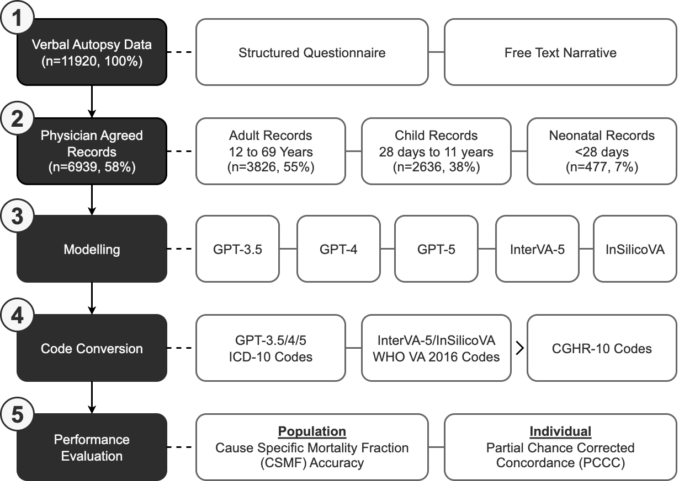
Fig. 1 Flow diagram for verbal autopsy coding comparison of 6939 sample deaths in Sierra Leone. Verbal autopsy data containing 11,920 sample deaths were initially collected from in-field surveys, and filtered to 6939 records where two randomly assigned physicians agreed on the cause of death. Five computer models GPT-3.5, GPT-4, GPT-5, InterVA-5, and InSilicoVA were compared to physicians using standardized CGHR-10 codes, and evaluated using individual PCCC and population CSMF accuracy metrics.

Verbal Autopsy (VA) Data
A total of 11,920 verbal autopsy (VA) records were obtained from the HEAL-SL study, a nationally representative survey covering about 5% of the homes in Sierra Leone, and collected from about 660 small sampling units [34,35]. HEAL-SL employs dual-coded Electronic Verbal Autopsy (EVA). Each record was independently reviewed by two randomly selected physicians, who assigned COD codes based on the International Classification of Diseases, 10th Revision (ICD-10) [36]. Agreement between physician-assigned CODs was evaluated using Central Medical Evaluation Agreement 10 (CMEA-10) codes, which group related ICD-10 codes into broader, clinically similar categories [37] (see Additional File 1). If both codes fell within the same CMEA-10 group, the record was considered in agreement. Disagreements entered a reconciliation phase, where each physician (blinded to the other physician’s identity) was shown both the assigned codes and the reasoning from the other physician. Physicians could then (1) retain their original code, (2) adopt the other physician’s code, or (3) assign a new code. Records that remained unresolved proceeded to adjudication, where a senior physician reviewed all reasoning and assignments and issued a final COD.
To ensure comparability with physician coding, only records with initial physician agreement were used in this study, as such cases provide higher confidence in the COD assignment [16,38,39]. From the original dataset, 6,942 records met this criterion. All ICD-10 codes were then standardized to CGHR-10 categories (see Appendix A), which group causes into 19, 10, and 7 categories for adults (12–69 years), children (28 days to 11 years), and neonates (under 28 days), respectively. After excluding three records without a valid CGHR-10 category, a total of 6,939 physician-agreed records (3,826 adult, 2,636 child, and 477 neonatal) were used for model comparison and performance evaluation. Further details on data preprocessing are provided in Appendix B.1, with COD and age group distributions summarized in Tables B4 and B5.

Modelling
Five computational models were used to assign causes of death (CODs) for each of the 6,939 physician-agreed verbal autopsy (VA) records: GPT-5, GPT-3.5, GPT-4, InterVA-5, and InSilicoVA. InterVA-5 and InSilicoVA are widely used statistical models within the OpenVA framework for COD assignment in VAs [11,19,20,22,23,40–42]. InterVA-5 applies a Bayesian probabilistic approach, using a standardized set of symptoms and expert-derived conditional probabilities to assign the most likely COD based on maximum probability [18,43,44]. InSilicoVA extends this approach by incorporating a hierarchical Bayesian framework and Markov Chain Monte Carlo methods [45–47], allowing for quantification of uncertainty, individual-level probability estimates, and the integration of additional data sources [15]. GPT-5, GPT-3.5 [48], and GPT-4 [32] are large language models (LLMs) that generate human-like text by learning from large amounts of textual data [49]. These models are trained using reinforcement learning from human feedback [50–53], enabling them to follow natural language instructions while generating human-level responses. GPT-4 demonstrated improvements over GPT-3.5, including more recent training data, enhanced reasoning capabilities, and multimodal input-output functionality (e.g. text, image, voice) [31], while GPT-5 has been reported in preliminary studies to outperform GPT-4 across multiple evaluation domains with enhanced reasoning capabilities and reduced hallucination [54–56].
For GPT-3.5, GPT-4, and GPT-5, the following user prompt was used to instruct each model to produce COD assignments as ICD-10 codes, where <age> and <sex> from the questionnaire, and <narrative> from the narratives, were replaced with values from the data:
Determine the underlying cause of death and provide the most probable ICD−10 code for a verbal autopsy narrative of a <age> years old <sex> death in Sierra Leone: <narrative>
InterVA-5 and InSilicoVA used structured questionnaire data, which were converted into OpenVA-compatible format [42]. Both models produced COD assignments coded using the WHO 2016 VA standard [57]. To ensure comparability across models, all output CODs were mapped to the CGHR-10 classification system for evaluation relative to physician-assigned CODs. Further details on model input formats, output mappings, and code conversion procedures are provided in Appendix B.2.

Performance Evaluation
Model performance was assessed at both the population and individual levels by comparing each model’s CGHR-10 COD assignments to those of physicians for all 6,939 records. Cause-specific mortality fraction (CSMF) accuracy was used to evaluate agreement at the population level (see Appendix B.3.1), while partial chance corrected concordance (PCCC) was used to assess individual-level agreement (see Appendix B.3.2) [58]. Both metrics range from 0 to 1, where higher values indicate stronger similarity with physician assignment. Given that model performance can vary by age and different CODs [40,41,59], both CSMF accuracy and PCCC were calculated overall and stratified by age group (adult, child, neonatal), CGHR-10 COD, and age at death. For adult and child groups, metrics were computed in five-year age bands for records with age at death of one year or older, and five-month bands for records between 28 days and one year. For the neonatal group, evaluations were conducted separately for age intervals of 0–6 days and 7–27 days. Additional details on the evaluation strategy and metric calculations are provided in Appendix B.3.

Results

Overall Performance
At the population level, GPT-5 achieved the highest performance (0.9 CSMF accuracy), while all other models had similar performances (0.74-0.79 CSMF accuracy). The remaining analyses focus on individual-level performances measured by PCCC. GPT-5 demonstrated the highest performance (0.71) followed by GPT-4 (0.61), GPT-3.5 (0.56), InSilicoVA (0.44), and InterVA-5 (0.44) (Figure 2). GPT-3.5/4/5 had improvements from 0.12-0.27 in the PCCC over InSilicoVA and InterVA-5, while GPT-5 improved over GPT-4 by 0.1 in the PCCC and GPT-4 slightly improved over GPT-3.5 by 0.05 in the PCCC. Figure 3 shows the individual performance across three age groups (adult, child, and neonate). GPT-5 had the best performance for all age groups (0.68, 0.72, and 0.65 for adult, child, and neonatal records respectively), while GPT-4 performed slightly worse for adult records (0.64). InSilicoVA and InterVA-5 performed the worst for adult and child records (less than 0.5), while GPT-3.5 performed the worse for neonatal records (0.35). Performance varied from 0.29-0.3 in the PCCC across the three age groups. Across ages, a trend in performance was observed for all models (Figure 4). In adults, performance decreased with age for 12 to 59 years (from 0.75 down to 0.35), suggesting greater difficulty in assigning CODs among older adults, with a modest improvement observed after age 59. Among children and neonates, performance improved from 5 months to 11 years (from 0.25 towards 0.75), indicating greater model reliability as developmental age advanced. The highest and lowest performances were observed for ages 12-29 years (0.4-0.75) and 1-11 months (0.25-0.68) respectively. In terms of individual performance, GPT-3.5/4/5 consistently outperformed InterVA-5 and InSilicoVA for most leading CODs identified in prior Sierra Leone studies [35,60] as seen in Table 1.
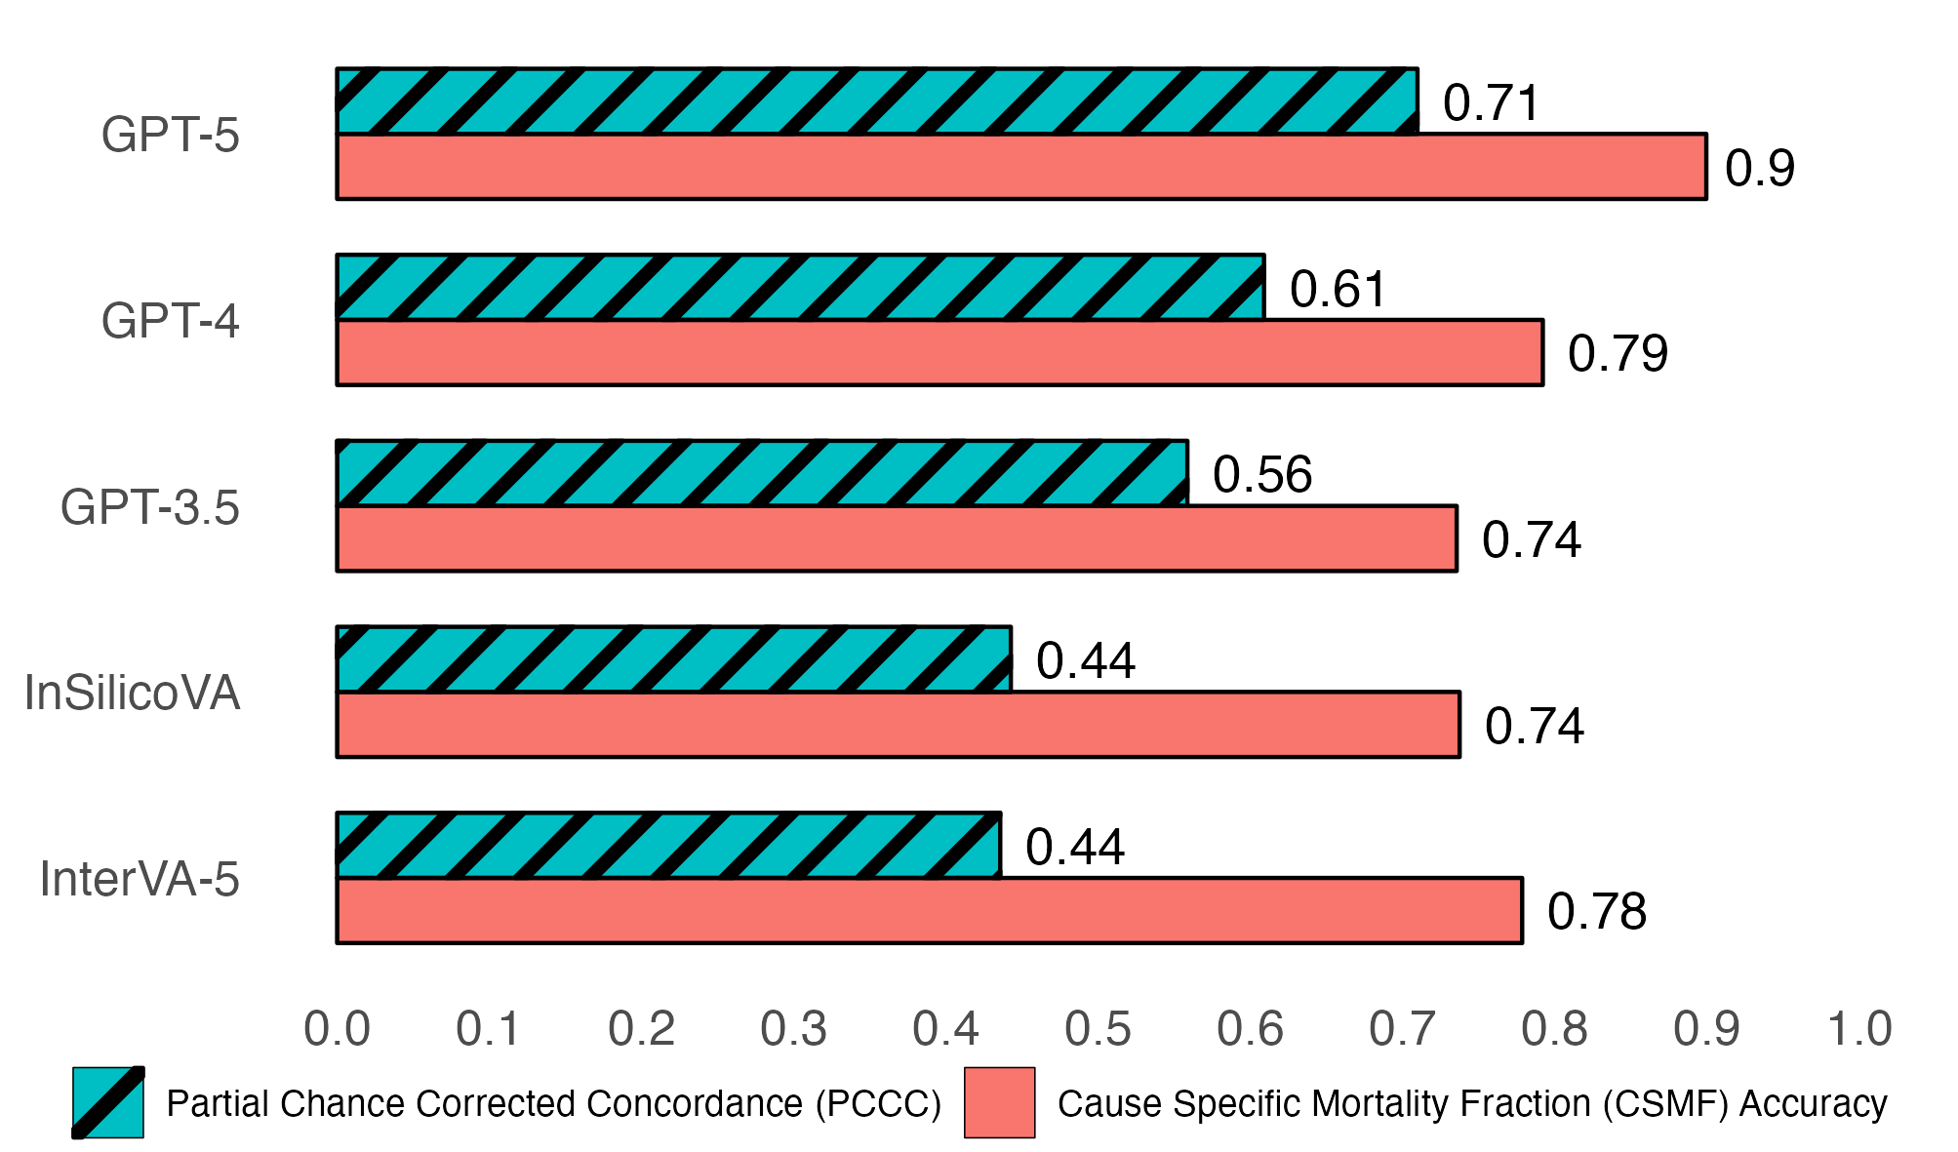
Fig. 2 Individual (PCCC) and population (CSMF accuracy) level verbal autopsy coding performance of all 6939 deaths. PCCC and CSMF accuracy values range from 0 to 1. PCCC values of 1 indicate complete agreement with physician coding per individual death, while CSMF accuracy values of 1 indicate complete agreement with physician coding per cause, irrespective of individual deaths.
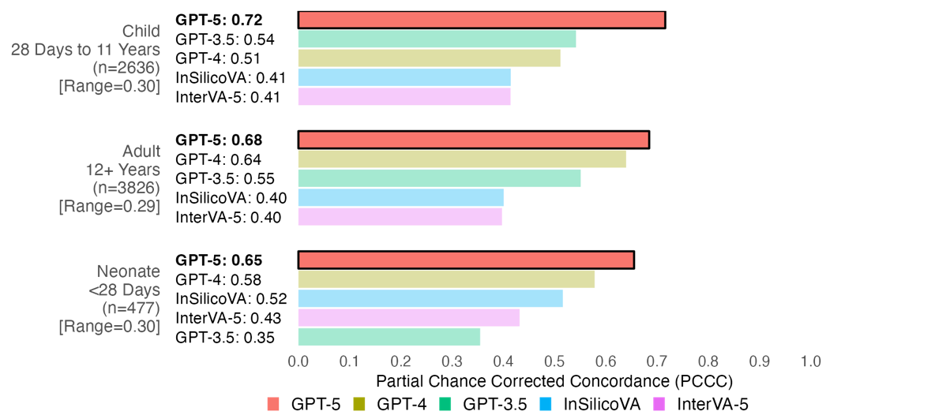
Fig. 3 Individual-level verbal autopsy coding performance by age group. PCCC values range from 0 to 1, with 1 indicating complete agreement with physician coding per individual death. Range represents the difference between the maximum and minimum PCCC values across all models per age group. Age groups are sorted by their model with the highest PCCC (highlighted in bold and opaque bars at the top of each age group), while models are sorted from highest to lowest PCCC within each age group.
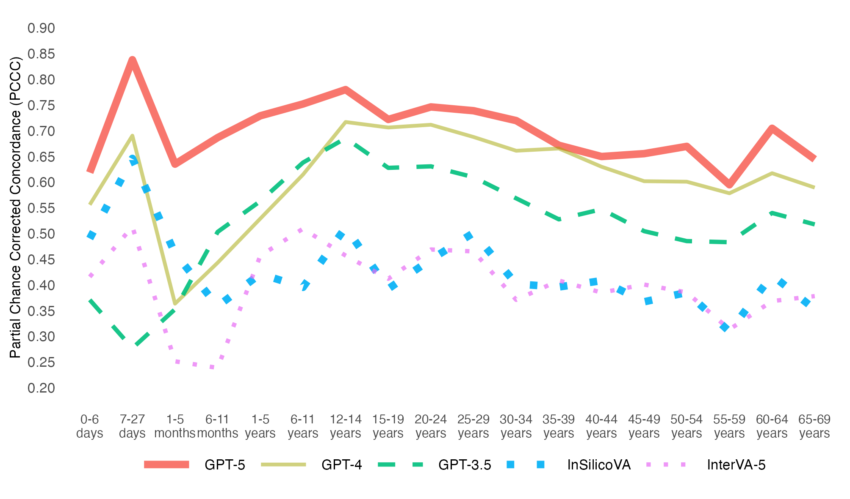
Fig. 4 Individual-level model performance by age of deceased. PCCC values range from 0 to 1, with 1 indicating complete agreement with physician coding per individual death. Ages 0-27 days represent neonatal deaths, ages 1-11 months represent child deaths, and ages 12-69 years represent adult deaths.
Table 1 Top ten leading causes of death for Sierra Leone in 2023 and best performing models for verbal autopsy coding.
Top 10 Leading Cause of Death  (∼71% of ∼76K deaths)¹ | Deaths (% of 76K)² | Best Model(s) at the individual-level
Malaria | 16,075 (21%) | GPT-5
Infections | 11,777 (16%) | GPT-3.5/GPT-5/InSilicoVA
Ischaemic heart and other vascular | 5,747 (8%) | GPT-5
Diarrhoea | 4,285 (6%) | GPT-4/GPT-5
Stroke | 4,262 (6%) | GPT-5
Pneumonia | 3,074 (4%) | GPT-4/InSilicoVA
Birth asphyxia and birth trauma | 2,431 (3%) | GPT-5
Tuberculosis | 2,399 (3%) | GPT-5
Low birth weight/preterm | 1,570 (2%) | GPT-5
Asthma and chronic respiratory | 1,551 (2%) | GPT-3.5
Other infections and severe systemic/localized infections were generalized into infections. Appendix, hernia, intestinal and Peptic ulcer/gastroesophageal causes did not have comparable CGHR-10 codes and were omitted from the top ten.
2Percentage of ∼76 thousand (K) total deaths [60]. Numbers are rounded.

Performance for 3826 Adult Records (12 to 69 years)
Figure 5 presents performance across 17 adult CODs. GPT-5 achieved the highest individual-level performance for 9 of 17 CODs (0.36–0.99), followed by GPT-4 for 5 CODs (0.61-0.99), and GPT-3.5 for 4 CODs (0.78–0.94). InterVA-5 had the lowest performance for 9 CODs (0–0.79), InSilicoVA for 6 CODs (0–0.5), and GPT-3.5 for 2 CODs (0.38 and 0.53). The greatest improvements of GPT-3.5/4/5 over InSilicoVA and InterVA-5 were observed in chronic respiratory diseases (0.74-0.94 in the PCCC), while the smallest improvements were for ischemic heart disease (0.02-0.23 in the PCCC). All models performed well for maternal conditions (0.79–0.99), but poorly for unspecified infections (0.35–0.58), malaria (0.26–0.51), and ill-defined CODs (0–0.36). GPT-5 showed performance improvements over all other models for stroke (0.13–0.58 in the PCCC) and tuberculosis (0.12-0.45 in the PCCC). GPT-4 demonstrated similar gains for cancers (0.1-0.36 in the PCCC), while GPT-3.5 improved over other models for chronic respiratory diseases (0.11-0.94 in the PCCC), diabetes (0.08-0.58 in the PCCC), other non-commnicable diseases (0.11-0.59 in the PCCC), and liver and alcohol-related diseases (0.25–0.52 in the PCCC). Performance variability across models was most pronounced for chronic respiratory diseases (range: 0.94), while narrower differences were observed for maternal conditions (range: 0.20), malaria (range: 0.25), ischemic heart disease (range: 0.23), and unspecified infections (range: 0.23).
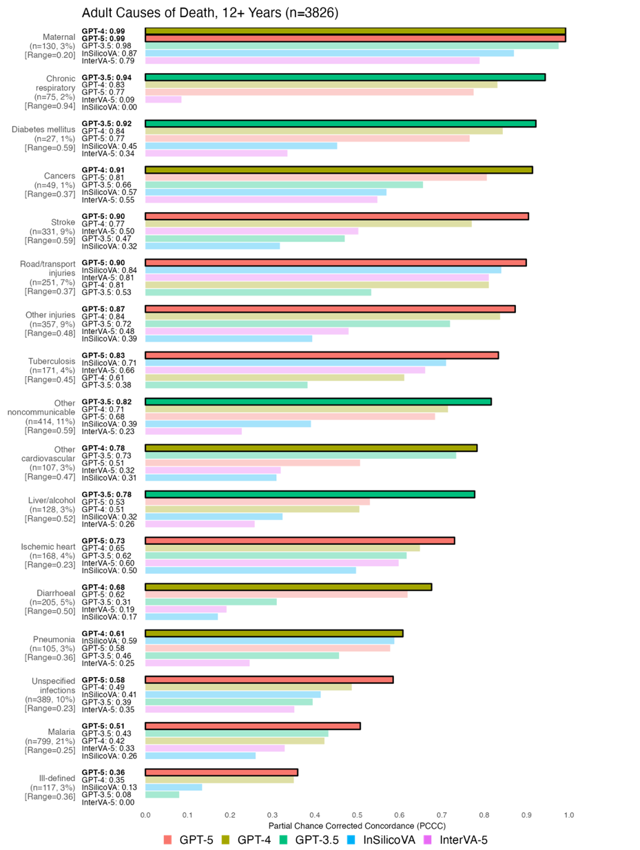
Fig. 5 Individual-level model performance for adult causes of death. PCCC values range from 0 to 1, with 1 indicating complete agreement with physician coding per individual death. Range represents the difference between the maximum and minimum PCCC values across all models per cause of death. Causes of death are sorted by their model with the highest PCCC (highlighted in bold text and opaque bars at the top of each cause of death), while models are sorted from highest to lowest PCCC within each cause of death. Suicide (n=3, <1%) was excluded due to low sample size.

Performance for 2636 Child Records (28 Days to 11 Years)
Figure 6 shows individual-level performance across 8 child CODs. GPT-5 achieved the highest PCCC for 4 of the 8 CODs (0.68–0.92), followed by GPT-3.5 for 2 CODs (0.44 and 0.88), GPT-4 for one COD (0.94), and InSilicoVA for one COD (0.78). InterVA-5 had the lowest performance for 4 CODs (0.09–0.79), InSilicoVA for 3 CODs (0–0.35), and GPT-3.5 for one COD (0.58). All models performed well for injuries (0.79–0.94), while showing lower performance for other infections (0.29–0.44). GPT-5 demonstrated an improvement over other models for malaria, with improvements between 0.28–0.47 in the PCCC, while demonstrating stronger performance along with GPT-4 for ill-defined CODs, with gains of 0.38-0.68 in the PCCC versus all other models. Performance differences exceeding 0.60 in the PCCC were observed for epilepsy, leukaemia, other communicable diseases (range: 0.73), ill-defined causes (range: 0.68), and nutritional deficiencies (range: 0.71). In contrast, narrower differences (less than 0.30 in the PCCC) were seen for injuries (range: 0.15) and other infections (range: 0.15).
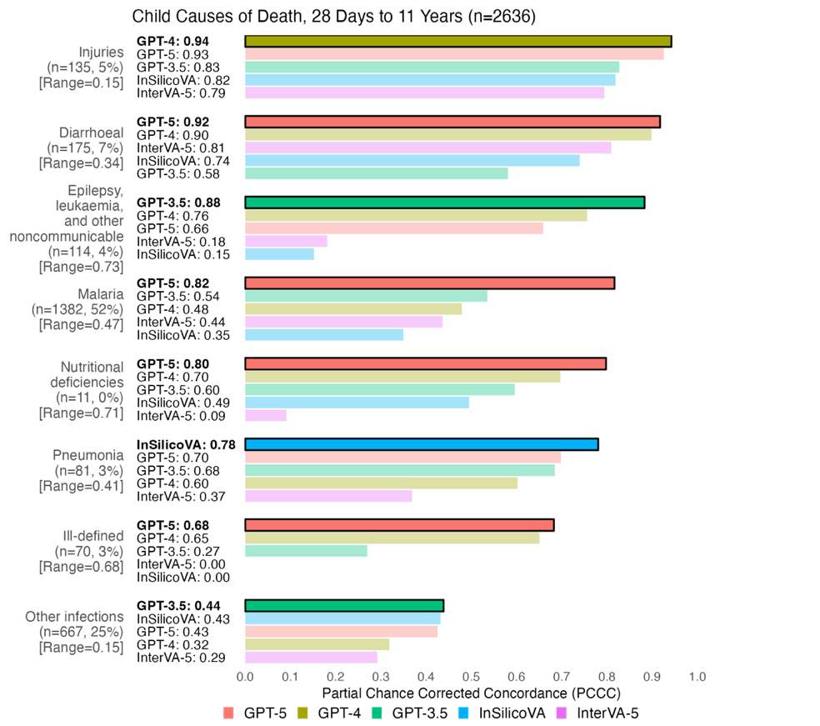
Fig. 6 Individual-level model performance for child causes of death. PCCC values range from 0 to 1, with 1 indicating complete agreement with physician coding per individual death. Range represents the difference between the maximum and minimum PCCC values across all models per cause of death. Causes of death are sorted by their model with the highest PCCC (highlighted in bold text and opaque bars at the top of each cause of death), while models are sorted from highest to lowest PCCC within each cause of death. Congenital anomalies (n=1, <1%) was excluded due to low sample size.

Performance for 477 Neonatal Records (Under 28 Days)
Figure 7 shows model performance across 5 neonatal CODs. GPT-5 achieved the highest performance for 2 of the 5 CODs (0.73 and 0.76), while InSilicoVA, GPT-3.5, and GPT-4 had the highest performance for one COD each (0.86, 0.57, and 0.39 respectively). GPT-3.5 showed the lowest performance for 3 CODs (0–0.13), and InterVA-5 for 2 CODs (0.01 and 0.48). Performance was similar across all models for stillbirths (0.48–0.57). Notably, only GPT-5 and GPT-4 achieved a PCCC greater than zero for ill-defined deaths. InSilicoVA outperformed most other models for neonatal infections (0.86) with gains of 0.18–0.73 in the PCCC, except for GPT-5, which performed very similarly (0.85). Larger performance differences between models were observed for infections (range: 0.73) and prematurity and low birthweight (0.72), while lower differences were seen in stillbirth (range: 0.09).
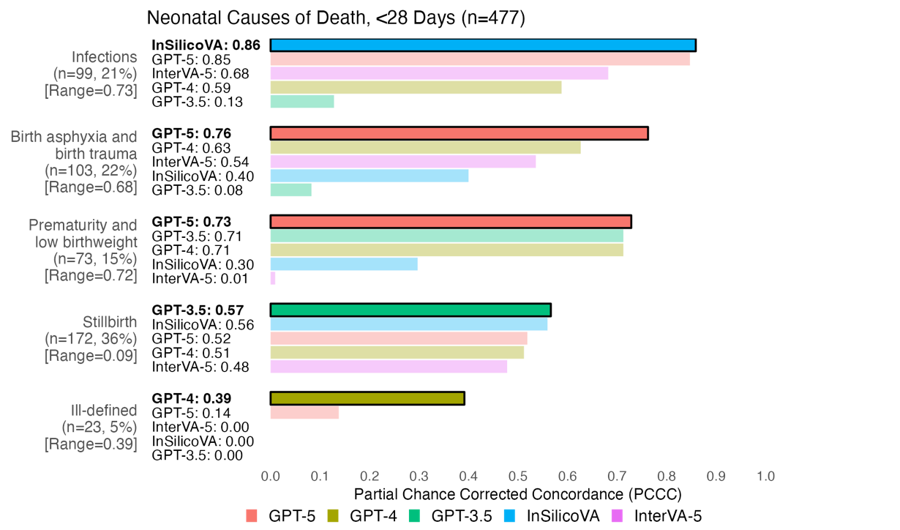
Fig. 7 Individual-level model performance for neonatal causes of death. PCCC values range from 0 to 1, with 1 indicating complete agreement with physician coding per individual death. Range represents the difference between the maximum and minimum PCCC values across all models per cause of death Causes of death are sorted by their model with the highest PCCC (highlighted in bold text and opaque bars at the top of each cause of death), while models are sorted from highest to lowest PCCC within each cause of death. Congenital anomalies (n=2, <1%) and other causes (n=5, 1%) were excluded due to low sample size.

Discussion
As model performance varied by disease and age, the findings suggest models trained for each COD to maximize performance across causes, and validating that performance across ages align with expectations from clinical literature [61,62]. From the results, we observed that GPT-3.5/4/5 consistently outperformed InterVA-5 and InSilicoVA for most CODs. A key advantage of GPT models was their ability to process and generate natural language text as input and output. Unlike InterVA-5 and InSilicoVA, GPT models assign CODs using the ICD-10 standard, mirroring physician practice. In contrast, InterVA-5 and InSilicoVA rely exclusively on structured WHO VA 2016 questionnaires and assign CODs using broader WHO VA 2016 codes. This dependency necessitates ongoing maintenance and conversion between questionnaire versions and coding systems, reducing interoperability and comparability across models. In addition, rarer diseases, underrepresented in questionnaire data, are better contextualized through external knowledge (e.g., web sources, journals, books) embedded in GPT models. The flexibility of GPT models in handling unstructured data allows them to capture latent and ambiguous information, such as health-seeking behaviors and social context, which are not encompassed by standardized VA codes or structured questionnaires [24,26].
Although GPT models improved over InterVA-5 and InSilicoVA models, several limitations exist. Despite GPT-3.5/4/5 configured for more deterministic outputs (see Appendix B.2.2), a brief experiment in Appendix C revealed that GPT-3.5/4/5 did not assign consistent CODs when repeated on identical records. Thus, GPT models were inherently non-deterministic, as identical outputs across runs were not guaranteed [63–65]. Nonetheless, adjusting model parameters (e.g., temperature, seed, reasoning, verbosity) can improve output consistency, though complete stability is not ensured in practice [66–68]. In contrast, InterVA-5 and InSilicoVA provide assignments with probabilities for alternative causes, which was made feasible by calculating probabilities using repeated runs without costs. Another limitation common to all models was their reliance on past training data, limiting potential to detect new or emerging diseases (e.g., COVID-19). This is often remedied with re-training or updating models with new data or knowledge [69–71]. We also note that GPT-3.5/4/5 required data sent to external servers, raising significant privacy concerns from reliance on third-party services [72,73]. In contrast, InterVA-5 and InSilicoVA are run on local systems under the control of the data owner. Privacy concerns are commonly addressed with the application of data anonymization techniques (e.g., generalization, suppression, de-identification) to remove or hide sensitive information [74–76]. While jurisdictions, such as the European Union, enforce strict protections under the general data protection regulation, most low‑ and middle‑income countries are only beginning to formalize regulatory frameworks for data protection and artificial intelligence governance [77–79]. As technology improves, larger GPT models may be possible on local systems, while currently, smaller LLMs exist as an alternative when adequate expertise and computing resources are available [80–82]. Although this study rigorously compares computer algorithms for COD assignment in Sierra Leone, the extent to which these findings are generalizable in other geographic or epidemiological contexts remains limited. Variations in local mortality profiles, linguistic expression, health system infrastructure, and culturally specific interpretations of illness shape the content and structure of VA narratives and questionnaires [83–85]. Similar to our results, we expect LLMs (GPT-3.5/4/5) to outperform statistical models (InterVA-5, InSilicoVA) overall and across most CODs, when applied to other regions. LLMs leverage sources of information available on the web (e.g. news, books, manuals, reports) containing knowledge for generalizing to other areas, such as widely known or changing regional variations in mortality and culture [71,86–89]. In contrast, the information from these sources is often not up to date or captured by structured training data in statistical models. Nonetheless, sources leveraged by LLMs hold bias, and performance is not guaranteed when applied to regions underrepresented in the training sources [89,90]. Given ongoing efforts to scale and integrate VA systems for mortality surveillance across diverse low- and middle-income countries, further validation across more geographically representative VA datasets is essential to evaluate model robustness, adaptability, and operational utility in practice [91–93].
This study establishes a basis for Computer Assisted Verbal Autopsy (CAVA), the integration of computer models into VA systems paired with physician assignment. Model-generated COD suggestions can be offered to physicians after their initial assignment, enabling reconsideration or confirmation of CODs as seen in step 2 of Figure 8. We highlight that this study and earlier randomized evaluation of algorithms compared to the physician standard emphasize the core need to have physician coding of verbal autopsies [19–21]. The HEAL-SL method of drawing on physicians during their non-clinical time and using rigorous online methods with dual anonymous coding are scalable to other settings [38]. At the time of analysis, GPT-3.5 cost ~$0.02 USD per 100 records, GPT-4 cost ~$1.65 USD per 100 records, and GPT-5 cost ~$0.05 USD per 100 records [94], while InterVA-5 and InSilicoVA were freely available as open-source software. These costs complement physician review, which is already affordable at ~$1 USD per household (including field survey) in settings like India [13,14]. The main costs of VA studies are in the field work, so the marginal costs of physician coding are small, and indeed our study suggests that quality enhancements introducing LLM and algorithms are very cost-effective. Given recent studies supporting improvement in physician diagnosis from LLM assistance [95,96], we foresee the potential of alternative COD suggestions from computer models reducing physician disagreement and frequency of ill-defined records. The HEAL-SL platform now incorporates LLM and algorithms, and the platform is available for use openly by other research and programmatic groups worldwide [34]. Presently, CAVA (using GPT-4, InterVA-5, and InSilicoVA) is integrated, with future work planned to evaluate the impact of CAVA on physician assignment.

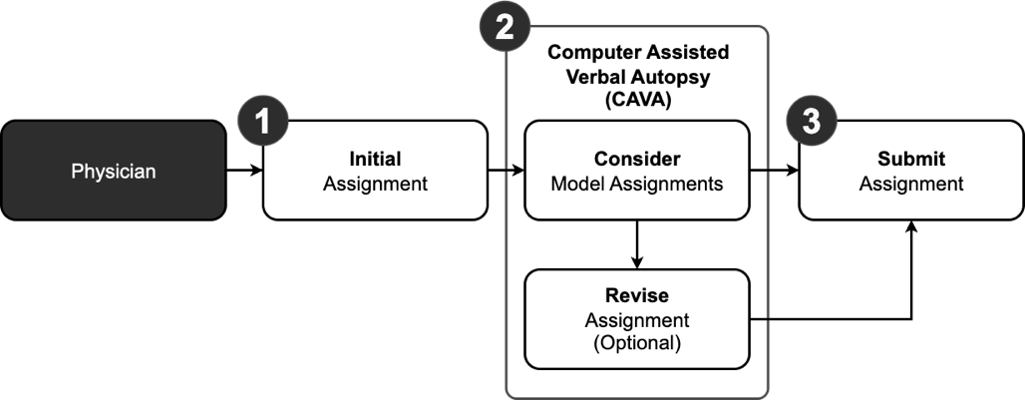
Fig. 8 Computer Assisted Verbal Autopsy (CAVA) integrated into physician coding as a three-step process. The first step involves the physician assigning an initial cause of death to a record without considering causes of death provided by models. The second step is the addition of CAVA, where the physician can compare their initial assignment in step one to model assignments and optionally choose to revise their initial assignments. The third step submits the record with either the initial or revised assignment to the verbal autopsy coding system.

Conclusion
This study evaluated the performance of GPT-3.5, GPT-4, GPT-5, InterVA-5, and InSilicoVA models against physicians in assigning CODs for 6,939 VA records from Sierra Leone (2019–2022). At the individual-level, GPT-5 had the highest performance (0.71 PCCC), followed by GPT-4 (0.61), GPT-3.5 (0.58), and InSilicoVA/InterVA-5 (0.44). By COD, GPT-5 performed best for 9 of 17 adult, 4 of 8 child, and 2 of 5 neonatal causes. GPT-4 led in 5 adult causes and one child and neonatal cause each, while GPT-3.5 led in 4 adult and 2 child causes, and one neonatal cause. Lastly, InSilicoVA led in one child and neonatal cause each. Performance increased (∼0.25–0.75 PCCC) as children and neonates matured (0 days to 14 years) and decreased (∼0.7–0.35) with adult aging (15 to 69 years). At the population level, GPT-5 had the highest performance with a CSMF accuracy of 0.9, while all other models achieved similar performance (0.74–0.79). These findings suggest that combining models tailored to specific CODs and age groups may optimize performance relative to physicians. All models demonstrated scalability and on-demand availability, enabling COD estimation and alternative diagnoses in low-resource or physician-scarce settings. The NLP capabilities of GPT models enabled performance closer to physician coding, but issues remain with reproducibility, reliance on historical data, data privacy, and verification in other regions. Thus, CAVA, in which models support and complement physician reasoning, offers a promising approach for the future of VA coding.
Supplementary information. Additional file 1 (.csv) titled ”Central Medical Evaluation Agreement 10 (CMEA-10) codes” with description” ICD-10 code ranges considered in physician agreement” was used to supplement this study.

Declarations
Ethics approval and consent to participate
The Sierra Leone Ethics and Scientific Review Committee (SLESRC No. 025/04/2023) and Unity Health Toronto Research Ethics Board (REB#15-231) granted ethics approval for the project. Relatives of the deceased provided informed consent.
Consent for publication
Not applicable.

Availability of data and materials
The datasets generated and/or analysed during the current study are available in the Open Mortality repository, https://openmortality.org, on reasonable request. All code files used and/or analysed during the current study are available in the Github repository, https://github.com/cghr-toronto/healsl-gpt-paper.
Competing interests
The authors had no conflicts of interest.
Funding
Bill & Melinda Gates Foundation, Canada Institutes of Health Research. The sponsors had no role in the design, implementation, data collection, analyses, or report preparation.

Authors’ contributions
PJ and RA are the study Principal Investigators. ATA and RK implemented the data collection procedures. RW, TKSN, and CM processed, documented, and prepared the data. RW, ASL, and RK ran the models. RW wrote the paper and conducted the analysis. AB and RCM provided medical domain guidance and feedback. All authors reviewed the results and contributed to the report. All authors read and approved the final manuscript.

Acknowledgements
Not applicable.
Abbreviations
CAVA: Computer Assisted Verbal Autopsy
CCVA: Computer Coded Verbal Autopsy
CGHR: Centre for Global Health Research
CMEA: Central Medical Evaluation Agreement
COD: Cause of Death
CSMF: Cause Specific Mortality Fraction
EVA: Electronic Verbal Autopsy
GPT: Generative Pre-trained Transformer
HEAL-SL: Healthy Sierra Leone
ICD: Internation Classification of Diseases
LLM: Large Language Model
PCCC: Partial Chance Corrected Concordance
VA: Verbal Autopsy
WHO: World Health Organization
Appendix A CGHR-10 Codes
Table A1 CGHR-10 codes for adults (12-69 years).
Adult CGHR-10 Code | ICD-10 Range
Acute respiratory infections | H65-H68, H70-H71, J00-J22, J32, J36, J85-J86, P23
Tuberculosis | A15-A16, B90, J65
Diarrhoeal | A00-A09
Unspecified infections | A17-A33, A35-A99, B00-B17, B19-B49, B55-B89, B91-B99, C46, D64, D84, G00-G09, H10, H60, I30, I32-I33, K02, K04-K05, K61, K65, K67, K81, L00-L04, L08, M00-M01, M60, M86, N10, N30,  N34, N41, N49, N61, N70-N74, P35-P39, R50, R75, ZZ21
Malaria | B50-B54
Maternal conditions | A34, F53, O00-O08, O10-O16, O20-O99
Nutritional deficiencies | D50-D53, E00-E02, E40-E46, E50-E64, X53-X54
Chronic respiratory | J30-J31, J33-J35, J37-J64, J66-J84, J90-J99, R04-R06, R84, R91
Cancers | C00-C26, C30-C45, C47-C58, C60-C97, D00-D48, D91, N60, N62-N64, N87, R59
Ischemic heart | I20-I25, R55
Stroke | G45-G46, G81-G83, I60-I69
Diabetes mellitus | E10-E14
Other cardiovascular | I00-I03, I05-I15, I26-I28, I31, I34-I52, I70-I99, R00-R01, R03, ZZ23
Liver and alcohol related | B18, F10, K70-K77, R16-R18, X45, Y15, Y90-91
Other noncommunicable | D55-D63, D65-D83, D86, D89, E03-E07, E15-E35, E65-E68, E70E90, F00-F09, F11-F52, F54-F99, G10-G37, G40-G41, G43-G44, G50-G80, G84-G99, H00-H06, H11-H59, H61-H62, H69, H72-H95, K00-K01, K03, K06-K14, K20-K31, K35-K38, K40-K60, K62-K64, K66, K78-K80, K82-K93, L05, L10-L99, M02-M54, M61-M85, M87-M99, N00-N08, N11-N29, N31-N33, N35-N40, N42-N48, N50N59, N75-N86, N88-N99, Q00-Q99, R10-R15, R19-R23, R26-R27, R29-R49, R56, R63, R70-R74, R76-R77, R80-R82, R85-R87, R90, ZZ25
Road and transport injuries | V01-V99, Y85
Suicide | X60-X84
Other injuries | S00-S99, T00-T99, W00-W99, X00-X44, X46-X52, X55-X59, X85-X99, Y00-Y14, Y16-Y84, Y86, Y89, Y92-Y98, ZZ27
Ill-defined | R02, R07-R09, R25, R51-R54, R57-R58, R60-R62, R64-R69, R78-R79, R83, R89, R92-R94, R96, R98-R99

Table A2 CGHR-10 codes for children and neonates.
Child CGHR-10 Code (28 days to 11 years) | ICD-10 Range
Pneumonia | A37, H65-H68, H70-H71, J00-J22, J32, J36, J85-J86, P23, U04
Diarrhoeal | A00-A09
Malaria | B50-B54
Other infections | A15-A28, A30-A36, A38-A44, A46, A48-A71, A74-A75, A77-A99, B00B09, B15-B27, B30, B33-B49, B55-B60, B64-B83, B85-B92, B94-B97, B99, G00-G09, H10, H60, I30, I32-I33, I39-I41, J65, K02, K04-K05, K61, K65, K67, K81, L00-L04, L08, M00-M01, M60, M86, N10, N30, N34, N41, N49, N61, N70-N74, P35-P39, R50, R75, U00, Y95, ZZ11
Congenital anomalies | P01, P05, P07, P21, Q00-Q99
Epilepsy, leukaemia, and other noncommunicable | C00-C97, D01-D48, D55-D89, E03-E35, E65-E90, F00-F02, F73, G10G99, H00-H06, H11-H59, H61-H62, H69, H72-H95, I00-I28, I31, I34-I38, I42-I99, J30-J31, J33-J35, J37-J47, J60, J64, J66-J70, J80-J82, J84, J90-J99, K00-K01, K03, K06-K60, K62-K63, K70-K80, K82-K93, L05, L10-L99, M02-M54, M61-M85, M87-M99, N00-N08, N11-N29, N31N33, N35-N40, N42-N48, N50-N51, N60, N62-N64, N75-N99, P04, P08, P27, P51, P53-P60, P70-P72, P74-P76, P78, P80-P83, P92-P94, R00-R01, R03-R06, R11-R23, R26-R27, R29-R49, R55-R56, R59, R63, R70-R74, R76-R77, R80-R82, R84-R87, R90-R91, ZZ12-ZZ13, ZZ15
Injuries | S00-S99, T00-T98, V01-V99, W00-W99, X00-X52, X57-X99, Y00-Y91, Y97-Y98
Nutritional deficiencies | D50-D53, E00-E02, E40-E46, E50-E56, E59-E61, E63-E64, X53-X54
Other | D00, F03-F72, F74-F99, P00, P02-P03, P10-P15, P20, P22, P24-P26, P28-P29, P50, P52, P61, P77, P90-P91
Ill-defined | P96, R02, R07, R09-R10, R25, R51-R54, R57-R58, R60-R62, R64, R68-R69, R78-R79, R83, R89, R92-R99
Neonate CGHR-10 Code (<28 days)
Prematurity & low birthweight | D64, O60, P01, P05, P07, P22, P25-P28, P52, P61, P77, P80, P92, R04
Neonatal infections | A00-A09, A20-A28, A32-A35, A37-A44, A46, A48-A49, A68A70, A74-A75, A77-A79, A81-A90, B54, B95-B96, G00-G09, H10, H60, H65-H68, H70-H71, I30, I32-I33, I39-I41, J00-J22, J32, J36, J85-J86, K65, K67, K81, L00-L04, L08, M00-M01, M60, M86, N10, N30, N34, N41, N49, N61, O85, P23, P35,P39, P58-P59, P63, U04
Birth asphyxia and birth trauma | G40, P00, P02-P03, P10-P15, P20-P21, P24, P29, P50-P51, P90-P91, R06, W79, Z37
Stillbirth | P95
Congenital anomalies | C76, Q00-Q99
Other | A15-A19, A30-A31, A36, A50-A67, A71, A80, A91-A99, B00-B09, B15-B27, B30, B33-B53, B55-B60, B64-B83, B85-B92, B94, B97, B99, C00-C75, C77-C97, D00-D48, D50-D53, D55-D63, D65-D89, E00-E35, E40-E46, E50-E56, E59-E61, E63-E90, F00-F99, G10-G39, G41-G99, H00-H06, H11-H59, H61-H62, H69, H72-H95, I00-I28, I31, I34-I38, I42-I99, J30, J31, J33-J35, J37-J47, J60, J64-J70, J80-J82, J84, J90J99, K00-K63, K70-K80, K82-K93, L05, L10-L99, M02-M54, M61-M85, M87-M99, N00-N08, N11-N29, N31-N33, N35N40, N42-N48, N50-N51, N60, N62-N64, N70-N99, P04, P08, P53-P57, P60,P70-P72, P74-P76, P78, P81-P83, P93-P94, R00-R01, R03-R05, R11-R23, R26-R27, R29-R36, R39-R50, R55-R56, R59, R63, R70-R77, R80-R82, R84-R87, R90-R91, S00-S99, T00-T98, U00, V01-V99, W00-W78, W80-W99, X00-X54, X57-X99, Y00-Y91, Y95, Y97-Y98
Ill-defined | P96, R02, R07, R09-R10, R25, R51-R54, R57-R58, R60-R62, R64, R68-R69, R78-R79, R83, R89, R92-R99

Appendix B Details on Methods
This section provides additional details on the methods described in Section 2. An overview of the methods used in this study is seen in Figure B1 as a five-step process. Section B.1 provides details on the preprocessed data used for modelling. Section B.2 describes the data and parameter inputs and outputs for each model, while Section B.3 details the evaluation of model outputs at the individual and population level across different CODs, age groups, and ages.

B.1 CGHR-10 Physician-Agreed Records
Initially, 11,920 records were collected from dual-coded EVA in the HEAL-SL study. Physicians were able to assign CODs for 11,820 of the 11,920 records, where 100 of these records could not be assigned a COD due to missing or inadequate information (e.g. low quality narrative, data loss). The 11,820 physician coded records were further filtered for records where both physicians agreed on the assigned codes (records that were not reconciled or adjudicated) resulting in 6942 physician agreed records (based on comparisons using CMEA-10 codes, see Additional File 1). The 6942 records were converted into CGHR-10 codes (see Appendix A) that generalized ICD-10 codes into 19, 10, and 7 categories for the adult (12 to 69 years), child (28 days to 11 years), and neonatal (under 28 days) age groups. After conversion, a final total of 6939 physician agreed records (3826 adult, 2636 child, and 477 neonatal) were used for modelling and performance evaluation, where three records were removed as their ICD-10 codes did not have a matching CGHR-10 code.
The 6,939 physician agreed records were collected using VA from the HEAL-SL study between 2019-2022, where deaths were collected using nationwide representative sampling units across Sierra Leone (Figure B2). The distribution of the study data are shown by CGHR-10 causes of death in Table B4. All age groups had relatively evenly distributed female and male records (44-55% of 6939 records each). Across CODs, there were noticeably more female records for cancers (65%), and maternal conditions (100%), while more male records for chronic respiratory diseases (61%), other noncommunicable diseases (61%), other injuries (77%), road and transport injuries (71%), and tuberculosis (68%). Most records were coded by physicians as malaria for adults (20%) and children (52%), and stillbirth (36%) and neonatal infections (21%) for neonates. Suicide, congenital anomalies, nutritional deficiencies, and other had low sample sizes for each age group (<1% of total records for each age group). Table B5 shows the distribution of the study data by age. Across ages, there were more male records for 50-59 years (60-62%), while all other records had between 49-59% female and male records. Most records were in the 65-69 years age range for adults (15%), 1-5 years for children (62%), and 0-6 days for neonates (83%).
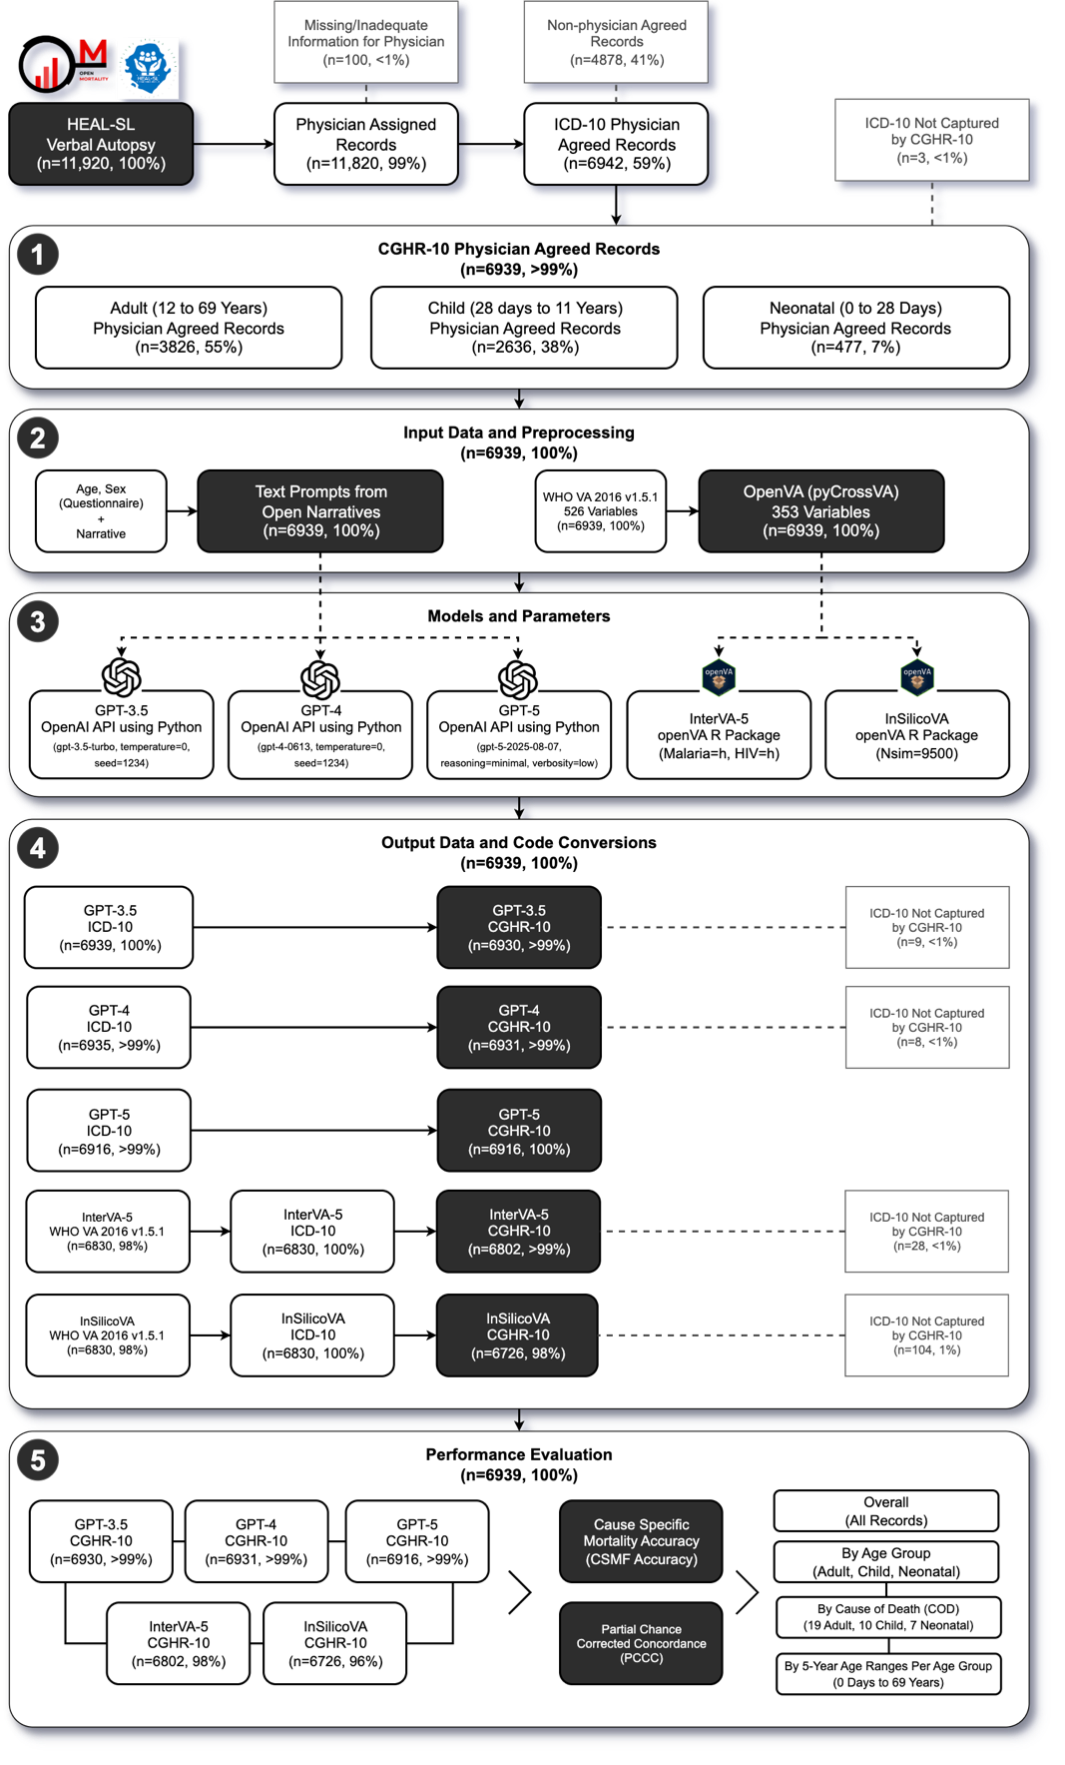
Fig. B1 Detailed flow diagram for verbal autopsy coding comparison of 6939 sample deaths in Sierra Leone. This supplements the diagram in Figure 1, providing additional details on removed records, model specifications, and sub-processes.
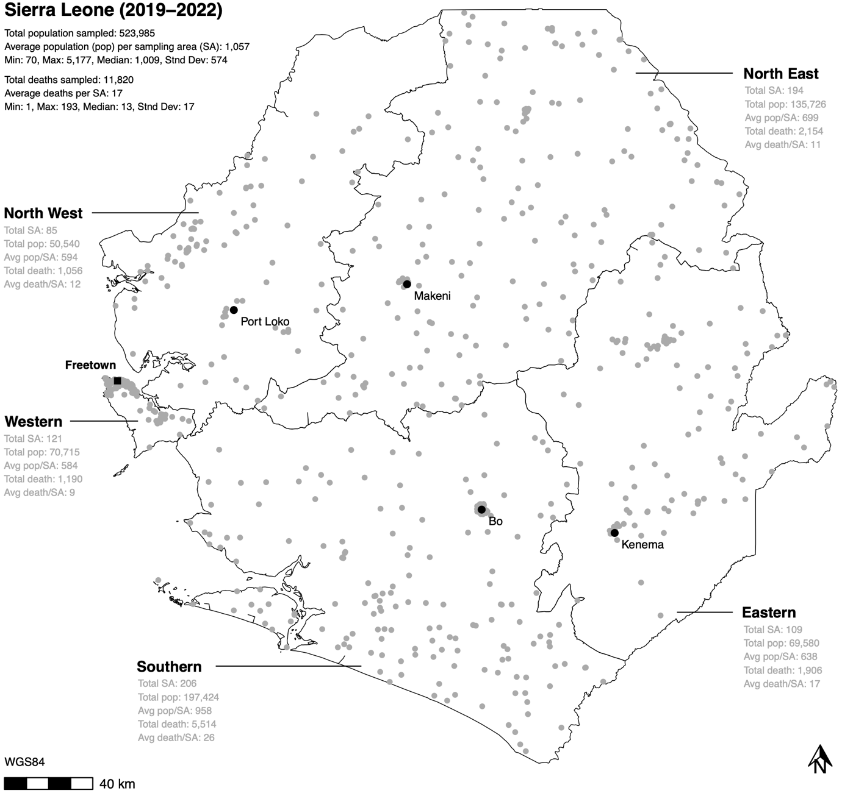
Fig. B2 Healthy Sierra Leone (HEAL-SL) verbal autopsy data sampling areas for Sierra Leone from 2019-2022. The boundaries represent Sierra Leone provinces. Each grey point represents the centroid of sampling areas. Pop=population, SA=sampling area.

B.2 Modelling Details
Each model (GPT-3.5, GPT-4, GPT-5, InSilicoVA, and InterVA-5) required pre-processing of the 6939 records into input data, and standardization of output COD codes from models for performance evaluation as not all models produced comparable codes across outputs. Although each model can assign multiple CODs per record, only the first generated COD response from GPT-3.5/4/5, and the most probable COD from InterVA-5 and InSilicoVA were used for evaluation. Section B.2.1 describes the input data and parameters for each model, while Section B.2.3 details the outputs from running each model.

Table B4 Study data by cause of death.
Age Group | CGHR-10 Cause of Death (COD) | Female | Male | Total
Adult, 18 CODs  (n=3826, 55.1%)  Adult Female  (n=1681, 43.9%)  Adult Male  (n=2145, 56.1%) | Acute Respiratory Infections  Cancers  Chronic Respiratory Diseases  Diabetes Mellitus  Diarrhoeal Diseases  Ill-Defined  Ischemic Heart Disease  Liver And Alcohol Related Diseases  Malaria  Maternal Conditions  Other Cardiovascular Diseases  Other Noncommunicable Diseases  Other Injuries  Road And Transport Injuries  Stroke  Suicide  Tuberculosis | 48 (45.7%)  32 (65.3%)  29 (38.7%)  14 (51.9%)  102 (49.8%)  56 (47.9%)  89 (53%)  58 (45.3%)  372 (46.6%)  130 (100%)  59 (55.1%)  160 (38.6%)  83 (23.2%)  73 (29.1%)  147 (44.4%)  N/A  54 (31.6%) | 57 (54.3%)  17 (34.7%)  46 (61.3%)  13 (48.1%)  103 (50.2%)  61 (52.1%)  79 (47%)  70 (54.7%)  427 (53.4%)  N/A  48 (44.9%)  254 (61.4%)  274 (76.8%)  178 (70.9%)  184 (55.6%)  3 (100%)  117 (68.4%) | 105 (2.7%)  49 (1.3%)  75 (2%)  27 (0.7%)  205 (5.4%)  117 (3.1%)  168 (4.4%)  128 (3.3%)  799 (20.9%)  130 (3.4%)  107 (2.8%)  414 (10.8%)  357 (9.3%)  251 (6.6%)  331 (8.7%)  3 (0.1%)  171 (4.5%)
Child, 9 CODs  (n=2636, 38%)  Child Female  (n=1290, 48.9%)  Child Male  (n=1346, 51.1%) | Congenital Anomalies  Diarrhoeal Diseases  Epilepsy, Leukaemia, & Other Non-communicable  Ill-Defined  Injuries  Malaria  Nutritional Deficiencies  Other infections  Pneumonia | 1 (100%)  79 (45.1%)  61 (53.5%)  34 (48.6%)  51 (37.8%)  680 (49.2%)  7 (63.6%)  338 (50.7%)  39 (48.1%) | N/A  96 (54.9%)  53 (46.5%)  36 (51.4%)  84 (62.2%)  702 (50.8%)  4 (36.4%)  329 (49.3%)  42 (51.9%) | 1 (0%)  175 (6.6%)  114 (4.3%)  70 (2.7%)  135 (5.1%)  1382 (52.4%)  11 (0.4%)  667 (25.3%)  81 (3.1%)
Neonate, 7 CODs  (n=477, 6.9%)  Neonate Female  (n=227, 47.6%)  Neonate Male  (n=250, 52.4%) | Birth Asphyxia and Birth Trauma  Congenital Anomalies  Ill-Defined  Neonatal Infections  Other  Prematurity And Low Birthweight  Stillbirth | 38 (36.9%)  2 (100%)  11 (47.8%)  49 (49.5%)  2 (40%)  39 (53.4%)  86 (50%) | 65 (63.1%) N/A  12 (52.2%)  50 (50.5%)  3 (60%)  34 (46.6%)  86 (50%) | 103 (21.6%)  2 (0.4%)  23 (4.8%)  99 (20.8%)  5 (1%)  73 (15.3%)  172 (36.1%)

B.2.1 Input Data and Preprocessing
For GPT-3.5, GPT-4, and GPT-5, 6939 text prompts were generated for each physician agreed record as input to instruct the models to assign CODs based on the open narratives. Two types of text prompts were used: user prompts and system prompts. System prompts contained textual instructions to assign the role of a physician ICD-10 coder with expertise in Sierra Leone. The following system prompt was used:
You are a physician with expertise in determining underlying causes of death in Sierra Leone by assigning the most probable ICD−10 code for each death using verbal autopsy narratives. Return only the ICD−10 code without description. E. g. A00. If there are multiple ICD−10 codes, show one code per line.
User prompts contained textual instructions to perform coding of VA records based on the age, sex, and narrative of the deceased. The following template was used to generate user prompts for each record, where <age> and <sex> from the questionnaire, and <narrative> from the narratives, were replaced with values from the data:
Determine the underlying cause of death and provide the most probable ICD−10 code for a verbal autopsy narrative of a <age> years old <sex> death in Sierra Leone: <narrative>
For InterVA-5 and InSilicoVA, the standardized questionnaire data from the HEAL-SL EVA were first converted into 2016 World Health Organization (WHO) VA questionnaire revision 1.5.1 Open Data Kit (ODK) format [97,98] consisting of 526 variables [99], followed by further conversion into OpenVA format [42] consisting of 353 variables [100] using the pyCrossVA version 0.97 Python package [101]. The 6939 records were all converted into OpenVA formatted records for InterVA-5 and InSilicoVA.
Table B5 Study data by age range.
Age Group | Age Range | Female | Male | Total
Adult (n=3826, 55.1%)  Adult Female (n=1681, 43.9%)  Adult Male (n=2145, 56.1%) | 12-14 Years  15-19 Years  20-24 Years  25-29 Years  30-34 Years  35-39 Years  40-44 Years  45-49 Years  50-54 Years  55-59 Years  60-64 Years  65-69 Years | 51 (37.8%)  115 (42.8%)  146 (53.1%)  159 (45.2%)  174 (50.9%)  153 (45.4%)  134 (42%)  148 (47%)  134 (39.6%)  96 (37.6%)  128 (40.8%)  243 (42.3%) | 84 (62.2%)  154 (57.2%)  129 (46.9%)  193 (54.8%)  168 (49.1%)  184 (54.6%)  185 (58%)  167 (53%)  204 (60.4%)  159 (62.4%)  186 (59.2%)  332 (57.7%) | 135 (3.5%)  269 (7%)  275 (7.2%)  352 (9.2%)  342 (8.9%)  337 (8.8%)  319 (8.3%)  315 (8.2%)  338 (8.8%)  255 (6.7%)  314 (8.2%)  575 (15%)
Child (n=2636, 38%)  Child Female (n=1290, 48.9%)  Child Male (n=1346, 51.1%) | 1-5 Months  6-11 Months  1-5 Years  6-11 Years | 146 (47.4%)  160 (50.8%)  822 (50.3%)  162 (42.6%) | 162 (52.6%)  155 (49.2%)  811 (49.7%)  218 (57.4%) | 308 (11.7%)  315 (11.9%)  1633 (61.9%)  380 (14.4%)
Neonate (n=477, 6.9%)  Neonate Female (n=227, 47.6%)  Neonate Male (n=250, 52.4%) | 0-6 Days  7-27 Days | 184 (46.6%)  43 (52.4%) | 211 (53.4%)  39 (47.6%) | 395 (82.8%)  82 (17.2%)

B.2.2 Models and Parameters
The GPT-3.5, GPT-4, and GPT-5 Application Programming Interfaces (APIs) were accessed using Python version 3.11.7 and used to assign CODs for each record. GPT-3.5 used the gpt-3.5-turbo model, GPT-4 used the gpt-4-0613 model, and GPT-5 used the gpt-2025-08-07 model. The parameter temperature for GPT-3.5 and GPT-4, representing the sampling temperature ranging from 0 to 2 (default of 1), was set to 0 to produce more deterministic outputs [102]. Higher values closer to 2 may produce less deterministic outputs, while lower values closer to 0 produce more deterministic outputs. Another parameter for GPT-3.5/4, seed was fixed at a constant value of 1234 to minimize randomness in token generation and improve output consistency [68]. Despite this setting, we note that GPT-3.5/4 were non-deterministic models, where using a constant seed value increases the likelihood of identical outputs across runs, but does not guarantee them. For GPT-5, the temperature and seed parameters were no longer available from the API, and we set the parameter reasoning to minimal and parameter verbosity to low as an alternative for producing more deterministic outputs, [66,67]. The reasoning parameter controls for the number of reasoning tokens, affecting the ability of GPT-5 to outline steps of thinking for refining the output. Values available were minimal, low, medium, or high, with higher values increasing the number of reasoning tokens to better refine outputs. We note that we use low reasoning for GPT-5 to reduce the likelihood of inconsistent outputs as the generation of more reasoning tokens increases output randomness. The verbosity parameter controls the number of output tokens, adjusting GPT-5 to provide more concise or more detailed output. Values available were high, medium, or low, where lower verbosity produces more concise output and higher verbosity produces more detailed output. We use low verbosity for GPT-5 to produce more concise and deterministic outputs. The openVA R package was used to run InterVA-5 and InSilicoVA models to assign CODs for each record in R version 4.3.1. The openVA package version 1.1.1 used dependent packages InterVA5 version 1.1.3 and InSilicoVA version 1.4.0. The Nsim (number of iterations to run) parameter [103] for InSilicoVA was set to 9500, while the HIV (level of prevalence of human immunodeficiency virus) and Malaria (level of prevalence of Malaria) parameters [104] for InterVA-5 were both set to h (high) reflecting HIV and Malaria disease assumptions in Sierra Leone [105,106]. Note that the default value of Nsim=10000 for InSilicoVA ran until 9500 iterations before it stopped due to errors, thus Nsim=9500 was used and ran successfully.

B.2.3 Output Data and Code Conversion
Of the 6939 input records, GPT-3.5, GPT-4, GPT-5, InterVA-5, and InSilicoVA were able to assign CODs for 6939 (100%), 6935 (>99%), 6916 (>99%), 6830 (98%), and 6830 (98%) records respectively. All 6830 (100%) InterVA-5 and InSilicoVA records with WHO VA 2016 v1.5 output codes [57] were converted into ICD-10 codes respectively. After all model outputs were converted to ICD-10 codes, they were further converted to CGHR-10 codes. The 6939 GPT-3.5, 6935 GPT-4, and 6916 GPT-5 output records with ICD-10 codes were converted into 6930 (>99%), 6931 (>99%), and 6196 (100%) records with CGHR-10 codes, where <1% (9, 8, and 0) records did not have matching CGHR-10 codes respectively. The 6830 InterVA-5 and InSilicoVA records with ICD-10 codes were converted into 6802 (>99%) and 6726 (98%) records with CGHR-10 codes respectively, where 28 (<1%) and 104 (1%) of records could not be converted into CGHR-10 codes.

B.3 Performance Evaluation Details
The performance of GPT-3.5, GPT-4, GPT-5, InSilicoVA, and InterVA-5 models were evaluated with metrics at the population and individual-level by comparing their CGHR-10 COD outputs for 6939 records to physician COD assignments. Section B.3.1 describes CSMF accuracy in detail for evaluating models on the population level, Section B.3.2 describes PCCC for evaluating models on the individual-level. Records that were assigned a COD by physicians, but not by a model were considered an incorrect COD assignment by the model. CSMF accuracy and PCCC were calculated for each model overall and by three age groups (adult, child, and neonatal), then further into age and COD for each age group.

B.3.1 Cause Specific Mortality Fraction (CSMF) Accuracy
CSMF accuracy measures the performance of models at the population level, comparing distributions of CODs between the physicians and the models [58]. To calculate CSMF accuracy, $\text{CSM}{\text{F}}_{\text{j}}$ was calculated as is the fraction of physician or model records for cause j, given by dividing the number of records for cause j with the total number of records as seen in Equation B1. Then, the CSMFMaximumError, representing the worst possible model, is calculated using Equation B2. Finally, the CSMF accuracy is given by Equation B3, where k is the number of causes, j is a cause, $CSMF_{j}^{true}$ is the true physician CSMF for cause j, and $CSMF_{j}^{pred}$ is the prediction model CSMF for cause j. CSMF accuracy ranges from 0 to 1, where 1 means that the model completely matched the physician COD distribution and 0 means that it did not match the distribution.
 | $$\text{CSM}{\text{F}}_{\text{j}}=\frac{\text{Record}{\text{s}}_{\text{j}}}{\text{Records}}$$ | (B1)

 | $$CSMFMaximumError = 2(1 - Min(CSMF_{j}^{true})$$ | (B2)

 | $$CSMFAccuracy=1-\frac{\sum_{j=1}^{k}{\left|CSMF_{j}^{true}-CSMF_{j}^{pred}\right|}}{CSMFMaximumError}$$ | (B3)

B.3.2 Partial Chance Corrected Concordance (PCCC)
PCCC measures the performance of models at the individual-level, comparing COD assignments between the physicians and models on a record by record basis, correcting for COD assignments made purely by chance [58]. PCCC is given by Equation B5, where k is the number of top COD assignments from the model to consider, N is number of causes, and C is fraction of records where the physician COD assignment is one of the top COD assignments from the model. For this study, k was set to 1, making C equivalent to the fraction of true positives TP or records, where the physician COD assignment is equal to the model COD assignment as shown in Equation B4. Higher PCCC values closer to 1 indicate that model COD assignments are similar to physician COD assignments, while values closer to 0 indicate that they are not similar to physicians.
 | $$C=\frac{TP}{Records}$$ | (B4)

 | $$PCCC\left(k\right)=\frac{C-\frac{k}{N}}{1-\frac{k}{N}}$$ | (B5)
Appendix C Experiment on Repeated Runs of GPT Models
A short experiment was conducted to test the consistency of GPT-3.5, GPT-4, and GPT-5 outputs repeated on the same record. 100 records, sampled randomly with approximately equal proportions across age groups, CODs, and survey rounds 1 and 2, were used to test repeated runs of each GPT model. Each record from the 100 records was rerun 10 times through each GPT model, resulting in ten COD outputs per record. The ICD-10 codes were then converted to CGHR-10 codes and tested for consistency, where completely inconsistent results had different ICD-10 or CGHR-10 codes for each of the 10 reruns (1 times+), and completely consistent results had an identical ICD-10 or CGHR-10 code for all 10 reruns (10 times), on identical records.
The results are shown in Table C6. For all 100 records, all models except GPT-3.5 assign an identical ICD-10 and CGHR-10 code for identical records 5 times or more out of 10, where GPT-3.5 has 99 records for CGHR-10 codes as the exception. GPT-3.5 and GPT-4 were the most consistent, assigning identical ICD-10 codes over reruns for more than 70 records (71 for GPT-3.5 and 75 for GPT-4), and identical CGHR-10 codes for more than 80 records (82 for GPT-3.5 and 84 for GPT-4) each . These numbers steadily increase (at 1 to 9 records) to over 90 records with a reduction in the number of times that an identical code was assigned (e.g. from 9 times+ of 10 to 6 times+ of 10). In contrast, GPT-5 was inconsistent with only 33 and 66 records with identical ICD-10 and CGHR-10 code assignments over reruns respectively. A steeper increase of 4 to 16 records was observed with a reduction in the number of times that an identical code was assigned. We note that the temperature and seed parameters that were available in GPT-3.5/4, and unavailable in GPT-5, were suspect for these differences. Thus, GPT models do not always guarantee identical outputs when repeated on the same record (10 times out of 10), despite parameter adjustments for more deterministic outputs (e.g. temperature set to 0, seed set to a constant of 1234, verbosity set to low, reasoning set to minimal). Although, this experiment revealed that GPT-3.5/4 did produce identical outputs when rerun for more than half the records, while this is true only for CGHR-10 codes in the case of GPT-5. For most records (approximately 90%), GPT-3.5 and GPT-4 produced the same outputs for identical records 7+ times of 10, while this was only observed at 5+ times out of 10 for GPT-5.
Table C6 Records with identical GPT-3.5/4/5 outputs based on 10 repeated reruns of 100 records.
# of Times with Identical GPT-3.5 Outputs | ICD-10 Records | CGHR-10 Records
1 times+ (inconsistent) | 100 | 100
2 times+ | 100 | 100
3 times+ | 100 | 100
4 times+ | 100 | 100
5 times+ | 100 | 99
6 times+ | 95 | 98
7 times+ | 90 | 95
8 times+ | 86 | 92
9 times+ | 80 | 89
10 times (consistent) | 71 | 82
# of Times with Identical GPT-4 Outputs | ICD-10 Records | CGHR-10 Records
1 times+ (inconsistent) | 100 | 100
2 times+ | 100 | 100
3 times+ | 100 | 100
4 times+ | 100 | 100
5 times+ | 100 | 100
6 times+ | 92 | 94
7 times+ | 89 | 93
8 times+ | 84 | 89
9 times+ | 81 | 87
10 times (consistent) | 75 | 84
# of Times with Identical GPT-5 Outputs | ICD-10 Records | CGHR-10 Records
1 times+ (inconsistent) | 100 | 100
2 times+ | 100 | 100
3 times+ | 100 | 100
4 times+ | 100 | 100
5 times+ | 97 | 100
6 times+ | 84 | 95
7 times+ | 68 | 89
8 times+ | 56 | 85
9 times+ | 47 | 77
10 times (consistent) | 38 | 66

References
1. Lawn JE, Kerber K, Enweronu-Laryea C, Cousens S. 3.6 Million Neonatal Deaths—What Is Progressing and What Is Not? Seminars in Perinatology. 2010 Dec 1;34(6):371–86.
2. Lassi ZS, Bhutta ZA. Community‐based intervention packages for reducing maternal and neonatal morbidity and mortality and improving neonatal outcomes. Cochrane Database of Systematic Reviews [Internet]. 2015 [cited 2023 Dec 18];(3). Available from: https://www.cochranelibrary.com/cdsr/doi/10.1002/14651858.CD007754.pub3/full
3. Liu NH, Daumit GL, Dua T, Aquila R, Charlson F, Cuijpers P, et al. Excess mortality in persons with severe mental disorders: a multilevel intervention framework and priorities for clinical practice, policy and research agendas. World Psychiatry. 2017;16(1):30–40.
4. Ewig S, Torres A. Community-acquired pneumonia as an emergency: time for an aggressive intervention to lower mortality. European Respiratory Journal. 2011 Aug 1;38(2):253–60.
5. World Health Organization. SCORE for health data technical package: global report on health data systems and capacity, 2020 [Internet]. 2021 [cited 2023 Dec 12]. Available from: https://www.who.int/publications/i/item/9789240018709
6. de Savigny D, Riley I, Chandramohan D, Odhiambo F, Nichols E, Notzon S, et al. Integrating community-based verbal autopsy into civil registration and vital statistics (CRVS): system-level considerations. Global Health Action. 2017 Jan 1;10(1):1272882.
7. Thomas LM, D’Ambruoso L, Balabanova D. Verbal autopsy in health policy and systems: a literature review. BMJ Global Health. 2018 May 1;3(2):e000639.
8. Rampatige R, Mikkelsen L, Hernandez B, Riley I, Lopez AD. Systematic review of statistics on causes of deaths in hospitals: strengthening the evidence for policy-makers. Bull World Health Organ. 2014 Sept 16;92:807–16.
9. Adair T. Who dies where? Estimating the percentage of deaths that occur at home. BMJ Global Health. 2021 Sept 1;6(9):e006766.
10. World Health Organization. Verbal autopsy standards: 2022 WHO verbal autopsy instrument [Internet]. 2023 [cited 2023 Dec 12]. Available from: https://www.who.int/publications/m/item/training-curriculum-for-the-training-of-verbal-autopsy-master-trainers-and-supervisors
11. Chandramohan D, Fottrell E, Leitao J, Nichols E, Clark SJ, Alsokhn C, et al. Estimating causes of death where there is no medical certification: evolution and state of the art of verbal autopsy. Global Health Action. 2021 Oct 26;14(sup1):1982486.
12. World Health Organization. Verbal autopsy standards: ascertaining and attributing cause of death [Internet]. World Health Organization; 2007 [cited 2024 Jan 23]. Available from: https://apps.who.int/iris/bitstream/handle/10665/43764/9789241547215_eng.pdf
13. Gomes M, Begum R, Sati P, Dikshit R, Gupta PC, Kumar R, et al. Nationwide Mortality Studies To Quantify Causes Of Death: Relevant Lessons From India’s Million Death Study. Health Affairs. 2017 Nov;36(11):1887–95.
14. Jha P, Gajalakshmi V, Gupta PC, Kumar R, Mony P, Dhingra N, et al. Prospective Study of One Million Deaths in India: Rationale, Design, and Validation Results. PLOS Medicine. 2005 Dec 20;3(2):e18.
15. McCormick TH, Li ZR, Calvert C, Crampin AC, Kahn K, Clark SJ. Probabilistic Cause-of-death Assignment using Verbal Autopsies. J Am Stat Assoc. 2016;111(515):1036–49.
16. Morris SK, Bassani DG, Kumar R, Awasthi S, Paul VK, Jha P. Factors associated with physician agreement on verbal autopsy of over 27000 childhood deaths in India. PloS one. 2010;5(3):e9583.
17. Soleman N, Chandramohan D, Shibuya K. Verbal autopsy: current practices and challenges. Bulletin of the World Health Organization. 2006;84(3):239–45.
18. Byass P, Hussain-Alkhateeb L, D’Ambruoso L, Clark S, Davies J, Fottrell E, et al. An integrated approach to processing WHO-2016 verbal autopsy data: the InterVA-5 model. BMC Medicine. 2019 May 30;17(1):102.
19. Jha P, Kumar D, Dikshit R, Budukh A, Begum R, Sati P, et al. Automated versus physician assignment of cause of death for verbal autopsies: randomized trial of 9374 deaths in 117 villages in India. BMC Medicine. 2019 June 27;17(1):116.
20. Leitao J, Desai N, Aleksandrowicz L, Byass P, Miasnikof P, Tollman S, et al. Comparison of physician-certified verbal autopsy with computer-coded verbal autopsy for cause of death assignment in hospitalized patients in low- and middle-income countries: systematic review. BMC Med. 2014 Feb 4;12(1):22.
21. Desai N, Aleksandrowicz L, Miasnikof P, Lu Y, Leitao J, Byass P, et al. Performance of four computer-coded verbal autopsy methods for cause of death assignment compared with physician coding on 24,000 deaths in low- and middle-income countries. BMC Medicine. 2014 Feb 4;12(1):20.
22. Tunga M, Lungo J, Chambua J, Kateule R. Verbal autopsy models in determining causes of death. Tropical Medicine & International Health. 2021;26(12):1560–7.
23. Oti SO, Kyobutungi C. Verbal autopsy interpretation: a comparative analysis of the InterVA model versus physician review in determining causes of death in the Nairobi DSS. Popul Health Metrics. 2010 June 29;8(1):21.
24. Jeblee S, Gomes M, Jha P, Rudzicz F, Hirst G. Automatically determining cause of death from verbal autopsy narratives. BMC Med Inform Decis Mak. 2019 July 9;19(1):127.
25. Blanco A, Pérez A, Casillas A, Cobos D. Extracting Cause of Death From Verbal Autopsy With Deep Learning Interpretable Methods. IEEE Journal of Biomedical and Health Informatics. 2021 Apr;25(4):1315–25.
26. King C, Zamawe C, Banda M, Bar-Zeev N, Beard J, Bird J, et al. The quality and diagnostic value of open narratives in verbal autopsy: a mixed-methods analysis of partnered interviews from Malawi. BMC Med Res Methodol. 2016 Feb 1;16(1):13.
27. Chang Y, Wang X, Wang J, Wu Y, Yang L, Zhu K, et al. A Survey on Evaluation of Large Language Models [Internet]. arXiv; 2023 [cited 2024 Jan 6]. Available from: http://arxiv.org/abs/2307.03109
28. Lund BD, Wang T. Chatting about ChatGPT: how may AI and GPT impact academia and libraries? Library Hi Tech News. 2023 Jan 1;40(3):26–9.
29. Svyatkovskiy A, Deng SK, Fu S, Sundaresan N. IntelliCode compose: code generation using transformer. In: Proceedings of the 28th ACM Joint Meeting on European Software Engineering Conference and Symposium on the Foundations of Software Engineering [Internet]. New York, NY, USA: Association for Computing Machinery; 2020 [cited 2024 Jan 6]. p. 1433–43. (ESEC/FSE 2020). Available from: https://doi.org/10.1145/3368089.3417058
30. Haupt CE, Marks M. AI-Generated Medical Advice—GPT and Beyond. JAMA. 2023 Apr 25;329(16):1349–50.
31. Wu T, He S, Liu J, Sun S, Liu K, Han QL, et al. A Brief Overview of ChatGPT: The History, Status Quo and Potential Future Development. IEEE/CAA JAS. 2023;10(5):1122–36.
32. OpenAI, Achiam J, Adler S, Agarwal S, Ahmad L, Akkaya I, et al. GPT-4 Technical Report [Internet]. arXiv; 2023 [cited 2024 Jan 6]. Available from: http://arxiv.org/abs/2303.08774
33. OpenAI. Introducing GPT-5 [Internet]. OpenAI. 2025 [cited 2025 Oct 19]. Available from: https://openai.com/index/introducing-gpt-5/
34. Njala University. Healthy Sierra Leone [Internet]. 2023 [cited 2024 Jan 7]. Available from: https://healsl.org/
35. Carshon-Marsh R, Aimone A, Ansumana R, Swaray IB, Assalif A, Musa A, et al. Child, maternal, and adult mortality in Sierra Leone: nationally representative mortality survey 2018–20. The Lancet Global Health. 2022 Jan 1;10(1):e114–23.
36. World Health Organization. ICD-10: International statistical classification of diseases and related health problems (10th revision). 2011.
37. Aleksandrowicz L, Malhotra V, Dikshit R, Gupta PC, Kumar R, Sheth J, et al. Performance criteria for verbal autopsy-based systems to estimate national causes of death: development and application to the Indian Million Death Study. BMC Medicine. 2014 Feb 4;12(1):21.
38. Barnett ML, Boddupalli D, Nundy S, Bates DW. Comparative Accuracy of Diagnosis by Collective Intelligence of Multiple Physicians vs Individual Physicians. JAMA Network Open. 2019 Mar 1;2(3):e190096.
39. Hsiao M, Morris SK, Bassani DG, Montgomery AL, Thakur JS, Jha P. Factors Associated with Physician Agreement on Verbal Autopsy of over 11500 Injury Deaths in India. PLOS ONE. 2012 Jan 17;7(1):e30336.
40. Murray CJ, Lozano R, Flaxman AD, Serina P, Phillips D, Stewart A, et al. Using verbal autopsy to measure causes of death: the comparative performance of existing methods. BMC Med. 2014 Jan 9;12(1):5.
41. Benara SK, Sharma S, Juneja A, Nair S, Gulati BK, Singh KhJ, et al. Evaluation of methods for assigning causes of death from verbal autopsies in India. Front Big Data. 2023 Aug 24;6:1197471.
42. Li ZR, Thomas J, Choi E, McCormick TH, Clark SJ. The openVA Toolkit for Verbal Autopsies. The R Journal. 2023 Feb 25;1.
43. Byass P, Chandramohan D, Clark SJ, D’Ambruoso L, Fottrell E, Graham WJ, et al. Strengthening standardised interpretation of verbal autopsy data: the new InterVA-4 tool. Global Health Action. 2012 Dec 1;5(1):19281.
44. BAYES. An essay towards solving a problem in the doctrine of chances. Biometrika. 1958;45(3–4):296–315.
45. Brooks S. Markov chain Monte Carlo method and its application. J Royal Statistical Soc D. 1998 Mar;47(1):69–100.
46. Chib S. Markov chain Monte Carlo methods: computation and inference. Handbook of econometrics. 2001;5:3569–649.
47. Han C, Carlin BP. Markov Chain Monte Carlo Methods for Computing Bayes Factors: A Comparative Review. Journal of the American Statistical Association. 2001 Sept;96(455):1122–32.
48. Brown TB, Mann B, Ryder N, Subbiah M, Kaplan J, Dhariwal P, et al. Language Models are Few-Shot Learners [Internet]. arXiv; 2020 [cited 2024 Jan 10]. Available from: http://arxiv.org/abs/2005.14165
49. Vaswani A, Shazeer N, Parmar N, Uszkoreit J, Jones L, Gomez AN, et al. Attention is All you Need. In: Advances in Neural Information Processing Systems [Internet]. Curran Associates, Inc.; 2017 [cited 2024 Jan 23]. Available from: https://papers.nips.cc/paper_files/paper/2017/hash/3f5ee243547dee91fbd053c1c4a845aa-Abstract.html
50. Ouyang L, Wu J, Jiang X, Almeida D, Wainwright CL, Mishkin P, et al. Training language models to follow instructions with human feedback [Internet]. arXiv; 2022 [cited 2024 Jan 23]. Available from: http://arxiv.org/abs/2203.02155
51. Christiano PF, Leike J, Brown T, Martic M, Legg S, Amodei D. Deep reinforcement learning from human preferences. Advances in neural information processing systems [Internet]. 2017 [cited 2024 Jan 23];30. Available from: https://proceedings.neurips.cc/paper_files/paper/2017/hash/d5e2c0adad503c91f91df240d0cd4e49-Abstract.html
52. Stiennon N, Ouyang L, Wu J, Ziegler D, Lowe R, Voss C, et al. Learning to summarize with human feedback. Advances in Neural Information Processing Systems. 2020;33:3008–21.
53. Wirth C, Akrour R, Neumann G, Fürnkranz J. A survey of preference-based reinforcement learning methods. J Mach Learn Res. 2017 Jan 1;18(1):4945–90.
54. Zhang C, Zhang C, Zheng S, Qiao Y, Li C, Zhang M, et al. A Complete Survey on Generative AI (AIGC): Is ChatGPT from GPT-4 to GPT-5 All You Need? [Internet]. arXiv; 2023 [cited 2025 Oct 19]. Available from: http://arxiv.org/abs/2303.11717
55. Wang S, Hu M, Li Q, Safari M, Yang X. Capabilities of GPT-5 on Multimodal Medical Reasoning [Internet]. arXiv; 2025 [cited 2025 Oct 19]. Available from: http://arxiv.org/abs/2508.08224
56. Georgiou GP. Capabilities of GPT-5 across critical domains: Is it the next breakthrough? [Internet]. arXiv; 2025 [cited 2025 Oct 19]. Available from: http://arxiv.org/abs/2508.19259
57. World Health Organization. Verbal autopsy standards: The 2016 WHO verbal autopsy instrument [Internet]. 2016 [cited 2024 Jan 17]. Available from: https://www.who.int/publications/m/item/verbal-autopsy-standards-the-2016-who-verbal-autopsy-instrument
58. Murray CJ, Lozano R, Flaxman AD, Vahdatpour A, Lopez AD. Robust metrics for assessing the performance of different verbal autopsy cause assignment methods in validation studies. Population Health Metrics. 2011 Aug 4;9(1):28.
59. Setel PW, Whiting DR, Hemed Y, Chandramohan D, Wolfson LJ, Alberti KGMM, et al. Validity of verbal autopsy procedures for determining cause of death in Tanzania. Tropical Medicine & International Health. 2006;11(5):681–96.
60. Ansumana R, Mohamed V, Carshon-Marsh R, Jambai A, Smart F, Sartie K, et al. Report on Causes of Death in Sierra Leone 2018 – 2023 [Internet]. 2023 [cited 2025 June 18]. Available from: https://healsl.org/storage/files/downloads/202403181115Sierra%20Leone%20Report%202018-2023_UPDATED%20MARCH%2013-online.pdf
61. Rasmussen LA, Cascio MA, Ferrand A, Shevell M, Racine E. The complexity of physicians’ understanding and management of prognostic uncertainty in neonatal hypoxic-ischemic encephalopathy. J Perinatol. 2019 Feb;39(2):278–85.
62. Faison G, Chou FS, Feudtner C, Janvier A. When the Unknown Is Unknowable: Confronting Diagnostic Uncertainty. Pediatrics. 2023 Sept 14;152(4):e2023061193.
63. Johnson D, Goodman R, Patrinely J, Stone C, Zimmerman E, Donald R, et al. Assessing the Accuracy and Reliability of AI-Generated Medical Responses: An Evaluation of the Chat-GPT Model. Res Sq. 2023 Feb 28;rs.3.rs-2566942.
64. Jang ME, Lukasiewicz T. Consistency Analysis of ChatGPT [Internet]. arXiv; 2023 [cited 2024 July 6]. Available from: http://arxiv.org/abs/2303.06273
65. Krishna S, Bhambra N, Bleakney R, Bhayana R, Atzen S. Evaluation of Reliability, Repeatability, Robustness, and Confidence of GPT-3.5 and GPT-4 on a Radiology Board–style Examination. Moy L, editor. Radiology. 2024 May 1;311(2):e232715.
66. OpenAI. Using GPT-5 [Internet]. OpenAI API. 2025 [cited 2025 Oct 14]. Available from: https://platform.openai.com/docs/guides/latest-model
67. OpenAI, Singh M. GPT-5 New Params and Tools [Internet]. OpenAI Cookbook. 2025 [cited 2025 Oct 14]. Available from: https://cookbook.openai.com/examples/gpt-5/gpt-5_new_params_and_tools
68. OpenAI, Anadkat S. How to make your completions outputs consistent with the new seed parameter [Internet]. OpenAI Cookbook. 2023 [cited 2025 Oct 9]. Available from: https://cookbook.openai.com/examples/reproducible_outputs_with_the_seed_parameter
69. Hoi SC, Sahoo D, Lu J, Zhao P. Online learning: A comprehensive survey. Neurocomputing. 2021;459:249–89.
70. Kavikondala A, Muppalla V, Prakasha DK, Acharya V. Automated retraining of machine learning models. International Journal of Innovative Technology and Exploring Engineering. 2019;8(12):445–52.
71. Wang S, Zhu Y, Liu H, Zheng Z, Chen C, Li J. Knowledge Editing for Large Language Models: A Survey. ACM Comput Surv. 2024 Nov 11;57(3):59:1-59:37.
72. Khowaja SA, Khuwaja P, Dev K, Wang W, Nkenyereye L. ChatGPT Needs SPADE (Sustainability, PrivAcy, Digital divide, and Ethics) Evaluation: A Review. Cogn Comput [Internet]. 2024 May 5 [cited 2024 July 5]; Available from: https://link.springer.com/10.1007/s12559-024-10285-1
73. Wu X, Duan R, Ni J. Unveiling security, privacy, and ethical concerns of ChatGPT. Journal of Information and Intelligence. 2024;2(2):102–15.
74. Olatunji IE, Rauch J, Katzensteiner M, Khosla M. A Review of Anonymization for Healthcare Data. Big Data. 2024 Dec 1;12(6):538–55.
75. Vovk O, Piho G, Ross P. Methods and tools for healthcare data anonymization: a literature review. International Journal of General Systems. 2023 Apr 3;52(3):326–42.
76. Zuo Z, Watson M, Budgen D, Hall R, Kennelly C, Al Moubayed N. Data Anonymization for Pervasive Health Care: Systematic Literature Mapping Study. JMIR Med Inform. 2021 Oct 15;9(10):e29871.
77. Intersoft Consulting. General Data Protection Regulation (GDPR) – Legal Text [Internet]. General Data Protection Regulation (GDPR). 2018 [cited 2025 June 24]. Available from: https://gdpr-info.eu/
78. Beck EJ, Gill ,Wayne, and De Lay PR. Protecting the confidentiality and security of personal health information in low- and middle-income countries in the era of SDGs and Big Data. Global Health Action. 2016 Dec 1;9(1):32089.
79. Kwarkye TG. “We know what we are doing”: the politics and trends in artificial intelligence policies in Africa. Canadian Journal of African Studies / Revue canadienne des études africaines. 2025;1–19.
80. Das BC, Amini MH, Wu Y. Security and Privacy Challenges of Large Language Models: A Survey. ACM Comput Surv. 2025 June 30;57(6):1–39.
81. Wang F, Lin M, Ma Y, Liu H, He Q, Tang X, et al. A Survey on Small Language Models in the Era of Large Language Models: Architecture, Capabilities, and Trustworthiness. In: Proceedings of the 31st ACM SIGKDD Conference on Knowledge Discovery and Data Mining V2 [Internet]. Toronto ON Canada: ACM; 2025 [cited 2025 Aug 10]. p. 6173–83. Available from: https://dl.acm.org/doi/10.1145/3711896.3736563
82. Corradini F, Leonesi M, Piangerelli M. State of the Art and Future Directions of Small Language Models: A Systematic Review. Big Data and Cognitive Computing. 2025;9(7):189.
83. Setel PW, Macfarlane SB, Szreter S, Mikkelsen L, Jha P, Stout S, et al. A scandal of invisibility: making everyone count by counting everyone. The Lancet. 2007;370(9598):1569–77.
84. Fottrell E, Byass P. Verbal autopsy: methods in transition. Epidemiologic reviews. 2010;32(1):38–55.
85. Byass P. The Imperfect World of Global Health Estimates. PLoS Med. 2010 Nov 30;7(11):e1001006.
86. Nalmpatian A, Heumann C, Alkaya L, Jackson W. Transfer learning for mortality risk: A case study on the United Kingdom. PLoS One. 2025;20(5):e0313378.
87. Singh H, Mhasawade V, Chunara R. Generalizability challenges of mortality risk prediction models: A retrospective analysis on a multi-center database. PLOS Digital Health. 2022 Apr 5;1(4):e0000023.
88. Jiang LY, Liu XC, Nejatian NP, Nasir-Moin M, Wang D, Abidin A, et al. Health system-scale language models are all-purpose prediction engines. Nature. 2023;619(7969):357–62.
89. Zhang Z, Zhao J, Zhang Q, Gui T, Huang X. Unveiling Linguistic Regions in Large Language Models [Internet]. arXiv; 2024 [cited 2025 Oct 20]. Available from: http://arxiv.org/abs/2402.14700
90. Dunn J, Adams B, Madabushi HT. Pre-Trained Language Models Represent Some Geographic Populations Better Than Others [Internet]. arXiv; 2024 [cited 2025 Oct 20]. Available from: http://arxiv.org/abs/2403.11025
91. Shawon MdTH, Ashrafi SAA, Azad AK, Firth SM, Chowdhury H, Mswia RG, et al. Routine mortality surveillance to identify the cause of death pattern for out-of-hospital adult (aged 12+ years) deaths in Bangladesh: introduction of automated verbal autopsy. BMC Public Health. 2021 Dec;21(1):491.
92. Maqungo M, Nannan N, Nojilana B, Nichols E, Morof D, Cheyip M, et al. Can verbal autopsies be used on a national scale? Key findings and lessons from South Africa’s national cause-of-death validation study. Global Health Action. 2024 Dec 31;17(1):2399413.
93. Onyango D, Awuonda B. Using verbal autopsy to enhance mortality surveillance. The Lancet Global Health. 2024;12(8):e1217–8.
94. OpenAI. Pricing [Internet]. OpenAI. 2024 [cited 2024 July 4]. Available from: https://openai.com/api/pricing/
95. Liu X, Liu H, Yang G, Jiang Z, Cui S, Zhang Z, et al. A generalist medical language model for disease diagnosis assistance. Nature medicine. 2025;31(3):932–42.
96. McDuff D, Schaekermann M, Tu T, Palepu A, Wang A, Garrison J, et al. Towards accurate differential diagnosis with large language models. Nature. 2025;1–7.
97. World Health Organization. ODK for verbal autopsy: A quick guide [Internet]. 2022 [cited 2024 Jan 24]. Available from: https://www.who.int/publications/m/item/odk-for-verbal-autopsy--a-quick-guide
98. Nafundi. ODK - Collect data anywhere [Internet]. 2023 [cited 2024 Jan 10]. Available from: https://getodk.org
99. DiPasquale A, Maire N, Bratschi M. Release ODK 2016 WHO VA instrument 1.5.1 SwissTPH/WHO-VA [Internet]. Swiss Tropical and Public Health Institute; 2016 [cited 2024 Jan 24]. Available from: https://github.com/SwissTPH/WHO-VA/releases/tag/1.5%2C1
100. Byass P. InterVA-5.1 User Guide [Internet]. 2020 [cited 2024 Jan 25]. Available from: http://www.byass.uk/interva/products
101. Thomas J, ekarpinskiMITRE, pkmitre, owentrigueros, Choi P, Chu Y. pycrossva: Prepare data from WHO and PHRMC instruments for verbal autopsy algorithms [Internet]. [cited 2024 Jan 10]. Available from: https://pypi.org/project/pycrossva/
102. OpenAI. OpenAI Platform: API Reference (temperature parameter). [Internet]. 2024 [cited 2024 Jan 26]. Available from: https://platform.openai.com/docs/api-reference/completions/create#completions-create-temperature
103. Li ZR, McCormick T, Clark S. InSilicoVA: Probabilistic Verbal Autopsy Coding with “InSilicoVA” Algorithm [Internet]. 2022 [cited 2024 Jan 26]. Available from: https://cran.r-project.org/package=InSilicoVA
104. Thomas J, Li Z, Byass P, McCormick T, Boyas M, Clark S. InterVA5: Replicate and Analyse “InterVA5” [Internet]. 2021 [cited 2024 Jan 26]. Available from: https://cran.r-project.org/package=InterVA5
105. Yendewa GA, Poveda E, Yendewa SA, Sahr F, Quiñones-Mateu ME, Salata RA. HIV/AIDS in Sierra Leone: Characterizing the Hidden Epidemic. AIDS reviews [Internet]. 2018 [cited 2024 Jan 26];20(2). Available from: https://www.researchgate.net/profile/George-Yendewa/publication/325996407_HIVAIDS_in_Sierra_Leone_Characterizing_the_Hidden_Epidemic/links/5b843e4f4585151fd136071a/HIV-AIDS-in-Sierra-Leone-Characterizing-the-Hidden-Epidemic.pdf
106. Walker PG, White MT, Griffin JT, Reynolds A, Ferguson NM, Ghani AC. Malaria morbidity and mortality in Ebola-affected countries caused by decreased health-care capacity, and the potential effect of mitigation strategies: a modelling analysis. The Lancet Infectious Diseases. 2015;15(7):825–32.

