October 21, 2025
Dr. Felix Busch and Diana Corogeanu
Editors, BMC Medicine
Re: Manuscript Revisions (Submission ID: ca1e83a9-6de9-4304-bcf3-2a0dfc85e94b)
Dear Felix, Diana, and Reviewers
We sincerely thank you for the time and effort dedicated to reviewing our manuscript titled “Computer Assisted Verbal Autopsy: Comparing Large Language Models to Physicians for Assigning Causes to 6939 Deaths in Sierra Leone from 2019–2022”. We have revised the entirety of the manuscript to incorporate GPT-5, ensuring its relevance and timeliness, while each reviewer’s comment has been addressed in detail with corresponding references to the changes made.
Please kindly find our responses to the reviewers below.
Sincerely,

Professor Prabhat Jha, OC, MD, DPhil
Director, CGHR, University of Toronto
On behalf of Richard Wen and the co-authors

Reviewer 1
I recommend minor revision.
Response 1.1: Thank you, we appreciate the time and effort to provide us with helpful feedback. We are pleased to provide detailed responses to your comments and have referenced each minor revision by its corresponding line number and section in the revised manuscript.
The section on reproducibility should be expanded. The short experiment in Appendix C shows inconsistency of GPT outputs, but the main text could discuss this more explicitly and propose how to ensure stability in practice.
Response 1.2: We have expanded the section on reproducibility. We included clarification in lines 239-241 of Section 4 (discussion) that explains the configuration of GPT-3.5/4/5 for more deterministic outputs. We also set a parameter “seed” suggested by OpenAI to provide mostly consistent outputs for GPT-3.5/4 in lines 422-425 of Appendix B.2.2. Note that provided the examples directly from OpenAI with a temperature of 0 and a constant seed of 1234 [1], we still observed that there was variation in the textual output despite the context being similar. Given that GPT models were controlled by an external provider (OpenAI), we also note that parameters were subject to support through OpenAI’s Application Programming Interface (API), which varied over newer versions. This was the case when we ran the latest GPT-5 model for this revision, where the previous parameters, “temperature” and “seed” were no longer supported in the updated API for deterministic outputs. Instead, we set “reasoning” and “verbosity” parameters to adjust for more deterministic outputs, as noted in lines 426-438 of Appendix B.2.2 [2,3]. We also included additional GPT-4/5 sample reruns showing non-deterministic outputs explained in Appendix C. Thus, ensuring complete stability is a difficult endeavour for GPT outputs. Although we agree that ensuring is stability is ideal, to the best of our knowledge, recently available works [4–6], and given our experiment, best efforts to adjust model parameters only increase stability in practice. We clarify this in lines 242-244 of Section 4 (discussion), with references to recent studies on the stability of GPT model outputs demonstrating similar findings.
The discussion on privacy is important, but the reader would benefit from concrete mitigation strategies, for example, the feasibility of local deployment of smaller LLMs or systematic anonymization of narratives before processing.
Response 1.3: We have referenced and mentioned data anonymization [7–9] as a common mitigation strategy in lines 263-265 of Section 4 (discussion). In line 269 of the same section, we have also addressed the feasibility of deploying local smaller LLMs by clarifying, with reference to literature [10–12], that it is an available alternative only if adequate expertise and computing resources are met.
Figures 5–7 are very informative, but the dense labeling makes interpretation difficult; simplifying or reformatting them would improve readability.
Response 1.4: We have simplified Figure 3 (for consistency) and Figures 5-7 by converting them into grouped bar charts to lower visual crowding of labels for better readability. Causes of death and age groups were sorted from the highest to lowest top performing models, while model performance text was grouped vertically into each cause of death and age group category for improved organization. The reader may conveniently compare performances across categories in top-down fashion, with the familiarity of the standard bar plot. For your convenience, we have provided an example of the neonatal performance plot (Figure 7) before and after to demonstrate this revision.
Before (Figure 7, original manuscript):
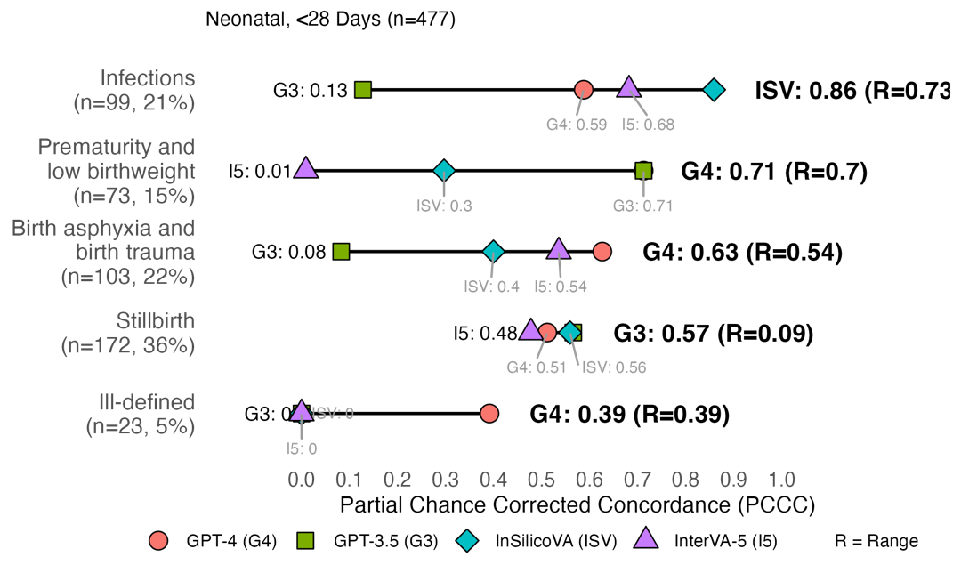
After (Figure 7, revised manuscript):
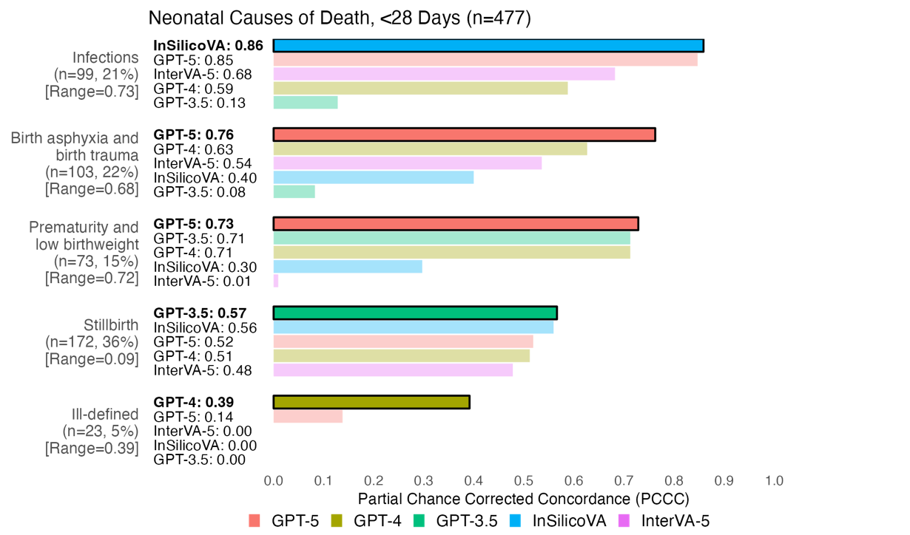
Finally, the generalisability of the results beyond Sierra Leone should be addressed more directly —highlighting to what extent findings may translate to other regions with different mortality profiles.
Response 1.5: We have addressed the generalizability of the results beyond Sierra Leone more directly through mention of regional variations [13–15] and its influence on the generalizability of models to other regions. We expect GPT models to outperform statistical models like InSilicoVA and InterVA-5 overall and for most CODs, similar to the results in our paper, as they have leverage up-to-date sources of information from the web (e.g., news, books, manuals, reports) that are often not available or missed in statistical models [16–20]. These sources hold information for generalizing to other regions, such as widely known or changing regional variations in mortality or culture. We also emphasize that these sources are not without bias, and performance is not guaranteed [20,21]. Thus, we note the need for further validation studies when applying them to other regions. We have included this revision with references in lines 276-283 of Section 4 (discussion).

Reviewer 2
Thank you for giving me the opportunity to review your paper. The experiments are interesting, and the paper is well written. I have a few questions that I would like you to answer and provide additional information.
Response 2.1: Thank you for taking the time to review our manuscript and for providing thoughtful and constructive feedback. We are pleased to offer additional information and clarification. Detailed responses to your comments are provided below, with references to each corresponding revision indicated by line number and section in the revised manuscript.

Issues of methodology
The GPT models are tested on narratives, the methods InterVA-5 and InSilicoVA use the standardised questionnaire, while the physician-assigned COD use both. The authors assume that the questionnaires and the narratives contain the same information. Or that the information on the narrative is reflected by the answers to questions on the questionnaires. Assuming equivalence is risky: even if the narrative seems to contain the same information as the questionnaire, the way this is expressed may be different. Relatives may emphasise different symptoms in the narrative versus when probed by fixed questions (recall bias and interpretation). What is the impact of using different data for the models on the results and comparison?
Response 2.2: We agree that the questionnaire and narratives do not contain equivalent information, and we wish to address this confusion, and clarify we do not assume this. Narratives are unstructured text that provide additional context and temporal information (e.g., event circumstances, symptom chronology, behaviours), often missed by the questionnaire, and as mentioned, are expressed differently than from structured responses. In past studies, this information in the narratives has been shown to improve the performance of COD prediction models, in contrast to solely relying on the questionnaire [22–24]. Building on these past studies, we use different data (narratives and questionnaire) to allow GPT models to leverage the latent patterns in the narratives, while providing comparison with widely adopted models (InterVA-5 [25] and InSilicoVA [26]) that are currently unable to leverage free-text narratives. We have included an additional clarification in the methods, lines 160-168 of Section 2.2 (modelling). Similar to the mentioned past studies, we noted the impact on individual-level performance relative to the results and comparisons in lines 411-421, where GPT models, capable of using the narratives, consistently outperform statistical models (InterVA-5/InSilicoVA) that rely exclusively on the questionnaire.
The prompts for the GPT models mentioned the country name. Why was that done and what implications could there be regarding the results returned by the models. Is it possible that the models use information (e.g. country statistics regarding diseases) that they already have, extracted from datasets and academic papers. Have you tried to prompt without giving away the country name?
Response 2.3: x.
Why did the prompt instruct the models to return an ICD-10 code rather than a CGHR-10 Code or the WHO VA cause list? Would the results have been different? Were the ICD-10 codes given to the models or did the models already know them?
Response 2.4: x.
What do you think the behaviour of the models would have been if the models were asked to return a cause of death in English? Rather than asking the model to “jump straight to the code”, asking the models to give both a code and an English COD could have provided a pathway to ICD-10 that could be audited. It may have helped with the issue of unreliability of the GPT-3 answers.
Response 2.5: x.
In the discussion, we are told that GPT-3.5 did not assign consistent CODs when repeated on the same record. This aspect should have been considered as part of the methodology (e.g. design choice to control the randomness of the model, using an ensemble approach, or the suggestion above, prompt engineering). The experiment described that the model gave different answers at different times for the same prompt and input. How about for a ‘slightly different’ prompt or for a different arrangement in the input data?
Response 2.6: We agree that evaluating GPT models and their variations is most interesting and an important consideration for this study. Thus, we have included mention of controlling for the randomness of the model with the objective of producing more deterministic GPT outputs in lines 168-179 of Section 2.2 (modelling). Further details have also been provided in Appendix B.2.2, where we describe each parameter and best efforts at configuration for deterministic outputs. Despite this, we mention in lines 463-470 of Section 4 (discussion), and explain for reviewer 1 in Response 1.2, that a limitation of GPT models is that they are inherently non-deterministic, and configuration of parameters are current best practice to increase the stability of outputs. We also note in lines 470-472 of the same section, that the analysis of output reliability for GPT models is out of the scope of this study and made infeasible by time and costs when hundreds or thousands of repetitions are needed. Therefore, the issue of consistent outputs remains a limitation discussed in our study.
Should the performance scores not be adjusted by an error component?
Response 2.7: x.
It would be important to know the following: Were the records given to the LLM models to be assessed one by one (in separate sessions?) or as a block? Was there a possibility of “memory contamination”?
Response 2.8: Thank you for bringing this to our attention. The records given to the LLM models (GPT-3.5/4/5) were assessed one by one in separate sessions (also known as stateless API calls). Thus, there was no “memory contamination” occurring to the best of our knowledge. We have included this information in lines 668-671 of Appendix B.2.2 (models and parameters), detailing the OpenAI APIs we had used and our intentions to ensure statelessness, as well as in lines 692-694 of the same appendix, describing the setting of the store parameter and include parameter to enable statelessness for GPT-5 (GPT-3.5/4 were stateless by default).
Was the data in some particular order or contained any groupings, e.g. all children tested together or in blocks?
Response 2.9: The data was in the order of record entry by surveyors and was tested in two blocks representing a survey round each. Each block contained all adult (12 to 69 years), child (28 days to 11 years), and neonate (under 28 days) records collected for the survey round.

Some other observations
Figure B1 – suggests that questionnaires were also input to GPT and that narratives were input to InterVA. Is that the case?
Response 2.10: Thank you for bringing our attention to this detail. We would like to clarify that only the age and sex were taken from the questionnaire and used to construct the prompts for GPT models. We have revised Figure B1 in Appendix B.1 to address this confusion.
Should Table 1 from discussion be moved to results?
Response 2.11: We have moved Table 1 and its accompanying sentence from the discussion to the results in Section 3.1 (overall performance).
Table B4 Study data by cause of death: how does the agreement between physicians for different conditions compare to that of the models.
Response 2.12: x.

References
1. OpenAI, Anadkat S. How to make your completions outputs consistent with the new seed parameter [Internet]. OpenAI Cookbook. 2023 [cited 2025 Oct 9]. Available from: https://cookbook.openai.com/examples/reproducible_outputs_with_the_seed_parameter
2. OpenAI. Using GPT-5 [Internet]. OpenAI API. 2025 [cited 2025 Oct 14]. Available from: https://platform.openai.com/docs/guides/latest-model
3. OpenAI, Singh M. GPT-5 New Params and Tools [Internet]. OpenAI Cookbook. 2025 [cited 2025 Oct 14]. Available from: https://cookbook.openai.com/examples/gpt-5/gpt-5_new_params_and_tools
4. Krishna S, Bhambra N, Bleakney R, Bhayana R, Atzen S. Evaluation of Reliability, Repeatability, Robustness, and Confidence of GPT-3.5 and GPT-4 on a Radiology Board–style Examination. Moy L, editor. Radiology. 2024 May 1;311(2):e232715.
5. Jang ME, Lukasiewicz T. Consistency Analysis of ChatGPT [Internet]. arXiv; 2023 [cited 2024 July 6]. Available from: http://arxiv.org/abs/2303.06273
6. Johnson D, Goodman R, Patrinely J, Stone C, Zimmerman E, Donald R, et al. Assessing the Accuracy and Reliability of AI-Generated Medical Responses: An Evaluation of the Chat-GPT Model. Res Sq. 2023 Feb 28;rs.3.rs-2566942.
7. Olatunji IE, Rauch J, Katzensteiner M, Khosla M. A Review of Anonymization for Healthcare Data. Big Data. 2024 Dec 1;12(6):538–55.
8. Vovk O, Piho G, Ross P. Methods and tools for healthcare data anonymization: a literature review. International Journal of General Systems. 2023 Apr 3;52(3):326–42.
9. Zuo Z, Watson M, Budgen D, Hall R, Kennelly C, Al Moubayed N. Data Anonymization for Pervasive Health Care: Systematic Literature Mapping Study. JMIR Med Inform. 2021 Oct 15;9(10):e29871.
10. Das BC, Amini MH, Wu Y. Security and Privacy Challenges of Large Language Models: A Survey. ACM Comput Surv. 2025 June 30;57(6):1–39.
11. Wang F, Lin M, Ma Y, Liu H, He Q, Tang X, et al. A Survey on Small Language Models in the Era of Large Language Models: Architecture, Capabilities, and Trustworthiness. In: Proceedings of the 31st ACM SIGKDD Conference on Knowledge Discovery and Data Mining V2 [Internet]. Toronto ON Canada: ACM; 2025 [cited 2025 Aug 10]. p. 6173–83. Available from: https://dl.acm.org/doi/10.1145/3711896.3736563
12. Corradini F, Leonesi M, Piangerelli M. State of the Art and Future Directions of Small Language Models: A Systematic Review. Big Data and Cognitive Computing. 2025;9(7):189.
13. Setel PW, Macfarlane SB, Szreter S, Mikkelsen L, Jha P, Stout S, et al. A scandal of invisibility: making everyone count by counting everyone. The Lancet. 2007;370(9598):1569–77.
14. Byass P. The Imperfect World of Global Health Estimates. PLoS Med. 2010 Nov 30;7(11):e1001006.
15. Fottrell E, Byass P. Verbal autopsy: methods in transition. Epidemiologic reviews. 2010;32(1):38–55.
16. Wang S, Zhu Y, Liu H, Zheng Z, Chen C, Li J. Knowledge Editing for Large Language Models: A Survey. ACM Comput Surv. 2024 Nov 11;57(3):59:1-59:37.
17. Nalmpatian A, Heumann C, Alkaya L, Jackson W. Transfer learning for mortality risk: A case study on the United Kingdom. PLoS One. 2025;20(5):e0313378.
18. Singh H, Mhasawade V, Chunara R. Generalizability challenges of mortality risk prediction models: A retrospective analysis on a multi-center database. PLOS Digital Health. 2022 Apr 5;1(4):e0000023.
19. Jiang LY, Liu XC, Nejatian NP, Nasir-Moin M, Wang D, Abidin A, et al. Health system-scale language models are all-purpose prediction engines. Nature. 2023;619(7969):357–62.
20. Zhang Z, Zhao J, Zhang Q, Gui T, Huang X. Unveiling Linguistic Regions in Large Language Models [Internet]. arXiv; 2024 [cited 2025 Oct 20]. Available from: http://arxiv.org/abs/2402.14700
21. Dunn J, Adams B, Madabushi HT. Pre-Trained Language Models Represent Some Geographic Populations Better Than Others [Internet]. arXiv; 2024 [cited 2025 Oct 20]. Available from: http://arxiv.org/abs/2403.11025
22. Jeblee S, Gomes M, Jha P, Rudzicz F, Hirst G. Automatically determining cause of death from verbal autopsy narratives. BMC Med Inform Decis Mak. 2019 July 9;19(1):127.
23. Blanco A, Pérez A, Casillas A, Cobos D. Extracting Cause of Death From Verbal Autopsy With Deep Learning Interpretable Methods. IEEE Journal of Biomedical and Health Informatics. 2021 Apr;25(4):1315–25.
24. King C, Zamawe C, Banda M, Bar-Zeev N, Beard J, Bird J, et al. The quality and diagnostic value of open narratives in verbal autopsy: a mixed-methods analysis of partnered interviews from Malawi. BMC Med Res Methodol. 2016 Feb 1;16(1):13.
25. Byass P, Hussain-Alkhateeb L, D’Ambruoso L, Clark S, Davies J, Fottrell E, et al. An integrated approach to processing WHO-2016 verbal autopsy data: the InterVA-5 model. BMC Medicine. 2019 May 30;17(1):102.
26. McCormick TH, Li ZR, Calvert C, Crampin AC, Kahn K, Clark SJ. Probabilistic Cause-of-death Assignment using Verbal Autopsies. J Am Stat Assoc. 2016;111(515):1036–49.

