What is the product: *Platform that makes physical product purchasing experience accessible and easily and in the hands of App Developers to identify the best route to optimal conversion.*

6-08-16

* Why Kit so big? : Andy
* Caching : Andy + Carlos
* Clutch: Show spinner while store loads, to make it more seamless:: Carlos

**6-06-16**

* CODEZ by Wed
  + ~~Clutch UI:~~ 
    - ~~Description font larger~~
      * ~~<p> → h3~~
    - ~~Decrement increment buttons closer spacing~~
      * ~~margin 15px → 0~~
    - ~~Price should not wrap and should fit inside cell~~
      * ~~Fixed~~
    - ~~Whole cell needs to be more compact (vertically)~~
      * ~~Smaller line spacing~~
      * 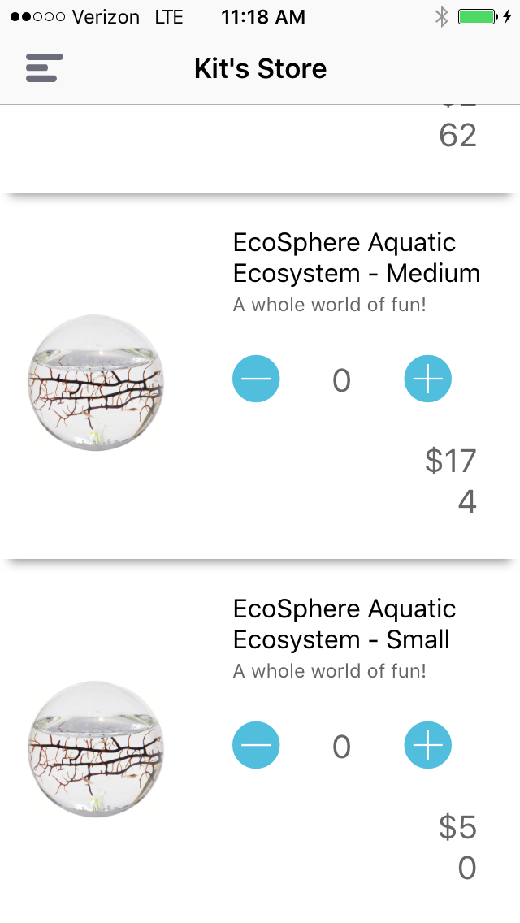
  + ~~Clutch: Add confirmation page~~
    - ~~This pushes the confirmation page onto the nav after a full checkout.~~
    - ~~This seems to work in the web-app but not in my sim. It's possible we'll need to communicate back to the host app to redirect us.~~
  + ~~Trie: Add some kind of Authentication for the API:: Carlos~~
  + Clutch: Improve load speed
    - Do we have a goal? 1s
  + ~~Clutch: Indicator wheel after purchase, and before confirmation~~
  + ~~Trie: Store filters~~
    - ~~Add a comma-separated list of products to return~~
    - ~~/stores/93c0a01f-31c5-4643-8334-10138ba6e59b?filter[product]=3a837af0-8c9e-4f89-91c6-03e1d2b1c6a7~~
  + Kit: add caching: Andy (<https://github.com/evermeer/EVURLCache>)
    - Is it possible to preload the store in a separate thread and serve from cache?
  + ~~Clutch: Put Stripe in test mode in Prod~~
  + ~~Upload Kit to testflight:: Andy~~
  + ~~Appetize.io:: Andy~~
* EMAILZ
  + Template email: Andy
  + Make a public github for our codez. Don’t email it: Carlos / Andy
  + Google plug-in (Email Hunter)
  + Build Baby Product Store
  + Remove duplicate biodomes from store
  + Top 10 apps + 100-110 in each top 20 categories
    - We need a way to track messaged apps, emails, responses
    - Build 20 demo stores
* SCHMOOZ
  + Joel, email when? + call
  + Robert Winter, next thursday 16th
  + Follow up w/ Warren on Wed

**5-30-16**

**For Demo:**

* Polish Up iPhone App :: Andy
  + Change name to polish
  + Small and simple as possible
  + Comments
  + No Errors or warnings in the IDE
  + Add a button inside the news feed
  + Style of the App should match the Tote App Style Karma UI
  + Make every page integrate with Tote (remove maps page)
  + *Library for the page calls
* ~~Idea of a store :: Carlos~~
  + ~~Multiple pages hosted (demo store)~~
  + ~~Fake Unique urls for each company~~
* Pick Products :: Andy
  + 10 fitness products
  + No customization
  + Low shipping cost
  + Prime
  + High ticket / premium products
* ~~Enable Stripe? :: Carlos~~
  + ~~Take callback from stripe to issue payment~~
  + ~~Fake credit cards~~
* ~~Sendgrid integration :: Carlos~~ 
  + ~~Signed up - waiting for provision approval~~
  + ~~Send emails to us/customer optionally~~
* Design Review of Clutch:: Andy
  + Send Andy ish 1 day before sending out
* Clutch: Cached and subdomain:: Carlos
* ~~Clutch: Add router to allow /store_ids navigation and path extraction~~
* ~~Trie: Add SSL, Enforce https connection:: Carlos~~

**5-24-16**

* Ways to boost business over time
  + Have our own mobile first app (m-commerce store) fed by data from our affiliate apps and their users
    - superset of all apps
  + Expand to other channels: Hosted mobile stores & affiliate program
    - Web
    - Blogs
    - Local brick and mortar stores wanting m-commerce platforms
  + List our own products in the stores to boost margins
    - Tote Fitness Tracker
    - Etc
  + Offer coupons across apps to incentivise purchasing and increase conversion
    - Reward program
  + Resell data: user/traffic
    - Enhance ads
    - Inform business decisions
    - Test new products in on key user groups
      * A/B test platform for products

**5-19-16**

* Marketing
* Feedback - early adopter interviews
  + Do we schedule calls
  + Respond to emails
    - Tony -
      * We're still a few weeks away from having a product ready to show. We're tailoring the service to early adopters. I think this could be awesome for you. If you're interested could you tell us what interests you and how you would use it by answering these q's below. If you have time would love to get you on the phone, or meet for a quick coffee. >> Otherwise, we can reach back out when we’re live.
    - Nicholas -
      * Enthusiastic, can he help us build the product and answer our questions. We're ready to build features that you want.
  + survey questions
    - What products do you want to stock
    - Let them tell us what they want
    - How do you want it embedded in their store
      * Store vs. items in buttons
    - What margins?
    - store experience - not native
    - What is your current monetization strategy
      * Is Tote principal or supplementary
    - What features do you need (and priority)
      * Recurring orders?
      * How often do you envision changing or updating products
      * What parts of the process do you want to be in control of?
        + Customer service
        + Analytics
        + Products on the store (or can Tote suggest replacement items from time to time to optimize)
        + Placement in the app

Buttons vs store front

* + - * Custom UI elements
        + Colors / buttons / font / etc
      * How much effort are you willing to put into integration
    - What analytics do you need
      * How often do you want reporting?
      * What types of reports do you need?
      * How granular (overall or per item / aggregate vs per user)
    - User behavior
      * # of active users
      * Visits to the app / month
      * Predict their conversion
      * how much time do users spend in their app
* Economics
  + Unit Cost
  + Retail vs wholesale answer
    - Abstract this - retail vs wholesale
    - What % share
      * Stripe costs - 3%
      * Customer service costs -
        + Who covers returns? Direct to retailer or back to us?

no returns policy? at first

* + - * Time: Estimate $1.50 per customer (at 10 customers / hour at $15/hour)
  + On boarding cost
    - Publishers
      * Marketing:
        + Whales: Unknown high costs + customization and retention
        + Average: Low 5-20$ in marketing costs to drive sign ups
    - Retailers
* Next steps - development
  + In-app store web-view (not customizable (how it's viewed and products don’t have options)
    - Integration w/ stripe
* Design
  + Finalized In-app store
  + Individual assets for everything in the store
  + Landing page
    - Remove white bar
    - Increase each section height by 30%
    - Contact us page fix footer
* Recruiting Engineer / Founders / Advisor
  + Nick Zukoski
* Pitching to Early Adopters
  + Pitching events
  + Robert
* Answer previous VC questions
  + [Mercury Ventures](https://docs.google.com/document/d/1oPbkfqpIqI04-Q7dh7eucDa2QEOA3w6Zp0RThgF_qMs/edit)
  + App marketplace research
    - How many apps exists with > 100,000 active users / month
    - How many users does the average app have?
    - How do users typically interact with apps
    - How much time do they spend in the average app

**5-11-16**

* Customize video or screenshots per app we want to approach
  + Screenshot of how it would look in their own app + Tote button
  + video of Tote
    - App workflow
    - Web app workflow
  + Maybe have different versions of Tote button we can show in different apps.
    - Call to action button
    - Header
    - Feed
    - Other?
* A quick understanding of what products have good margins; where should we focus? Fitness products?
  + https://www.amazon.com/gp/help/customer/display.html?nodeId=1161240
* List of companies to approach
  + Prioritize london and SF
  + 100
* Stock email requesting
* Domain Name
* Landing page
  + List assets needed and Andy will give
  + Sketch using Google open fonts
  + Mailing list
* Domain name -- Carlos, available:
  + getote.com
  + grabtote.com
  + toteapp.io
  + gettote.io
  + totesimple.com
  + meettote.com
  + notetote.com
  + dotote.com
  + trytote.com

**4-25-16**

TODO:

1. Explicite wireframes
2. Create pitch for Andy to give to VC friends, business model and numbers
3. Find early adopter

Deprioritized for next week:

Create Trello engineering tasks and start engineering work.

**4-09-16 Email Carlos to Andy**

“ Also look at mobi-cart and appypie, the two leading mcommerce app builders. Their apps look horrendous, but they each boast 12,000 and 17,000 apps under them. They host the apps at $20-200 a month.

I'm starting to think mcommerce is a great space with little innovation.

From the business side, it would be so easy to just compete with these guys and charge a monthly subscription. We could also offer free tiers, and use our current model of deeplinking within the free tier.

I think the interesting part here, is once you're signed up with traction to your app, you're basically locked in.

In fact, this could be an amazing way to build the partnerships with retailers that we need to make our marketplace work.”

**4-09-16**

Possible iOS UI kits from UI8

1. [Kama](https://ui8.net/products/kama-ios-ui-kit) has a theme that stands out a little more than the rest.
2. [Canvas](https://ui8.net/products/canvas-ui-kit) has some style/flare simple and easy to understand
3. [Aow](https://ui8.net/products/aow-ui-kit) is pretty clean and seems to be pretty comprehensive, but it looks more like a generic ecommerce app and doesn't stand out too much.

Todo

* Review [MVP hand sketches](https://drive.google.com/drive/u/0/folders/0B6I_PlZVoOpXR21URWpOdjF1eDQ), iterate on ideas for MVP
* Decide on theme for MVP
* Trim down MVP ideas and create [MVP PRD](https://docs.google.com/document/d/1toS8VGMB6svHvK0C1xslixN45fYdud11gFcvJ-DaneI/edit), with only most basic/required features

Research

* mCommerce app builders. Examples: Appy pie, mobi-cart
  + Built with the web in mind, ripe for innovation
  + 12,000+ apps
  + Interesting way to build the partnerships/get retailers signed up for deeplinking marketplace advertising
  + What’s the competition, how easy would it be to make our MVP compatible?
  + Upside?

**4-08-16**

* Added [MVP hand sketches and design notes](https://drive.google.com/drive/u/0/folders/0B6I_PlZVoOpXR21URWpOdjF1eDQ)

Todo

* Investigate UI8 UI kits

Ideas

* mCommerce app builder.

**4-07-16 gChat**

Deep Linking b/w apps: “and if using one app could get you credits for another”

**4-07-16**

Decisions

* Persistent Marketplace
* Marketplace connects buyers/sellers
* 100MM+ VC backed company
* Yolo to the wind, create MVP
* Carlos + Andy create mockups
* We won’t use Firebase :p

Pages

*For sellers:*

* Done by hand (spreadsheet we will hate)
  + Listing items
  + Setting prices
  + Sending orders
  + Confirming shipment
  + Handling returns

*For clients:*

* Analytics page
  + We do by hand
* Make a store wizard
* Search and pick items
* Url scheme to give links to custom baskets
* URL scheme to give custom marketplaces (subset of main store)

For customers:

* Search page
* Basket
* Payment page
* Confirmation somehow

Research

* How to get/pass unique mobile ids to backend
* Ways to refund items
* Shipping confirmation
* How can we store cc information (Stripe and Square research)

**4-06-16**

**What does a marketplace look like? What type of partnerships will we need?**

**How do we turn a potential 10MM idea into a 100MM idea?**

Competitive Landscape

* OpenX 100% growth / annualized
* inMobi
* Button
* Virool
* [Arbor](https://arbor.io/#home) (Comically the CEO reached out to me for recruiting purposes today)

Research

* Current ad competitors - revenue to apps / month
* Average price per item sold via targeted advertising
* Wholesale to Retailer markups

Continue:

* Contact friends with Apps

**4-05-16**

**What if anything can we patent?**

Research

* Arbitrage
  + Selling on Amazon
* Apple In-app purchases
* Stripe Relay
* Strava
* Partnerships with retailers or wholesalers: way to offload goods / additional online marketplace to sell goods.
  + Community first? Drive local sales/goods.
* How much control do app developers need/want?
  + How much work are they willing to put in?
  + Expected ROI
* What products do apps want to sell?

Mock Up a Case Study / Example Workflow

Platform can we offer:

* analytics
* tools
* Partnerships
* Scale

Competitive Landscape

* Shopify
* Button
* Facebook: Audience Network

MVP

* Amazon wrapper
* UIWebView + link to web app
  + Shopify
* API layer + payments for in app experience
  + Stripe Relay