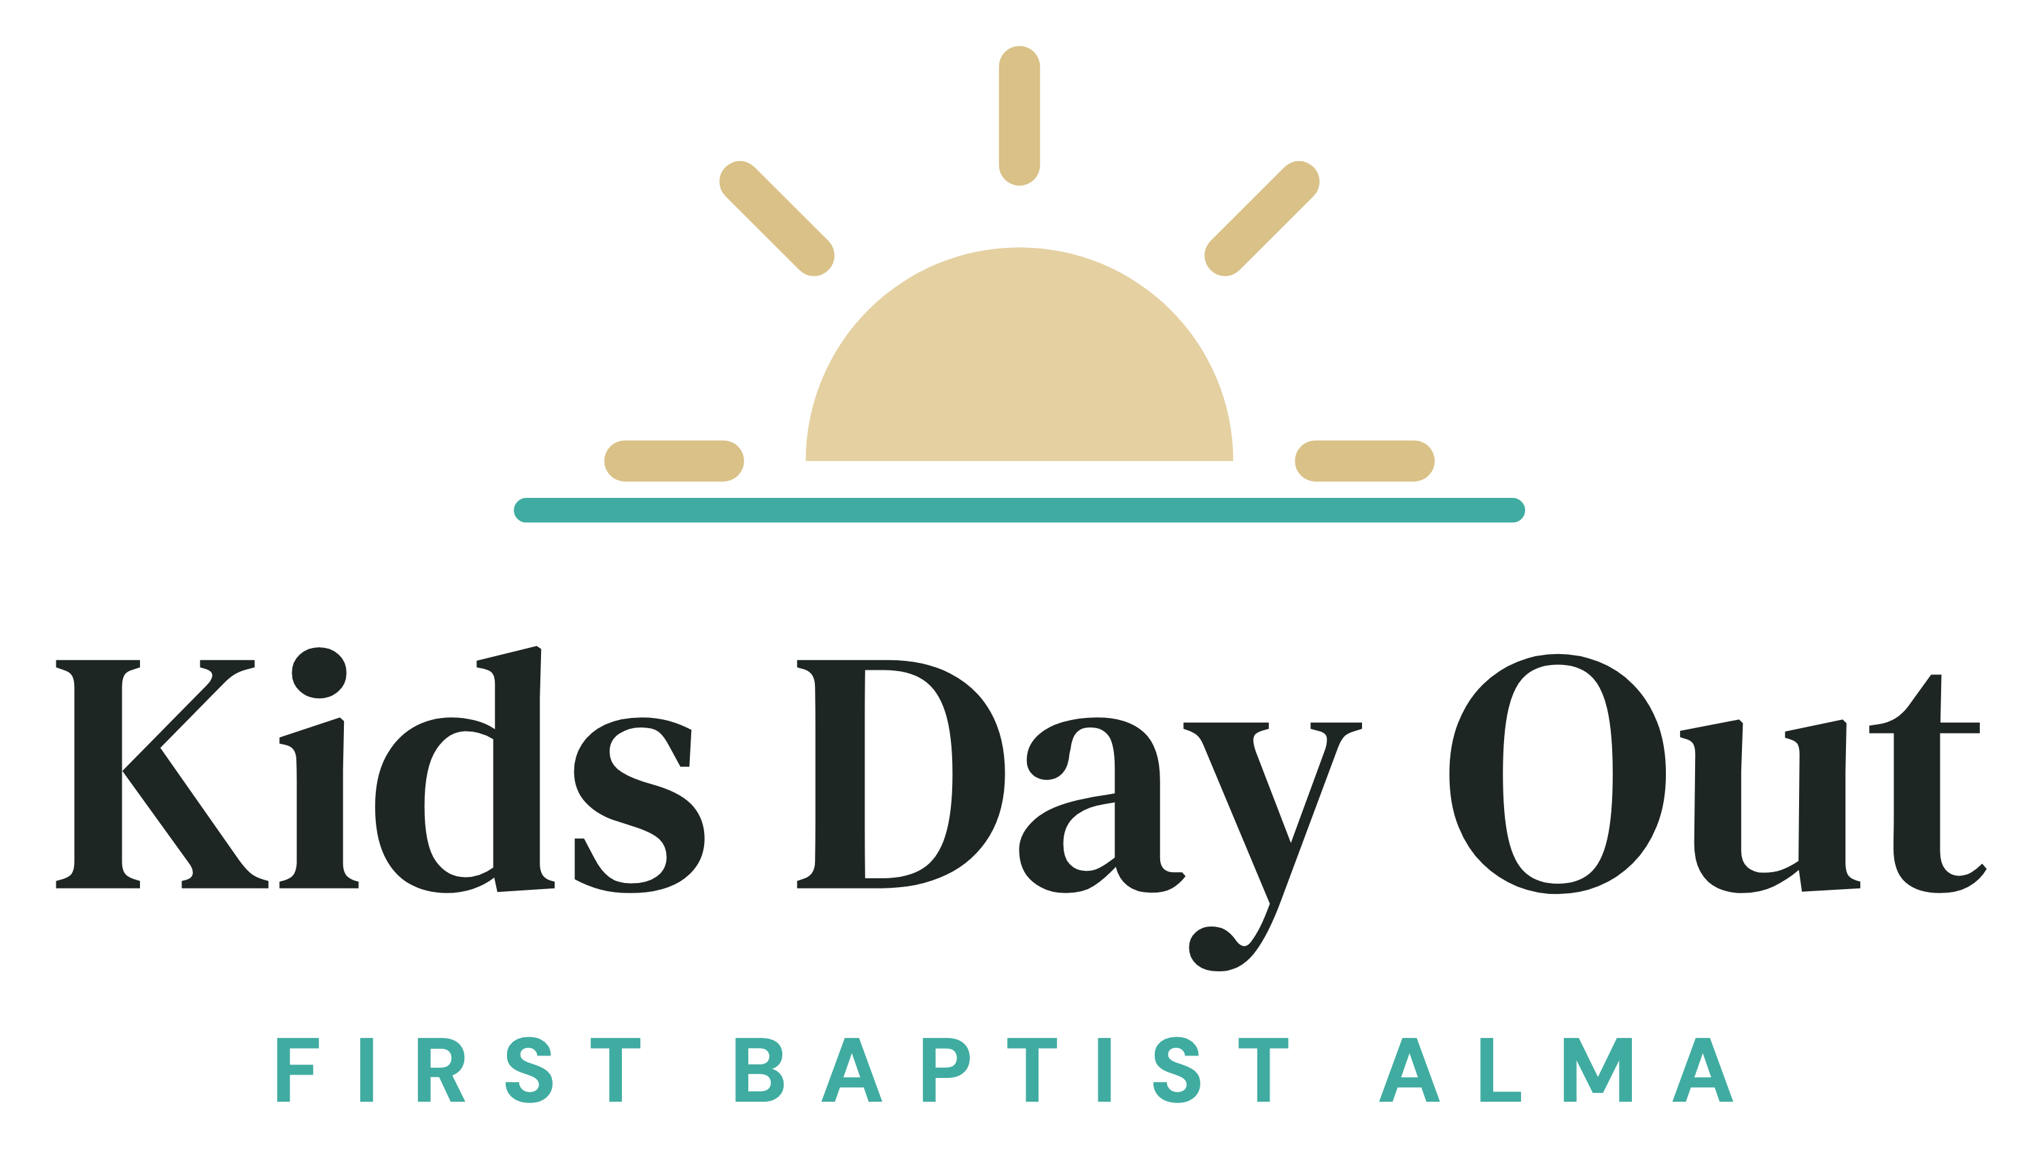

Parent Handbook
Kids Day Out at First Baptist Church Alma | Spring 2027 | Kim Vaught, Director

Welcome to Kids Day Out
Kids Day Out (KDO) is a Christ-centered ministry of First Baptist Church Alma for children ages 6 months to Pre-K. We provide a quality experience for your child in a nurturing environment designed to bring out the best in each child. We are so glad you are here, and we look forward to getting to know your family.

Our Mission
KDO exists to lay a foundation of creative learning for our students. Our goals are to inspire a love for God, and learning, as we nurture relationships with the families in our care.

Program Information
- Location: First Baptist Church Alma, 211 N Mountain Grove Rd, Alma, AR 72921
- Director: Kim Vaught, (501) 951-5991, kdo@firstalma.com
- Days and hours: Thursdays only, 9:00 am to 2:00 pm
- Spring 2027 semester: January 7 to May 20, 2027 (18 Thursdays)
- Calendar: KDO follows the Alma Public Schools calendar for holidays, spring break, and weather closings.

Age Groups and Ratios
Children are placed in classrooms by their age on the first day of the semester, January 7, 2027. Children must be at least 6 months old by January 7, 2027 to enroll.
- Babies (6 to 17 months): 1 adult to 3 children, with a maximum of 6 children per room
- Toddlers (18 months to 3 years): 1 adult to 6 children, with a maximum of 12 children per room
- Preschool (3 years to Pre-K): 1 adult to 6 children, with a maximum of 12 children per room
There are always two adults in every room. No adult is ever alone with a child.

Registration and Enrollment
Registration is online at https://firstalma-kdo.vercel.app. Spots are filled first come, first served. A classroom opens only when it is fully staffed. If your child’s room is full or not yet staffed, your family will be placed on the waitlist in the order you registered.
Nothing is due when you register. Once your spot is confirmed, the first payment is due by January 7.
The snacks and supplies fee and tuition are nonrefundable.
We place children in specific rooms using their date of birth. Classroom and teacher assignments are given out to parents before we have our Open House. Once a child has been given a permanent spot in our program, we will guarantee a place for that child in his or her age group for the entire semester (January 7 to May 20, 2027). If for some reason your child leaves our program, we require a 30 day written notice prior to their departure date. We require this in order to successfully fill your child’s open spot in our program.

Tuition and Fees

Snacks and Supplies Fee
There is one $60 non-refundable snacks and supplies fee per child for each semester. It covers snacks, wipes, and craft materials, and it is spread over your monthly payments.

Founding Family Tuition
Families who enroll in our first semester are Founding Families. Founding Families keep the Founding Family rate for as long as they stay enrolled.
- Toddlers and preschool: $20 per Thursday
- Babies: $25 per Thursday
Families who join next semester will pay $25 per Thursday for toddlers and preschool and $30 per Thursday for babies.

How Tuition Is Calculated
Tuition is paid monthly. The January through April payments each cover 4 Thursdays, plus $12 toward the snacks and supplies fee. May covers the last 2 Thursdays, so it is smaller.
- Toddlers and preschool: $20 x 4 Thursdays + $12 = $92 a month, and $52 in May
- Babies: $25 x 4 Thursdays + $12 = $112 a month, and $62 in May
For the whole semester (18 Thursdays), that is $420 for a toddler or preschooler and $510 for a baby.

Discounts
- Siblings: a 10% tuition discount is given for each additional sibling enrolled in the program. The child with the highest rate pays full price.
- Pay in full: families who pay the full semester’s tuition up front receive 10% off tuition.
- Teachers’ children: a tuition discount is available for teachers’ children. Please ask the Director for details.

Payment Options
- Pay monthly: five payments, due by the 7th of each month, January through May. The January through April payments each cover 4 Thursdays, and May covers the last 2, so it is smaller. The snacks and supplies fee is split evenly across all five.
- Pay in full: pay the whole semester by January 7 and save 10% on tuition.
We accept cash and check, which allows families to avoid a processing fee.
Tuition is not based on attendance. It stays the same whether or not your child attends a given Thursday, and missed Thursdays are not refunded. If tuition is more than two weeks past due, your child’s spot may be given to the next family on the waitlist. If you have questions about payment, please contact the Director.

Late Pick Up Fee
Children must be picked up by 2:00 pm. If you are late to pick up, please understand that there is a late fee of $5.00 per minute that will be charged beginning after 2:05 pm. This will be added to your next tuition payment. Please expect to receive text or call notifications if you are late.
If you have an emergency that prevents you from picking up your child on time, please notify the Director. However, late fees may still apply even in cases of emergency and will be left up to the discretion of the Director.

Discipline
When a child is not obeying or is disrupting the class, the following steps of discipline are taken:
- The child is talked with privately by the teacher to make sure he or she understands the rules for proper classroom behavior. The teacher will follow their specific classroom management routines.
- If improper behavior persists, the child is separated from the other children and must stay with a teacher away from classroom activities for a little while. The teacher will talk to the child about proper classroom behavior and what it means to be a friend.
- If improper behavior still persists, the child will be sent to the Director for time away from the classroom. At this point, the Director talks with the child, assuring him or her of our love, but also that his or her behavior must improve, otherwise his or her parent will be consulted. After a certain amount of time away from the classroom, the child is returned to the classroom.
- If improper behavior still persists after this point, the Director will consult with the parent and ask for their assistance to help guide the child. The situation will be discussed privately with the parent.
- If all efforts have been made to correct negative behavior by parents and teachers, and a child’s behavior is a physical or emotional threat to other children or the teachers, the child will be discharged from the program.
Very seldom are all of these steps of discipline necessary, but they will be carried out so the individual child and the class as a whole can have a happy, productive experience. Please know that we will work diligently on our end to ensure your child receives more than reasonable support in hopes of finding working solutions should there be a problem.

Discharge
Reasons for discharge are as follows:
- As outlined in our discipline policy, if all efforts have been made to correct negative behavior by parents and teachers, and a child’s behavior is a physical or emotional threat to the other children or teachers, a discharge notification will be communicated.
- A parent or guardian is a physical or emotional threat to other children, teachers, or parents.
- KDO is unable to meet the physical, social, emotional, and/or developmental needs of the child.
- Failure to meet financial obligations. If tuition is more than two weeks past due, the child’s spot may be given to the next family on the waitlist.

Parent Communication
Each classroom will use the Homeroom app to share pictures, reminders of daily activities, and updates. Homeroom is accessible through the app or through a web browser.
Any emergency contact that needs to be made will be done by phone call. This includes, but is not limited to, injury, illness, etc. If a parent is not available, we will call down your approved list of emergency contacts.
You can always reach the Director by cell at (501) 951-5991.

Arrival
The exterior doors will open at 8:50 am for you to enter the lobby and check in. Your child’s classroom doors will open at 9:00 am for drop-off. Our structured time begins at 9:15 am, so please do your best to drop off before that time. The exterior doors will be locked at 9:15 am. If you are running late, please call the Director and someone will assist you at the door.
Please do your best to allow your child to be present for the full day and schedule any personal appointments around KDO days, when possible.

Departure
Pick up your child by 2:00 pm. Exterior and interior doors will open at 1:50 pm. See our Tuition and Fees section for the policy regarding late pick up.
Children are released only to authorized adults on your child’s pick-up list. For the smoothest pick-up process, whoever is picking up your child must have the pick-up tag (sticker) or a picture of that tag for your child to be released.
Life happens, and sometimes we just can’t find that tag. This is not a problem and should not cause you to panic. We will ask that you provide your driver’s license (a picture of it works great too). Pick up by driver’s license must be overseen by the Director, and your child’s teacher cannot release your child without approval. If you don’t have your driver’s license with you at pick-up, we will ask you to go get it from your car.
We know this may seem like a huge inconvenience, but we pray you see that the safety of your child is very, very important to us. This policy is one we will not cut corners on, and we appreciate your understanding.

Safety
Your child’s safety is our highest priority. Here is what we do to keep every child safe:
- Our doors are locked at all times.
- We use tagged pick-up, and children are released only to authorized adults.
- Every staff member has passed a background check.
- Our staff are CPR and first aid certified.
- There are always two adults in every room, and no adult is ever alone with a child.
- We hold fire and tornado drills every month.
- Parents receive updates through the Homeroom app, and the Director is always reachable by cell.
All KDO staff are mandated reporters under Arkansas law. This means we are required to report any suspected child abuse or neglect to the Arkansas Child Abuse Hotline at 1-800-482-5964.

Licensing
KDO is exempt from Arkansas child care licensing because we are open 5 hours a day or less and 10 hours a week or less. Even so, we voluntarily follow the state’s standards for licensed programs.

Sickness Policy
Please be considerate of others and keep your child at home on days when they have shown any of the following symptoms in the 24 hours before a KDO day:
- A temperature above 100.4 F
- Vomiting or diarrhea
- Any sign of infection (green nasal discharge, severe cough, contagious diseases such as measles, mumps, chicken pox, etc.)
- Common cold or sore throat
- Croup
- Any unexplained rash
- Any skin infection (boils, ringworm, etc.)
- Pink eye or other eye infections
- Head lice (must be nit-free for 24 hours; if there is uncertainty, please do not bring your child)
- Lethargic or uncharacteristic behavior
If your child has been sick, he or she must be free of fever (without the help of medication) and symptoms for 24 hours before returning to Kids Day Out. Please do not bring siblings if you have a sick child at home. If your child develops symptoms while at Kids Day Out, we will contact you so you can promptly pick up your child and any other children you have in our program. This helps ensure the health and safety of other children and our staff.
Any open wounds must be properly bandaged before your child may attend.
Medication will only be administered in life threatening situations.

What to Bring to Kids Day Out
Each child will need a full size backpack, a leak proof cup, and a lunch box. Toddlers and preschool children (18 months and older) will need a nap mat. KDO will provide a morning snack for all children.

Lunch
It is your responsibility to provide your child with a nutritious lunch. KDO does not cook or heat food, so lunch should require no heating or refrigeration.

Nap Time
All rooms have a nap time after lunch. Children in rooms without cribs need to bring a nap mat to rest on. Linens are provided for rooms with cribs, but please bring whatever items your child needs to feel comfortable during this time. This may include things like a sleep sack or a favorite stuffed animal.

Change of Clothes
Every child in the program needs to bring a change of clothes in a labeled ziplock bag each day in case of accidents or everyday spills. If your child is potty training, please include extra changes of clothes. You may also choose to include bags for soiled clothes. Children 3 1/2 and older must be potty trained.

Label Everything
Please label everything with your child’s first and last name: cups, bottles, clothes, coats, stuffed animals, lunch boxes, backpacks, hats, gloves, diapers, pull-ups (must have velcro sides), etc. This helps ensure your items return home with your child at the end of the day.

What We Do During the Day at KDO
All classrooms have a structured schedule that they follow during the day. There is a set Music and Chapel time every KDO day that includes the Bible story for that day. Your child’s day may include a craft, fine motor and gross motor activities, singing, dancing, puppets, dramatic play, books, blocks, science experiments, and other learning activities. We have an indoor and an outdoor playground where the children have the opportunity to play each day. Daily class schedules will be provided at Open House.

Birthdays and Special Days
One of our favorite things to do at KDO is to celebrate birthdays and holidays! Before each class party, there will be a sign up sheet outside the classroom. A calendar of these dates will also be provided at Open House.
If you would like to provide a treat for your child’s birthday, you are welcome to do so. Please arrange with your child’s teacher the day you would like to bring store bought treats for the entire class. Please be mindful of any allergies in your child’s classroom.

Closings
We follow the Alma Public Schools calendar and will be closed for holidays, spring break, inclement weather, and other times when the school district is closed. If Alma schools close or have a delayed start due to weather, KDO is closed for the day. If Alma schools close early due to inclement weather, KDO will close 1 hour before their closing time.
Please check internet, radio, and television stations for this information during bad weather. We will post on Instagram and the Homeroom app as soon as we become aware of any closings, and an email and text will also be sent.
There will be no refunds for inclement weather closings. Any pre-scheduled closings will be listed on the calendar provided at Open House.

Questions and Concerns
We want to hear from you! If you have a question or concern, please reach out to Kim Vaught, KDO Director, at (501) 951-5991 or kdo@firstalma.com. Kim reports to the Family Minister of First Baptist Church Alma.

