**Activity 3.6 Refactoring (Reorganizing the code, break it up into parts!)**

* **Accessing var from PY in a different folder.**

**One off** 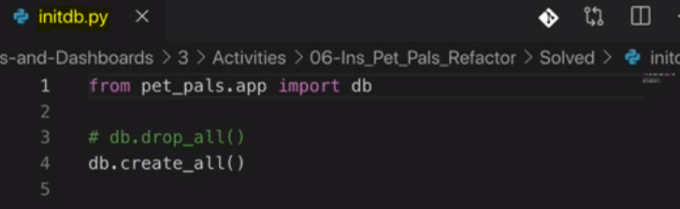

* + **Folder Structure**

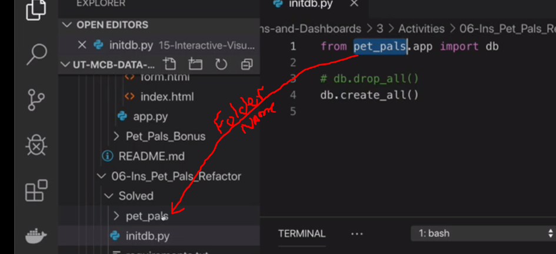

**That fold MUST Contain a __init__.py file if your going to CALL anything into another PY file outside that folder.**

**Init is converting the folder to a callable library.**

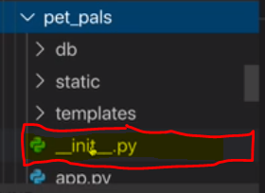

**Which doesn’t contain ANY code and is a reference only to access the app.py file. (incase you were wondering)**

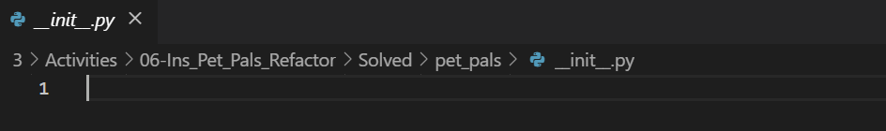

**So it can then import the db variable from app.py, located in the pet_pals folder)**

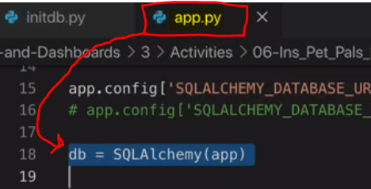

* **Accessing var from PY in Same Folder**

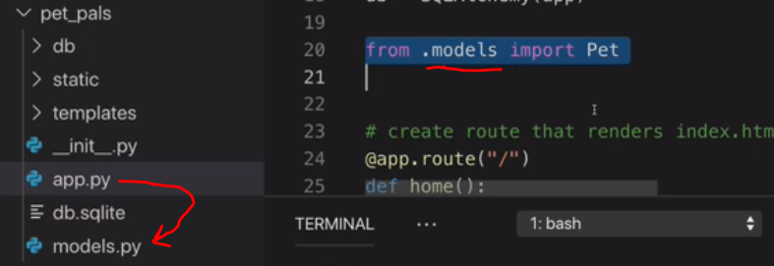

**Calling Pet from Models.py, which is also utilizing the db var from the app.py (So they are sharing stuff!)**

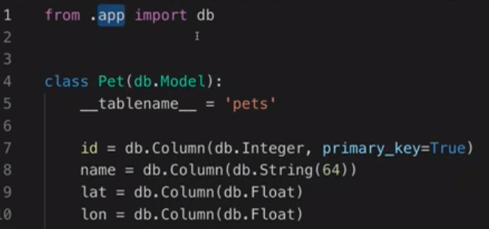

* **Requirements.text (Super important for Heroku)**

**This is a text file that indicates what version and libraries used for your code.**

* + **If you need to match the requirements on your system**
    - $ pip install -r requirements.txt
  + **To Get the requirements of what is currently installed on your virtual Environment for your text file**
    - $ pip freeze

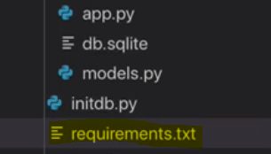 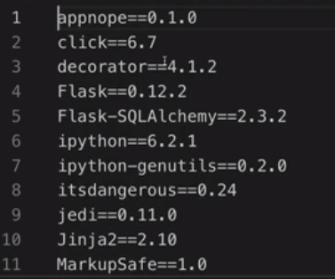

* **Run.sh**

**Shell command to execute your python file (Heroku will use the run.sh)**

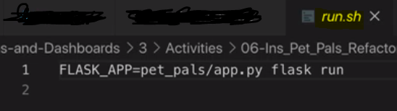

**You can run it manually in the terminal by doing this without a shell command file**



* **Overview Structure**

**All your App Code is separated out into it’s own folder, and the items required to run it, or manage it, are outside the folder.**

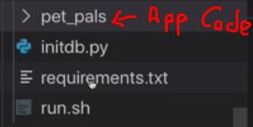

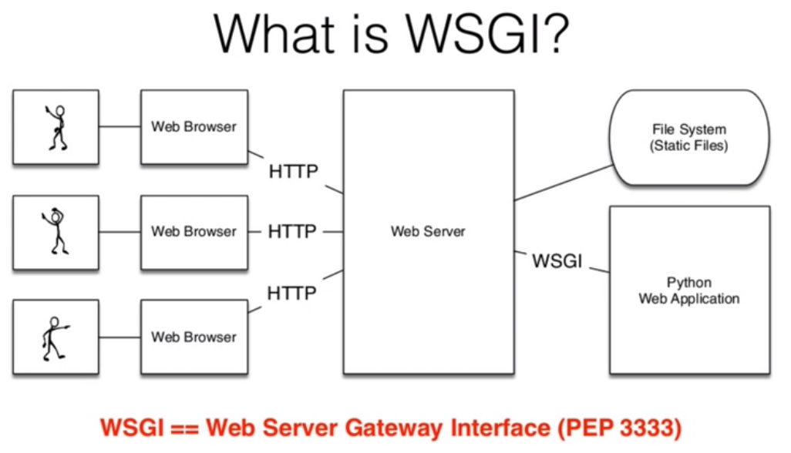

**This is a production Level thing ONLY! (Heroku)**

**Heroku**

**(Cloud Provider of the Application)**

**Activity 3.7**

[**https://devcenter.heroku.com/articles/procfile**](https://devcenter.heroku.com/articles/procfile)

Heroku apps include a **Procfile** that specifies the commands that are executed by the app on startup. You can use a Procfile to declare a variety of **process types**. Webserver Gateway Interface. (gunicorn)

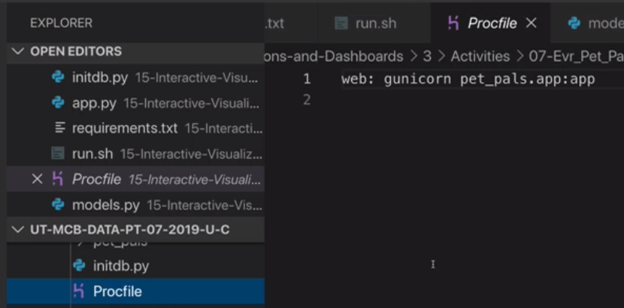

**\*\* Requirements.txt tells the Procfile what requirements are needed for your application.**

**You also need a runtime.txt file so Heroku knows which python version it should use.**

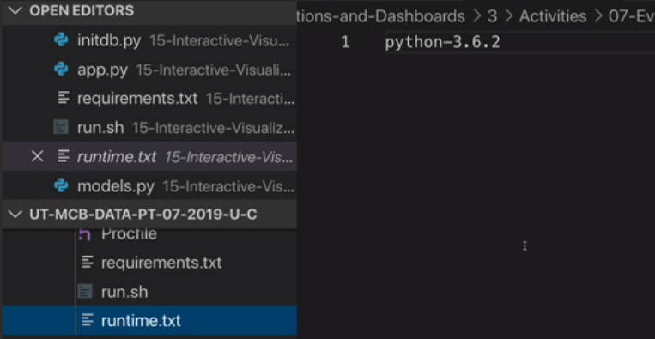

**Ready to upload:**

1. **You can do this by downloading a CLI from Heroku**
2. **Use github with continuous delivery.**
   1. **Create a repository**

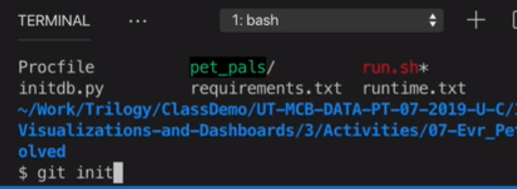

* + - **Then**  **(to add all those files to the repository)**
    - **Create a repository on Github**

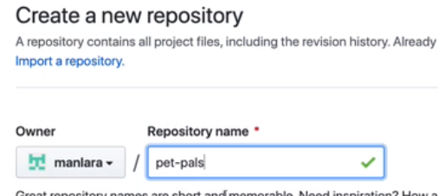

* + - **In Terminal** 
    -  **(https!)**
    - 
    - **Confirm on Github**

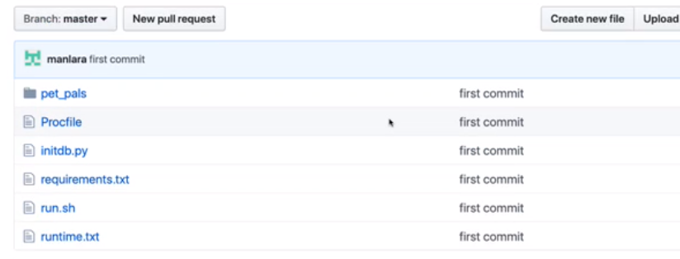

**Log into Heroku (you can create a free account)**

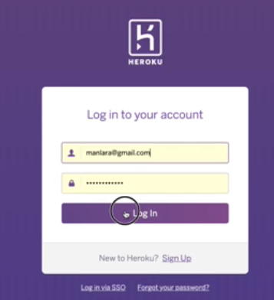 **Create a New app** 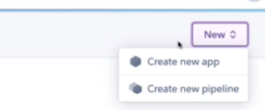

**Using a unique name**

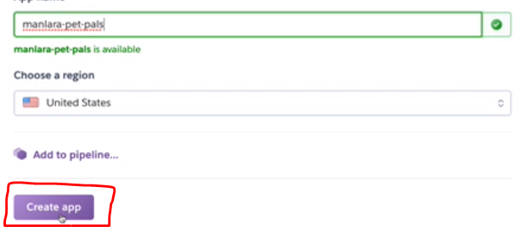

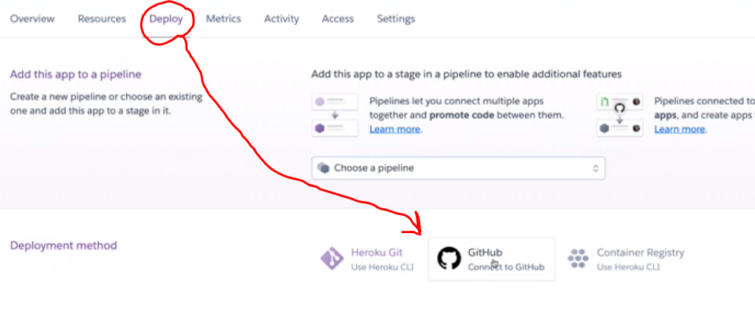

**Follow steps below this, to connect GitHub Repository, Deploy, (auto updates optional), after everything loads you can VIEW your app online.**