Session 1: Homework

Task 1:

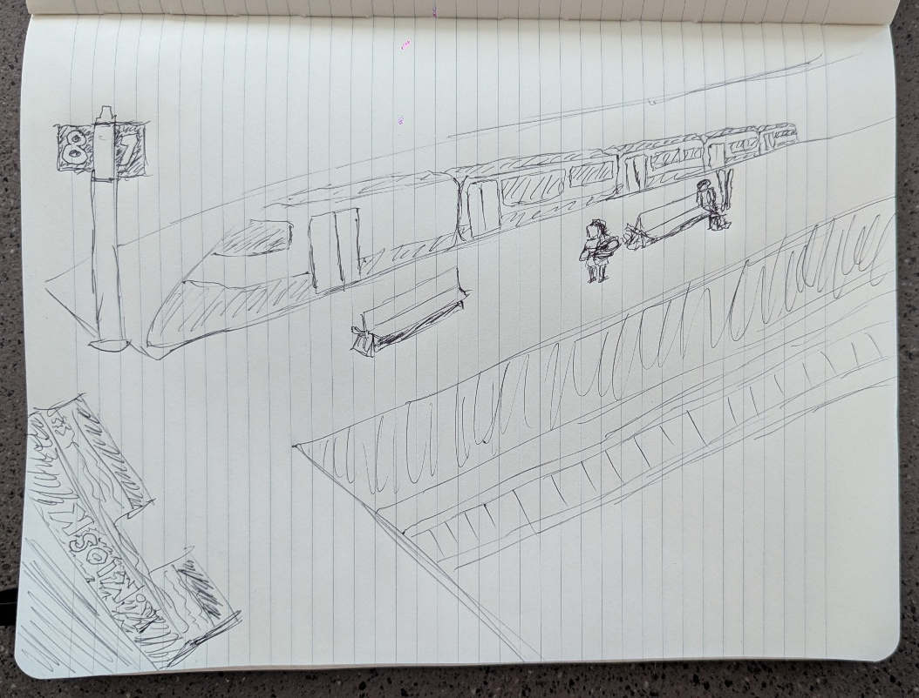

Task 2:
The audio clip begins and the first thing I feel is that this is a public space, not too crowded. Then you hear an announcement over a PA system, which leads me to believe this is taking place in a train station. I can’t understand exactly what is being said, but there’s a baby screaming, perhaps he/she is hungry. I assume the baby is there with their mother, as that’s typically who babies are accompanied by. Ski season is around the corner, so I imagine at least one person is headed to the mountains hoping for some fresh snow. I also visualize a Kiosk, as there’s always a Kiosk at a train station.

Task 3:
Check IM_CZM_bike.wav for the audio file.

Task 4:
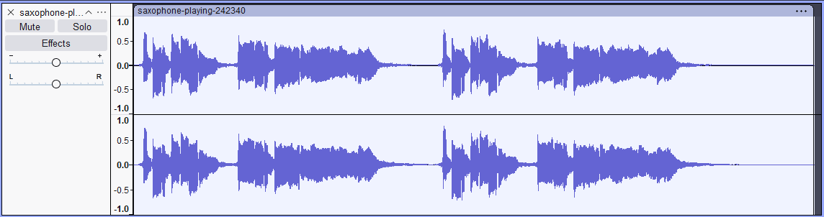
The above sound waves were generated with Audacity from an audio clip of a saxophone. Before listening to the sound clip, we can see that there seems to be two iterations of the same sequence, split in the middle. After listening, we can hear the air clearly flow into the instrument before a note is produced. There also seems to be an echo, which could indicate the clip was recorded in some sort of chamber to allow this effect to happen.

Task 5:
Task 5 (Python sound generator) can be found within this folder, called sound_generator.py.

