Session 2 Homework

Task 1 & 2:
The values for f1 and f2 were acquired using Praat, and the following plot was made using the matplotlib Python library:
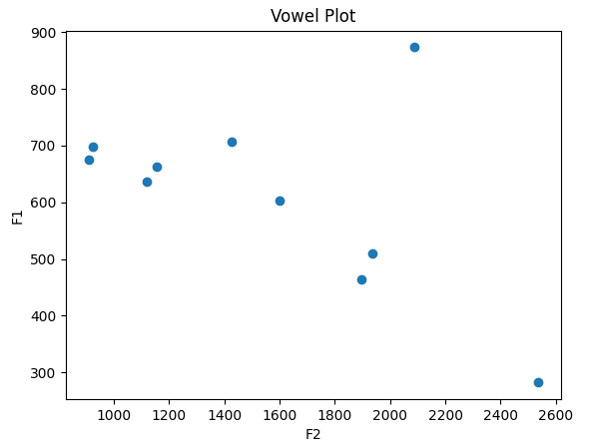
Bonus: While F1 and F2 define the vowel type, F3 indicates lip rounding (like in who’d) or the American /r/ sound, which causes a dramatic drop in F3.

Task 3:
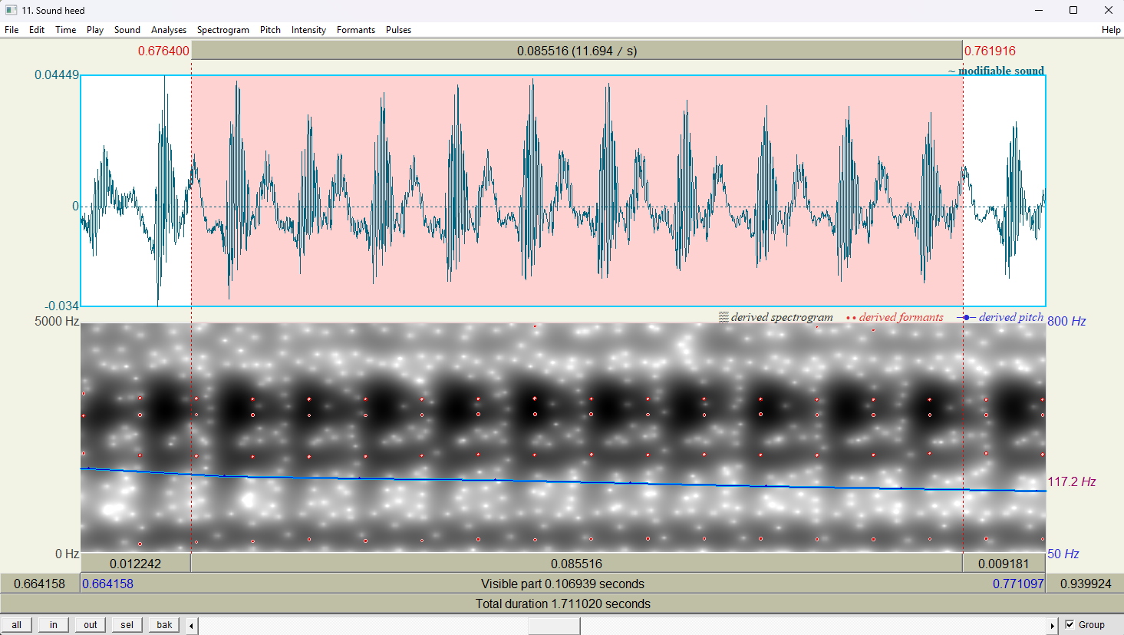
The maximum amplitude during the vowel of the word ‘heed’ seems to be around 750Hz, with a bit of variability (perhaps because I’ve been sick recently?). In the frequency domain, I seem to have an average, but a bit deeper voice at ~117Hz, where most men’s voices lie between 100-150Hz. It also appears to be monotone with a slow decline in frequency.

Task 4:
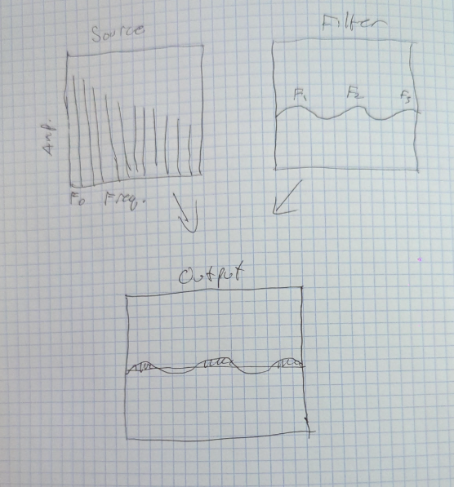
My recording is unique because of the source, defined by the vibration speed of my vocal chords and the filter, defined by the physical length and shape of my vocal tract. A different speaker would have a different F0 spacing and different formant peak location. The uniqueness therefore comes from biological, behavioral, and acoustic features.

Task 5:
The code for the algorithm can be found in the task_5.py file. The output can be seen below:
