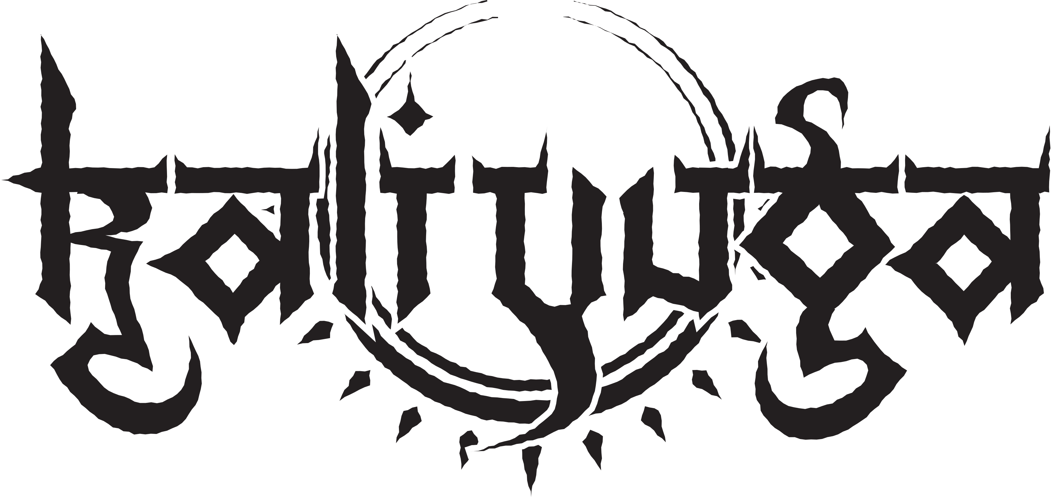
Releases
- Kali Yuga (2015, G.U.C.) https://open.spotify.com/intl-de/album/3zYG04z6RWu2KwvOk13tY2
- Wrath of Durga (2012, G.U.C.)
https://open.spotify.com/intl-de/album/3Jq3t4DCFyEJOqRCN8P6RB
- Slaves to the Subliminal (2011, G.U.C.)
https://open.spotify.com/intl-de/album/5xfbMFj9p0wxGNr1ZhxTow
- Dead Shall Reign (2009)

