Data Analytics — Project 3

Lauren Tureaud, Coleman Craig, Christina Thip, Charles Glover

**Topic**

Analyze Medicare Part D data (prescription drug plan) by state, prescribed medicines and cost by quantity

**Link to data set(s) — screenshot of metadata *if it exists*:**

<https://www.kaggle.com/cms/cms-medicare>

**Framing our creative fodder: Inspiring Visualizations**

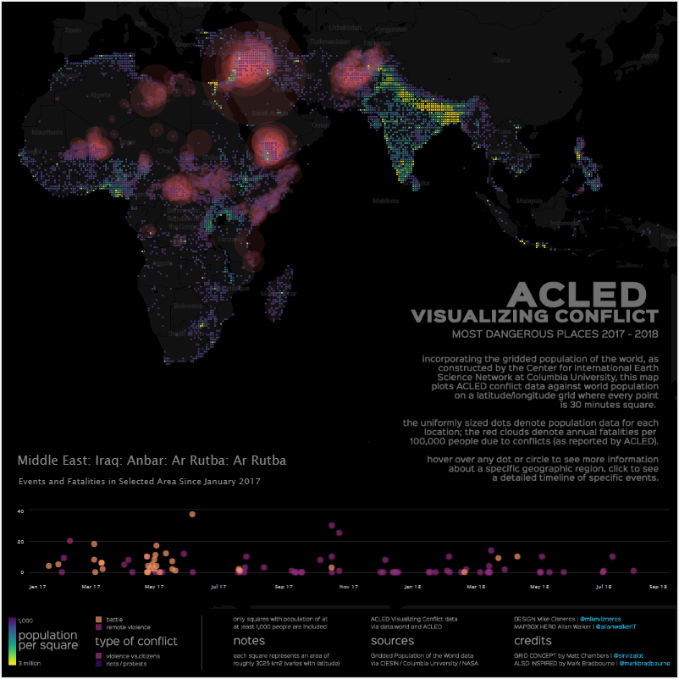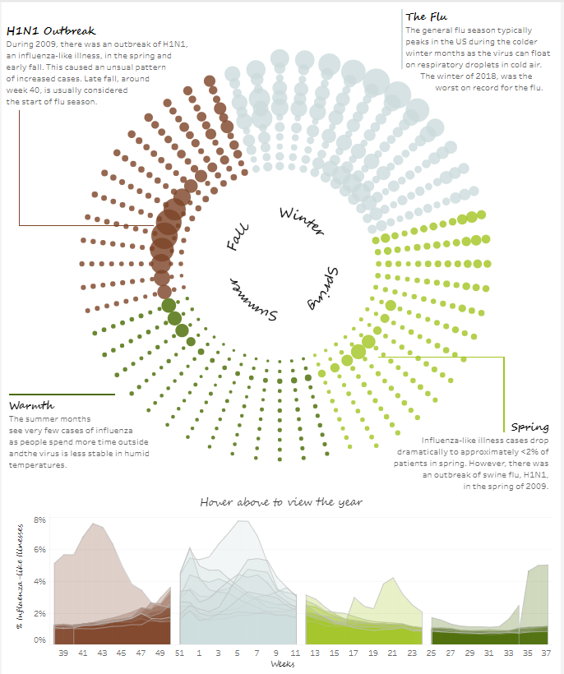

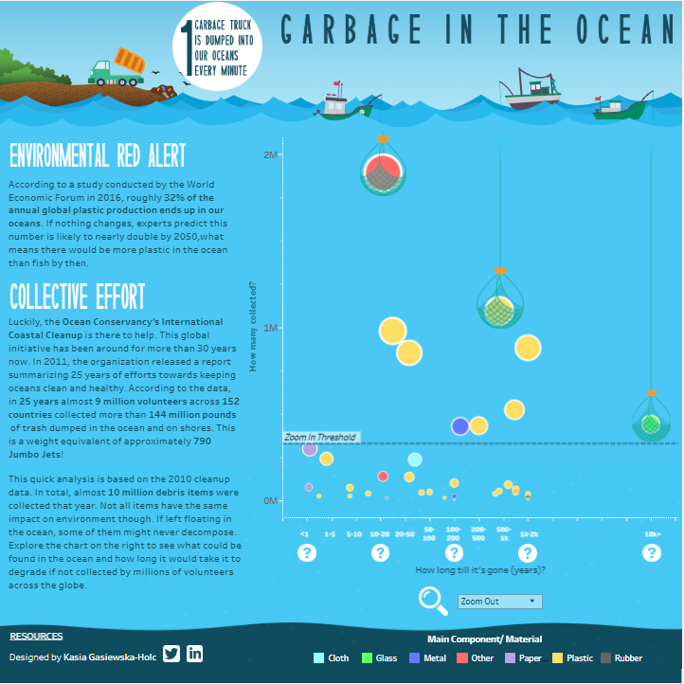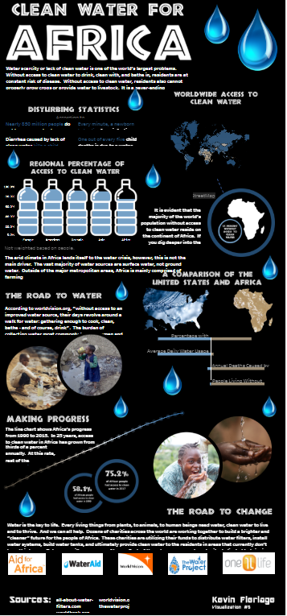

**Sketch of the final design**

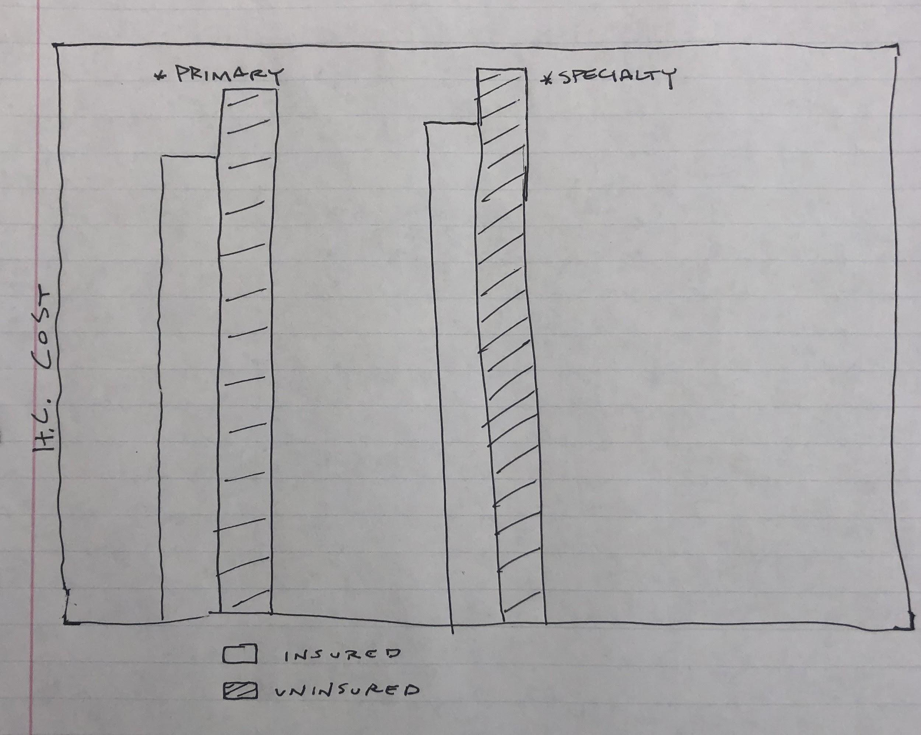

**Github Repository**

<https://github.com/christinathip/visual_project.git>