Copernicus Global Land Service Resampling Tool Using R

22/9/2018

Xavier Rotllan-Puig1,2,✉, Tim Jacobs3, Federico Gianoli1, Pier Lorenzo Marasco1, and Michael Cherlet1

1 Joint Research Centre – European Commission. Directorate D – Sustainable Resources. Unit D6 – Knowledge for Sustainable Development & Food Security Unit. Via Enrico Fermi 2749. I-21027 Ispra (VA), ITALY  
2 ASTER-Projects. Barri Reboll, 9, 1r. 08694 Guardiola de Berguedà (Barcelona), SPAIN  
3 VITO NV. Boeretang 200. BE-2400 Mol, BELGIUM

✉ Correspondence: [Xavier Rotllan-Puig <xavier.rotllan.puig@aster-projects.cat>](mailto:xavier.rotllan.puig@aster-projects.cat)

* Both methods, give similar and good results compared with unprocessed images at 1km
* An R-based tool to perform these resampling methods could be developed in order to be shared with the Copernicus Global Land Product portal users to help them with the process

# Overview

Bla bla bla

## Problem

On the one hand To solve these problems, the idea behind the package is to sequentially fit several until a satisfactory model is reached.

## Evaluation metrics

A certain controversy exists in the best way to evaluate the performance of e and how the quality of the models evolves, or (2) to stop the process when it reaches certain conditions, which can be defined by the user as well. The latter option is adequate for very large species distributions. In this case, the user also has several options, mainly depending in the aim of the study. It also plots the execution time by fitting a linear regression model.

# Implementation (Case Studies)

To assess the hypothesis formulated at the beginning of for most of the species were those fitted with.

beginCluster(cors2use) # it uses 'cors2use' cores for parallelizing  
yrs <- (nlayers(CycleFraction_rstr) - 4):nlayers(CycleFraction_rstr)  
CycleFraction_rstr_average <- clusterR(CycleFraction_rstr, calc, args = list(fun = mean_years_function), export = "yrs")  
endCluster()

# Tables

Table1: ñihweiuhñ

|  |  |  |  |
| --- | --- | --- | --- |
| fwe | WEFwfe | wfwfwf | fWEFqw |
| 3451 | 653 | 2451 | 3241234 |
| 15 | 151 | 6565 | 12542 |

# Including Plots

You can also embed plots, for example:

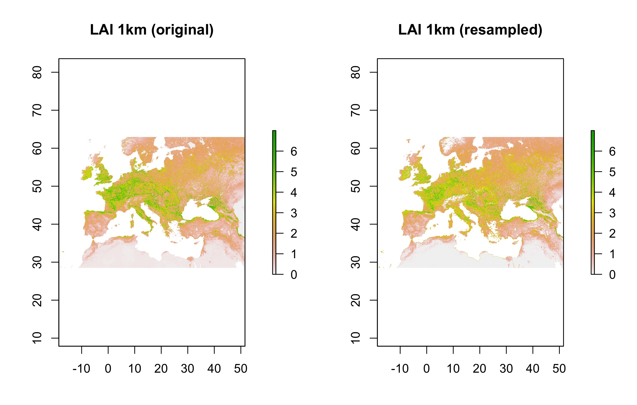  
Figura 1: blanbanoflñojivonvn ñohvñoE

Figura 2. Note that was added to the code chunk to prevent printing of the R code that generated the plot.

# References

Phillips, S. J., R. P. Anderson, and R. E. Schapire. 2006. “Maximum Entropy Modeling of Species Geographic Distributions.” Journal Article. *Ecological Modelling* 190 (3-4): 231–59. doi:[10.1016/j.ecolmodel.2005.03.026](https://doi.org/10.1016/j.ecolmodel.2005.03.026).

Thuiller, Wilfried, Bruno Lafourcade, Robin Engler, and Miguel B. Araujo. 2009. “BIOMOD - a Platform for Ensemble Forecasting of Species Distributions.” Journal Article. *Ecography* 32 (3): 369–73. doi:[10.1111/j.1600-0587.2008.05742.x](https://doi.org/10.1111/j.1600-0587.2008.05742.x).