

**MAPUA INSTITUTE OF TECHNOLOGY AT LAGUNA**

**Academic Year 2019 - 2020**

**IMPLEMENTATION OF COMPUTER-BASED DC MACHINE LABORATORY**

Ar-Jhay Aguirre MARCAIDA

John David Munar MUÑIZ

Adviser: Engr. Cesar G. Manalo Jr.

A Capstone Project Proposal Submitted

In Partial Fulfilment of the Requirements for the Degree of

Bachelor of Science in Electrical Engineering

**Methodology**

The study shall follow the system architecture shown below:

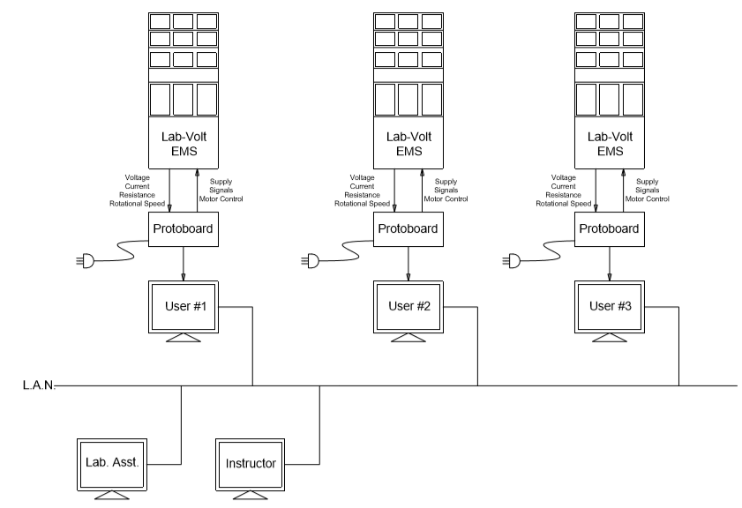

**Figure 3.0.** DC Machine Laboratory System Architecture

**LabVolt Module**. It is used for experimentation. Resistor bank, capacitor bank, and inductor bank are all provided by the LabVolt module. The DC Machines are also part of the LabVolt module and will be used as the material for gathering data.

**Protoboard**. Computer based machine designed for DC Machine laboratory. It has provision for motor control and capable for fine tuning. It is also where the terminals for the ammeter and voltmeter reading are connected. This connection allows the computer to display the reading on the screen.

The protoboard is designed to eliminate the problems posed by the manual characteristic of the laboratory. It can read the voltage, current, and speed of the DC Machine through a computer or a laptop. The protoboard consists of terminals for the connection of ammeter, voltmeter, and ohmmeter. It also has terminals for motor control. It also has provision for field circuit adjustment, speed adjustment, and voltage supply adjustment.

**User Station**. The computer/laptop of students or laboratory performer. It is connected to the Instructor and the Laboratory Assistant through a L.A.N. It has a logging system where the laboratory performer should log in before doing the experiment. It displays the electronic manual that is used for the laboratory activity. It displays the current reading and voltage reading asked by the electronic manual.

The subject of interest is the DC Machines. The manual provides the different machine configuration and the laboratory procedures needed to be performed. Each machine has its own application and configuration. The machines are run and operated using the LabVolt module which shall be experimented and observed through performing the laboratory procedure instructed by the manual.

The laboratory manual provided by the instructor is the compilation of instructions that students need to follow. This is to guide students on how they should perform a laboratory activity. Each configuration of motor is given a set of procedure so students can understand their operation.

The manual contains questions that ask for the reading given off by the machine. It also contains questions that tests the students understanding on the machine.

**Instructor Station**. The computer/laptop of the laboratory instructor. It is connected to the User through a L.A.N. The instructor station can monitor the results and progress of the User. Once the User submit the results, the Instructor station will compare it to the expected value. It shall also be graded except for the essay part of the manual.

**Laboratory Assistant Station**. The computer/ laptop of the laboratory assistant. It is connected to the User through a L.A.N. It receives a message notifying the laboratory assistant that the user will borrow laboratory materials. The station shall approve the list signifying that the materials are ready for dispatching.

**Local Area Network**. Provides connection between User, Instructor and Laboratory Assistant.

A User Station, Laboratory Assistant Station, and Instructor Station is on the system.

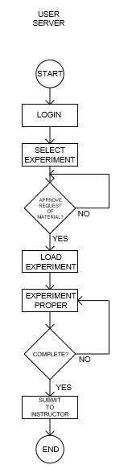

**Figure 3.1.** User Station Flowchart

The User Station consists of logging system where students should log in before starting the experiment. It shall also provide an electronic instructor manual. The manual shall include the content of the physical manual that is used for experimenting DC Machineries. The electronic manual also has a provision to read the voltage, current, and speed of the motor which shall be automatically imprinted to the manual. The client also has a warning system. It will notify the client when the machine is operating abnormally or when there is abnormality on the connection.

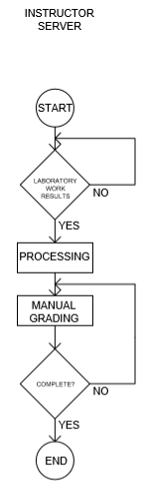

**Figure 3.2.** Instructor Station

The Instructor Station can monitor the client. Upon submission of the results, the program will compare the answers to the instructor's answers. The program shall automatically grade the results except for essay questions.

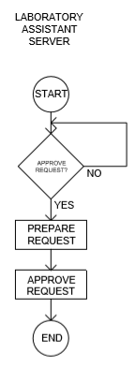

**Figure 3.3.** Laboratory Assistant Station

The Laboratory Assistant Station shall receive the request form submitted by the User Station. The Laboratory Assistant will approve the form notifying the User Station that the materials are ready for distribution.

The students should log in through a computer before starting the laboratory activity. The program shall ask for the materials needed for the activity. Upon submission of the materials, the laboratory assistant shall receive a message notifying that the students are borrowing. The laboratory assistant shall click approve through their computer. After the borrowing process, the student can now use the electronic manual also provided by the program. The students can then perform the experiment. The ammeter and voltmeter is connected to the protoboard which shall perform the reading process of the circuit parameters. When the circuit is energized, a "read" button can be clicked which shall display the parameters asked by the manual. Essays can also be answered through the electronic manual. After submitting the results, the program will compare the answers to the instructor's and grade the results.

The following test shall be conducted to test the over-all performance of the computer based DC Machine laboratory:

**Instrumentation Reliability Test**

The readings of the computer-based protoboard will be tested. A reliable ammeter and voltmeter will be used to test the accuracy of the system when it comes to reading the circuit parameters. It shall be accepted when the readings are within the tolerance of the expected value.

The system reading will be compared to the expected value and to the value displayed by a reliable multimeter.

The expected value will be governed by Ohm’s Law:

$V=IR$ (1)

The expected current reading shall be:

$I = \frac{V}{R}$ (2)

Through voltage divider, the expected voltage reading shall be:

$V=V_{in}\left(\frac{1}{2}\right)$ (3)

The LabVolt Multimeter will be used as the reliable multimeter. It has provision for both ammeter and voltmeter.

1. **Ammeter Test**

**Table 3.0.** Ammeter Test results

|  |  |  |  |  |
| --- | --- | --- | --- | --- |
| **RESISTANCE(Ω)** | **TEST VOLTAGE(V)** | **EXPECTED VALUE**  **(THEORETICAL)**  **(A)** | **RELIABLE MULTIMETER**  **(A)** | **SYSTEM READING**  **(A)** |
| 1 | 100 | 100 |  |  |
| 10 | 100 | 10 |  |  |
| 100 | 100 | 1 |  |  |
| 1k | 100 | 0.1 |  |  |
| 10k | 100 | 0.01 |  |  |
| 100k | 100 | 1m |  |  |
| 1M | 100 | 0.1m |  |  |
| 10M | 100 | 0.01m |  |  |
| 100M | 100 | 0.001m |  |  |
| 1G | 100 | 0.0001m |  |  |

1. **Voltmeter Test**

**Table 3.1.** Voltmeter Test results

|  |  |  |  |  |
| --- | --- | --- | --- | --- |
| **SERIES OF TWO RESISTANCE(Ω)** | **TEST VOLTAGE(V)** | **EXPECTED VALUE**  **(THEORETICAL)**  **(V)** | **RELIABLE MULTIMETER**  **(V)** | **SYSTEM READING**  **(V)** |
| 1 | 100 | 50 |  |  |
| 10 | 100 | 50 |  |  |
| 100 | 100 | 50 |  |  |
| 1k | 100 | 50 |  |  |
| 10k | 100 | 50 |  |  |
| 100k | 100 | 50 |  |  |
| 1M | 100 | 50 |  |  |
| 10M | 100 | 50 |  |  |
| 100M | 100 | 50 |  |  |
| 1G | 100 | 50 |  |  |

**Laboratory Assistant vs. User request of materials**

The laboratory assistant to user connection will be tested. The list of materials requested by the User Station will be compared to the list of materials received by the Laboratory Assistant Station. It ensures that the Laboratory assistant Station will receive an exact copy of the materials requested by the User Station. It will test the accuracy of the computer-based laboratory when it comes to requesting laboratory materials.

**Table 3.2.** Requested Material Accuracy Test

|  |  |
| --- | --- |
| **User Station requested laboratory materials** | **Laboratory Assistant Station display of requested materials** |
|  |  |

**Response time or turn-around time of material request from submission to approval**

The time interval between the submission of the request of material and the approval of the request will be tested. The test was done to ensure that the new material request approval system meets the demand of the study. This test determines if the new system is accepted for implementation.

The test will be done by imprinting a time-stamp on the request form submitted by the user Station and received by the laboratory assistant Station. The difference between the times will be recorded.

**Submitted Form Time Stamp:**

**Received Form Time Stamp:**

**Time Difference:**

**Laboratory Instructor vs. User laboratory results**

The Laboratory Instructor and User connection will be tested. The laboratory results displayed on the Instructor Station monitor will be compared to the Laboratory results submitted by the User Station. It shall test the accuracy of the checking system. It ensures that the instructor Station will receive the exact copy of the results given off by the user Station.

**Table 3.3.** Laboratory Results Accuracy Test

|  |  |
| --- | --- |
| **User Station submitted laboratory results** | **Laboratory Instructor Station display of laboratory results** |
|  |  |

**Response time from submission of laboratory results to checking by instructor test**

The time interval between the submission of the user's laboratory results and the checking of the results will be tested. This is to test if the checking of laboratory results meets the demand of the study. The results shall be accepted when it beats that of the normal checking of the instructor.

The test will be done by imprinting a time-stamp on laboratory results submitted by the user Station and received by the laboratory instructor Station. The difference between the times will be recorded.

**Submitted Form Time Stamp:**

**Received Form Time Stamp:**

**Time Difference:**

**Parameter Limit test**

The warning system will be tested. The warning system should notify the user if a certain parameter exceeds the set value. The set value determines the parameter that is dangerous for the machine. This is to determine if the warning system can notify the user at the set value.

The test is done by setting a limit value. The machine will be operated near the set value and will be adjusted gradually until the system notifies the user Station.

**Table 3.4.** Voltage Limit test result

|  |  |
| --- | --- |
| **Voltage (V)**  **(Note: * is Set point)** | **Notification** |
| 230 |  |
| 231 |  |
| 233 |  |
| 235 |  |
| 237 |  |
| 238 |  |
| 239 |  |
| **\* 240** |  |