Experiment 2

The DC Separately Excited Shunt Generator

OBJECTIVES

To study the properties of the separately excited DC shunt generator under no-load and full-load conditions.

To obtain the saturation curve of the generator.

To obtain the armature voltage vs armature current load curve of the generator.

DISCUSSION

A DC machine can run either as a motor or as a generator. A motor converts electrical power into mechanical power while a generator converts mechanical power into electrical power. A generator must, therefore, be mechanically driven in order that it may produce electricity.

Since the field winding is an electromagnet, current must flow through it to produce a magnetic field. This current is called the excitation current, and can be supplied to the field winding in one of two ways; it can come from a separate, external DC source, in which case the generator is called a separately excited generator; or it can come from the generator’s own output, in which case the generator is called a self-excited generator.

Assume that the shunt field is excited by a DC current, thereby setting up a magnetic flux in the generator. If the rotor (or more correctly, the armature) is rotated by applying mechanical effort to the shaft, the armature coils will cut the magnetic flux, and a voltage will be induced in them. This voltage is AC and in order to get DC out of the generator, a rectifier must be employed. This role is carried out by the commutator and the brushes.

The voltage induced in the coils (and, therefore, the DC voltage at the brushes) depends only upon two things o the speed of rotation and the strength of the magnetic field. If the speed is doubled, the voltage doubles. If the field strength is increased by 20%, the voltage also increases by 20%.

Although separate excitation requires a separate DC power source, it is useful in cases where a generator must respond quickly and precisely to an external control source, or when the output voltage must be varied over a wide range.

With no electrical load connected to the generator, no current flows and only a voltage appears at the output. However, if a resistance load is connected across the output, current will flow, and the generator will begin to deliver electric power to the load.

The machine which drives the generator must then furnish additional mechanical power to the generator. This is often accompanied by increased noise and vibration of the motor and the generator, together with a drop-in speed.

EQUIPMENT REQUIRED

<To be updated>

PROCEDURE

**CAUTION!**

**High voltages are present in this Experiment! Do not make any connections with the power on! The power should be turned off after completing each individual measurement!**

No Load Characteristics

1. Because of its constant running speed, the synchronous motor will be used to mechanically drive the DC generator. Using your Power Supply, AC Ammeter and Three-Phase Synchronous Motor/Generator, connect the circuit shown in Figure 2.1.

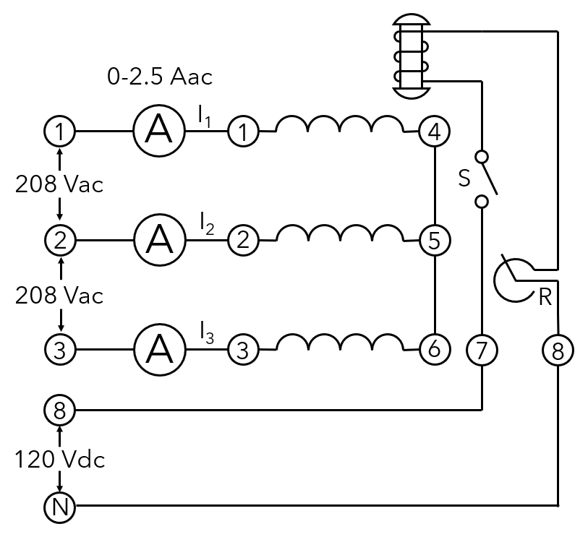

Figure 2.1.

**DO NOT APPLY POWER AT THIS TIME!**

1. Terminals 1, 2 and 3 on the power supply provide fixed three-phase power for the three stator windings. (Three-phase power will be covered in later Experiments). Terminals 8 and N on the power supply provide fixed DC power for the rotor winding. Set the rheostat control knob to its proper position for normal excitation (Experiment 1, procedure 6).
2. :
   1. Using your DC Motor/Generator and DC Voltmeter/Ammeter, connect the circuit shown in Figure 2.2.
   2. Connect the shunt field of the generator, terminals 5 and 6, to the variable DC output of the power supply, terminals 7 and N, while connecting the 500 mA meter in series with the positive lead.
   3. Connect the 200 V dc meter across the generator output (armature terminals 1 and 2).
   4. Couple the synchronous motor and the DC generator with the timing belt.
   5. Make sure the brushes are in their neutral position.
   6. Have your instructor check your circuit.

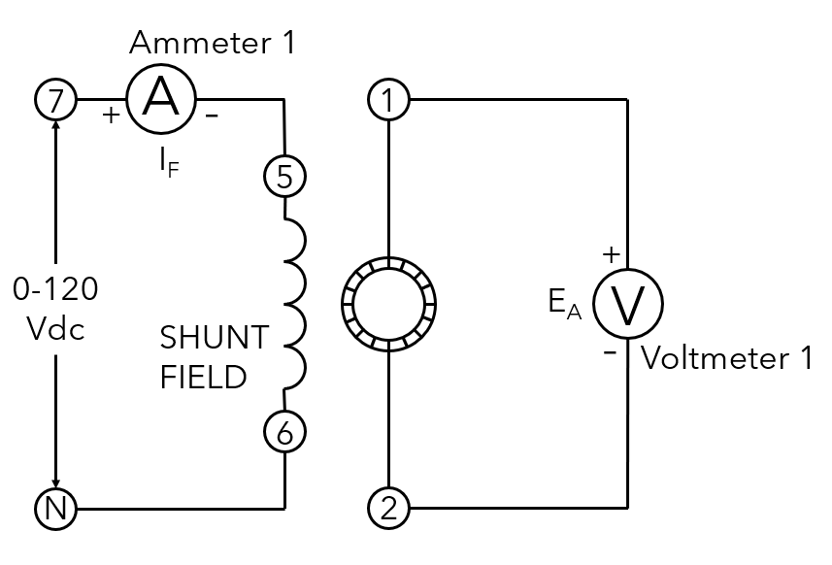

Figure 2.2.

**CAUTION!**

**The switch in the excitation circuit of the synchronous motor should be closed (I) only when the motor is running.**

1. :
   1. Turn on the power supply. The synchronous motor should start running.
   2. Close the switch S.
   3. Vary the shunt field current IF by rotating the voltage control knob on the power supply. Note the effect on the generator output (armature voltage) EA as indicated by the 200 Vdc meter.
   4. Measure and record in Table 2.1 the armature voltage EA for each of the listed field currents.

Table 2.1.

|  |  |
| --- | --- |
| IF (milliamperes) | EA (volts) |
| 0 |  |
| 50 |  |
| 100 |  |
| 150 |  |
| 200 |  |
| 250 |  |
| 300 |  |
| 350 |  |
| 400 |  |

* 1. Return the voltage to zero and turn off the power supply.
  2. Can you explain why there is an armature voltage even when the field current is zero?

____________________________________________________________________________________________________________________________________

1. :
   1. Reverse the polarity of the shunt field by interchanging the leads to terminals 5 and 6 on the DC generator.
   2. Turn on the power supply and adjust for a field current IF of 300 mAdc.
   3. Did the armature voltage reverse its polarity? Yes/No
   4. Return the voltage to zero and turn of the power supply.
2. :
   1. Interchange the leads to the 200 Vdc meter.
   2. Turn on the power supply and adjust for a field current IF of 300 mAdc.
   3. Measure and record the armature voltage.

EA = __________ Vdc

* 1. Is the armature voltage approximately the same as in procedure 4 (at an IF of 300 mA), except for reversed polarity? Yes/No
  2. Return the voltage to zero and turn off the power supply.

1. :
   1. Reverse the rotation of the driving motor by interchanging any two of the stator lead connections (terminals 1, 2 or 3) to the synchronous motor.
   2. Turn on the power supply and adjust for a field current IF of 300 mAdc.
   3. Did the armature voltage reverse its polarity? Yes/No
   4. Return the voltage to zero and turn off the power supply.
2. :
   1. Interchange the leads to the 200 Vdc meter.
   2. Turn on the power supply and adjust for a field current IF of 300 mAdc.
   3. Measure and record the armature voltage.

EA = __________ Vdc

* 1. Is the armature voltage approximately the same as in procedure 4 (at an IF of 300 mA), except for reversed polarity? Yes/No
  2. Return the voltage to zero and turn off the power supply.

LOAD CHARACTERISTICS

1. Using your Resistive Load, connect the circuit shown in Figure 2.3. Place the resistance switches so that the total load resistance is 120 Ω.

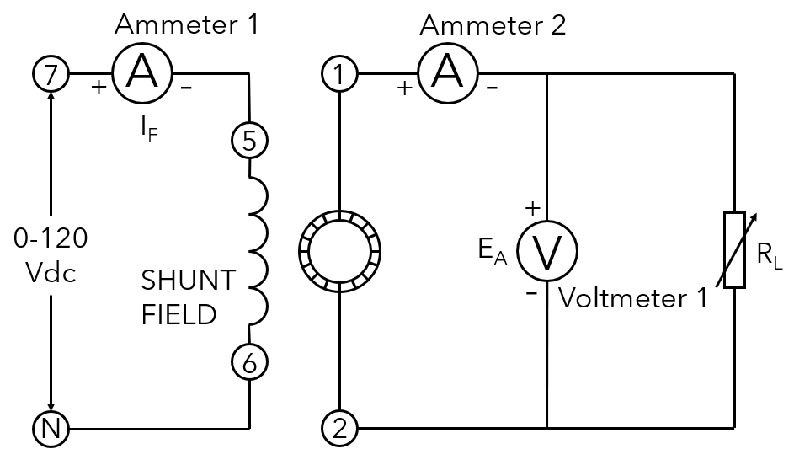

Figure 2.3.

1. :
   1. Turn on the power supply. The synchronous motor should start running.
   2. Adjust the shunt field current IF until the generator is delivering an output voltage of 120 Vdc. The ammeter IA should indicate 1 Adc.
   3. Record the shunt field current IF.

IF = __________ mA

This is the nominal IF at the rated power output (120 V x 1 A = 120 W) of the DC generator.

1. :
   1. Adjust the load resistance to obtain each of the values listed in Table 7.2 while maintaining the nominal IF value found in procedure 10.
   2. Measure and record EA and IA for each of the resistance values listed in the Table.

**Note:** Although the nominal output current rating of the generator is 1 Adc, it may be loaded up to 1.5 Adc (50% overload) without harm.

Table 2.2.

|  |  |  |  |
| --- | --- | --- | --- |
| RL (ohms) | IA (amps) | EA (volts) | Power (watts) |
| ∞ |  |  |  |
| 600 |  |  |  |
| 300 |  |  |  |
| 200 |  |  |  |
| 150 |  |  |  |
| 120 |  |  |  |
| 100 |  |  |  |
| 80 |  |  |  |
| 75 |  |  |  |

1. :
   1. With the load resistance adjusted for an output current IA of 1.5 A, turn the field current IF on and off by removing the connecting lead from terminal 6 to the DC generator.
   2. Do you notice that the driving motor is obviously working harder when the generator is delivering power to the load? Yes/No
   3. Return the voltage to zero and turn off the power supply.
2. Calculate and record the power for each of the values listed in Table 7.2.
3. :
   1. Place a dead short across the armature (terminals 1 and 2).
   2. Make sure that the power supply voltage control knob is turned down for zero field current.
   3. Turn on the power supply.
   4. Gradually increase the field current IF until the motor stalls.

**CAUTION!**

**Do not leave the motor in the stalled condition for more than a couple of seconds.**

* 1. What value of shunt field current IF is needed to stall the motor?

IF = __________ mA

* 1. Turn off the power supply.

Note: With a short-circuit across the armature, its current becomes very large; this produces a strong braking effect sufficient to stall the driving motor.

REVIEW QUESTIONS

1. State two ways by which the output polarity of a shunt DC generator can be changed.

________________________________________________________________________________________________________________________________________________________________________________________________________________________________________________________________________________________________

1. If a DC generator delivers 180 W to a load, what is the minimum mechanical power (in watts) needed to drive the generator (assume 80% efficiency)?

________________________________________________________________________________________________________________________________________________________________________________________________________________________

1. If a DC generator delivers 180 W to a load, what is the minimum hp needed to drive the generator (assume 100% efficiency)?

________________________________________________________________________________________________________________________________________________________________________________________________________________________

1. Plot the EA vs IF characteristic curve for your DC shunt generator on the graph of Figure 2.4. Use the data from Table 2.1. Note that the curve “bends over” as the field current increases. Can you explain why this happens?

________________________________________________________________________________________________________________________________________________________________________________________________________________________

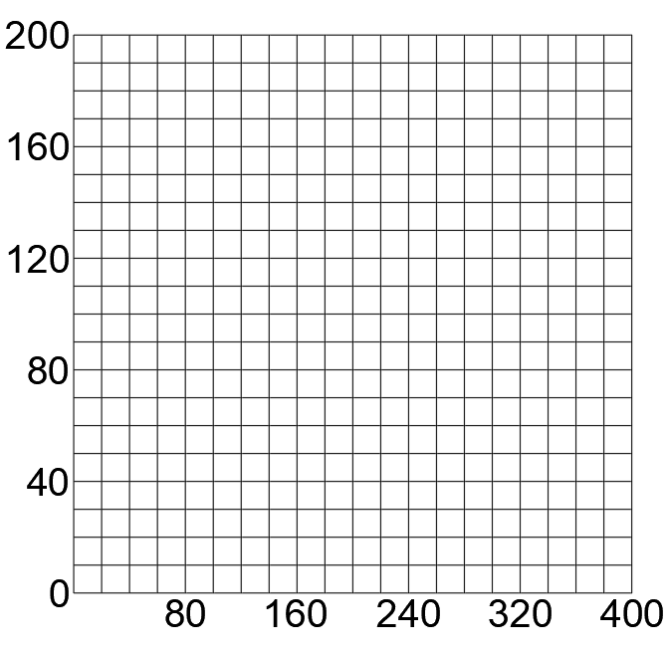

Figure 2.4.

1. Plot the EA vs IA regulation curve on the graph of Figure 2.5. Use the data from Table 2.2.

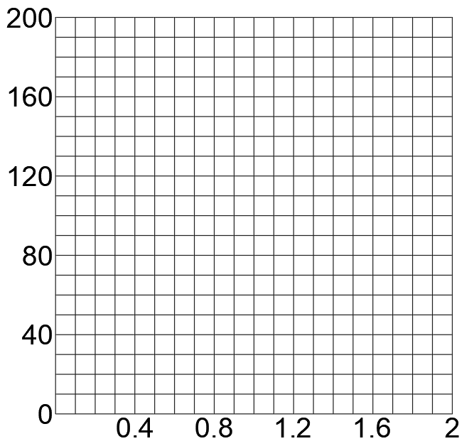

Figure 2.5.

1. Calculate the regulation from no-load to full-load (1 Adc).

________________________________________________________________________________________________________________________________________________________________________________________________________________________

Regulation = __________ %