Experiment 3-1

The DC Self Excited Shunt Generator

OBJECTIVE

To study the properties of the self-excited DC shunt generator under no-load and full-load conditions.

To learn how to connect the self-excited generator.

To obtain the armature voltage vs armature current load curve of the generator.

DISCUSSION

The separately-excited generator has many applications. However, it does have the disadvantage that a separate direct current power source is needed to excite the shunt field. This is costly and sometimes inconvenient; and the self-excited DC generator is often more suitable.

In a self-excited generator, the field winding is connected to the generator output. It may be connected across the output, in series with the output, or a combination of the two. The way in which the field is connected (shunt, series or compound) determines many of the generator’s characteristics.

All of the above generators can have identical construction. Self-excitation is possible because of the residual magnetism in the stator pole pieces. As the armature rotates a small voltage is induced across its windings. When the field winding is connected in parallel (shunt) with the armature a small field current will flow. If this small field current is flowing in the proper direction, the residual magnetism will be reinforced which further increases the armature voltage and thus, a rapid voltage build-up occurs.

If the field current flows in the wrong direction, the residual magnetism will be reduced, and voltage build-up cannot occur. In this case, interchanging the shunt field leads will correct the situation. It is the purpose of this Experiment to show these major points.

EQUIPMENT REQUIRED

<To be updated>

PROCEDURE

**CAUTION!**

**High voltages are present in this Experiment! Do not make any connections with the power on! The power should be turned off after completing each individual measurement!**

1. Because of its constant running speed, the synchronous motor will be used to mechanically drive the DC generator. Using your Power Supply, AC Ammeter and Three-Phase Synchronous Motor/Generator, connect the circuit shown in Figure 3.1.

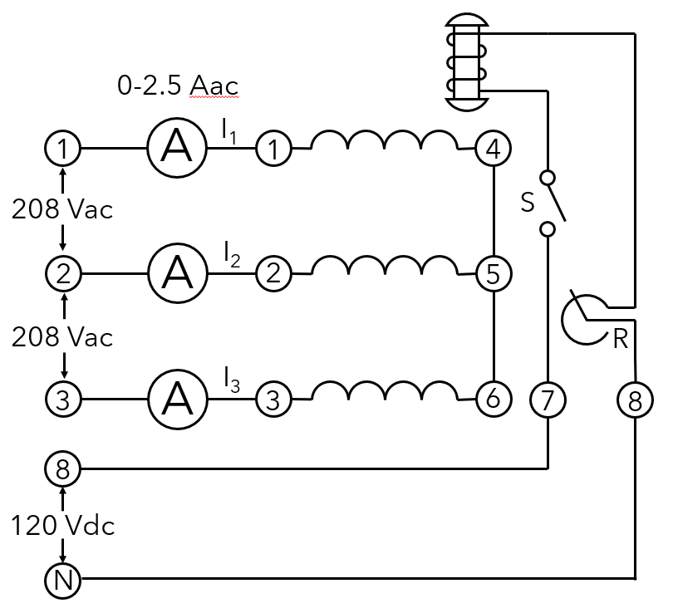

Figure 3.1.

**DO NOT APPLY POWER AT THIS TIME!**

1. Terminals 1, 2, and 3 on the power supply provide fixed three-phase power for the three stator windings. (Three-phase power will be covered in later Experiments). Terminals 8 and N on the power supply provide fixed DC power for the rotor winding.

Set the rheostat control knob to its proper position for normal excitation.

1. :
   1. Using your DC Motor/Generator, DC Voltmeter/Ammeter and Resistive Load, connect the circuit shown in Figure 3.2.
   2. Couple the synchronous motor and the DC generator with the timing belt.
   3. Turn the DC generator field rheostat control knob full cw for minimum resistance.
   4. Make sure the brushes are in their neutral position.
   5. Place the resistance switches for no-load (all switches open).

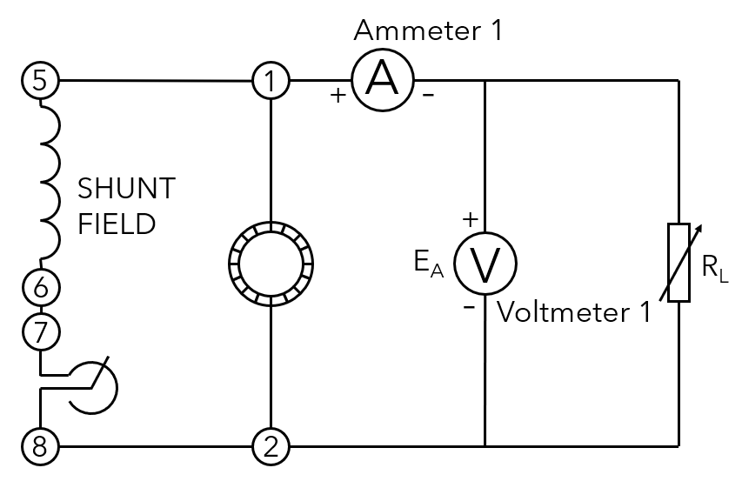

Figure 3.2.

**CAUTION!**

**The switch in the excitation circuit of the synchronous motor should be closed (I) only when the motor is running.**

1. :
   1. Turn on the power supply. The synchronous motor should start running.
   2. Close the switch S.
   3. Not if voltage EA builds up. Yes/No
   4. If not, turn off the power supply and interchange the shunt field leads at terminals 5 and 6.
   5. Measure the open circuit armature voltage.

EA = __________ Vdc

1. Vary the field rheostat and notice if the armature voltage EA changes. Explain. Yes/No

________________________________________________________________________________________________________________________________________________________________________________________________________________________

1. :
   1. Place the resistance switches so that the total load resistance is 120 Ω. Adjust the field rheostat until the generator is delivering an output voltage of 120 Vdc. The ammeter IA should indicate 1 Adc.
   2. This is the correct setting of the field rheostat control for the rated power output (120 V x 1 A = 120 W) of the DC generator.

Do not touch the field rheostat control for the remainder of the Experiment!

1. :
   1. Adjust the load resistance to obtain each of the values listed in Table 3.1.
   2. Measure and record EA and IA for each of the resistance values listed in the Table.

Table 3.1

|  |  |  |  |
| --- | --- | --- | --- |
| RL (ohms) | IA (amps) | EA (volts) | Power (watts) |
| ∞ |  |  |  |
| 600 |  |  |  |
| 300 |  |  |  |
| 200 |  |  |  |
| 150 |  |  |  |
| 120 |  |  |  |
| 100 |  |  |  |
| 80 |  |  |  |
| 75 |  |  |  |

**Note:** Although the nominal output current rating of the generator is 1 Adc, it may be loaded up to 1.5 Adc (50% overload) without harm.

* 1. Turn off the power supply.
  2. Calculate and record the power for each of the resistance shown in Table 3.1.

1. :
   1. Reverse the rotation of the driving motor by interchanging any two of the stator lead connections (terminals 1, 2, or 3) to the synchronous motor.
   2. Remove the generator load by opening all of the resistance switches.
   3. Turn on the power supply.
   4. Does the generator voltage build up? Explain. Yes/ No

______________________________________________________________________________________________________________________________________________________________________________________________________

* 1. Turn off the power supply.

REVIEW QUESTIONS

1. If a self-excited generator has lost all of its residual magnetism, can it build up an output voltage? Yes/No
2. How would you get a generator to work after it had lost all of its residual magnetism?

________________________________________________________________________________________________________________________________________________________________________________________________________________________

1. Does a generator slowly lose its residual magnetism with time? Yes/No
2. Plot the EA vs IA regulation curve on the graph of Figure 3.3.

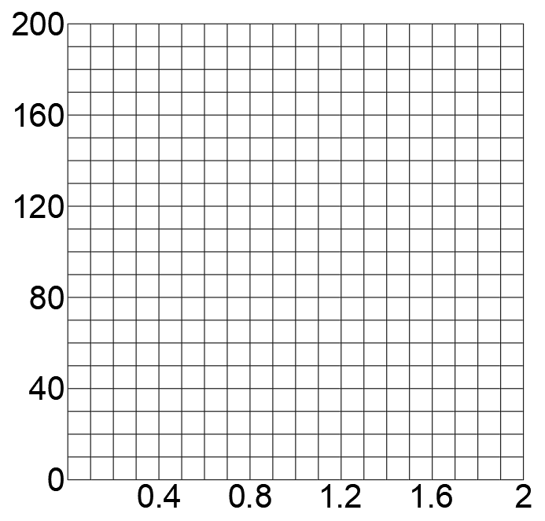

Figure 3.3.

1. Calculate the regulation from no-load to full-load (1 Adc).

________________________________________________________________________________________________________________________________________________

Regulation = __________ %

1. Compare the regulation of the self-excited generator with the regulation of the separately-excited generator.

________________________________________________________________________________________________________________________________________________

1. Explain why one of the generators has better regulation than the other.

________________________________________________________________________________________________________________________________________________________________________________________________________________________

Experiment 3-2

The DC Series Generator

OBJECTIVE

To study the properties of the series DC generator.

To learn how to connect the series generator.

To obtain the armature voltage vs armature current load curve of the generator.

DISCUSSION

When the field winding is connected in series with the armature winding, the generator is called a series generator. The exciting current through the field winding of a series generator is the same current the generator delivers to the load. See Figure 3.4.

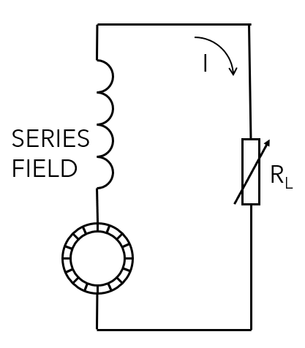

Figure 3.4.

If the load has high resistance only a minimum output voltage can be generated because of the minimum field current. On an open circuit, the generator will only have a minimum output voltage due to its residual magnetism. If the load draws current, the excitation current increases, the magnetic field becomes stronger and the generator delivers an output voltage.

You can see then that in a series generator, changes in load current greatly affect the generator output voltage. A series generator has very poor voltage regulation and is not recommended for use as a power source.

Series generators have been used on DC distribution systems as line voltage boosters. Consider for example, the circuit shown in Figure 3.5 in which a power

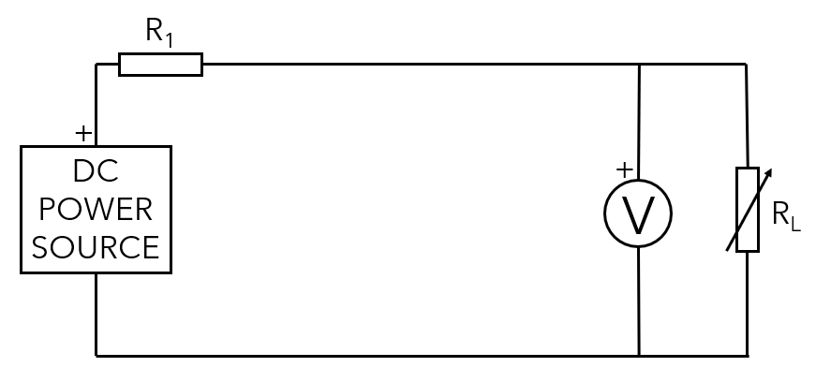

Figure 3.5.

The load voltage will fluctuate according to whether the line current is large or small. This fluctuating load voltage can be corrected by inserting a series generator in the line as shown in Figure 3.6. As the load current increases, the generator voltage VG increases, compensating for the voltage drop across the transmission line resistance R1, thereby maintaining a relatively constant voltage across the varying load.

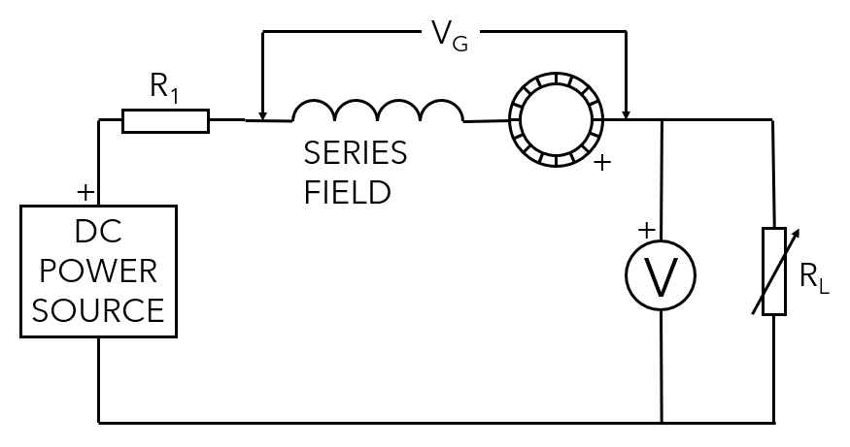

Figure 3.6.

EQUIPMENT REQUIRED

<To be updated>

PROCEDURE

**CAUTION!**

**High voltages are present in this Experiment! Do not make any connections with the power on! The power should be turned off after completing each individual measurement!**

**Note:** To perform this experiment, you will need three Resistive Load. So, two collaborating groups may work together.

**Note:** Before proceeding, set the polarity of the residual magnetism and his intensity to the maximum. To do so, make sure the Power Supply is turned off and connect terminals 7 and N of the Power supply to terminals 3 and 4 of the DC Motor/Generator, respectively. On the Power Supply, set the voltage control knob at 50 %. Turn on the Power Supply then turn it off.

1. Because of its constant running speed, the synchronous motor will be used to mechanically drive the DC generator. Using your Power Supply, AC Ammeter and Three-Phase Synchronous Motor/Generator, connect the circuit shown in Figure 3.7.



Figure 3.7.

**DO NOT APPLY POWER AT THIS TIME!**

1. Terminals 1, 2, and 3 on the power supply provide fixed three-phase power for the three stator windings. (Three-phase power will be covered in later Experiments.) Terminals 8 and N on the power supply provide fixed DC power for the rotor winding.

Set the rheostat control knob to its proper position for normal excitation.

1. :
   1. Using your DC Motor/Generator, DC Voltmeter/Ammeter and Resistive Load, connect the circuit shown in Figure 3.8.
   2. Couple the synchronous motor and the DC generator with the timing belt.
   3. Make sure the brushes are in their neutral position.
   4. Place the resistance switches for no-load (all switches open).

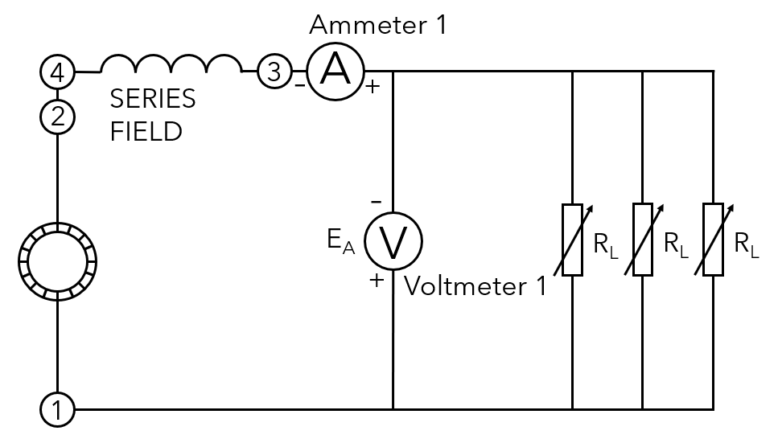

Figure 3.8.

**CAUTION!**

**The switch in the excitation circuit of the synchronous motor should be closed (I) only when the motor is running.**

1. :
   1. Turn on the power supply. The synchronous motor should be running. Close the switch S.
   2. Measure the generator output voltage across the open load circuit.

EA = __________ Vdc

* 1. To what do you attribute this open circuit voltage?

____________________________________________________________________________________________________________________________________

1. :
   1. Place a 19 Ω load in the circuit by closing all of the resistance switches on the three resistance modules and note whether EA increases.
   2. If not, turn off the power supply and interchange the series field leads at terminals 3 and 4.
2. :
   1. Adjust the load resistance to obtain each of the values listed in Table 3.2.
   2. Measure and record EA and IA for each of the resistance values listed in the table.
   3. Turn off the power supply.
   4. Calculate and record the power for each of the resistances shown in Table 3.2.

Table 3.2.

|  |  |  |  |
| --- | --- | --- | --- |
| RL (ohms) | IA (amps) | EA (volts) | Power (watts) |
| ∞ |  |  |  |
| 44.3 |  |  |  |
| 36.3 |  |  |  |
| 30.7 |  |  |  |
| 26.7 |  |  |  |
| 23.7 |  |  |  |
| 21 |  |  |  |
| 19 |  |  |  |

REVIEW QUESTIONS

1. Plot the EA vs IA regulation curve on the graph of Figure 3.9. Use the data from Table 3.2.

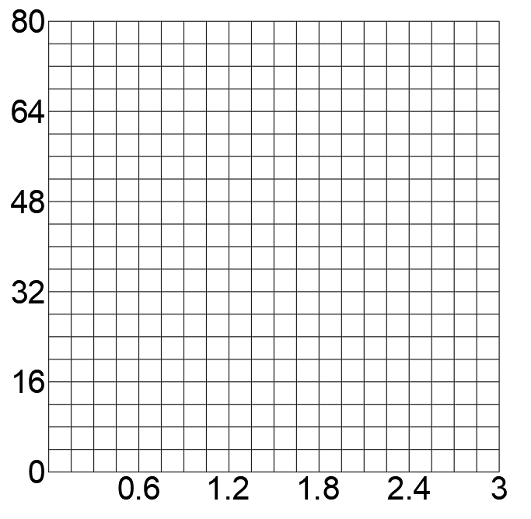

Figure 3.9.

1. Calculate the regulation from no-load to full-load (1 Adc).

________________________________________________________________________________________________________________________________________________

Regulation = __________ %

1. Comment about the characteristics of each generator:
   * Separately excited shunt generator.
   * Self-excited shunt generator.
   * Compound generator.
   * Differential compound generator.
   * Series generator.

________________________________________________________________________________________________________________________________________________________________________________________________________________________________________________________________________________________________________________________________________________________________________________________________________________________________________________________________________________________________________________________________________________________________________________________________________________________________________________________________________________________________________________________________________________