cgmisc: package tutorial

Marcin Kierczak, Jagoda Jablonska, Simon Forsberg, Matteo Bianchi, Katarina Tengvall, Mats Pettersson, Jennifer Meadows, Patric Jern, Orjan Carlborg, Kerstin Lindblad-Toh

18 Feb 2015

**cgmisc** is an R package for enhanced genome-wide association studies (GWAS) and visualisation. This document aims at guiding you through the installation process and to demonstrate package capabilities in a series of practical examples based on an example data included in the package.

# Package installation

The **cgmisc** package can be installed in the same way as any other R package. One way is to issue the following command in R console:

install.packages("cgmisc")

Other possibilities include using graphical user interface (GUI) of, e.g. R console or RStudio.

After the package has been installed, to use the package, it is necessary to load it into environment:

library("cgmisc")

## Loading required package: GenABEL  
## Loading required package: MASS  
## Loading required package: GenABEL.data  
##   
## Package cgmisc contains miscellaneous functions, useful for extending  
## genome-wide association study (GWAS) analyses.   
##   
## Package Name: cgmisc   
## Version: 2.9.8   
## Date: 2015-01-28   
## Author: Marcin Kierczak <marcin.kierczak@imbim.uu.se>   
## License GPL (>=2.10)   
##   
## Package contains various functions useful in computational  
## genetics, especially in genome-wide association studies.

# Loading data

Whenever possible, the **cgmisc** package uses data structures used by the GenABEL (Aulchenko et al., 2007) package. In particular, the gwaa.data-class and the gwaa.scan-class structures are used. The package is shipped with an example dataset called **cgmisc_data** that contains genotyping data (Illumina, canFam2) for N=207 German shepherds originally collected for the project described in (Tengvall et al., 2012). The phenotypes, though, have been simulated in order to be able to illustrate various features of **cgmisc**. To load the example dataset, use the following command:

data("data")

# Example analyses

In order to illustrate how to use particular functions, we will perform a very much simplified GWAS analysis. We begin by initial quality control where we prune the data with per marker of per individual call rates below 95%. Based on 2000 randomly selected markers, we remove one (with lower call rate) from each pair of too similar (more than 95% similarity) individuals. We also set very low (${10}^{−3}$) threshold for pruning on minor allele frequency (in practise only the monomorphic markers will be removed) and turn off checks based on the departure form Hardy-Weinberg equilibrium (p.level=10e-18)

qc1 <- check.marker(data, callrate = .95, perid.call = .95, ibs.threshold = .95, ibs.mrk=2000, ibs.exclude="lower", p.level=10e-18, maf=1e-3)

## Excluding people/markers with extremely low call rate...  
## 174375 markers and 207 people in total  
## 0 people excluded because of call rate < 0.1   
## 1069 markers excluded because of call rate < 0.1   
## Passed: 173306 markers and 207 people  
##   
## RUN 1   
## 173306 markers and 207 people in total  
## 42743 (24.66331%) markers excluded as having low (<0.1%) minor allele frequency  
## 1468 (0.8470567%) markers excluded because of low (<95%) call rate  
## 650 (0.3750591%) markers excluded because they are out of HWE (P <1e-17)  
## 0 (0%) people excluded because of low (<95%) call rate  
## Mean autosomal HET is 0.2658536 (s.e. 0.01917125)  
## 0 people excluded because too high autosomal heterozygosity (FDR <1%)  
## Mean IBS is 0.7749262 (s.e. 0.01468507), as based on 2000 autosomal markers  
## 2 (0.9661836%) people excluded because of too high IBS (>=0.95)  
## In total, 128942 (74.40135%) markers passed all criteria  
## In total, 205 (99.03382%) people passed all criteria  
##   
## RUN 2   
## 128942 markers and 205 people in total  
## 0 (0%) markers excluded as having low (<0.1%) minor allele frequency  
## 0 (0%) markers excluded because of low (<95%) call rate  
## 0 (0%) markers excluded because they are out of HWE (P <1e-17)  
## 0 (0%) people excluded because of low (<95%) call rate  
## Mean autosomal HET is 0.2660211 (s.e. 0.01918304)  
## 0 people excluded because too high autosomal heterozygosity (FDR <1%)  
## Mean IBS is 0.7788386 (s.e. 0.01414693), as based on 2000 autosomal markers  
## 0 (0%) people excluded because of too high IBS (>=0.95)  
## In total, 128942 (100%) markers passed all criteria  
## In total, 205 (100%) people passed all criteria

data.qc1 <- data[qc1$idok, qc1$snpok]

Next, we analyse population structure by means of genomic-kinship:

autosomal <- which(data.qc1@gtdata@chromosome != 39)  
data.qc1.gkin <- ibs(data.qc1, snpsubset = autosomal, weight = 'freq')  
data.qc1.dist <- as.dist(0.5 - data.qc1.gkin)  
data.qc1.mds <- cmdscale(data.qc1.dist)  
plot(data.qc1.mds, pch=19, xlab="MDS1", ylab="MDS2")

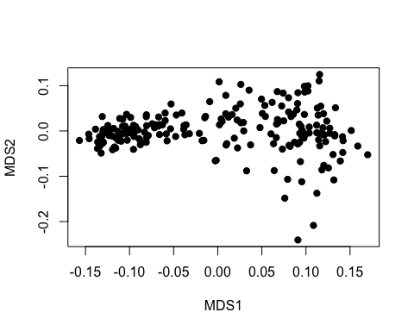

We can see that there is possible population structure here. We should investigate this further, but for our purposes, let's just run simple K-means clustering with the number of clusters *a priori* set to $K=2$

kclust <- kmeans(data.qc1.mds, centers = 2)  
plot(data.qc1.mds, pch=19, xlab="MDS1", ylab="MDS2", col=kclust$cluster)

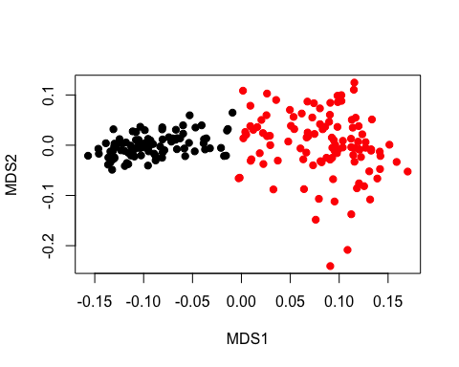

pop <- kclust$cluster

Having defined subpopulations, we can proceed to association analyses using mixed model with genomic kinship as random effect.

h2h <- polygenic_hglm(formula = ct ~ sex, data.qc1.gkin, data.qc1)

## Loading required package: hglm  
## Loading required package: Matrix  
## Loading required package: hglm.data  
##   
## hglm: Hierarchical Generalized Linear Models  
## Version 2.0-11 (2014-10-30) installed  
## Authors: Xia Shen, Moudud Alam, Lars Ronnegard  
## Maintainer: Xia Shen <xia.shen@ki.se>  
##   
## Use citation("hglm") to know how to cite our work.  
##   
## Discussion: https://r-forge.r-project.org/forum/?group_id=558  
## BugReports: https://r-forge.r-project.org/tracker/?group_id=558  
## VideoTutorials: http://www.youtube.com/playlist?list=PLn1OmZECD-n15vnYzvJDy5GxjNpVV5Jr8

mm <- mmscore(h2h, data.qc1, strata = pop)  
plot(mm, cex=.5, pch=19, col=c("darkgrey","grey"))

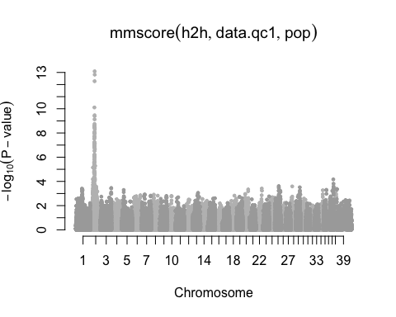

As we can see, there is a very strong association signal on chromosome 2. We can examine it a bit closer using the plot.manhattan.ld function.

# Visualization and analyses of linkage structure

Say, we would like to zoom in on chromosome 2 and visualise LD to the top-associated marker. First, we need the name and cooridinates of the marker:

summary(mm, top=1)

## Summary for top 1 results, sorted by P1df

## Chromosome Position Strand A1 A2 N effB se_effB  
## BICF2S2365880 2 38256927 u T C 205 1.095257 0.1466398  
## chi2.1df P1df Pc1df effAB effBB chi2.2df P2df  
## BICF2S2365880 55.78642 8.078765e-14 3.540639e-13 NA NA 0 NA

We see that the top-associated marker is **BICF2S2365880** and its position is **38256927bp**. We will zoom in on a 2Mbp region centered on the marker:

plot.manhattan.LD(data = data.qc1, gwas.result = mm, chr = 2, region = c(37256927,39256927), index.snp = "BICF2S2365880", legend.pos=c(38.9e6, 15), bonferroni = F, mafThreshold = 1e-3)

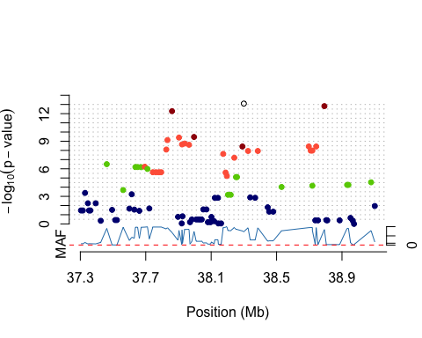 It is also possible to identify regions of interest using clumping procedure as described in PLINK documentation [cite]:

clumps <- clump.markers(data.qc1, mm, 2)  
plot.clumps(mm, clumps, chr = 2, c(37256927,39256927))

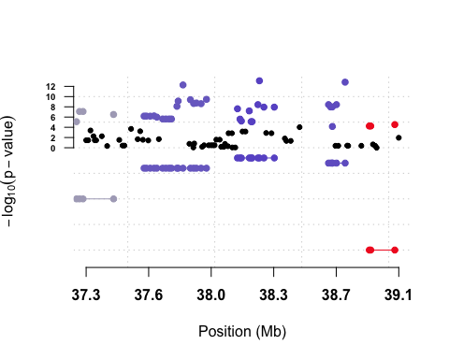

To visualise LD decay on chromosome 2, one can call the plot.ld.decay function.

#plot.LD.decay(data.qc1[,data.qc1@gtdata@chromosome==2], N=100, dmin = 1e2, dmax = 1e3)