






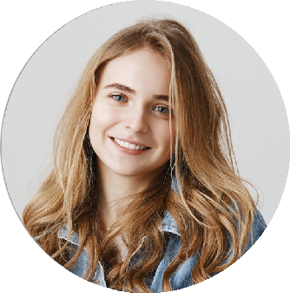
Nadine Kerstin Lehrer
SENIOR GRAPHIC DESIGNER
Loreme liliipsum modolor sit amet, consectetureru adipiscing elit, sed do eiusmod temporada incididunt ut labore et dolore magna aliqua. Ut enim ad minim veniam, quis nostrud exercitation ullamco laboris nisi ut aliquip ex ea commodo consequat.
ONLINE PORTFOLIO
PROFESSIONAL EXPERIENCE
Dribbble:
@nadineLehrer
Instagram:
@nadineLehrer
Linkedin:
Nadine Kerstin Lehrer
2018 - 2020
Head of Design ABC Company
San Francisco
Sed utama perspiciatis underarmor omnis iste natus error sit voluptatemono accusanmuyi tiumyu dolor emque laudantium, totam remaperi tiumyu dolor. Underarmor omnis iste natus error sit voluptatemono.
Omnis iste natus error sit voluptatem error sit
Totam remaperi natus error sit voluptatem error Omnis iste natus error sit voluptatem error sit
CONTACT INFORMATION
2016 - 2018
Senior Designer DEF Company
San Francisco
Sed utama perspiciatis underarmor omnis iste natus error sit voluptatemono accusanmuyi tiumyu dolor emque laudantium, totam remaperi tiumyu dolor. Underarmor omnis iste natus error sit voluptatemono.
nadine@email.com
telegram.me/username
222 333 444 555
yourwebsite.com
Omnis iste natus error sit voluptatem error sit Totam remaperi natus error sit voluptatem error
Omnis iste natus error sit voluptatem error sit
PROFESSIONAL SKILLS
2013 - 2016
Junior Designer GHI Company
San Francisco
Team Management
Website Design
Sed utama perspiciatis underarmor omnis iste natus error sit voluptatemono accusanmuyi tiumyu dolor emque laudantium, totam remaperi tiumyu dolor. Underarmor omnis iste natus error sit voluptatemono.
Marketing
Omnis iste natus error sit voluptatem error sit
Totam remaperi natus error sit voluptatem error
Social Media
Print Design
REFERENCES
Jonathan Doe | General Manager joe.doe@email.com 0800 222 33344
Mariana Grande | Manager
mariana@email.com 0800 222 33344
LATEST EDUCATION
Design Visual
Master Degree
California University | 2018
AWARDS
Winner Web Design Competition
ITA Awards 2019
Winner Web Design Competition
ITA Awards 2018

