Optimize your resume to get more job interviews

This free resume template will help you write an ATS-friendly resume. But how do you know what the hiring manager is looking for? What skills and experience should you list to show you’re the best candidate?

Jobscan’s resume scanner helps you optimize your resume for each job listing so that your application is more attractive to recruiters and hiring managers.

An optimized resume leads to more responses, more interviews, and more offers for the jobs you really want.

“Honestly, it was like the floodgates opened. Within a week…I was absolutely flooded with contacts and people reaching out.” Kelly, South Carolina, Jobscan User

”It’s the greatest tool that I have seen when it comes to searching for jobs.” Mark Stark, Career Success Coach

“We’re seeing easily 30% or more increase in calls from recruiters when our students use Jobscan to tailor their resumes.” Jeffrey Stubbs, Director, Baylor University Career Center

It’s frustrating to apply for dozens of jobs and not get any interviews. Use Jobscan to optimize your resume, cover letter, and LinkedIn profile.

90% of Jobscan Premium users landed an interview.

Jobscan users have been hired by:

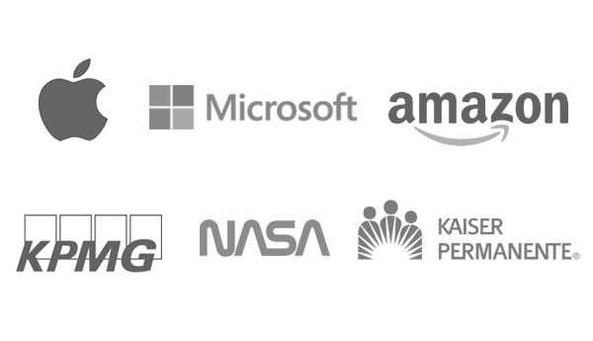


Once you’ve filled out the template, check to see how well it matches the job description on Jobscan
(Don’t forget to delete this when using)

Ayesha Abidi
City, State Zip • (555) 555-1234
ayeshaabidi@email.com • linkedin.com/in/your-name-here

Executive Summary

(Insert key strength(s)) (insert target job title) with (insert years of experience) in the (insert specialty/ industry) space. Specialties include (insert 3 – 5 areas of relevant expertise). A (insert key strength) (insert noun to describe yourself – i.e. leader, change agent, etc.) recognized for (insert key trait) and/ with (insert key trait) to (insert outcome – i.e. achieve goals, drive revenue, ensure operational efficiency, etc).

Highlights

- The above template is just one way to do it. Learn more about writing bold executive summaries
- Punctuate your summary with bullet point highlights for key achievements
- Mention your biggest gains and savings in terms of dollar amounts if possible
- Add any awards, honors, and designations you’ve earned as an executive

Professional Experience

Company 6, Location
Job Title MM/YYYY-Present

At the executive level, little attention should be paid to your day-to-day duties, work habits, or even hard skills. Instead, it’s all about results and impact. Under your leadership, what was the business able to achieve? What were your biggest initiatives? What bold moves did you make improve the company’s standing? How much did the business grow while you were in the position?
- Learn more about creating powerful, concise executive accomplishments
- Numbers and results. Executive recruiters need to know you’re going to move the needle
- For example: “Added $32M in new profit over 3 years by developing differentiated product line which decreased service time 50% for end users.”

Company 5, Location
Job Title MM/YYYY-Present

When applying for executive positions, you can’t lean on your hard skills as much as you did earlier in your career. Executive soft skills take on greater significance. Unfortunately, you can’t just say you have leadership and expect executive recruiters to believe you. You have to find a way to prove it. For example:
- Leadership: Ask yourself, what situations benefited the most from your timely leadership?
- Vision: When you mention your big ideas, initiatives, and accomplishments, demonstrate your vision by including the why and placing them in context of the bigger picture.
- Entrepreneurial: Think back to any pet projects you nurtured, departments you grew, or calculated risks that paid off big.

Company 4, Location
Job Title MM/YYYY-Present

Typically, we advise to keep your resume to one page if at all possible. But if you’ve been at it long enough to reach the C-suite -- particularly if it’s been 10+ years -- you deserve another page or two. Don’t worry too much about expanding beyond a single page as you show your career trajectory. That said, make sure to put your most important information and achievements on page one.
- Just because you can go beyond one page doesn’t mean you should take the opportunity to get overly wordy or dig into the mundane details of the work.
- Use short bullet points and strong accomplishments to keep your experience powerful and to-the-point.

Company 3, Location
Job Title MM/YYYY-Present

Your executive brand is important to executive recruiters. “I don’t care if it goes back 15 or 30 years,” an executive recruiter told Jobscan. “I just want to see that the resume is promoting a highly competent, proven executive who knows what they’re best at, where they want to go, and what they really want to do next in their career.”
- Find opportunities to show not only the end results, but how you identify opportunities and achieve results
- If possible, communicate your business values. Give the recruiter an idea of what you’ll want to accomplish first at this new job based on what you’re sharing about your previous jobs.

Company 2, Location
Job Title MM/YYYY-Present

As you get further back in your career to your roles as a manager or individual contributor, start to pepper in more of your hard skills and domain knowledge. Executive recruiters will like to gain an understanding of your career foundation.

Company 1, Location
Job Title MM/YYYY-Present

“What have you done for me lately?” You don’t need to include your entire career on your resume. If something is 15 or more years old, think hard about whether it adds to your candidacy or not, especially if age discrimination is a concern.

Education

Degree, Graduation Year (YYYY - Optional)
College Name, Location
List additional certifications obtained or relevant leadership or management trainings completed

