Optimize your resume to get more job interviews

This free resume template will help you write an ATS-friendly resume. But how do you know what the hiring manager is looking for? What skills and experience should you list to show you’re the best candidate?

Jobscan’s resume scanner helps you optimize your resume for each job listing so that your application is more attractive to recruiters and hiring managers.

An optimized resume leads to more responses, more interviews, and more offers for the jobs you really want.

“Honestly, it was like the floodgates opened. Within a week…I was absolutely flooded with contacts and people reaching out.” Kelly, South Carolina, Jobscan User

”It’s the greatest tool that I have seen when it comes to searching for jobs.” Mark Stark, Career Success Coach

“We’re seeing easily 30% or more increase in calls from recruiters when our students use Jobscan to tailor their resumes.” Jeffrey Stubbs, Director, Baylor University Career Center

It’s frustrating to apply for dozens of jobs and not get any interviews. Use Jobscan to optimize your resume, cover letter, and LinkedIn profile.

90% of Jobscan Premium users landed an interview.

Jobscan users have been hired by:

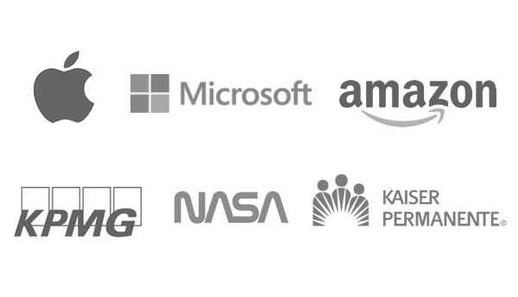


Once you’ve filled out the template, check to see how well it matches the job description on Jobscan
(Don’t forget to delete this when using)

Esther Kim
City, State Zip • (555) 555-1234 • estherkim@email.com • linkedin.com/in/your-name-here

Summary

Add a strong resume summary here that highlights what it is you do, the types of companies you’ve worked with, and why you’re great at your job. Experience, specializations, areas of interest, etc. Key skills include:

Skill 1 | Skill 2 | Skill 3 | Skill 4 | Skill 5 | Skill 6

Experience
Company 4, Location
Job Title, MM/YYYY-Present

When writing your experience section for a management position, be sure to focus on the teams you managed and the outcomes they were able to achieve.
- Use bullet points to highlight some of the most important things about your work.
- Tailor your resume by focusing on skills and accomplishments that relate to the job description, rather than simply listing your day-to-day duties.

Company 3, Location
Job Title, MM/YYYY-MM/YYYY

Try replacing some of your duties with accomplishments rather than duties. Remember, “duties tell, accomplishments sell.” To create a strong measurable result, try this format:
- [Action verb] [brief explanation of accomplishment] resulting in [quantifiable outcome. Using %, $, etc. will draw the eye and make an impact].

Company 2, Location
Job Title, MM/YYYY-MM/YYYY

Keep your sentences short and to the point. This will make it easier for a recruiter or hiring manager to read or skim.
- For your more recent positions, really play up your management skills.
- Your older positions will give you an opportunity to delve deeper into your technical know-how and hard skills.

Company 1, Location
Job Title, MM/YYYY-MM/YYYY

Recruiters like to see the arc of your career. Make sure your resume conveys how your responsibilities have increased from one stop to the next.
- It’s OK to leave certain positions off your resume if they aren’t relevant.

Education
Degree, Graduation Year (YYYY), College Name, Location

