Optimize your resume to get more job interviews

This free resume template will help you write an ATS-friendly resume. But how do you know what the hiring manager is looking for? What skills and experience should you list to show you’re the best candidate?

Jobscan’s resume scanner helps you optimize your resume for each job listing so that your application is more attractive to recruiters and hiring managers.

An optimized resume leads to more responses, more interviews, and more offers for the jobs you really want.

“Honestly, it was like the floodgates opened. Within a week…I was absolutely flooded with contacts and people reaching out.” Kelly, South Carolina, Jobscan User

”It’s the greatest tool that I have seen when it comes to searching for jobs.” Mark Stark, Career Success Coach

“We’re seeing easily 30% or more increase in calls from recruiters when our students use Jobscan to tailor their resumes.” Jeffrey Stubbs, Director, Baylor University Career Center

It’s frustrating to apply for dozens of jobs and not get any interviews. Use Jobscan to optimize your resume, cover letter, and LinkedIn profile.

90% of Jobscan Premium users landed an interview.

Jobscan users have been hired by:

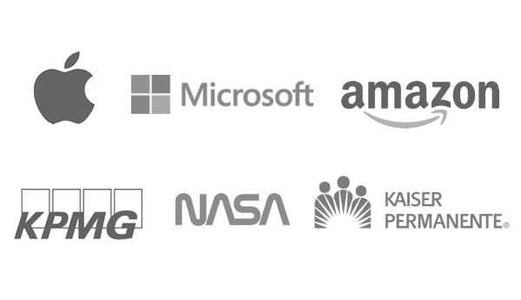


- BENJAMIN HENDERSON -
Use a strong headline. For example:
President and CEO: Manufacturing Start-Ups and Turnarounds
P&L up to $150M | Global Teams of 400+ | 300% Revenue Growth in 4 Years

City, State Zip • (555) 555-1234 • benhenderson@email.com • linkedin.com/in/your-name-here

- Learn how to write bold executive summaries (examples and templates)
- Include your target job title, industry/space, years of experience, and specialties.
- Highlight key achievements or career themes
PROFESSIONAL EXPERIENCE

Company 6, Location • Job Title MM/YYYY - Present
At the executive level, little attention should be paid to your day-to-day duties, work habits, or even hard skills. Instead, it’s all about results and impact. Under your leadership, what was the business able to achieve? What were your biggest initiatives? What bold moves did you make improve the company’s standing? How much did the business grow while you were in the position?
- Learn more about creating powerful, concise executive accomplishments
- Numbers and results. Executive recruiters need to know you’re going to move the needle
- For example: “Added $32M in new profit over 3 years by developing differentiated product line which decreased service time 50% for end users.”

Company 5, Location • Job Title MM/YYYY - MM/YYYY
When applying for executive positions, you can’t lean on your hard skills as much as you did earlier in your career. Executive soft skills take on greater significance. Unfortunately, you can’t just say you have leadership and expect executive recruiters to believe you. You have to find a way to prove it. For example:
- Leadership: Ask yourself, what situations benefited the most from your timely leadership?
- Vision: When you mention your big ideas, initiatives, and accomplishments, demonstrate your vision by including the why and placing them in context of the bigger picture.
- Entrepreneurial: Think back to any pet projects you nurtured, departments you grew, or calculated risks that paid off big.
- Innovation: Compile the best examples and stories from your past experience in which you changed operating procedure, streamlined processes, consolidated systems, or mined a previously untapped sector of the market.

Company 4, Location • Job Title MM/YYYY - MM/YYYY
Typically, we advise to keep your resume to one page if at all possible. But if you’ve been at it long enough to reach the C-suite -- particularly if it’s been 10+ years -- you deserve another page or two. Don’t worry too much about expanding beyond a single page as you show your career trajectory. That said, make sure to put your most important information and achievements on page one.
- Just because you can go beyond one page doesn’t mean you should take the opportunity to get overly wordy or dig into the mundane details of the work.
- Use short bullet points and strong accomplishments to keep your experience powerful and to-the-point.

Company 3, Location • Job Title MM/YYYY - MM/YYYY
Your executive brand is important to executive recruiters. “I don’t care if it goes back 15 or 30 years,” an executive recruiter told Jobscan. “I just want to see that the resume is promoting a highly competent, proven executive who knows what they’re best at, where they want to go, and what they really want to do next in their career.”
- Find opportunities to show not only the end results, but how you identify opportunities and achieve results
- If possible, communicate your business values. Give the recruiter an idea of what you’ll want to accomplish first at this new job based on what you’re sharing about your previous jobs.

Company 2, Location • Job Title MM/YYYY - MM/YYYY
As you get further back in your career to your roles as a manager or individual contributor, start to pepper in more of your hard skills and domain knowledge. Executive recruiters will like to gain an understanding of your career foundation.
Company 1, Location • Job Title MM/YYYY - MM/YYYY
“What have you done for me lately?” You don’t need to include your entire career on your resume. If something is 15 or more years old, think hard about whether it adds to your candidacy or not, especially if age discrimination is a concern.

EDUCATION

Degree • College Name, Location
Graduation Year (YYYY - Optional)
List additional certifications obtained or relevant leadership or management trainings completed

