SENG 430 · Software Quality Assurance

Weekly Progress Report
Sprint 2 · Week 2

HEALTH-AI ML Visualisation Tool

Group Name | Junior Engineers | Week | Week 2 (Sprint 2)
Scrum Master | Elif Istanbulluoğlu | Date Submitted | 18 March 2026
Domains Implemented | 20 / 20 (all domains complete) | Sprint Goal | Complete Steps 2 & 3 user stories

Burndown Chart
1

The Jira burndown chart for Sprint 2 (5–18 Mar). The red line (remaining work) stayed near zero for most of the sprint as story points were logged late in Jira, then spiked to ~35 pts on 17 Mar when all in-progress tickets were added. The ideal guideline (grey dashed) shows the expected linear burn rate.
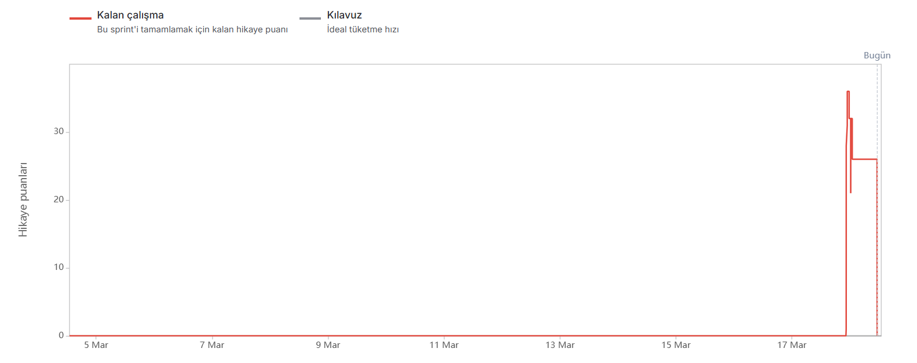
Jira Sprint 2 Burndown Chart — Remaining story points vs. ideal burn rate.

.

Completed This Week
2

21 user stories moved to Done this week, totalling 51 story points.

Jira ID | US ID | Title | Points | Status
SCRUM-25 | US-001 | Select medical specialty from domain pill bar | 3 | DONE
SCRUM-26 | US-002 | Confirm specialty switch and reset pipeline | 3 | DONE
SCRUM-27 | US-003 | Display privacy notice on all screens | 2 | DONE
SCRUM-28 | US-004 | Display clinical problem, population, and predicted outcome | 2 | DONE
SCRUM-29 | US-005 | Use built-in example dataset | 3 | DONE
SCRUM-30 | US-006 | Upload custom CSV dataset | 3 | DONE
SCRUM-32 | US-008 | Enforce CSV size limit | 1 | DONE
SCRUM-31 | US-007 | Validate CSV file format and requirements | 3 | DONE
SCRUM-33 | US-009 | Enforce minimum dataset size | 1 | DONE
SCRUM-34 | US-010 | Require at least one numeric measurement column | 1 | DONE
SCRUM-35 | US-011 | Display column summary with missing value indicators | 3 | DONE
SCRUM-36 | US-012 | Display outcome distribution | 2 | DONE
SCRUM-37 | US-013 | Display class imbalance warning | 2 | DONE
SCRUM-38 | US-014 | Map target and measurement columns | 5 | DONE
SCRUM-39 | US-015 | Gate Step 3 until Column Mapper is saved | 3 | DONE
SCRUM-40 | US-016 | Adjust training and testing split | 3 | DONE
SCRUM-41 | US-017 | Select missing value handling strategy | 3 | DONE
SCRUM-42 | US-018 | Select normalization method | 3 | DONE
SCRUM-43 | US-019 | Enable SMOTE for class imbalance when relevant | 5 | DONE
SCRUM-44 | US-020 | Apply preparation settings and show before/after comparison | 5 | DONE
SCRUM-45 | US-021 | Gate Step 4 until Step 3 is validated | 2 | DONE

SCRUM-33 | US-009 | Enforce minimum dataset size | 1 | DONE
SCRUM-35 | US-011 | Display column summary with missing value indicators | 3 | DONE
SCRUM-36 | US-012 | Display outcome distribution | 2 | DONE
SCRUM-37 | US-013 | Display class imbalance warning | 2 | DONE
SCRUM-41 | US-017 | Select missing value handling strategy | 3 | DONE
 |  | Total | 51

Jira Board — Current Sprint state
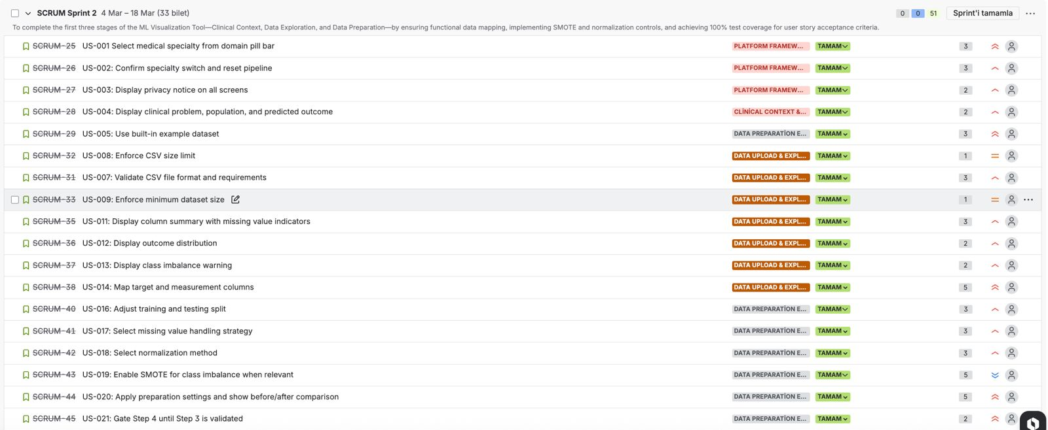
Jira Sprint 2 board: TAMAM = Done, DEVAM EDiYOR = In Progress, iNCELEMEDE = In Review.

In Progress
3

There are no stories currently in progress. All user stories (US-001 to US-021) have been completed this week.

Blocked / At Risk
4

No blockers identified this week. All team members are able to continue their assigned tasks.

Story | Blocker | Risk Level | Resolution Plan
— | No blockers | LOW | N/A

Key Decisions Made
5

Architecture Change — React to HTML/CSS/JS:
The team decided to replace the initially planned React frontend with a plain HTML, CSS, and Vanilla JavaScript stack. This removes the build-tool dependency (npm/Webpack), simplifies deployment to a single static file served via URL or localhost, and reduces onboarding friction for team members less familiar with React's component model.

SMOTE Applied to Training Split Only:
It was confirmed that SMOTE oversampling will be applied exclusively to the training partition after the train/test split, leaving the test set untouched. This prevents data leakage and ensures evaluation metrics reflect true model generalisation on unseen data.

Identifier Column Detection Client-Side:
The heuristic for detecting and excluding identifier-type columns (e.g. patient ID) was implemented entirely in the browser via analyseCSV() rather than as a separate backend step, keeping PII-adjacent logic local and avoiding unnecessary server round-trips for a feature that requires no ML computation.

Test Results
6

All completed stories have been manually tested against their acceptance criteria. Full screenshot evidence is included in the separate Manual Test Report (SENG384_Test_Report.pdf).

US ID | Title | AC Status | Evidence
US-005 | Use built-in example dataset | PASS | TR_008, TR_009, TR_010
US-007 | Validate CSV file format and requirements | PASS | TR-023, TR_029, TR_030, TR_031
US-009 | Enforce minimum dataset size | PASS | TR_029
US-011 | Display column summary with missing values | PASS | TR_009
US-012 | Display outcome distribution | PASS | TR_008, TR_015
US-013 | Display class imbalance warning | PASS | TR_015
US-017 | Select missing value handling strategy | PASS | TR_017

Sprint Metrics
7

Metric | Value
Sprint | Sprint 2
Sprint Duration | 5 Mar – 18 Mar 2026 (2 weeks)

Total Story Points Planned | 51 pts
Story Points Completed (Done) | 51 pts
Story Points In Progress | 0 pts
User Stories Done This Week | 21 stories
User Stories In Progress | 0 stories
Domains Implemented (Cumulative) | 20 / 20 (100%)
Blockers | 0
CSV Upload Success Rate (manual) | 100% — 5/5 valid accepted, 5/5 invalid rejected
Column Mapper Gate | 0 bypass bugs confirmed
Step 3 Controls | All dropdowns + slider functional
Test Coverage (done stories) | 100% — all 7 done stories have passing test cases

Next Week Plan
8

The following stories are planned for Week 3. Assignees to be confirmed at sprint planning.

US ID | Title | Points | Assignee
US-022 | Select one of six ML models | 3 | [To be assigned]
US-023 | Enable Auto-Retrain by default | 3 | [To be assigned]
US-024 | Provide manual training option when Auto-Retrain is disabled | 5 | [To be assigned]
US-025 | Add trained models to comparison table | 3 | [To be assigned]
US-026 | Gate Step 5 until a model is trained | 2 | [To be assigned]
US-027 | Display performance measures with plain-language explanations | 5 | [To be assigned]
US-028 | Display confusion matrix with clinical labels | 3 | [To be assigned]
US-029 | Display ROC curve with interpretation guidance | 3 | [To be assigned]
US-030 | Display low-sensitivity warning | 2 | [To be assigned]
US-031 | Gate Step 6 until Step 5 results are available | 2 | [To be assigned]

Retrospective Note (Week 2 — Even Week)
9

Two retrospective boards were completed by the team this sprint. Combined insights are summarised below.
- Architecture discussion before coding
- Early GitHub setup before heavy development
- Clear role distribution

- Strong Domain Integration

- Early testing of UI components

- Clear task breakdown in Jira
KEEP
- Some tasks were not clearly broken into smaller subtasks
- Technical stack decisions were discussed too late in the sprint
- Strong GitHub collaboration

- Documentation Speed

- UI/Backend integration timing
IMPROVE
- Short mid-sprint sync meeting (15 minutes)
- Start adding basic unit structure for ML pipeline early
- Create task breakdown template before sprint planning
- Prepare sample datasets for testing
- Automate some test cases
TRY

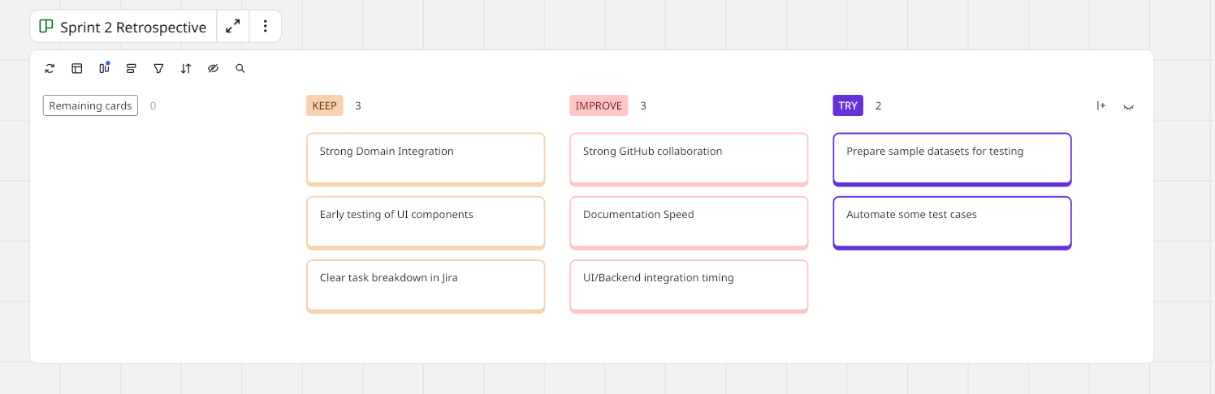

Retrospective board screenshot — Sprint 2) retros.

