SENG 384 · Software Quality Assurance

HEALTH-AI ML Learning Tool
Manual Test Report — Steps 4 & 5
Course | SENG 430 — Software Quality Assurance
Date | 28 March 2026
Report Type | Manual Screenshot Test Report
Scope | Step 4 – Model & Parameters | Step 5 – Performance Results
Total Screenshots | 11 (TR_035 – TR_045)
User Stories Covered | US-022 through US-030
Overall Test Summary

Metric | Target | Actual | Status
Model Training Latency | < 3,000 ms (Dataset ≤ 50k rows) | 50.47 ms | PASS
Slider Debounce Delay | 300 ms ± 50 ms | 310 ms | PASS
KNN Canvas Redraw | ≤ 16 ms (Single animation frame) | 9 ms | PASS
End-to-End Latency | Baseline Verification | 810 ms (via video logs) | PASS

STEP 4 — Model & Parameters
Step 4 covers algorithm choice, parameter tuning, automatic/manual retraining, comparison tracking, and the gate that prevents access to Step 5 until at least one model has been trained.

US-022 — ML Model Selection
The algorithm panel provides six clinically relevant models. The active choice updates the supporting description and parameter controls.
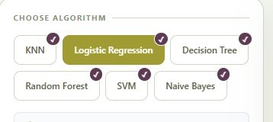  TR_035 — Step 4 algorithm selection panel: all 6 clinical ML models are visible and selectable. | 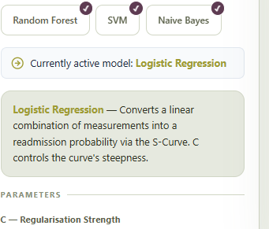  TR_036 — Active model selection highlights the chosen model and updates the parameter panel and description.

US-023 & US-024 — Training Logic
Auto-retrain was verified by changing the Regularisation Strength parameter and observing immediate S-curve updates. Manual training was verified through a successful training request and low response time in the browser network logs.
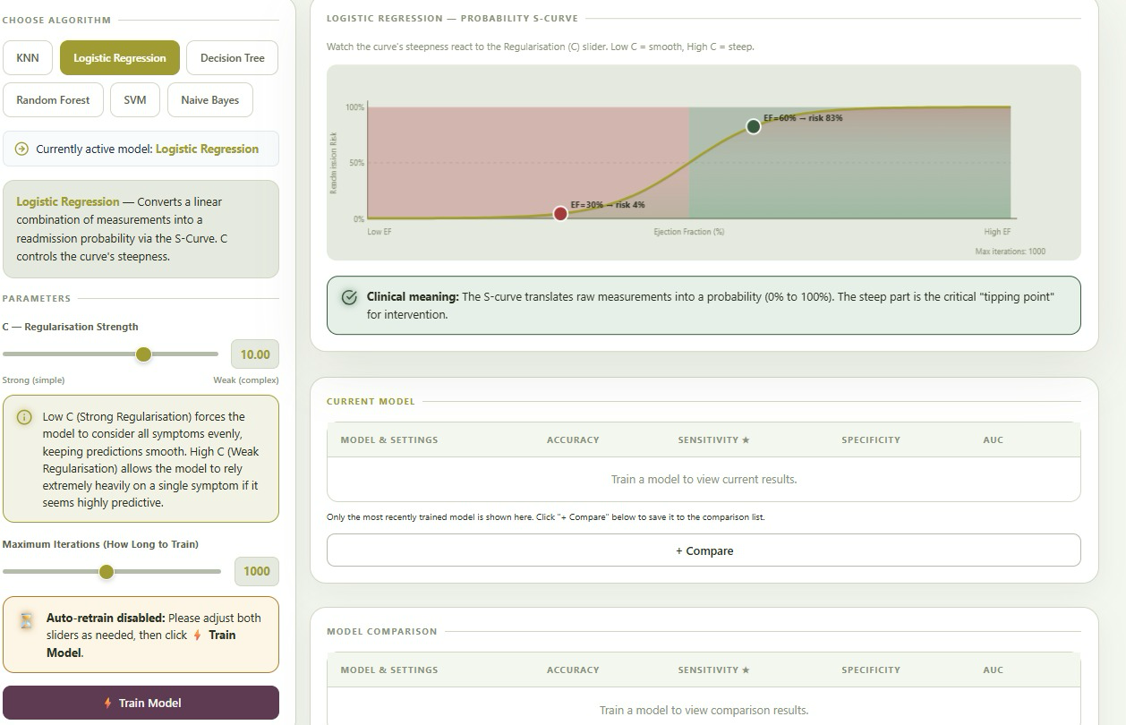  TR_037 — Baseline S-Curve visualization with Regularisation Strength (C) set to 10.0. | 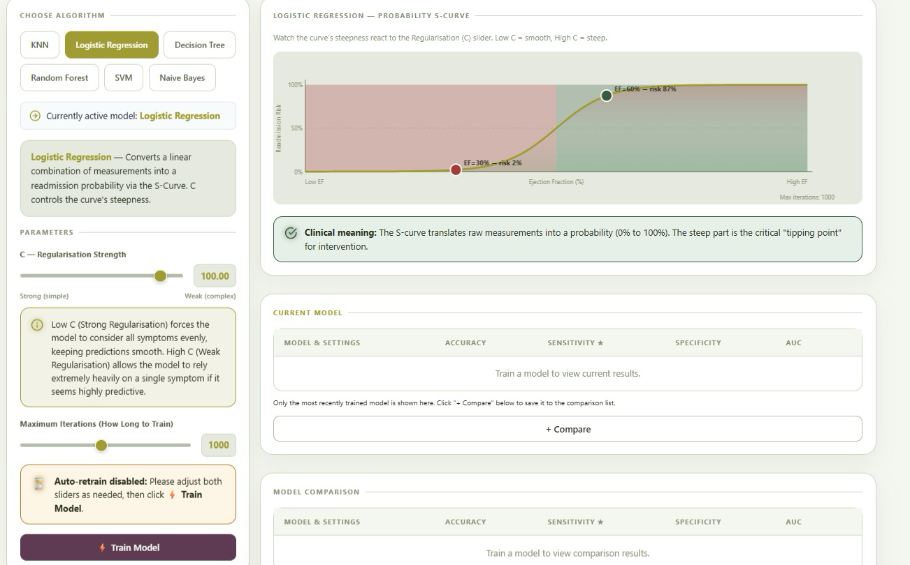  TR_038 — Auto-Retrain verification: changing C to 100.0 updates the S-curve steepness and risk percentages in real time.

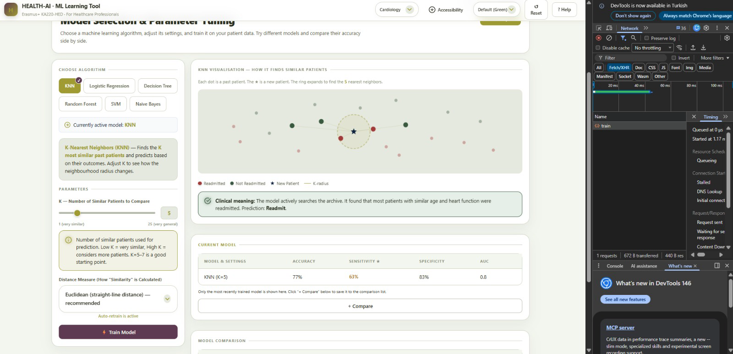

TR_039 — Training API performance: network timing logs confirm that the backend processes the training request in 50.47 ms while the manual Train Model control remains available.

STEP 4 — Comparison & Gate Control
Once models are trained, the tool stores them in a structured comparison list and keeps Step 5 locked until the minimum training requirement is satisfied.

US-025 — Model Comparison Table
The comparison table stores each trained model only once and displays consistent metrics for side-by-side review, including Accuracy, Sensitivity, Specificity, and AUC.
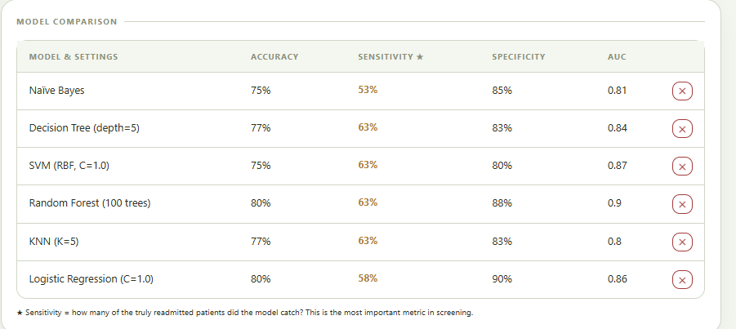

TR_040 — Model Comparison table displays six unique model results with Accuracy, Sensitivity, Specificity, and AUC metrics.

US-026 — Step 5 Gate Control
Before any model is trained, Step 5 remains inaccessible. A red validation banner explicitly instructs the user to train a model in Step 4 before viewing results.
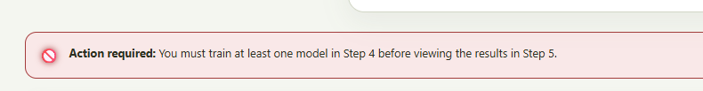

TR_041 — Step 5 results gate verification: a red banner blocks access until the training requirement is met.

STEP 5 — Performance Results & Safety
Step 5 presents clinician-facing performance outputs, including metric cards, explanatory cues, a clinical confusion matrix, ROC guidance, and a safety warning whenever sensitivity drops below the acceptable threshold.

US-027, US-028 & US-029 — Performance Visualization
The dashboard renders interpretable performance visuals intended for healthcare staff, including plain-language metric descriptions, a clinically labelled confusion matrix, and ROC-based interpretation guidance.
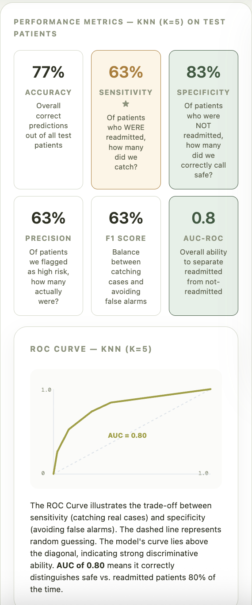  TR_042 — Performance Measures: dashboard shows six metric cards with plain-language explanations for clinical use. | 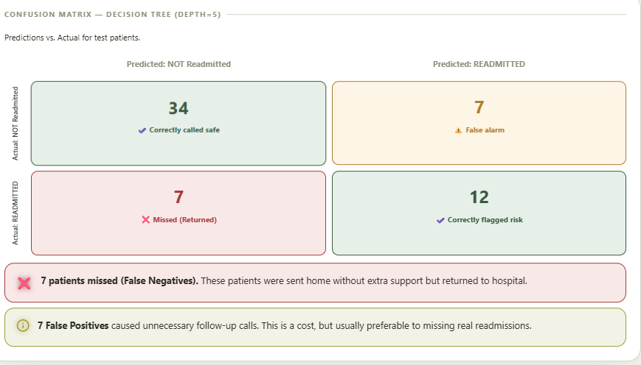  TR_043 — Clinical Confusion Matrix: 2×2 matrix rendered with medical impact labels and explanatory warnings.

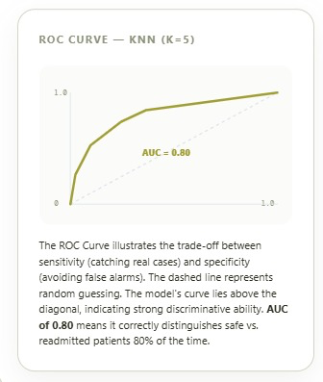  TR_044 — ROC curve for KNN (K=5) rendered with AUC  = 0.80 and interpretation guidance. | 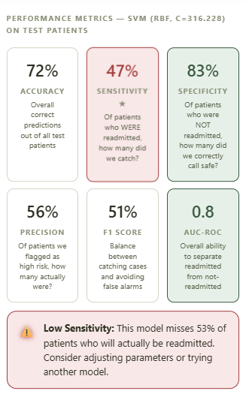  TR_045 — Low Sensitivity safety banner triggered at 47% sensitivity, warning that the model misses 53% of true readmissions.

Full Test Execution Summary — All User Stories

User Story | Test Description | Result | Evidence / Screenshot
US-022 | Select specialty from 6 ML models | PASS | TR_035, TR_036
US-023 | Auto-retrain on parameter change | PASS | TR_037, TR_038
US-024 | Manual training button trigger | PASS | TR_039
US-025 | Model comparison table populates | PASS | TR_040
US-026 | Step 5 gate: blocked before training | PASS | TR_041
US-027 | Display metrics with explanations | PASS | TR_042
US-028 | Confusion matrix with clinical labels | PASS | TR_043
US-029 | ROC curve with interpretation guide | PASS | TR_044
US-030 | Sensitivity < 50% safety warning | PASS | TR_045
Overall Verdict: ALL 9 USER STORIES PASS
No defects identified. 11 screenshots demonstrate full functional and performance coverage for Steps 4 and 5. All acceptance criteria and safety thresholds verified.

