Software Requirements Specification (SRS)
Team name: CoreStack (Group G1, Section-1)
Version: ☒ First version (Week 6) ☐ Final (Week 10)
Last updated: 2026-10-25
Project: Gelişim Ağı – AI-Assisted Child Development Platform
Team member | Role
Ceren Gökdere | Developer
Elif İstanbulluoğlu | Project Manager
Aytuğ Saygı | Tester

Repository: https://github.com/cgokdere/core-stack · CI: https://github.com/cgokdere/core-stack/actions/workflows/ci.yml

1. Introduction
Purpose of the system (2–3 sentences):
Gelişim Ağı is a web platform that gives a child's parent, the child's specialists and the child one shared weekly
schedule, one task list and one record of observations and documents. For each week it shows statistics and an
AI-generated summary written for the parent or the specialist. The summary supports their decisions and never makes them.
Users of the system:
User type | Description
Parent | Logs in, sees their own children, links and unlinks specialists, adds schedule events, assigns tasks, uploads and views documents, reads specialist entries, views weekly statistics and reads and rates the parent version of the AI summary.
Specialist (teacher, psychologist, doctor, special education teacher, coach) | Logs in and works only with children they are linked to: adds schedule events, assigns tasks, writes and edits their own entries, uploads and views documents, views weekly statistics and reads and rates the specialist version of the AI summary.
Child | Logs in, sees their own weekly schedule and task list and marks their own tasks as done.

An external AI service (Gemini or GitHub Models, or a built-in mock) is a supporting system, not a user.
Scope, status and assumptions:
All requirements below describe the system planned for v1.0 (Week 12). As of this version the repository has the
walking skeleton (a health check through every layer), the complete database schema with synthetic seed data, and
CI. No requirement in Section 2 is available to users yet. Only the schema constraints behind FR-M1-02, FR-M1-06,
FR-M2-02 and FR-M4-03 exist. The SDD records the status of each module.
Requirements without a mark follow from the Jira task titles (docs/JIRA_PLAN.md), the database schema, the
backend configuration or the project description. Requirements marked † contain a detail that none of these
settles. They are proposals and the team must confirm them:
- Accounts are created by the seed script. The first version has no self-registration and no screen for creating children (FR-M1-01).
- Session length is not decided. 8 hours is proposed (FR-M1-04).
- The login error is generic, so it does not reveal whether the e-mail address exists (FR-M1-03).
- A parent identifies the specialist to link by the specialist's registered e-mail address (FR-M2-01).
- Only the parent links, lists and unlinks specialists (FR-M2-01, FR-M2-03, FR-M2-04).
- The parent and linked specialists, not the child, add events, assign tasks and upload documents (FR-M3-02, FR-M4-01, FR-M6-01).
- The child sees only their own schedule and tasks (FR-M3-05). The child has no access to entries, documents, statistics or AI summaries. The README says "an AI summary for each role", but the Jira plan has prompts only for parents and specialists (CST-52).
- Only the child can mark a task as done (FR-M4-06).
- Weeks run Monday to Sunday (FR-M3-01, FR-M7-01, FR-M8-01).
- Accepted upload types are PDF, JPEG and PNG (FR-M6-03). The 10 MB limit (FR-M6-02) comes from the backend configuration.
- The statistics metrics are proposed (FR-M7-01 – FR-M7-05). The Jira plan names only a "statistics service".
- Smaller interface and validation details are proposed: week navigation, end-after-start check, newest-first entries, and the empty-week and AI-error behaviour (FR-M3-03, FR-M3-04, FR-M5-03, FR-M8-05, FR-M8-07).

2. Functional Requirements
Priority: Must (required for v1.0) / Should (planned) / Could (if time allows). Areas used throughout (from backend/src/constants.js): academic, social, health, sport.

M1 – Login and roles
ID | Requirement | Priority
FR-M1-01 † | The system shall allow a registered user to log in with an e-mail address and a password. | Must
FR-M1-02 | The system shall treat e-mail addresses as case-insensitive during login. | Must
FR-M1-03 † | The system shall reject a login with an unknown e-mail address or a wrong password and show one generic error message that does not reveal which of the two was wrong. | Must
FR-M1-04 † | The system shall keep a user logged in for subsequent requests until the user logs out or the session expires. | Must
FR-M1-05 | The system shall allow a logged-in user to log out. | Must
FR-M1-06 | The system shall give every user exactly one role: parent, specialist or child. | Must
FR-M1-07 | The system shall show each role, after login, only the screens and actions permitted for that role. | Must
FR-M1-08 | The system shall refuse any request for protected data or actions that is not made by a logged-in user. | Must
FR-M1-09 | The system shall refuse an action when the logged-in user's role is not permitted to perform it. | Must

M2 – Linking specialists
ID | Requirement | Priority
FR-M2-01 † | The system shall allow a parent to link a registered specialist to one of their own children, recording the specialty (teacher, psychologist, doctor, special education, coach). | Must
FR-M2-02 | The system shall prevent the same specialist from being linked to the same child more than once. | Must
FR-M2-03 † | The system shall show a parent the specialists linked to their child with name, specialty and link date. | Must
FR-M2-04 † | The system shall allow a parent to unlink a specialist from their child only after the parent confirms the action. | Must
FR-M2-05 | The system shall show a parent the children registered to them and a specialist the children linked to them, so that the user can select a child. | Must
FR-M2-06 | The system shall give a user access to a child's data only if the user is that child's parent, a specialist currently linked to that child, or the child. | Must
FR-M2-07 | The system shall revoke a specialist's access to a child's data as soon as the specialist is unlinked. | Must

M3 – Weekly schedule
ID | Requirement | Priority
FR-M3-01 † | The system shall display a child's events for one selected calendar week, grouped by day. | Must
FR-M3-02 † | The system shall allow the parent or a linked specialist to add an event to a child's schedule with a title, a start date and time, an optional end date and time, and an area. | Must
FR-M3-03 † | The system shall reject an event whose title, start or area is missing, or whose end is before its start, and show which field is invalid. | Must
FR-M3-04 † | The system shall allow the user to move to the previous and the next week in the schedule view. | Should
FR-M3-05 † | The system shall show a child their own weekly schedule without the ability to change it. | Must

M4 – Tasks
ID | Requirement | Priority
FR-M4-01 † | The system shall allow the parent or a linked specialist to assign a task to a child with a title, an optional description, an area and a due date. | Must
FR-M4-02 | The system shall reject a task whose title, area or due date is missing and show which field is invalid. | Must
FR-M4-03 | The system shall give every new task the status "to do". | Must
FR-M4-04 | The system shall show a child their own tasks with title, description, area, due date and status. | Must
FR-M4-05 | The system shall allow a child to mark one of their own "to do" tasks as done and record the time of completion. | Must
FR-M4-06 † | The system shall prevent any user other than the child from marking a task as done. | Must
FR-M4-07 | The system shall show the parent and linked specialists a child's tasks with status, the user who assigned each task and the completion time. | Must

M5 – Specialist entries
ID | Requirement | Priority
FR-M5-01 | The system shall allow a linked specialist to add an entry for a child with a date, a title, a text body and an area. | Must
FR-M5-02 | The system shall reject an entry whose date, title, body or area is missing and show which field is invalid. | Must
FR-M5-03 † | The system shall show the parent and linked specialists a child's entries, newest first, with author name, author specialty and entry date. | Must
FR-M5-04 | The system shall allow the author of an entry to edit its date, title, body and area. | Must
FR-M5-05 | The system shall mark an edited entry as "edited" and show the time of the last edit to everyone who can see the entry. | Must
FR-M5-06 | The system shall prevent users from editing entries written by someone else. | Must

M6 – Documents
ID | Requirement | Priority
FR-M6-01 † | The system shall allow the parent or a linked specialist to upload a file for a child with a document type (report, evaluation, health, form, other). | Must
FR-M6-02 | The system shall reject an uploaded file larger than 10 MB with an error message stating the limit. | Must
FR-M6-03 † | The system shall reject an uploaded file whose type is not PDF, JPEG or PNG with an error message listing the accepted types. | Must
FR-M6-04 | The system shall list a child's documents with original file name, document type, uploader, upload date and size. | Must
FR-M6-05 | The system shall allow a user with access to the child to download a document under its original file name. | Must
FR-M6-06 | The system shall allow a user with access to the child to open a PDF or image document in the browser without downloading it first. | Should

M7 – Weekly statistics
ID | Requirement | Priority
FR-M7-01 † | The system shall show the parent and linked specialists, for one child and one selected week, the number of tasks due and the number of those tasks completed, per area. | Must
FR-M7-02 † | The system shall show the task completion rate of the selected week as a percentage. | Should
FR-M7-03 † | The system shall show the number of events per area in the selected week. | Should
FR-M7-04 † | The system shall show the number of specialist entries per area in the selected week. | Should
FR-M7-05 † | The system shall show zero values instead of an error when the selected week contains no records. | Should

M8 – Role-based AI summary
ID | Requirement | Priority
FR-M8-01 | The system shall generate, on request by a parent, a summary of a child's tasks, events and entries for a selected week, written for the parent. | Must
FR-M8-02 | The system shall generate, on request by a linked specialist, a summary of a child's tasks, events and entries for a selected week, written for a specialist. | Must
FR-M8-03 | The system shall show with each summary the list of records (tasks, events, entries) the summary is based on. | Must
FR-M8-04 | The system shall label every summary as AI-generated and state that it supports but does not replace the user's own decisions. | Must
FR-M8-05 † | The system shall tell the user that no summary can be produced when the selected week has no tasks, events or entries. | Should
FR-M8-06 | The system shall be able to generate summaries in a mock mode that does not contact any external AI service. | Must
FR-M8-07 † | The system shall show an error message when the external AI service fails or does not answer, and leave the rest of the application usable. | Should
FR-M8-08 | The system shall allow the parent or specialist to rate a summary as "helpful" or "incorrect" and store the rating with the child, the user, the role and the week. | Should

3. Non-Functional Requirements
Thresholds marked (proposed) are targets the team still has to confirm. No threshold has been measured yet.
ID | Category | Requirement
NFR-01 | Security | The system shall store passwords only as bcrypt hashes (already done by the seed script). Every API endpoint except the health check and login shall reject requests without a valid session with HTTP 401, and requests for a child the user may not access with HTTP 403. Measure: no plain-text password in the database, and an automated test for 401 and 403 on every child route.
NFR-02 | Security / privacy | The repository, seed data and demos shall contain only synthetic personal data (as backend/src/seed.js does now). (proposed) When an external AI service is used, the system shall send it only the selected child's records for the selected week, never e-mail addresses or password hashes. Measure: review of the seed script and the AI prompt builder before each release.
NFR-03 | Reliability | The system shall answer every API error with a JSON body that contains an error field and a 4xx/5xx status code (done for unknown /api paths). The CI pipeline shall pass before any pull request is merged into main. Measure (from the sprint plan): branch coverage at least 40% at v0.2 and at least 60% at v1.0, and end-to-end tests for the three critical flows at v0.2.
NFR-04 | Performance (proposed) | On the seeded data set, measured on a developer laptop, 95% of non-AI API requests shall complete within 500 ms. An AI summary shall complete within 2 s in mock mode and within 15 s with an external provider.
NFR-05 | Usability and compatibility | The user interface shall be in Turkish (the page language is already tr). The backend shall run on Node.js 22 or newer without a separate database server (CI runs on Node.js 22). (proposed) Every main screen shall be usable on current Chrome, Firefox and Safari at widths of 360 px and 1280 px, with visible labels on all form fields and full keyboard operation, checked manually before each release.

4. Critical Flows and Acceptance Criteria
The demo accounts below are the synthetic accounts created by npm run seed.
Flow | Related requirements | Acceptance criteria
Flow 1: Log in and open the role's home screen | FR-M1-01, FR-M1-02, FR-M1-03, FR-M1-04, FR-M1-07, FR-M1-08, FR-M1-09, FR-M2-05 | 1. Given the parent account selin.yildiz@example.com with password Password123! When the user logs in with Selin.Yildiz@example.com and that password Then the system logs the user in and shows the parent home screen with the child "Deniz Yıldız".  2. Given a registered account When the user logs in with a wrong password or an unknown e-mail address Then the system shows the same generic error in both cases and does not log the user in.  3. Given a user who is not logged in When the user requests any child's schedule, tasks, entries, documents, statistics or AI summary Then the system refuses the request and shows the login screen.  4. Given a logged-in child When the child tries a parent-only action such as linking a specialist Then the system refuses the action.
Flow 2: Assign a task and complete it as the child | FR-M2-06, FR-M4-01, FR-M4-02, FR-M4-03, FR-M4-04, FR-M4-05, FR-M4-06, FR-M4-07 | 1. Given a specialist linked to a child When the specialist assigns a task with title "Read 10 pages", area "academic" and a due date Then the task appears in the child's task list with the status "to do".  2. Given the assign form When the title, area or due date is missing Then the system creates no task and shows which field is missing.  3. Given a specialist who is not linked to the child When the specialist tries to assign a task to that child Then the system refuses the request and creates no task.  4. Given a logged-in child with a "to do" task When the child marks it as done Then its status becomes "done", the completion time is recorded, and the parent and linked specialists see the new status.  5. Given a parent or specialist viewing the child's tasks When they try to mark a task as done Then the system refuses the action and the status stays "to do".
Flow 3: View and rate the weekly AI summary | FR-M2-06, FR-M8-01, FR-M8-02, FR-M8-03, FR-M8-04, FR-M8-05, FR-M8-06, FR-M8-07, FR-M8-08 | 1. Given a parent whose child has tasks, events or entries in the selected week, and the AI service in mock mode When the parent opens the AI summary for that week Then the system shows a summary written for the parent, labelled as AI-generated, with the list of records it is based on.  2. Given a linked specialist and the same week When the specialist opens the AI summary Then the system shows the specialist version with its own source list.  3. Given a week with no tasks, events or entries When the user opens the AI summary Then the system says there is nothing to summarise and does not call the AI service.  4. Given an external AI service that returns an error or does not answer When the user opens the AI summary Then the system shows an error message and the other tabs keep working.  5. Given a summary on screen When the user rates it "helpful" or "incorrect" Then the system stores the rating for that child, user, role and week and confirms it.

5. Use Case Diagram
Mermaid has no UML use case notation, so the diagram below is a flowchart: actors on the left, use cases (grouped by
module) in the system boundary, and the external AI service on the right.
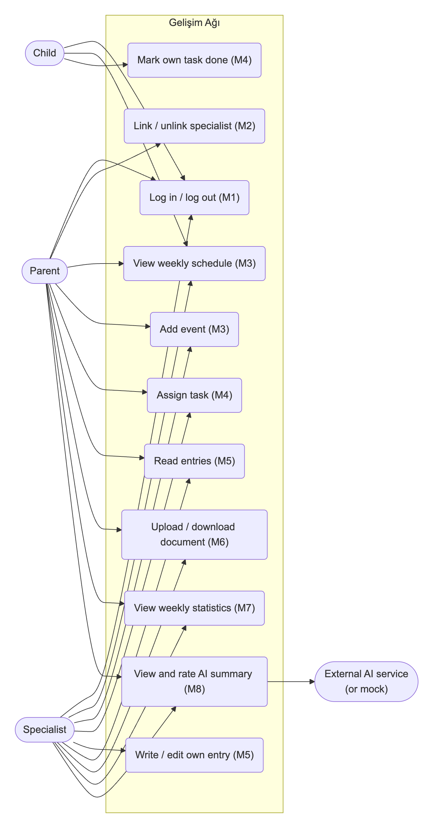

6. Change Log
Date | Change | By
2026-10-25 | First version: user types, functional requirements for M1–M8, non-functional requirements, three critical flows with acceptance criteria and use case diagram (CST-22). | Ceren Gökdere
2026-10-25 | Aligned the layout with the instructor's SRS template. Marked every requirement detail not settled by the Jira plan, schema or configuration with † and listed it under Scope, status and assumptions. | Ceren Gökdere

