the report of pedestrians walking around Melbourne

chenjie Gong

23/07/2020

library("rwalkr")  
start_date=as.Date("2017-07-01")  
ped_walk=melb_walk(from = start_date, to = start_date + 6L)  
library("ggplot2")  
ggplot(data=subset(ped_walk, Sensor == "Melbourne Central")) +  
 geom_point(aes(x = Time, y = Count),shape=I('triangle'))

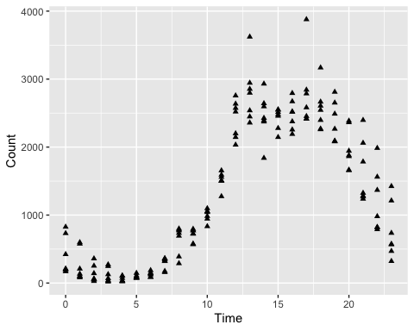 Through one day of observation, the number of pedestrians between 11 am and 5 pm *table*

|  |  |  |  |  |
| --- | --- | --- | --- | --- |
| Sensor | Date_Time | Date | Time | Count |
| Southern Cross Station | 2017-07-01 | 2017-07-01 | 0 | 35 |
| Victoria Point | 2017-07-01 | 2017-07-01 | 0 | 27 |
| Waterfront City | 2017-07-01 | 2017-07-01 | 0 | 2 |
| New Quay | 2017-07-01 | 2017-07-01 | 0 | 48 |
| Flagstaff Station | 2017-07-01 | 2017-07-01 | 0 | 0 |
| Sandridge Bridge | 2017-07-01 | 2017-07-01 | 0 | 229 |
| State Library | 2017-07-01 | 2017-07-01 | 0 | 334 |
| *equation* |  |  |  |  |
| $$J_(x) = _{m=0 | }^ | c{(-1)^m}{m! |  | (m + + 1)} {({ })}^{2m + } $$ |
| #end# |  |  |  |  |