**DERIVATIVES**

Table of Contents

Reading 50: Fixed-Income Securities: Defining Elements 3

a. Describe basic features of a fixed-income security 3

b. Describe content of a bond indenture 3

c. Compare affirmative and negative covenants and identify examples of each 3

d. Describe how legal, regulatory and tax considerations affect the issuance and trading of fixed income securities 3

# Reading 56: Derivatives Markets and Instruments

## Define a derivative and distinguish between exchange-traded and over-the-counter derivatives

Derivative -> security which value is derived from the value or return of another asset.

Exchange trade derivatives -> standardized and backed by a clearinghouse.

OTC -> dealer market with no central location and are not standardized.

## Contrast forward commitments with contingent claims

Forward commitment -> legally binding promise to perform some action in the future.

Contingent claim -> Claim that depend on a particular event (like options).

## Define forward contracts, futures contracts, options, swaps and credit derivatives and compare their basic characteristics

**Forward contracts**

One party agrees to buy and the other to sell in the future. Typically, at the beginning of the contract, no payments are made.

Deliverable forward: the short party will have to deliver the asset to the long party.

Cash-settled forward (contracts for differences or non-deliverable forwards NDFs): one party pays cash to other based on the difference between the forward price and the market price (spot price) at the settlement date.

**Future contracts**

Is standardized and exchange traded. They are traded in an active secondary market, subject to greater regulation, backed by a clearinghouse and require daily cash settlement of gains and losses.

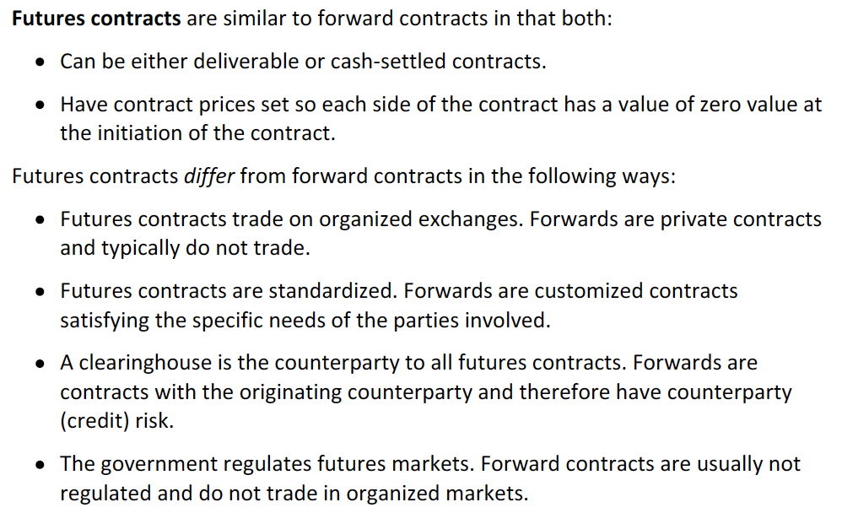

The exchange sets a minimum price fluctuation (tick size), daily price move limit, settlement date and the trading times.

Settlement price: is an average of the prices of the trades during the last period of trading (closing period), which is set by the exchange. This price is used to calculate the daily gain or loss at the end of each trading day. On the settlement date, the settlement price is equal to the spot price of the underlying asset (por que los precios convergen al final?).

Open interest: number of future contracts of a specific kind.

Clearinghouse: guarantees that obligations will be honored. It acts as the opposite part of the party (buyer for a seller and seller for a buyer) so that either side can reverse its position without having to contact the other side.

** You are not buying the contract, you are entering into de contract.

Margin: a performance guarantee that must be deposited before entering into a contract. Mark to market is the process through which the margins are adjusted to each day’s settlement price. The margin is about one day’s maximum price fluctuation on the total value of the assets covered by the contract.

Maintenance margin: is the minimum amount of margin in a futures account. If the margin falls below this level, additional funds must be deposited to bring the margin back to the initial margin.

Price limits: are imposed by the exchange and refer to how much can the settlement price change compared to the previous settlement price. Trades cannot be made outside of these limits.

Limit move: when the price is move to the upper (limit up) or lower (limit down) limit because of trade that was to be made either to the price limit or exceeding the price limit (in this last, the price will move but the trade will not take place).

Locked limit: when trades cannot take place because of a limit move.

**Swaps**

Agreement to exchange a series of payments on periodic settlement dates over a certain period. At each settlement date, the two payments are netted so that only one payment is made.

Tenor: length of the swap.

Termination date: day in which the contract ends.

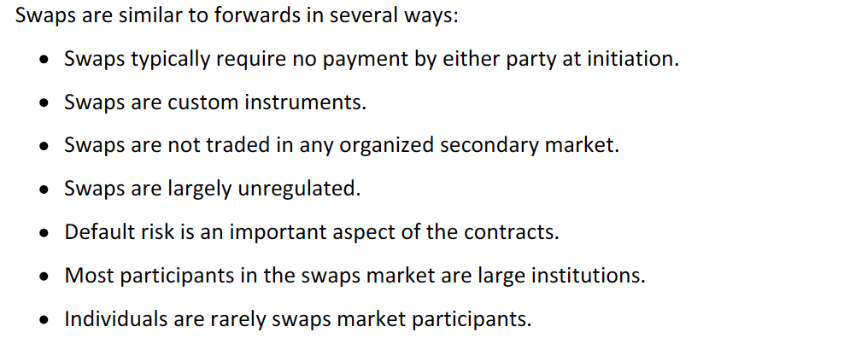

There are facilitators that bring together swap parties but there are also dealers, large bankes and brokerage firms.

Plain vanilla interest swap: one party makes fixed rate payments on a notional principal value (previously specified) in return for floating rate payments from the other party.

Basis swap: trading one set of floating rate payments for another.

**Options**

Gives the owner the right but not the obligation to either buy or sell an underlying asset at the exercise (strike) price.

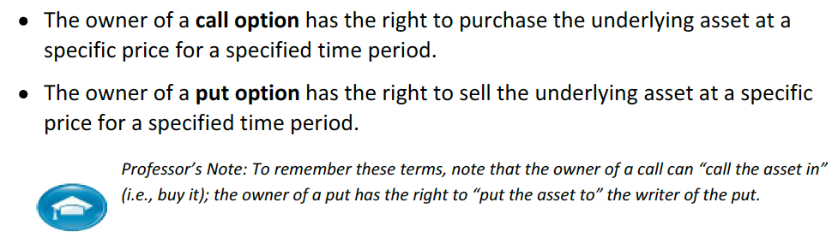

Option writer = seller of the option

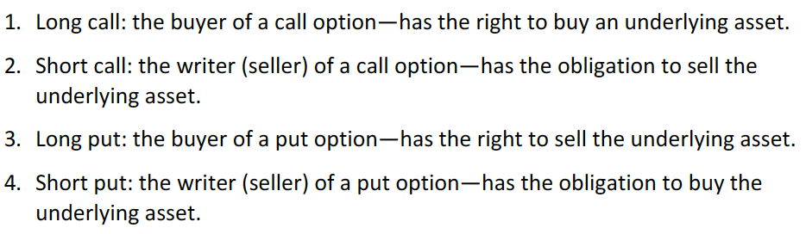

Option price = option premium

American options: may be exercised at any time up to and including the contract’s expiration date.

European options: can only be exercised on the expiration date.

*At expiration date, the price of these two types of options is the same.

**Credit derivatives**

Contract that provides a bondholder with protection against a downgrade or default by the borrower. Credit default swap is kind of an insurance against default where the bond makes payments to the credit protection seller and receives a payment if the bond defaults.

Credit spread options are typically call options based on a bond’s yield spread relative to a benchmark so that, whenever the spread increases (mainly due to a loss of credit quality), the bondholder will collect a payoff on the option.

## Describe purposes of, and controversies related to, derivative markets

Criticism involves the saying that they are too risky due to the high leverage involved.

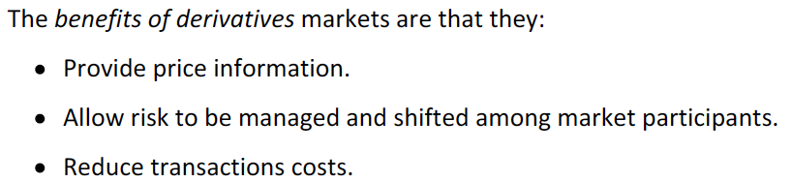

## Explain arbitrage and the role it plays in determining the prices and promoting market efficiency

If a return greater than the risk free rate can be earned holding a portfolio of assets that produces a certain return, then arbitrage opportunity exists.

Arbitrage occurs due to mispricing and happens until the price are brought to efficient (no-arbitrage) levels.

Arbitrage arguments:

* Two assets that have identical cash flows should have the same price. If A = B and price A < price B then buy A and sell B.
* If there is an asset that has a return higher than the risk-free but the same risk, then, an investor could borrow at Rf and invest in the portfolio and keep the excess after pying the loan. If the asset has a lower return, it could be sold and the proceed be used to buy Rf.

# Reading 57: Basics of Derivative Pricing and Valuation

## Explain how the concepts of arbitrage, replication and risk neutrality are used in pricing derivatives NO ENTENDI NI MIERDA

Convenience yield: non-monetary benefits of owning an asset.

Cost of carry: net cost of holding an asset (cost and benefits).

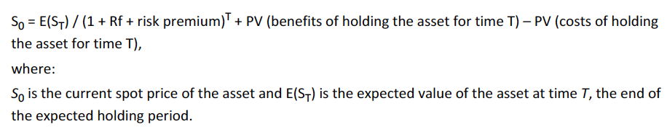

What benefits?

The risk premium is added as it is assumed that investors are risk averse.

In contrast of the previous model, derivatives valuation is based on a no-arbitrage condition because it is believed that they will be rapidly exploited.

A hedged portfolio constructed by a derivative and the alternate position on the underlying asset can be represented as (as the derivative future payment is supposed to be certain and its hedge with the counter position, its discount rate is the risk-free rate):



No me quedo muy claro:

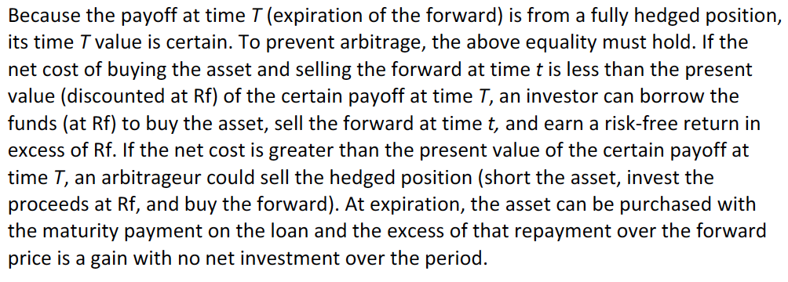

The no-arbitrage pricing method is also a risk-neutral pricing.

Replication

## Distinguish between value and price of forward and futures contracts

Value of futures and forwards its zero at initiation.

Price is the specified price in the contract (like the forward or exercising price). As the time passes, if the expected value of the underlying asset increases, the value of the long position will increase and the value of the short position will decrease in the same amount (but the price is kept equal). If a new forward contract is created, its price will be adjusted to reflect the expected value of the asset.

## Explain how the value and price of a forward contract are determined at expiration, during the life of the contract and at initiation

The contract price must be set so that the value is zero at initiation (since no party is paying to enter de contract).

To understand this, it is assumed that the asset’s only cost is the opportunity cost (risk-free rate). So, then:



If the forward price were greater than the right side of the equation, an arbitrageur could take a short position in the forward contract, promising to sell the asset at time T at the forward price but buys the asset at spot borrowing funds at Rf. At T, he will deliver at the forward, repay the loan and keep the positive difference.

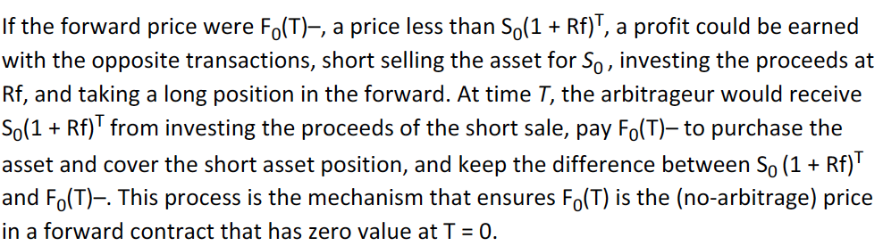

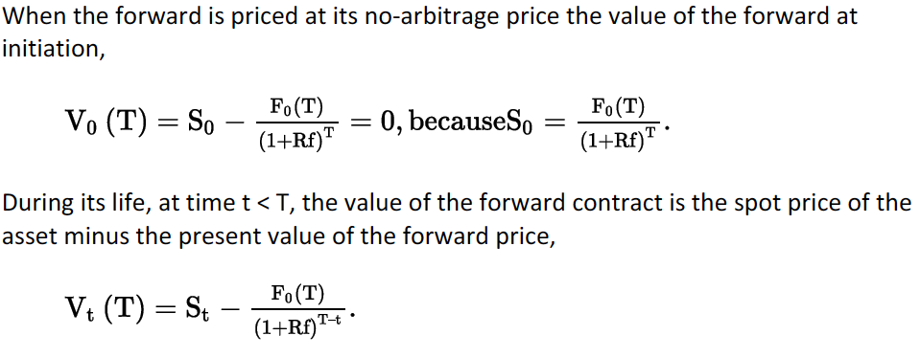

## Describe monetary and nonmonetary benefits and costs associated with holding the underlying asset and explain how they affect the value and price of a forward contract

The no-arbitrage price for a forward with holding costs and benefits at initiation is determined as:



As time passes, costs and benefits are lower. The value is calculated as:

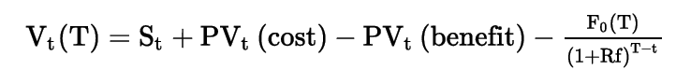

At expiration, the formula shows that the value for the long position will simply be Spot – Forward.

## Define a forward rate agreement and describe its uses

Forward rate agreement (FRA): derivative contract that has a future interest rate as its underlying. The point of using it is to lock a certain interest rate for future operations and needs.

Long position -> pay fixed, receive floating. If the rate increases, the position receives. Hedges if you want to borrow in the future.

Synthetic FRA -> borrow for a long period of time (days until expiration of the forward+days of the loan) and lend for the days until expiration. As we know the rate today, it is possible to have a fixed rate for the period of the loan (without considering the period in which the money is lended, since the return and the costs of the funds will net out).

## Explain why forward and futures prices differ

Although theoretically, due to liquidity, risk, standardization and the fact that future’s profit and losses are settled every day, prices should be different.

However, in practice, the difference between futures and forwards prices are mainly derived by interest rates, due to the possibility of reinvesting the excess margin funds.

So if interest rate were constant or uncorrelated with the prices of the contracts, then, the prices would be the same. Nevertheless, as the interest rate does affect the prices, then, it must be consider that if the prices are positively correlated then the future prices will be higher than forward prices (because an increase of interest rates will increase prices, creating excess margins that could be invested at the higher interest rate (this applies for a long position)).

Doesn’t this refers to value and not to price??

## Explain how swap contracts are similar to but different from a series of forward contracts

## Distinguish between the value and price of swaps

In a simple IRS, one party pays fixed and the other party pays floating. At the payment date, the difference between payments is netted out so only one payment is made.

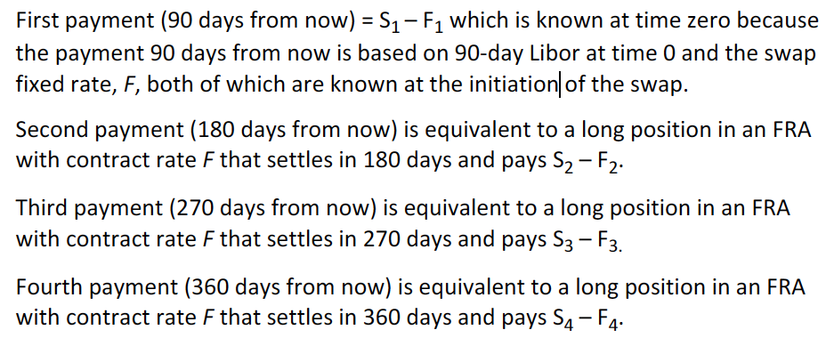

The first one is said to be known and is not like a forward since it is the notional times the rate of today for 90 days.

The difference between swaps and forwards is that if several forwards (for each payment) are taken, each with a different maturity but, with the same rate, then the contracts will not have a value of zero at initiation.

Off-market forward: a forward that gives a non-zero value at initiation.

The swap is composed with several off-market forwards where some produce a positive and others a negative present value, leading the value of the whole contract to equal zero.

Replicating a swap can be simply done by borrowing at a fix rate and lending the proceeds at a floating rate.

An increase in expected short-term future rates will produce a positive value for the fixed-rate payer in an IRS and a decrease a negative value since the promised fixed rate payments have more value than the expected floating rate payments.

## Explain how the value of a European option is determined at expiration

## Explain the exercise value, time value and moneyness of an option

Moneyness refers to whether an option is in or out of the money.

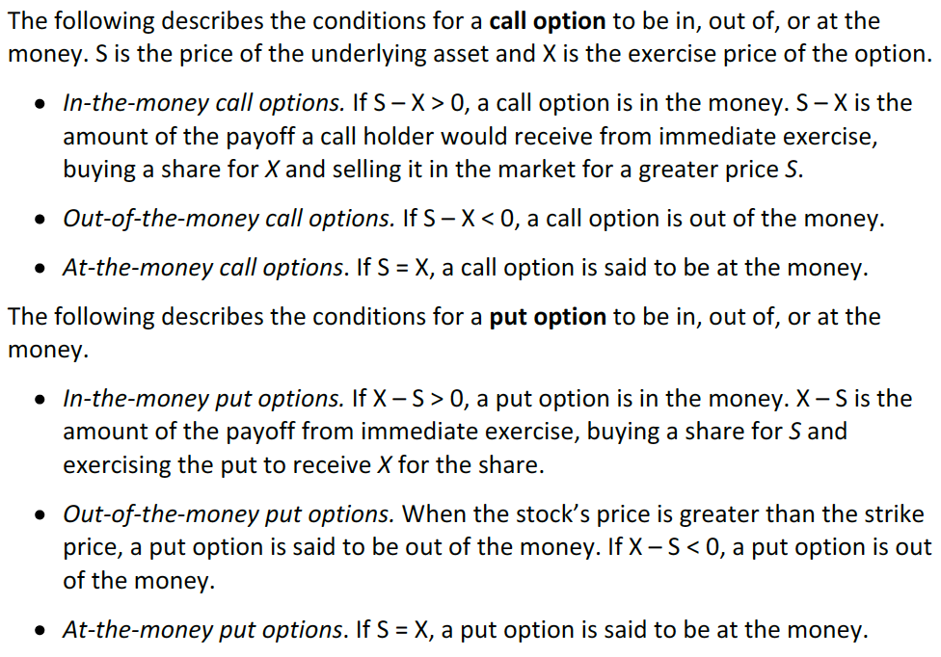

Intrinsic value or exercise value is the amount an option is in the money (equals zero when it is at or out of the money) if it is exercised immediately.

Time value (also known as speculative value) is the amount by which the option premium (price) exceeds the intrinsic value. Results from volatility (if volatility equals zero, time value equals zero).



At expiration the time value equals to zero.

## Identify the factors that determine the value of an option and explain how each factor affects the value of an option

|  |  |  |  |
| --- | --- | --- | --- |
|  |  | Call | Put |
| An increase on the following variables has the following effect on the option value | Price of underlying | Increase | Decrease |
| Exercise price | Decrease | Increase |
| Risk free rate | Increase | Decrease |
| Volatiity of the underlying | Increase | Increase |
| Time to expiration | Increase | Increase* |
| Benefits of holding asset** | Decrease | Increase |
| Costs of holding asset | Increase | Decrease |

*For deep in the money put’s a longer time to expiration could decrease its value.

**This happens because a dividend payment, for instance, will decrease the value of the underlying asset, having then the stated effect.

## Explain put-call parity for European options

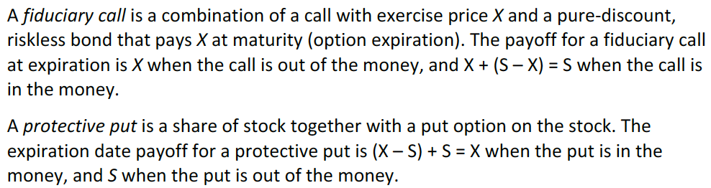

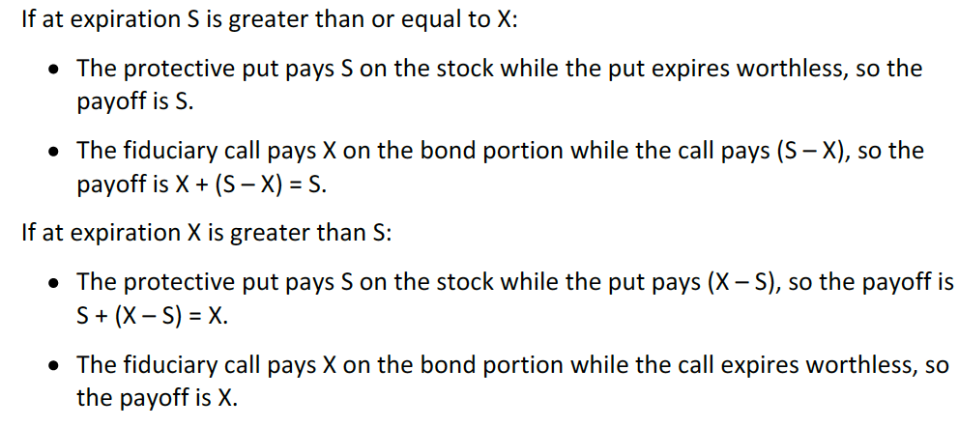

So a payoff on a protective put is the same as the one on a fiduciary call. No-arbitrage condition explains that two portfolios with identical flows should be priced the same, leading to the following call-put parity:

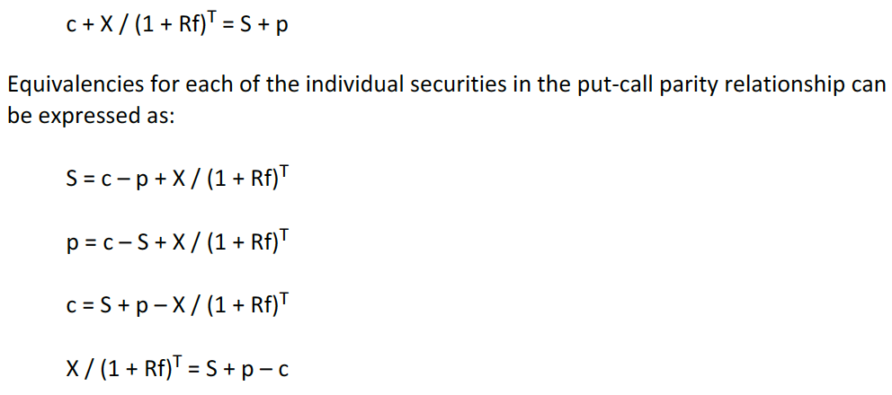

This applies for European options with the same exercise price and the same time to expiration.

The equalities showed above express the conditions to male synthetic conditions. For the first one:

A long stock equals a long call, a short put and a long position in a risk-free discount bond.

## Explain put-call-forward parity for European options

This parity uses forwards rather than the asset itself.

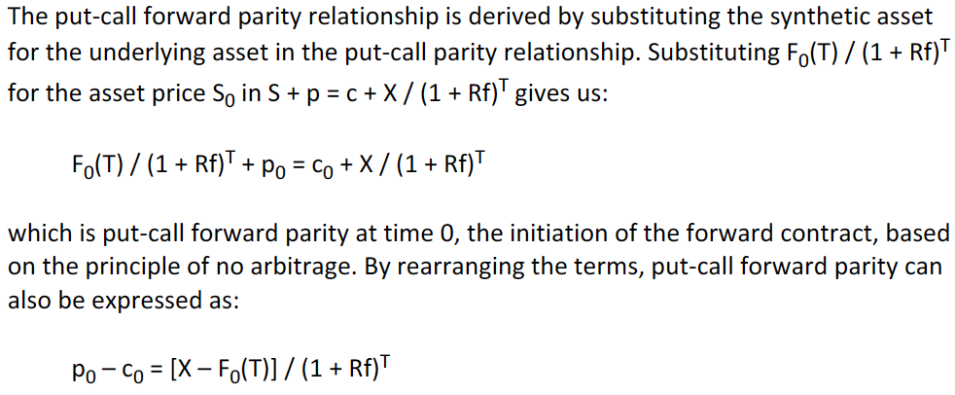

## Explain how the value of an option is determined using a one-period binomial model

It is literally the present value (discounted using the risk free, since the probabilities are adjusted) of the weighted average (weighted by probabilities) of the possible values of the options considering the down and up-sides on the underlying stock.

Probabilities are adjusted by risk, but I do not need to learn the formula.

Check the examples.

## Explain under which circumstances the values of European and American options differ

Only if the right to exercise prior to expiration has a positive value, then they would be different.

At expiration they are equivalent.

For a call option with no cash flows during the life of the option, there is no advantage to early exercise. In this case, the American and European option have the same value.

When they are positive cash flows involved, the American option will have a higher value (since the holder could exercise before the ex-dividend date and receive the dividend or sell the stock avoiding to lose any value due to the decrease of the underlying asset.)

When the put option is deep in the money, it might advantageous to exercise (in any other case, no).