**EQUITY**

Table of Contents

Reading 44: Market Organization and Structure 6

a. Explain the main functions of the financial system 6

b. Describe classifications of assets and markets 6

c. Describe the major types of securities, currencies, contracts, commodities and real assets that trade in organized markets, including their distinguish characteristic and major subtypes 7

d. Describe types of financial intermediaries and services that they provide 9

e. Compare position an investor can take in an asset 10

f. Calculate and interpret the leverage ratio, the rate of return on a margin transaction and the security price at which the investor would receive a margin call 11

g. Compare execution, validity and clearing instructions 11

h. Compare market orders with limit orders 11

i. Define primary and secondary markets and explain how secondary markets support primary markets 13

j. Describe how securities, contracts and currencies are traded in quote-driven, order-driven and brokered markets 14

k. Describe characteristics of a well-functioning financial system 15

l. Describe objectives of market regulation 15

Reading 45: Security Market Indexes 16

a. Describe a security market index 16

b. Calculate and interpret the value, price return and total return of an index 16

c. Describe the choices and issues in index construction and management 16

d. Compare the different weighting methods used in index construction 16

e. Calculate and analyze the value and return of an index given its weighting method 17

f. Describe rebalancing and reconstitution of an index 17

g. Describe uses of security market indexes 18

h. Describe types of equity indexes 18

i. Describe types of fixed-income indexes 18

j. Describe indexes representing alternative investments 18

k. Compare types of security market indexes 19

Reading 46: Market Efficiency 21

a. Describe market efficiency and related concepts, including their importance to investment practitioners 21

b. Distinguish between market value and intrinsic value 21

c. Explain factors that affect a market’s efficiency 21

d. Contrast weak-form, semi-strong form and strong-form market efficiency 21

e. Explain the implications of each form of market efficiency for fundamental analysis, technical analysis and the choice between active and passive portfolio management 22

f. Describe market anomalies 22

g. Describe behavioral finance and its potential relevance to understanding market anomalies 23

Reading 47: Overview of Equity Securities 25

a. Describe characteristics of types of equity securities 25

b. Describe difference in voting rights and other ownership characteristics among difference equity classes 25

c. Distinguish between public and private equity securities 25

d. Describe methods of investing in non-domestic equity securities 26

e. Compare the risk and return characteristics of different types of equity securities 27

f. Explain the role of equity securities in the financing of a company’s assets 27

g. Distinguish between the market value and book value of equity securities 27

h. Compare a company’s cost of equity, its (accounting) return of equity and investors’ required rates of return 27

Reading 48: Introduction to Industry and Company Analysis 29

a. Explain uses of industry analysis and the relation of industry analysis to company analysis 29

b. Compare methods by which companies can be grouped, current industry classification systems and classify a company, given a description of its activities and the classification system 29

c. Explain the factors that affect the sensitivity of a company to the business cycle and the uses and limitations of industry and company descriptors such as “growth”, “defensive” and “cyclical”. 31

d. Explain how a company’s industry classification can be used to identify a potential peer group for equity valuation 31

e. Describe the elements that need to be covered in a thorough industry analysis 32

f. Describe principle of strategic analysis of an industry 32

g. Explain the effects of barriers to entry, industry concentration, industry capacity and market share stability on pricing power and price competition 32

h. Describe industry life cycle models, classify an industry as to life cycle stage and describe limitations of the life-cycle concept in forecasting industry performance 33

i. Compare characteristics of representative industries from the various economic sectors 34

j. Describe macroeconomic, technological, demographic, governmental and social influences on industry growth, profitability and risk 35

k. Describe the elements that should be covered in a thorough company analysis 35

Reading 49: Equity Valuation: Concepts and Basic Tools 36

a. Evaluate whether a security, given its current market price and a value estimate, is overvalues, fairly valued or undervalued by the market 36

b. Describe major categories of equity valuation models 36

c. Describe regular cash dividends, extra dividends, stock dividends, stock splits, reverse stock splits and share repurchases 36

d. Describe dividend payment chronology 36

e. Explain the rationale for using present value models to value equity and describe the dividend discount and FCFE models 37

f. Calculate the intrinsic value of a non-callable, non-convertible preferred stock 38

g. Calculate and interpret the intrinsic value of an equity security based on the Gordon (constant) growth dividend discount model or a two-stage dividend discount model as appropriate 38

h. Identify characteristics of companies for which the constant growth or a multistage dividend discount model is appropriate 40

i. Explain the rationale for using price multiples to value equity, how the price to earnings multiple relates to fundamentals and the use of multiples based on comparables 40

j. Calculate and interpret the following multiples: price to earnings, price to an estimate of operating cash flow, price to sales and price to book value 40

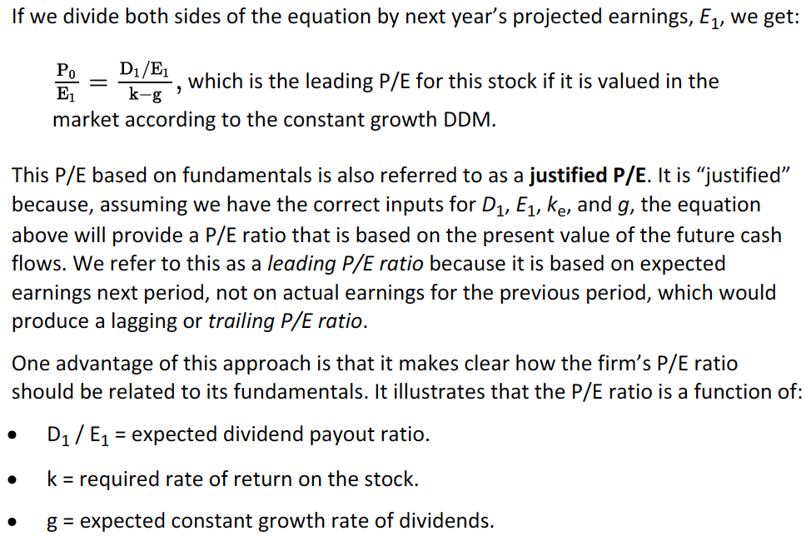 41

k. Describe enterprise value multiples and their use in estimating equity value 42

l. Describe asset-based valuation models and their use in estimating equity value 42

m. Explain advantages and disadvantages of each category valuation model 42

# Reading 44: Market Organization and Structure

## Explain the main functions of the financial system

Functions:

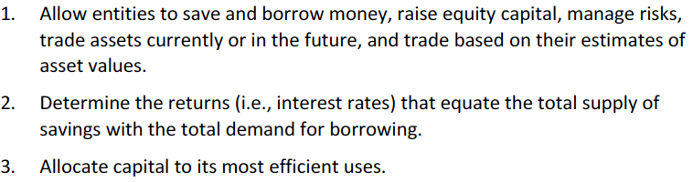

2. The financial system provides a mechanism to determine the rate that equates borrowing with lending (saving). This is the equilibrium interest rate.

## Describe classifications of assets and markets

Assets:

* Financial: securities (stocks and bonds), derivatives and currencies.
* Real: real estate, equipment, commodities and other physical assets.

Financial securities:

* Debt.
* Equity.

Another classification:

* Public securities: traded on exchanges or through dealers.
* Private securities: not traded.

Derivative contracts:

* Financial: based on equities, equity indexes, debt, debt indexes or other financial contracts.
* Physical: based on physical assets like commodities.

Delivery:

* Spot: immediate delivery.
* Future: future delivery.

Type of market:

* Primary: IPO’s.
* Secondary: subsequent trades.

Another classeification:

* Money market: debt securities with maturities less than a year.
* Capital market: longer-term debt securities and equities.

Type of investment:

* Traditional: debt and equity.
* Alternative: Hedge funds, commodities, real estate, collectivles, gemstones, leases and equipment.

## Describe the major types of securities, currencies, contracts, commodities and real assets that trade in organized markets, including their distinguish characteristic and major subtypes

**Securities:**

* Fixed income securities: debt securities. Short term are 0-2 years, intermediate term are 3-4 years and long term 5-10 years.

Types of instruments:

* + Bonds: Long term.
  + Notes: intermediate term.
  + Commercial paper: short term and issued by a firm.
  + Bills: issued by government and are short term.
  + Certificates of deposit: issued by banks, short and intermediate term.
  + Repurchase agreements: the borrower sells an asset and has the obligation to repurchase it at a higher price in the future.
  + Convertible debt: debt that can be exchange for a specified number of equity shares.
* Equity securities: represent ownership of a firm.

Type of instruments:

* + Common stock: residual claim on a firm’s assets. Are almost the last to recover any money in the event of firm liquidation.
  + Preferred stock: has scheduled dividends and have seniority over the common stocks and will also receive dividends first.
  + Warrants: similar to options as it gives the holder the right to buy a number of shares at an exercise price. The difference is that the firm issues the warrants (is not a bilateral contract between two investors, but between an investor and the company) and that the shares that are given to the investors are newly issued shares.
* Pooled investment vehicles: structures that combine funds of many investors. Investor’s ownership parts are referred as shares, units, depository receipts or limited partnership interests.

Types:

* + Mutual funds: fund’s shares can be purchase directly to the fund (open-end) or in the secondary market (closed-end).
  + Exchange-traded funds and exchange-traded notes (ETNs): trade like closed end funds but have special provisions to keep their market value close to the value of their proportional interest in the overall portfolio. These funds are also known as depositories and their shares as depository receipts.
  + Asset-backed securities: represent a claim of a portion of a pool of financial assets (mortgages, car loans, credit card debt…). The return of the assets is passed to the investors. They may be different classes of claims (tranches).
  + Hedge funds: are organized as limited partnerships, where investors are limited partners and the fund manager a general partner.

**Currencies**

Issued by central banks. Reserve currencies are usually the dollar and euro primarily, and secondarily, the pound, yen and franc.

**Contracts**

* Forward contract: are OTC and not standardized.
* Future contracts: are standardized to amount, asset characteristics and delivery time. Are traded in a secondary market.
* Swap contract: payments equivalent to one asset being traded for another in multiple periods.
  + IRS: a variable rate is traded for a fixed rate.
  + Currency swap: one currency for another.
  + Equity swap: exchange of return of an equity index for the interest payment on a debt instrument.
* Option contract: right to buy or sell at a specific exercise price at some specific time. Sellers are also known as writers. They can be traded in exchanges or OTC.
* Insurance contract: pays if a future event occurs.
* Credit default swaps: form of insurance that makes a payment if an issuer defaults on its bonds. They can be acquired by the bond-holders or by third parties that want to benefit in the case that the issuer suffers financial distress.

**Commodities**

They trade in spot, forward and future markets.

**Real Assets**

They provide income, tax advantage and diversication. However, management costs might be high and due diligence may be complex. They are usually illiquid.

Real estate investment trusts (REIT) or master limited partnership (MLP) allow investor to purchase the assets indirectly. This type of ownership is typically more liquid. Another way it to buy stocks of firms that own the assets.

## Describe types of financial intermediaries and services that they provide

Financial intermediaries: stand between buyers and sellers.

* Brokers: find counterparties to their clients to trade in a cost efficient manner. Found in banks, brokerage firms and exchanges.
* Block brokers: help with placement of large trades controlling that the market does not move against it clients.
* Investment banks: help corporations to sell securities to investors. Provide advice in matters of mergers, acquisitions and capital raising.
* Exchanges: provide a venue for traders to meet. They sometimes act as brokers. Acquire certain regulatory power.
* Alternative trading systems (ATS) or Electronic communication networks (ECNs) or Multilateral trading facilities (MTFs): are as exchanges but without any regulatory power (There are ATS that do not reveal client orders and are known as dark pools.
* Dealers: offer securities for trading from their own inventory. They profit from the spread between bid and ask.
* Broker-dealers: they may have certain conflicts of interest since they need to profit while looking for the best interest of their clients.
* Primary dealers: affect directly the money supply by trading with central banks.
* Securitizers: pool large amount of assets and pass to the investors the returns of the pool net of the securitizer’s fees. The benefit of securitizing assets is that it decreases the funding cost for the entity who is financing.
* Depositary institutions: banks, credit union and savings and loans. Also include paydau lenders, factoring companies. They normally finance their operations with debt.
* Prime brokers: provide loans to hedge funds and other institutions to purchase securities on margin.
* Insurance companies: collect premiums to cover events when needed. Moral hazard: the inured takes more risks once it is protected. Adverse selection: when the most likely to experience losses buy insurance. Fraud: the insured purposely causes damage to collect its policy.
* Arbitrageurs: provide liquidity by buying and selling in different markets. They use replication (create similar positions using different assets).
* Clearinghouses: provide escrow services (transfer assets and cash to the parties), guarantees of contract competition, assure that margin traders have adequate capital, limits aggregate net order quantity. They limit counterparty risk.
* Custodians: hold client securities and prevent losses due to frauds.

## Compare position an investor can take in an asset

* Long position: owns or has the right or obligation to purchase the asset.
* Short position: borrows, sells, has to deliver an asset.
* Hedgers: uses counter a position to cover its original position. They must acquire the position that they will face in the future.
* Call long: earns the right to buy.
* Call short: sells the obligation to sell.
* Put long: earns the right to sell.
* Put short: sells the obligation to buy.
* Swaps: each party is long and short on asset. Depends on the party, the long asset will be the one that benefits from increases in price.
* Currency contracts: each party is long in a currency and short in another one.

**Short sales:**

The short seller simultaneously borrows and sells securities through a broker, then it must return the securities to the lender (covering the short position) and will profit from the difference in prices.

If any dividends or interest are earned while the borrower possesses the security, he must pay them to the lender. These payments are known as payments-in-lieu.

The borrower must deposit the proceeds of the short sale as a collateral. This may generate interest at a rate known as short rebate rate which is usually 0.1% less than overnight interest rate.

Check the last paragraph.

**Leverage positions:**

Known as the use of borrow funds to take a position. Investors that use leverage to purchase securities are said to buy on margin. The borrowed funds are known as a margin loan. The interest rate paid on the fund is the call money rate (usually higher than the government bill rate).

The initial margin requirement is the minimum amount of equity that investors must have when buying on margin which is determined by the government, exchange, clearinghouse or broker.

## Calculate and interpret the leverage ratio, the rate of return on a margin transaction and the security price at which the investor would receive a margin call

The leverage ratio of a margin investment is the value of the asset divided by the value of the equity position.

The leverage ratio times the asset total return will equal the leveraged return without loan interests or commissions. REVIEW THE EXAMPLE.

The minimum amount of equity percentage is called the maintenance margin requirement and is typically 25% of the postion. Whenever the percentage of equity falls below the maintenance margin, a margin call is received requiring the investor to bring the equity levels back to margin. If the call is not met, the broker sells the position.

The margin call price is calculated as:

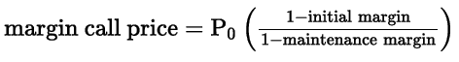

In a short sale, something similar happens.

## Compare execution, validity and clearing instructions

## Compare market orders with limit orders

Bid and ask size: specific trade sizes.

Dealers business is funded in the bid-ask spread.

In the market, the quotation is the highest dealer’s bid and the lowest ask in a particular security.

The ones who post bids and offers are said to make a market, while the ones that use them are said to take the market.

Execution instructions: how to trade.

Validity instructions: when the order can be filled.

Clearing instructions: how to settle the trade

**Execution instructions:**

Market order: instructs the broker to execute the trade immediately at the best price possible.

Limit order: places a minimum and a maximum when selling or buying the security respectively. A limit order which takes a price less (for bid prices, sell orders) or above (for ask prices buy order) the best price is said to be marketable or aggressively priced. If it is between the best bid and the best ask, it is said to be making a new market or inside the market. Limit orders at the best bid or sell price is said to make the market. Limit orders with a price less (for buy orders) and above (for sell orders) the best price is known to be behind the market. When this happens with a considerable difference with the best prices, it is known to be far from the market. Limit orders that are waiting to be executed are called standing limit orders.

All-or-nothing orders: are the ones that are only met if the whole order can be executed at once. Also, a minimum size of a trade can be instructed.

Hidden orders: are those for which only the broker or exchange knows the trade size.

Display size: when only a part of the trade can be visible to the rest of the market. Also known as iceberg orders.

**Validity instructions:**

Day orders: expire if unfilled by the end of the day.

Good-till-canceled orders: last until they are filled.

Immediate-or-cancel orders: cancelled unless they are filled immediately. Also known as fill-or-kill.

Good-on-close orders: only filled at the end of the trading day. If they are market orders, they are known as market-on-close orders.

Good-on-open orders: same but only valid at the beginning of the day.

Stop orders: not executed unless the stop price has been met. Also known as stop loss orders. They contribute with a market’s momentum.

* Stop-sell order: triggers a market order to sell once the stop price is met.
* Stop-buy order: is the same as the last one and used to stop a short position or when an investor believes a stock is undervalued but wants to wait until the stock gains a certain percentage to own the asset.

**Clearing instructions:**

What is a long sale?

I believe that it has to do with when are the proceeds from the operations are given to the investor.

## Define primary and secondary markets and explain how secondary markets support primary markets

Primary capital markets:

* New shares issued by firms whose shares are already trading. Known as seasoned offerings or secondary issues.
* First-time issued known as initial public offering (IPOs).

Secondary financial markets: securitites traded after their initial offering.

**Public Offerings:**

Investment banks look for investors that agree to buy part of the issue. These are referred as indications of interest and the process of gathering indications is known as book building (the book builder may be known as the book runner). Depending of these indications, the offering price might be adjusted. When the issue must be done quickly, an accelerated book build occurs.

Underwritten offering: the bank purchases all of the issue and then trades it. In the case that the issue takes place and not every share is sold, the bank must buy the unsold bit. May generate conflicts of interest, as the bank would prefer to set the price of the shares low in order to sell all.

Best efforts basis: the issue is not purchase and if the issue is undersubscribed, the bank is not obligated to buy the unsold portion.

For IPOs, banks usually agree to make a market in the stock for a period of time to provide price support.

Hot issue: term use to refer to IPO that is expected to have its securities trading at prices significantly higher than the issued price.

**Private placements and other transactions:**

Private placement: securities are sold directly to qualified investors. Is cheaper than a public offering. Shares are sold at a lower price as they are not so valuable (they cannot be resold in public markets).

Shelf registration: the firm makes its public disclosure as it normally does but it only issues the security over time whenever they desire it.

Dividend reinvestment plan (DRP or DRIP): allows investors to purchase new shares with their dividends with a slight discount.

Rights offering: The firm gives the right to investor to purchase new shares at a lower price (investors do not really like it as they have to exercise their right to avoid their ownership from being diluted. Rights can sometimes be traded

**Importance of secondary market**

Provide liquidity and price/value information.

## Describe how securities, contracts and currencies are traded in quote-driven, order-driven and brokered markets

Call markets: the stock is only traded at specific times.

Continuous market: trades occur at any time the market is open.

**Market structures**

Quote-driven markets: trader transact with dealers. Also known as dealer markets, price-driven markets or over-the-counter markets. Trading is mostly done electronically.

Order-Driven markets: trading rules are needed since traders are usually anonymous. Exchanges and automated trading are examples. Types of rules:

* Order matching rules: establish an order precedence hierarchy. Price priority is a criterion where the priority is given to the highest bid price and lowest sell price. If orders have the same price, a secondary precedence rules gives priority to non-hidden orders and earliest arriving orders.
* Trade pricing rules: The uniform pricing rules indicate that all order trade at the same price which results for the highest volume of trading. Discriminatory pricing uses the limit price of the order that arrived first as the trade price. Derivative pricing is used in electronic crossing networks and what it does is that it takes an average between the bid and ask of the security’s original exchange.

Brokered markets: brokers find the counterparty and execute the trade. Usually used for illiquid assets.

**Market information**

Pre-trade transparent: if investors can obtain information regarding quotes and orders before the trade is done.

Post-trade transparent: When the information is obtained after the trade is done.

## Describe characteristics of a well-functioning financial system

Well-functioning markets are known as complete markets where:

* Investors can save fo the future at fare rates.
* Creditworthy borrower can obtain funds.
* Hedgers can manage risks.
* Traders can obtain the assets they need.

If a market is able to fulfill with this, it is known to be operationally efficient. If prices reflect all the information associated with the security, it is informationally efficient.

A well-functioning financial system has intermediaries that:

* Organize trading venues (exchanges, brokerages and others).
* Supply liquidity.
* Securitize assets.
* Manage banks that use depositor capital to fund borrowers.
* Manage insurance firms that pool unrelated risks.
* Manage investment advisory.
* Provide clearinghouses that settle trades.
* Manage depositories for asset safety.

Markets that are able to correctly allocate funds are known to be allocationally efficient.

## Describe objectives of market regulation

Problems without regulations:

* Fraud and theft.
* Insider trading: trades with inside information.
* Costly information.
* Defaults.

Regulations then often point to:

* Protect unsophisticated investors.
* Require minimum standards of competency.
* Prevent insiders from exploiting other investors.
* Require common financial reporting requirements.
* Require minimum levels of capital.

# Reading 45: Security Market Indexes

## Describe a security market index

They are portfolios composed of assets known as the constituent securities and it represents the performance of an asset class, a market or a segment.

## Calculate and interpret the value, price return and total return of an index

*Price return refers to changes only on price while total return includes other flows.

## Describe the choices and issues in index construction and management

Decisions:

* What is the target market to be measured?
* Which securities should be included?
* How should securities be weighted?
* How often should the index be rebalanced?
* When should the selection and weighting of securities be re-examined?

## Compare the different weighting methods used in index construction

**Price-weighted index**

Simply an arithmetic average of the prices of the securities. The disadvantage here is that the priciest stocks will affect more the index. The DJIA and the Nikkei Dow are examples.

**Equal-weighted index**

Is the arithmetic average return of the index’s stocks. The thing is that the index might need to be constantly rebalanced so that the positions in each stock are kept, which makes it costly. Another issue comes because the small and large capitalization companies have the same weight. Examples are The Value Line Composite Average and the Financial Times Ordinary Share Index.

**Market capitalization-weighted index or value-weighted index**

The weights of the stocks are calculated as a proportion of the total market capitalization. Also, a market float can be used, which refers to the total value of the shares that are actually available for the public (excluding the ones hold by the controlling parties). When the calculation does not include the shares that are not available to foreign buyers is referred as the free float.

**Float-adjusted market capitalization-weighted index**

The weights are determined proportionally to each firm’s shares that are available to investors to the total market value of the shares of index stocks that are available to investors. So if a larger proportion is held by the controlling party, the weight of the firm will be lower. The S&P 500 is an example.

**Fundamental weighting**

The weights are determined based on a specific fundamental.

In general, I do not get why does the price in most of the index is said to affect the weight.

## Calculate and analyze the value and return of an index given its weighting method

**Price weighting**

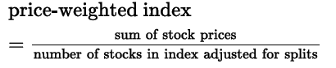

To calculate the denominator in the case of a split, I must calculate the index a day before, and solve the equation for the denominator using the new price of the stock and the index value calculated previously.

**Market capitalization weighting**

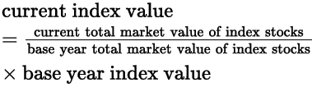

So, the market capitalization index depends of both price and shares (value) rather than only price.

**Equal weighting**

It is a simple average of the returns of the stocks.

## Describe rebalancing and reconstitution of an index

Rebalancing refers to adjusting weights after price changes have affected them. It is said that price and value indexes do not needed. Equally weighted indexes do need rebalancing.

Reconstitutions refers to adding or deleting securities.

Normally, when a stock is added to the index its value increases, as investors purchase it to follow the index.

## Describe uses of security market indexes

* Reflection of market sentiment.
* Benchmark of manager performance.
* Measure of market return and risk.
* Measure of beta and risk-adjusted return.
* Model portfolio for index funds.

## Describe types of equity indexes

* Broad market index: usually contain more than the 90% of the total market value.
* Multi-market index: constructed from indexes of markets from several parts of the world.
* Multi-market index with fundamental weighting: uses market-capitalization indexes but, then, groups them and weights them using fundamental factors.
* Sector index: they can be for a specific country or global and are useful to check for cyclical sectors.
* Style index: considers market capitalization or the type of stocks (value or growth).

## Describe types of fixed-income indexes

There are several types of indexes created on some of the basis of the equity indexes as well as based on type of issuer, collateral, coupon, type of market (broad, sector, style), maturity…

There are certain issues regarding these indexes:

* Large universe of securities, besides, they mature and need to be replaced.
* Dealer markets and infrequent trading: as dealers trade them, they are the price providers. Also, illiquid securities difficult the pricing.

## Describe indexes representing alternative investments

**Commodity indexes:**

Represented by future contracts of commodities. Issues are the following:

* Weighting method: equal, global production values, fixed.
* Future vs actual: future prices are used, and they depend on other various factors. Also, they mature.

**Real estate indexes:**

Based on appraisals of properties or performance of Real Estate Investment Trusts (REITs) which are kind of closed-end mutual funds.

**Hedge fund indexes:**

Most are equally weighted and reflect the returns of funds. The thing is that only the funds that like to report their results actually do, which makes the indexes have a certain bias.

## Compare types of security market indexes

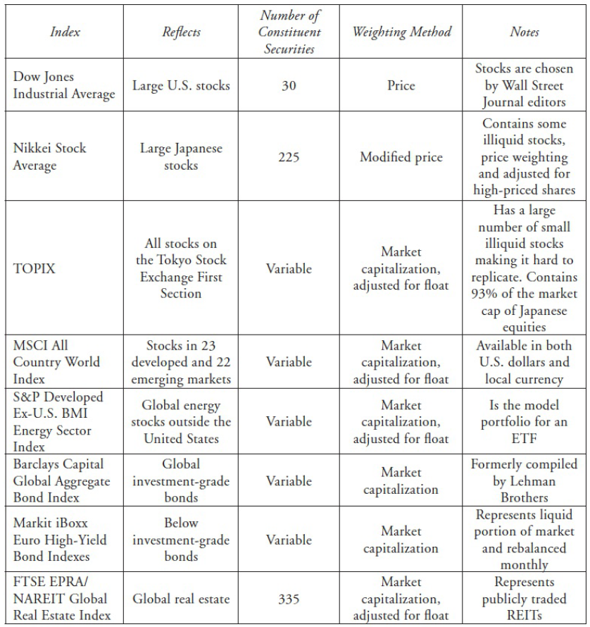

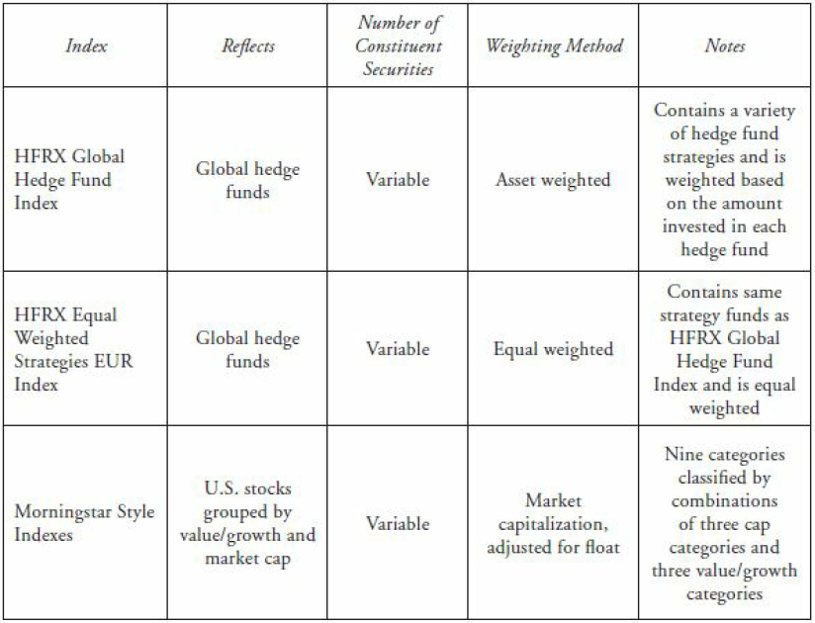

# Reading 46: Market Efficiency

## Describe market efficiency and related concepts, including their importance to investment practitioners

Informationally efficient capital market: one in which the price reflects all available information. This implies that he market cannot be beaten. So, active investment strategies will likely underperform due to costs and fees.

The degree of efficiency can be measure by considering the lag of the response of the price towards new information.

Prices should only be moved by unexpected information.

## Distinguish between market value and intrinsic value

Market value: current market price.

Intrinsic or fundamental value: value that an investor with full knowledge of the asset is willing to pay.

In efficient markets, these two values should match.

## Explain factors that affect a market’s efficiency

* Number of market participants: including investors, analysts and traders.
* Availability of information.
* Impediments to trading: high costs may prevent arbitrage will, then, could cause inefficiency.
* Transaction and information costs: whenever they are higher than the possible profit, investors will not trade, and the price will not be efficient.

*Short selling improves efficiency as it prevents assets from becoming overvalued.

## Contrast weak-form, semi-strong form and strong-form market efficiency

* Weak-form market efficiency: assures that prices reflect all **currently** available security market data, but only past information. Past prices cannot predict future prices because they are independent so, profit cannot be generated from using technical analysis.
* Semi-strong form market efficiency: prices fully reflect all publicly available information. Prices adjust rapidly without bias. Prices include past information and nonmarket information available. Investors can generate profit using fundamental analysis.
* Strong-form market efficiency: prices fully reflect all information from both public and private sources. This includes all types of information (past, public and inside information). Then, there should not be a specific group with special access to information and achieve abnormal returns will not be possible. (due to insider trading prohibition, this form of efficiency is not possible).

## Explain the implications of each form of market efficiency for fundamental analysis, technical analysis and the choice between active and passive portfolio management

Abnormal profit = risk-adjusted returns.

Technical analysis: on weak-form market efficiency, it is said that it is not good. In emerging markets, however, it works to a certain degree.

Fundamental analysis: Here it says that for semi-strong it does not work, but in the past LOS says that it does.

Event study: used to test semi-strong form of efficiency. It checks the behavior of abnormal returns before and after information is released. Evidence shows that markets usually show this form of efficiency. Fundamental analysts, however, provide information that helps the market’s efficiency.

Passive management: should be used when the market is semi-strong.

Portfolio management is useful as it adds value by establishing and implementing risk and return objectives and by assisting in diversification, asset allocation and tax management.

## Describe market anomalies

Market anomaly, in EMH, refers to something that will lead to rejecting the EMH.

Data mining or snooping: refers to the process of investigating data to look for statistical significances.

Anomalies in time-series data:

* Calendar anomalies: January effect or turn-of-the-year effect consists in finding that during the first five days of January, small firms returns are on average higher than in the rest of the year (a possible reason is tax-loss selling, where investors sell to realize losses and then repurchase them in January. Another reason is window dressing, where managers sell risky positions to remove them from their year-end reports and repurchase them in January).

Other effects are turn-of-the-month effect, day-of-the-week effect (Average Monday returns are negative), weekend effect (positive returns of Friday followed by negative in Monday) and holiday effect (pre-holiday returns are higher).

* Overreaction and momentum anomalies: Overreaction effects refers to findings that suggest that poorly performing stocks over the past three-five years have better subsequent returns

Momentum effects refer tocases where high short-term returns are continued by high returns.

Anomalies in cross-sectional data:

* Size effect: small-cap firms outperform large-cap. This, however, has not been fully confirmed.
* Value effect: value stocks (low P/E, low P/BV) outperforming growth stocks (high P/E, high P/BV).

Other anomalies:

* Closed-end investment funds: Prices of their chares often trade at large discounts to its NAV. Arbitrage should avoid this discount but due to fees, taxes and illiquidity it is not done.
* Earnings announcements: Earnings surprises generate adjustments that usually do not happen immediately.
* IPOs: Because they are typically underpriced, investors overact.
* Economic fundamentals: nothing interesting.

Portfolio management should not be based on these anomalies since there is not any economic base that confirms the anomalies.

## Describe behavioral finance and its potential relevance to understanding market anomalies

Behavioral finance looks at the actual decisions made by investors. It suggest that there is a certain bias on the decisions made by investors based on others’ decisions.

Irrational behavior includes:

* Loss aversion: investors have a higher risk aversion when facing losses than when facing gains.
* Investor overconfidence: tendency of investors to overestimate their analysis abilities.
* Herding: tendency of investors to act on the same side of the market.

Information cascade refers to the event in which investors follow more knowledge investors in their decisions, affecting the price of the security (which usually tend to generate efficiency).

Markets are efficient if it is assumed that risk-adjusted returns cannot constantly be obtained (research supports this). However, the assumption that investor are rationale is not supported.

# Reading 47: Overview of Equity Securities

## Describe characteristics of types of equity securities

* Common shares: represent an ownership of interest. The firm has no obligation to pay them dividends. They have voting rights. The types of voting systems are statutory (each share equals to one vote in the election of each member of the board) and cumulative voting (votes can be allocated to one or more candidates as they choose, which allows minority to have more proportional representation).
* Callable common shares: give the firm the right to repurchase the shares at a strike price.
* Putable common shares: gives the shareholder the right to sell the shares back to the firm at a given price. Are issued and traded at a premium price.
* Preference shares (preferred stock): dividends are not a contractual obligation, shares do not mature and may have callable or putable features. A fixed periodic payment is done and usually do not have voting rights. They have a par value and the dividends are given on the basis of this value (could be more if the firm’s profit exceeds a certain stated level or in the case of liquidation. This is the case for participating preference shares. For non-participating it does not apply).
* Cumulative and non-cumulative preference shares: If the company does not pay dividends when it was supposed to do, in the case of cumulative shares, the dividends are accumulated until they are paid (in fact, if in the next period the company is going to pay dividends, it must pay them first before paying common stock holders). This will not be the case for non-cumulative preference shares.
* Convertible preference shares: can be exchanged for common stocks at a conversion ratio stated. Are usually used to finance venture capital and private equity firms.

## Describe difference in voting rights and other ownership characteristics among difference equity classes

Classes discriminate voting rights, seniority, dividends, stock splits, ownership…

## Distinguish between public and private equity securities

Private equity is usually issued to institutional investors and has the following characteristics:

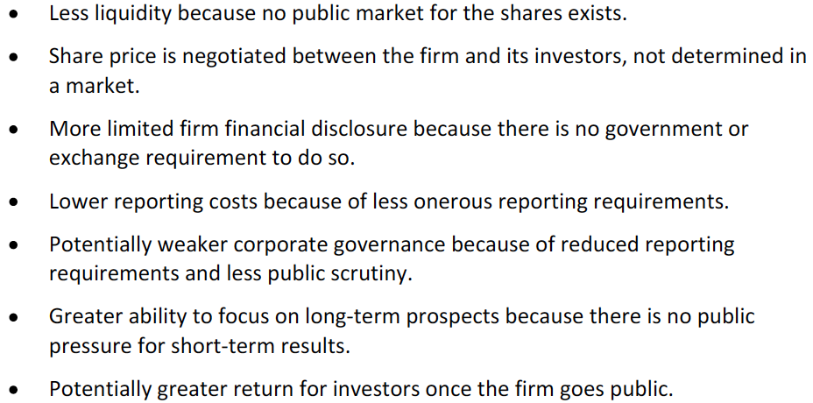

Types of private equity investments:

* Venture capital: is known as seed, strat-up, early stage or mezzanine financing. Usually the commitment of entering in this type of investment implies a time horizon of 3-10 years.
* Leveraged buyout (LBO): investors buy all of a firm’s equity using debt (when buyers are the management, the LBO is known as management buyout (MBO)). LBO CFs are used to repay the debt.
* Private investment in public equity (PIPE): happens when public firms needs capital quickly so it issues a private offer which are sold at a discounted price.

## Describe methods of investing in non-domestic equity securities

Integrated markets: capitals flow freely.

Direct investing: buying the security in the foreign market. Disadvantages: investment denominated in foreign currency, liquidity issues, regulation may be different.

Depository receipts (DRs): represent ownership of a foreign firm in the local market and local currency. A depositary bank (who manages corporate events) deposits shares of the firm and issues receipts. It may be sponsored (with firm involvement, it gives voting rights to holders and require greater disclosure) or unsponsored (the bank holds the voting rights).

Global depository receipts (GDRs): are outside the US but are usually denominated in USD.

American Depositary receipts (ADRs): only trade in the US. The shares are known as ADS. Types of ADRs:

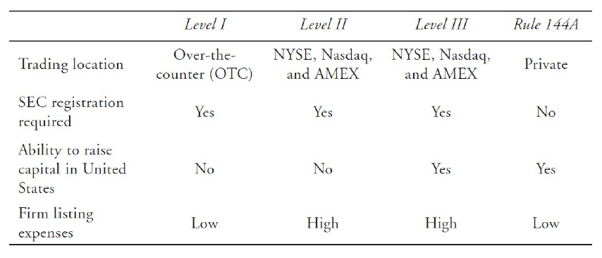

Global registered shares (GRS): are traded in different currencies.

Basket of listed depositary receipts (BLDR) is an ETF that collects DRs.

## Compare the risk and return characteristics of different types of equity securities

Equity returns are composed by price changes, dividends and exchange rate variations.

Preferred stocks are less risky due to seniority and the fixed dividend payment.

Cumulative preferred shares are even less risky.

For both common and preferred stocks, putable shares are less risky and callable shares are riskier than shares without an option.

## Explain the role of equity securities in the financing of a company’s assets

Equity is used for:

* Long term assets
* Equipment
* Research and development
* Expansion

## Distinguish between the market value and book value of equity securities

Book value of equity: value of the firm’s assets in the balance sheet minus liabilities.

Market value of equity: outstanding shares * market price and the expectations of investors.

## Compare a company’s cost of equity, its (accounting) return of equity and investors’ required rates of return

Return on equity:

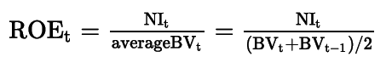

It is also calculated using just the beginning balance of equity, which is more appropriate when examining ROE for a number of years.

Price-to-book or market-to-book ratio is the market value divided by the book value. Low P/BV stocks are known as growth stocks and the ones with high P/BV are known as value stocks.

The cost of equity is equal to the total return expected. It is normally estimated using dividend discount models or with the CAPM.

# Reading 48: Introduction to Industry and Company Analysis

## Explain uses of industry analysis and the relation of industry analysis to company analysis

Industry analysis provide a framework for understanding the firm.

Industry analysis is also used to identify undervalued and overvalued industries.

Industry rotation: over and underweighting industries depending on the current phase of the business cycle.

## Compare methods by which companies can be grouped, current industry classification systems and classify a company, given a description of its activities and the classification system

Sector: Group of similar industries.

By products and services: use the principal business activity (largest source of sales or net income) to classify firms. Examples are GICS (Global Industry Classification System), RGS (Russel Global Sectors) and ICB (Industry Classification Benchmark).

By their sensitivity to business cycles: cyclical and non-cyclical.

Statistical methods: cluster analysis of correlated return, although it has several limitations.

**Industry classification systems:**

Commercial classifications:

Generally, the levels used are sector level -> industry level -> sub-industry level.

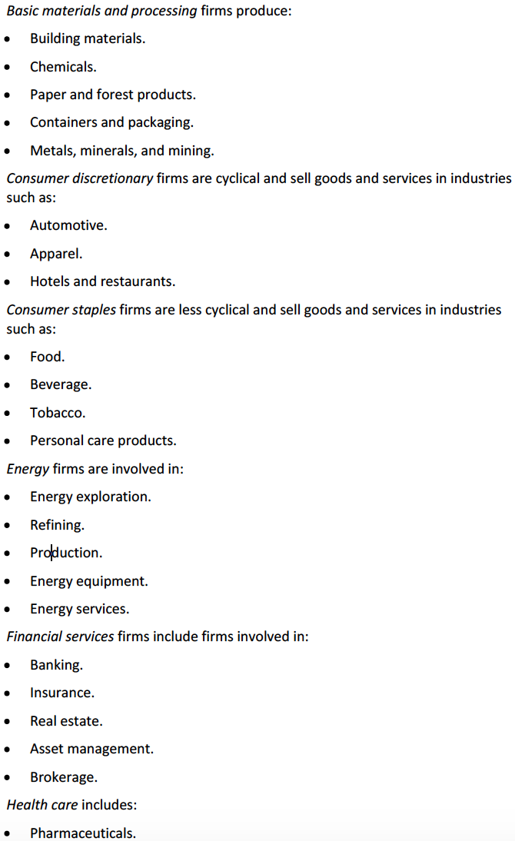

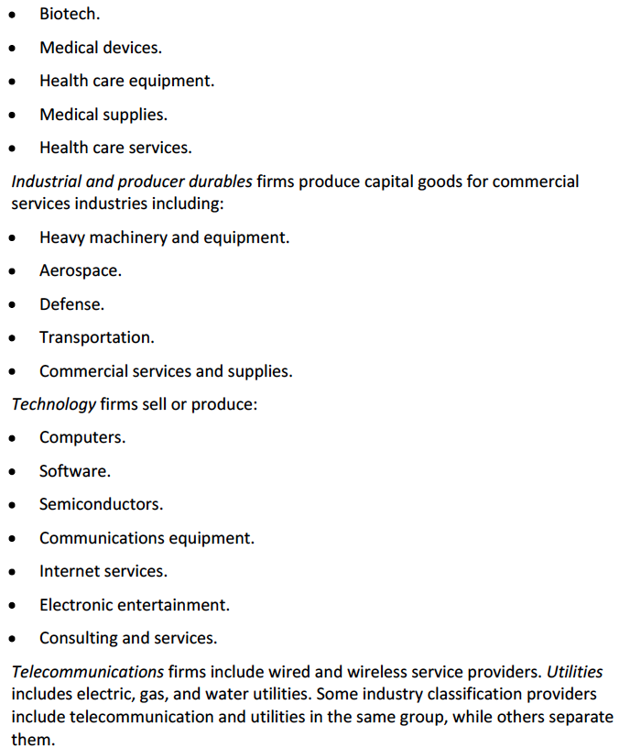

Government Classifications:

Government make these classifications to keep a standard for comparisons and economic information publishing. Some other systems are:

* + International Standard Industrial Classification of All Economic Activities (ISIC) produced by the UN.
  + Statistical Classification of Economic Activities in the European Community (like the ISIC but for Europe).
  + Australian and New Zealand Standard Industrial Classification.
  + North American Industry Classification System (NAICS) for Canada, the US and Mexico.

The advantages of commercial providers is that the information disclosed is more precise and in more detail.

## Explain the factors that affect the sensitivity of a company to the business cycle and the uses and limitations of industry and company descriptors such as “growth”, “defensive” and “cyclical”.

Cyclical firm: its earnings highly depends on the stage of the business cycle. These products are usually expensive (basic materials and processing, consumer discretionary, energy, financial services, industrial and producer durables, and technology).

Non-cyclical firm: firms whose products’ demands are relatively stable through the business cycle (health care, utilities, telecommunications and consumer staples). This may be:

* Defensive industries: the ones that are least affected by the stage of the cycle (utilitities, consumer staples and basic services).
* Growth industries: their demand is so strong, that they are unaffected by the cycle (they can also be cyclical but less affected). (nome queda clara la diferencia)

## Explain how a company’s industry classification can be used to identify a potential peer group for equity valuation

Peer group: a set of similar companies used for valuation (similar business activity, demand drivers, cost structure drivers and availability of capital).

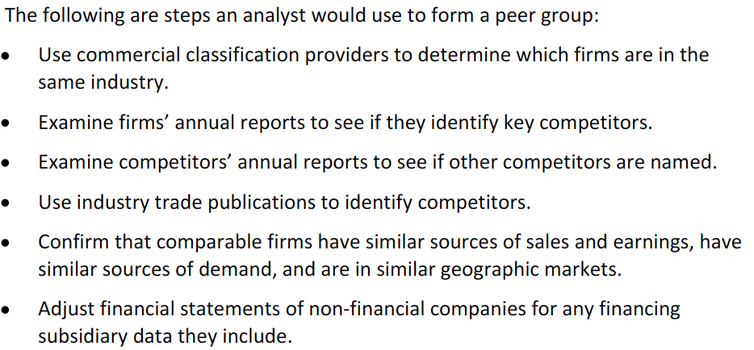

## Describe the elements that need to be covered in a thorough industry analysis

The following element should be included:

* Evaluate the relationship between macroeconomic variables and industry trends using general and specific information of the industry.
* Estimate industry variables using different approaches and scenarios.
* Compare forecasts with other analysts to find misvaluations.
* Determine the relative valuation of different industries.
* Compare the value of the industry over time and stages of the business cycle.
* Use strategic groups (groups distinct from the rest of the industry).
* Classify the industries by their life-cycle stage (embryonic, growth, shakeout, mature or declining).
* Position the industry on the experience curve (cost per unit relative to output) which declines.
* Consider forces that affect the industry.
* Consider forces that determine competition.

## Describe principle of strategic analysis of an industry

Economic profits: return on invested capital minus its cost.

The analysis should be forward-looking.

Strategic analysis: examines how an industry’s competitive environment influences a firm’s strategy. Porter’s five forces are used to make this analysis:

* Rivalry among exiting competitors.
* Threat of entry.
* Threat of substitutes.
* Power of buyers.
* Power of suppliers.

The two first factors affect almost every company. The industry could be affected as follows:

* High barriers reduce competition.
* Greater concentration (few firms) reduces competition.
* Unused capacity result in intense price competition.
* Stability in market share reduces competition.
* The more elastic the good, the greater the competition.
* Greater maturity of the industry is a synonym of slow growth.

## Explain the effects of barriers to entry, industry concentration, industry capacity and market share stability on pricing power and price competition

Barriers to entry: high barriers mean low competition and, in some cases, high pricing power (as there can still be some pricing competition, especially in undifferentiated products).

Industry concentration: market share importance is relative to the market share of competitors (it gives pricing power). Differentiation is really important, it gives a higher pricing power. Fragmentation of the market leads to strong competition.

Industry capacity: undercapacity result in pricing power and higher return on capital. It is important to check for future changes in capacity and demand.

Market share stability: variable market share indicate high competition and little pricing power. Market share stability are affected by barriers to entry, new products and innovation and switching costs (faced by customers when changing from a supplier to another one).

## Describe industry life cycle models, classify an industry as to life cycle stage and describe limitations of the life-cycle concept in forecasting industry performance

The industry’s life cycle stage might change, so it must be monitored through time.

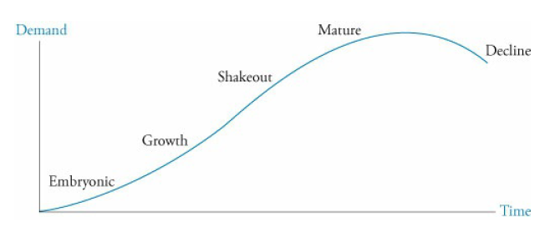

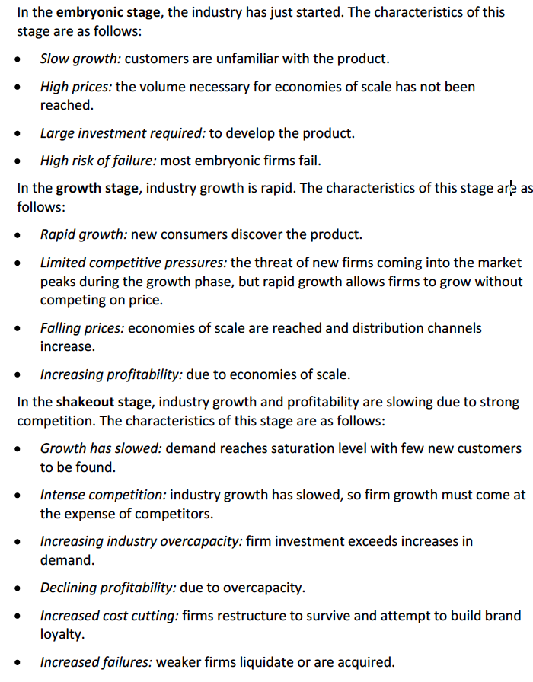

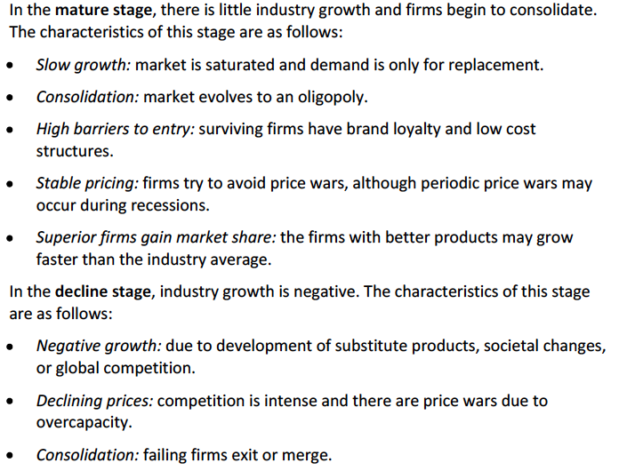

It is also important to check if the subject firm is in the stage of the industry or in a different stage.

Life cycle analysis is useful during stable periods and can present lots of variations.

## Compare characteristics of representative industries from the various economic sectors

So, the characteristics that should be checked are:

* Major firms
* Barrier to entry and success
* Industry concentration
* Influence of industry
* Industry stability
* Like cycle
* Competition
* Demographic influence
* Government influence
* Social influence
* Business cycle sensitivity

## Describe macroeconomic, technological, demographic, governmental and social influences on industry growth, profitability and risk

* Macroeconomy: GDP, interest rates, credit availability, inflation, business and consumer confidence.
* Technology: introduction of new products and technologies.
* Demography: age distribution, population size, population composition.
* Governments: taxes, regulation, government consumption.
* Social: work, free time, what they like and do.

## Describe the elements that should be covered in a thorough company analysis

The company analysis is done after looking at the industry. Competitive strategies need to be checked (defensive or offensive, to protect from the market or gain market share. Predatory pricing may appear where competitors are driven out) and can be a cost leadership (low-cost) strategy or a service differentiation strategy (customers premium over the firm should be lower than the higher costs its facing).

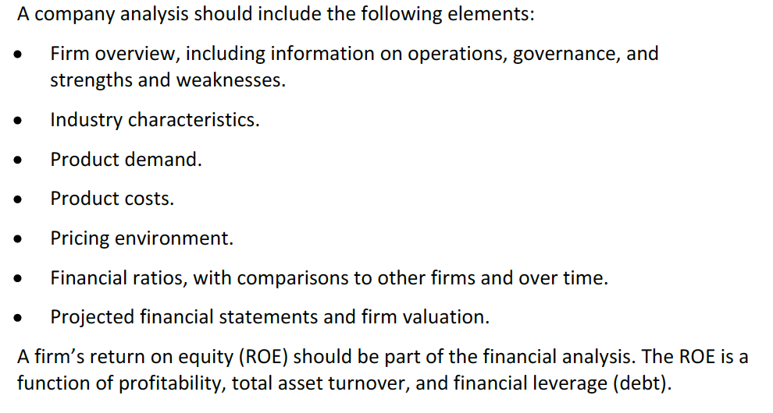

# Reading 49: Equity Valuation: Concepts and Basic Tools

## Evaluate whether a security, given its current market price and a value estimate, is overvalues, fairly valued or undervalued by the market

Issues to considering when investing in stocks in which the intrinsic value is different from the market value:

* The larger the difference, the more likely the investor will take a position.
* The more confident the investor is in his model and inputs, the more likely he will invest.
* Investors must consider why the stock is mispriced.
* The investor must foresee that the stock will get to the price given the time horizon. Cómo se hace esto??

## Describe major categories of equity valuation models

* Discounted cash flow or present value models: either the present value of cash distributed to shareholder (dividends) or the present value of free cash flows to equity (no era el FCF to the firm y luego le resto la deuda?).
* Multiplier or market multiple models: the first approach uses price in the numerator and the second one uses enterprise value.
* Asset-based models: uses the fair values of assets and then subtract liabilities and preferred stock at their fair value.

## Describe regular cash dividends, extra dividends, stock dividends, stock splits, reverse stock splits and share repurchases

* Cash dividends: may be regular or special dividends (extra or irregular) and are given in cash.
* Stock dividends: here, total shareholders’ equity remains unchanged because each share is worth less (entonces qué les está pagando?). Are usually stated as a percentage of the ownership of each shareholder.
* Stock splits: divide each share into more shares. The price drops but the owners wealth is the same.
* Reverse stock splits: the opposite.
* Share repurchase: the firm buys shares. The firm does it to support its price or because it believes their share is undervalued. Also to decrease outstanding shares. (movimiento contable)

## Describe dividend payment chronology

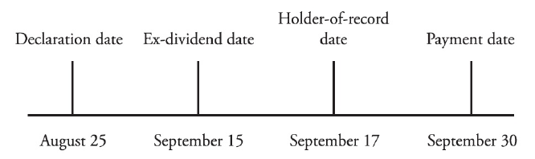

Declaration date: the date the board approves the paument, specifying the amount, the date the holders must own the share (record date) and the payment date.

Ex-dividend date: if the share is bought after this date, the holder will not receive the dividend and it is usually 1-2 days before the holder-of-record date. The share price will be adjusted by aprox the dividend (decrease).

Holder-of-record date (record date): the date in which the payment is received.

Payment date: the date the payment is mailed or electronically done.

## Explain the rationale for using present value models to value equity and describe the dividend discount and FCFE models

**Dividend discount model (DDM)**

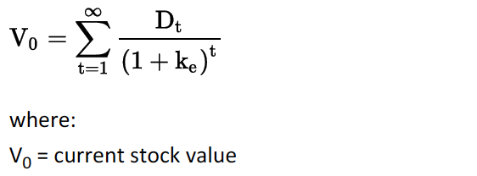

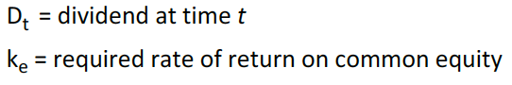

One-year holding period DDM: consists on the value of the stock today given it would be hold for a year:

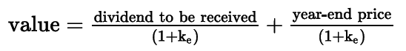

Multiple-year holding period DDM: it is the same but for more years:

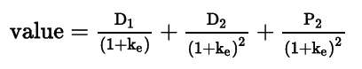

The perpetuity can also be used. When using the perpetuity, do I take into account the price?

**Free cash flow to equity (FCFE)**

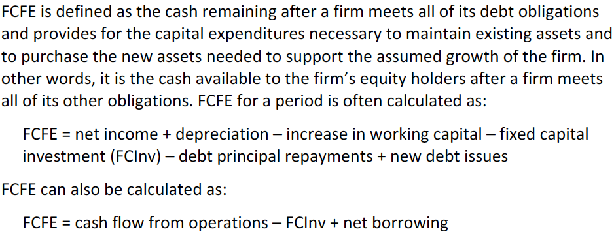

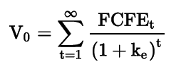

It uses cost of equity.

**Estimating ke**

The CAPM can be used. Normally, risk is added to the current bond yield.

## Calculate the intrinsic value of a non-callable, non-convertible preferred stock

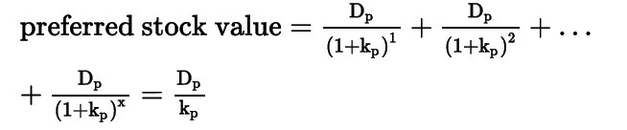

If it has maturity, it is simply considered by adding a selling price.

## Calculate and interpret the intrinsic value of an equity security based on the Gordon (constant) growth dividend discount model or a two-stage dividend discount model as appropriate

It assumes a constant annual growth

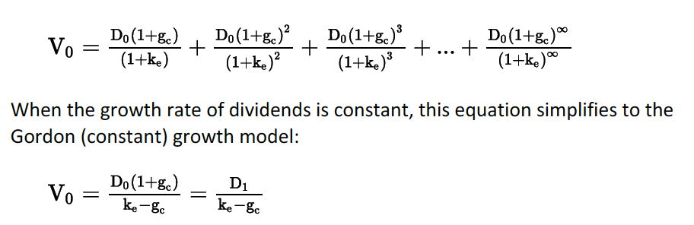

Ke > g, if not, it would not work.

words like “forever,” “infinitely,” “indefinitely,” “for the foreseeable future” refer to a perpetuity.

Words like “Just paid” or “recently paid” refer to D0.

Words like “will pay” or “is expected to pay” refer to D1.

An analyst should calculate the value using different k and g due to the sensitivity of the model.

* To calculate how much of the value is due to the growth, calculate g = growth and g = 0 and compute the difference.

**Estimating growth rates in dividends**

* Use historical growths of the firm.
* Use the median industry dividend growth rate.
* Estimate the sustainable growth (the rate at which equity, earning and dividends can grow indefinitely assuming a constant ROE and dividend payout:

Sustainable growth = (1 – dividend payout ratio) * ROE

1 – payout ratio is the retention rate

The estimate must be reasonable (1-digit, not two) with the economy and the industry.

If a firm does not pay dividends but will do in a future, the model can be used making the appropriate adjustments.

When using constant growth models, we use the next period’s cash flow (t+1) to calculate the present value on t. Then, it should be brought back to present from t to 0. -> if a firms does not paid dividend and it is expected to do in year 4, I will calculate the value in year three and bring it to PV using the dividend of year 4.

**Multistage dividend growth models**

When a firm experiences a growth rate higher than the required rate of return, it will attract competition which will drop the growth back to where it was. This is why the growth rate could change.

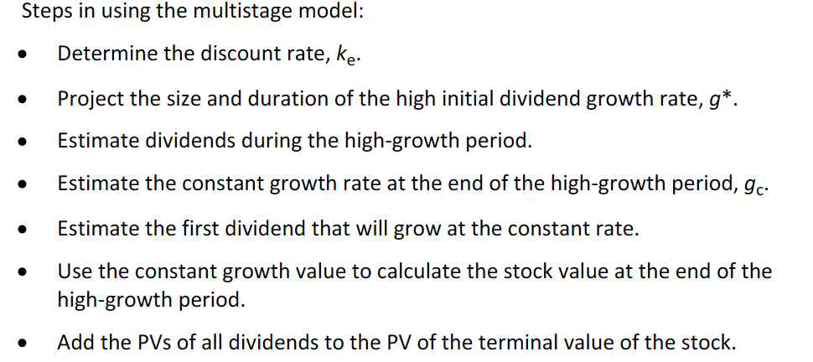

Since the year that the dividend will begin to grow at a constant rate, the annuity will take effect: Since Y4 the growth is constant, then I take to PV Y1-Y3 and with an annuity onwards.

## Identify characteristics of companies for which the constant growth or a multistage dividend discount model is appropriate

The Gordon growth model is appropriate for firms that pay constant dividends, firms that are stable, mature and non-cyclical.

As long as the growth of dividends stabilizes one time in the future, a multistage model may be appropriate. If a firm does not pays dividends and the is expected to do but without full certainty, the FCFE model should be used.

## Explain the rationale for using price multiples to value equity, how the price to earnings multiple relates to fundamentals and the use of multiples based on comparables

The thing with multiples is that they reflect only the past, that is why some investors use forward value in the denominator. When the multiple is based on comparables, it is based on the market while when it is based on fundamentals, it is based on a model.

## Calculate and interpret the following multiples: price to earnings, price to an estimate of operating cash flow, price to sales and price to book value

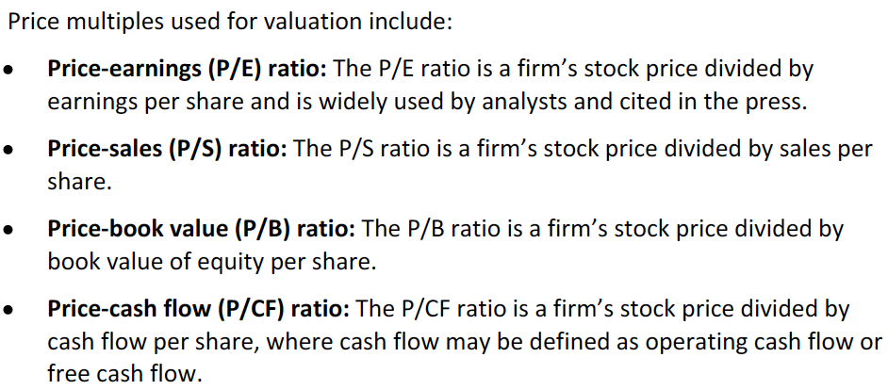

**Fundamental multiples**

Also referred as justified multiples

## 

The justified P/E is used as benchmark for the trailing P/E. If this last one is lower, the stock will be undervalued.

Divided displacement of earning: net effect of dividend payment reduces growth.

**Multiple based on comparables**

It is based on the law of one price, where identical asset should be priced the same.

P/CF -> uses net cash from operations.

When ratios trend downward, it may mean that the firm is undervalued compared to its previous valuations.

## Describe enterprise value multiples and their use in estimating equity value

EV = market value of common and preferred stock + market value of debt – cash and short-term investments

EV is useful when comparing firms with different capital structure.

Why is cash subtracted?

For consistency, the numerator should consider earnigs of both debt and equity owners. Revisar cuáles son earnings to the company.

Whenever there is no access to the market value of debt, similar bonds can help.

Market value of short term investments or debt = book value. This, because they are very similar as they are close to maturity.

## Describe asset-based valuation models and their use in estimating equity value

It consists on subtracting the asset’s fair or market value minus the debt fair or market value. To do this, every asset and liability must be calculated. Some methods include: value at their depreciated values, inflation adjustments or replacement values.

Intangible assets may trouble this method.

## Explain advantages and disadvantages of each category valuation model

