Table of Contents

Welcome to GIS for Geologists 2020 1

Course topics 1

Instruction formats 2

Introduction to GIS with ArcGIS Pro 2

Learning outcomes 2

Introduction to the exercises 3

Obtaining and opening the sample map 3

Extra image 3

Digimap for UK spatial data 4

Ordnance Survey collection 4

OS Roam 4

OS Download 4

British Geological Survey collection 4

# Welcome to GIS for Geologists 2020

Warning **Warning**

Note that at the moment these pages contain trial formatting, ideas etc rather than actual instructions.

GIS for geologists is a brief introduction to the use of GIS and spatial data for students on the geology programme at the University of Leeds. The aim is to give a broad overview of how GIS can be used to explore, analyse and display geological data.

## Course topics

The sections in this course build on each other and should be worked through in order. Cross-references to skills learnt in earlier sections will be included, and you can use the search box to find specific terms.

|  |  |  |
| --- | --- | --- |
| Week | Section | Skills |
| 1 | Introduction to GIS | Exploring ArcGIS Pro and the data |
| 2 | Finding data | How to find data online |

## Instruction formats

These web pages will be kept updated as the course progresses. If you would prefer a version for printing please download the [Word](Word/gis4geol.docx) or pdf version. Note that these may not be quite as up to date.

If you need the instructions in a different format please contact Clare. Contact details are in [Minerva](https://minerva.leeds.ac.uk/) for my students.

Note **Note**

This is a note - it will contain background information about the tasks you’ve been following.

Then there can be more text here giving more instructions.

Warning **Warning**

Warnings will give information about how to avoid some common problems. They may include saving your work regularly or backing it up!

Obviously I need to split up these sections if they are going to look reasonably sensible in Word. And actually on the web pages.

Video clip **Video clip**

Have a look at this exciting video! You can find it in [Minerva](https://minerva.leeds.ac.uk/).

And some more text here…

Information / tip **Information or tip**

Tips will include key tasks that aren’t directly related to the GIS instructions, but which you need to be able to carry them out, e.g. how to unzip files once you have downloaded them.

# Introduction to GIS with ArcGIS Pro

The background to Geographic Information Systems (GIS) and an explanation of what it is will be covered in the lecture segment at the beginning of the class and the presentation and any other supporting materials will be available in [Minerva](https://minerva.leeds.ac.uk/). The lecture segment should help you to understand why you are doing these exercises. If you still aren’t sure, please ask Clare.

## Learning outcomes

When you have completed this section of the workbook you will be able to

* demonstrate how to open a map project in ArcGIS
* select appropriate tools to navigate in a map document
* use layers to organise and display information on a map
* add information to a layout and prepare it for printing or display
* demonstrate different ways of finding help when using GIS

## Introduction to the exercises

As a GIS specialist you have been asked by the Field Studies Council to produce a geological map of the area around the Malham Tarn National Nature Reserve (NNR).

For this first exercise I have created a basic geological map of Malham Tarn so that you can explore the GIS application and get used to basic navigation and functions. In future sessions you will be preparing the data and setting up the basics for yourself.

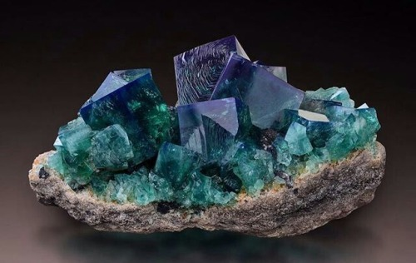

Flourite crystals

## Obtaining and opening the sample map

The sample map is based on British Geological Survey data covering Malham Tarn in North Yorkshire and uses data from a number of sources with which you will become familiar during this module.

### Extra image

This colourful image should cheer up your day. I’ve added it for “fun”.



Colourful pebbles

And I’ll add some text afterwards for good measure

# Digimap for UK spatial data

You can download all sorts of exciting data for the UK from Digimap.

Go to [Digimap](https://digimap.edina.ac.uk/)

## Ordnance Survey collection

And some text here

### OS Roam

More text…

### OS Download

And yet more text

## British Geological Survey collection

* you can roam again
* and you can download again