# Step 1: (March 9th, 2021)

For this step, I created a terminate boolean variable initialized to false in Santa, Reindeer, and Elf. Additionally, I created a publicly accessible deferredTerminate function in SantaScenario, Santa, Reindeer, and Elf. In Santa, Reindeer, and Elf, this function sets terminate to true. In SantaScenario, deferredTerminate calls the corresponding deferredTerminate for each santa, elf, and reindeer in the scenario. Additionally, I modified the while loop in Santa, Reindeer, and Elf to only run while terminate is false (while(!terminate)), rather than to run indefinitely (while(true)). In the SantaScenario thread, I called deferredTerminate on day 370.

# 

# Step 2: (March 9th, 2021)

For this step, I first removed all references to reindeer in SantaScenario. Then, I modified the behavior of an Elf when it is in TROUBLE. When it is in TROUBLE, its state switches to AT_SANTAS_DOOR. When it is AT_SANTAS_DOOR, it calls a function I created in the Santa thread to wake Santa. This function sets the elfAtDoor variable (a private elf variable I created in the santa class) to the elf that called the wakeByElf function and sets the state to WOKEN_UP_BY_ELVES. Then in the WOKEN_UP_BY_ELVES case, santa calls the setState function in the elf class to set the elf state to WORKING and then sets the santa state to SLEEPING.

# 

# Step 3: (March 22nd, 2021)

For this step, I created a publicly accessible ArrayList named elvesInTrouble in the SantaScenario class that contains the elves that are in trouble and are waiting for the third elf to be in trouble. In the elf class, I modified the Trouble state to add itself to the elvesInTrouble list if it is not present in the ArrayList and it has less than 3 members. Then, if the ArrayList had 3 members, the elves would go to change their state to AT_SANTAS_DOOR. Then, when the elf was in a working state, it would check if it was present in the ArrayList and remove itself accordingly.

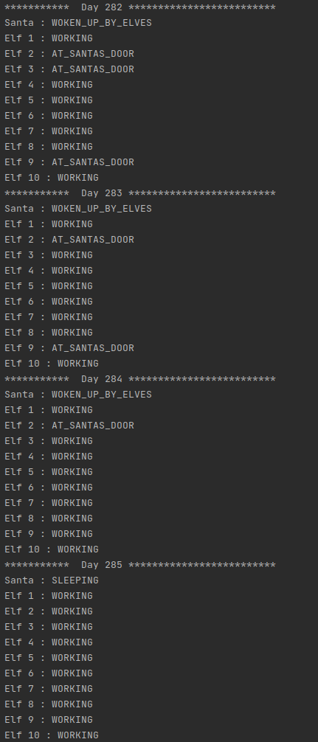

# Step 4: (March 22nd, 2021)

For this step, I created a publicly accessible semaphore with 3 permits named elvesInTrouble. When an elf is in trouble, it attempts to acquire a permit. If it can not get a permit, it waits until one is available. When it acquires a permit, it calls the wakeByElf function in the Santa class. This class adds an elf to an ArrayList of elves and changes the state of each of the member elves to AT_SANTAS_DOOR and santa’s state to WOKEN_UP_BY_ELVES when there are exactly 3 members in the array list. Then santa sets all of the member’s states to WORKING and removes them from the ArrayList. When an elf’s state is WORKING, it releases their permit.

# 