**NAME:1**

GOOGLE MAPS

Image:

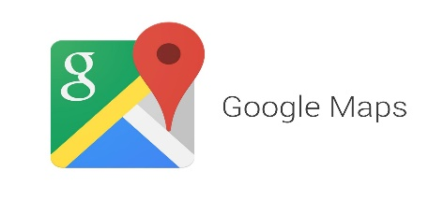

IMAGE DISCRIPTION; Navigate your world faster and easier

Find the best places in town and the information you need to get there.

Data:

**Google Maps** is a [web mapping](https://en.wikipedia.org/wiki/Web_mapping) service developed by [Google](https://en.wikipedia.org/wiki/Google). It offers [satellite imagery](https://en.wikipedia.org/wiki/Satellite_imagery), street maps, 360° panoramic views of streets ([Street View](https://en.wikipedia.org/wiki/Google_Street_View)), real-time traffic conditions ([Google Traffic](https://en.wikipedia.org/wiki/Google_Traffic)), and [route planning](https://en.wikipedia.org/wiki/Route_planner) for traveling by foot, car, bicycle (in [beta](https://en.wikipedia.org/wiki/Software_release_life_cycle#Beta)), or [public transportation](https://en.wikipedia.org/wiki/Public_transportation).

Google Maps began as a [C++](https://en.wikipedia.org/wiki/C%2B%2B) desktop program designed by [Lars](https://en.wikipedia.org/wiki/Lars_Rasmussen_(software_developer)) and [Jens Eilstrup Rasmussen](https://en.wikipedia.org/wiki/Jens_Eilstrup_Rasmussen) at Where 2 Technologies. In October 2004, the company was acquired by Google, which converted it into a web application. After additional acquisitions of a geospatial data visualization company and a realtime traffic analyzer, Google Maps was launched in February 2005. The service's [front end](https://en.wikipedia.org/wiki/Front_and_back_ends)utilizes [JavaScript](https://en.wikipedia.org/wiki/JavaScript), [XML](https://en.wikipedia.org/wiki/XML), and [Ajax](https://en.wikipedia.org/wiki/Ajax_(programming)). Google Maps offers an [API](https://en.wikipedia.org/wiki/Application_programming_interface) that allows maps to be embedded on third-party websites, and offers a locator for urban businesses and other organizations in numerous countries around the world. [Google Map Maker](https://en.wikipedia.org/wiki/Google_Map_Maker) allowed users to collaboratively expand and update the service's mapping worldwide but was discontinued from March, 2017. However, crowdsourced contributions to Google Maps were not discontinued as the company announced those features will be transferred to Google Local Guides program.

Google Maps' satellite view is a "top-down" or "birds eye" view; most of the high-resolution imagery of cities is [aerial photography](https://en.wikipedia.org/wiki/Aerial_photography) taken from aircraft flying at 800 to 1,500 feet (240 to 460 m), while most other imagery is from satellites. Much of the available satellite imagery is no more than three years old and is updated on a regular basis. Google Maps uses a close variant of the [Mercator projection](https://en.wikipedia.org/wiki/Mercator_projection), and therefore cannot accurately show areas around the poles.

The current redesigned version of the desktop application was made available in 2013, alongside the "classic" (pre-2013) version. [Google Maps for Android and iOS devices](https://en.wikipedia.org/wiki/Google_Maps_(app)) was released in September 2008 and features [GPS](https://en.wikipedia.org/wiki/GPS_navigation_device) [turn-by-turn navigation](https://en.wikipedia.org/wiki/Turn-by-turn_navigation) along with dedicated parking assistance features. In August 2013, it was determined to be the world's most popular app for [smartphones](https://en.wikipedia.org/wiki/Smartphone), with over 54% of global smartphone owners using it at least once.

In 2012, Google reported having over 7100 employees and contractors directly working in mapping.

**NAME:2**

GOOGLE CALENDAR

Image:

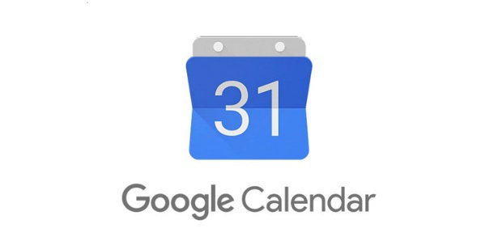

IMAGE DISCRIPTION; Save time and make the most of every day

Get flights, hotels, concerts, reservations and more added to your calendar automatically.

Data:

**Google Calendar** is a time-management and scheduling [calendar](https://en.wikipedia.org/wiki/Calendar) service developed by [Google](https://en.wikipedia.org/wiki/Google). It became available as a limited [beta release](https://en.wikipedia.org/wiki/Software_release_life_cycle#Beta) on April 13, 2006, and exited the beta stage in July 2009. It is available on the [web](https://en.wikipedia.org/wiki/Web_application) and as [mobile apps](https://en.wikipedia.org/wiki/Mobile_app) for the [Android](https://en.wikipedia.org/wiki/Android_(operating_system)) and [iOS](https://en.wikipedia.org/wiki/IOS) mobile operating systems.

Google Calendar allows users to create and edit events. Reminders can be enabled for events, with options available for type and time. Event locations can also be added, and other users can be invited to events. Users can enable or disable the visibility of special calendars, including Birthdays, where the app retrieves dates of births from Google contacts and displays birthday cards on a yearly basis, and Holidays, a country-specific calendar that displays dates of special occasions. Over time, Google has added functionality that makes use of [machine learning](https://en.wikipedia.org/wiki/Machine_learning), including "Events from Gmail", where event information from a user's [Gmail](https://en.wikipedia.org/wiki/Gmail) messages are automatically added to Google Calendar; "Reminders", where users add to-do activities that can be automatically updated with new information; "Smart Suggestions", where the app recommends titles, contacts, and locations when creating events; and "Goals", where users enter information on a specified personal goal, and the app automatically schedules the activity at optimal times.

Google Calendar's mobile apps have received polarized reviews. 2015 reviews of the Android and iOS apps both praised and criticized the design. While some critics praised the design for being "cleaner", "bold" and making use of "colorful graphics", other reviewers asserted that the graphics took up too much space. The Smart Suggestions feature was also liked and disliked, with varying levels of success in the app actually managing to suggest relevant information upon event creation. The integration between Google Calendar and Gmail was praised, however, with critics writing that "all of the relevant details are there".

**NAME:3**

GOOGLE KEEP

Image:

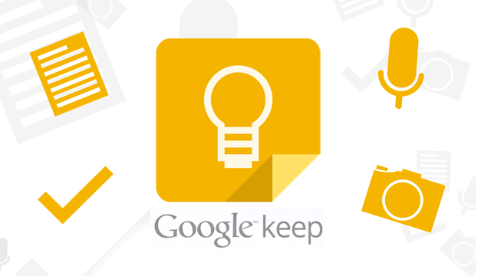

IMAGE DISCRIPTION; Offload ideas, thoughts, and to-dos without losing focus

Capture, edit, share, and collaborate on any device by adding notes, lists, photos, and audio.

Data:

**Google Keep** is a [note-taking](https://en.wikipedia.org/wiki/Note-taking) service developed by [Google](https://en.wikipedia.org/wiki/Google). Launched on March 20, 2013, Google Keep is available on the [web](https://en.wikipedia.org/wiki/Web_application), and has [mobile apps](https://en.wikipedia.org/wiki/Mobile_app) for the [Android](https://en.wikipedia.org/wiki/Android_(operating_system)) and [iOS](https://en.wikipedia.org/wiki/IOS) mobile operating systems. Keep offers a variety of tools for taking notes, including text, lists, images, and audio. Users can set reminders, which are integrated with [Google Now](https://en.wikipedia.org/wiki/Google_Now). Text from images can be extracted using [optical character recognition](https://en.wikipedia.org/wiki/Optical_character_recognition), and voice recordings can be transcribed. The interface allows for a single-column view or a multi-column view. Notes can be color-coded, and labels can be applied for organization. Later updates have added functionality to pin notes, and to collaborate on notes with other Keep users in real-time.

Google Keep has received mixed reviews. A review just after launch in 2013 praised its speed, the quality of voice notes, synchronization, and the widget that could be placed on the Android home screen. Reviews in 2016 have criticized the lack of formatting options, inability to undo changes, and an interface that only offers two view modes where neither was liked for their handling of long notes. However, Google Keep received praise for features including universal device access, native integration with other Google services, and the option to turn photos into text through optical character recognition.

**NAME: 4**

Google Chrome

Image:

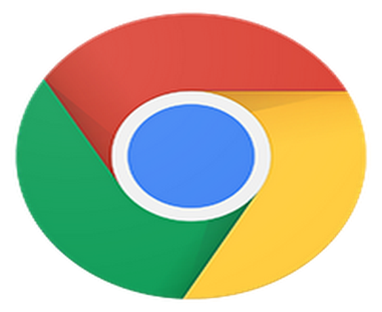

IMAGE DESCRIPTION: Browse fast on your phone and tablet

Sync tabs across devices, search by voice, and save data while browsing.

Data:

**Google Chrome** is a [freeware](https://en.wikipedia.org/wiki/Freeware) [web browser](https://en.wikipedia.org/wiki/Web_browser) developed by [Google](https://en.wikipedia.org/wiki/Google). It was first released in September 2008, for [Microsoft Windows](https://en.wikipedia.org/wiki/Microsoft_Windows), and was later ported to [Linux](https://en.wikipedia.org/wiki/Linux), [macOS](https://en.wikipedia.org/wiki/MacOS), [iOS](https://en.wikipedia.org/wiki/IOS) and [Android](https://en.wikipedia.org/wiki/Android_(operating_system)). Google Chrome is also the main component of [Chrome OS](https://en.wikipedia.org/wiki/Chrome_OS), where it serves as a platform for running [web apps](https://en.wikipedia.org/wiki/Web_app).

Google releases the majority of Chrome's source code as the [Chromium](https://en.wikipedia.org/wiki/Chromium_(web_browser)) [open-source](https://en.wikipedia.org/wiki/Open-source_software)project. One component that is not open-source is the built-in [Adobe Flash Player](https://en.wikipedia.org/wiki/Adobe_Flash_Player) (that Chrome has disabled by default since September 2016). Chrome used the [WebKit](https://en.wikipedia.org/wiki/WebKit" \o "WebKit) [layout engine](https://en.wikipedia.org/wiki/Layout_engine) until version 27. As of version 28, all Chrome ports except the iOS port use [Blink](https://en.wikipedia.org/wiki/Blink_(web_engine)), a [fork](https://en.wikipedia.org/wiki/Fork_(software_development))of the WebKit engine.

As of 2018, [StatCounter](https://en.wikipedia.org/wiki/StatCounter" \o "StatCounter) estimates that Google Chrome has a 66% worldwide [usage share of web browsers](https://en.wikipedia.org/wiki/Usage_share_of_web_browsers) as a desktop browser. It also has 56% market share across all platforms combined, because it has over 50% share on smartphones; and thus Chrome is most used browser in virtually all countries (most exceptions in Africa). Its success has led to Google expanding the "Chrome" brand name on various other products such as [Chromecast](https://en.wikipedia.org/wiki/Chromecast), [Chromebook](https://en.wikipedia.org/wiki/Chromebook), [Chromebit](https://en.wikipedia.org/wiki/Chromebit), [Chromebox](https://en.wikipedia.org/wiki/Chromebox) and [Chromebase](https://en.wikipedia.org/wiki/Chromebase).

**NAME:5**

YOUTUBE

Image:



IMAGE DISCRIPTION; See what the world is watching

Subscribe to channels you love, share with friends, and watch on any device.

Data:

**YouTube** is an American [video-sharing](https://en.wikipedia.org/wiki/Video_hosting_service) website headquartered in [San Bruno, California](https://en.wikipedia.org/wiki/San_Bruno,_California). The service was created by three former [PayPal](https://en.wikipedia.org/wiki/PayPal) employees—[Chad Hurley](https://en.wikipedia.org/wiki/Chad_Hurley), [Steve Chen](https://en.wikipedia.org/wiki/Steve_Chen), and [Jawed Karim](https://en.wikipedia.org/wiki/Jawed_Karim)—in February 2005. [Google](https://en.wikipedia.org/wiki/Google) bought the site in November 2006 for US$1.65 billion; YouTube now operates as one of [Google](https://en.wikipedia.org/wiki/Google)'s [subsidiaries](https://en.wikipedia.org/wiki/Subsidiary).

YouTube allows users to upload, view, rate, share, add to favorites, report, comment on [videos](https://en.wikipedia.org/wiki/Video), and [subscribe to other users](https://en.wikipedia.org/wiki/List_of_most-subscribed_YouTube_channels). It offers a wide variety of [user-generated](https://en.wikipedia.org/wiki/User-generated_content) and [corporate media](https://en.wikipedia.org/wiki/Corporate_media) videos. Available content includes [video clips](https://en.wikipedia.org/wiki/Video_clip), [TV show](https://en.wikipedia.org/wiki/TV_show) clips, [music videos](https://en.wikipedia.org/wiki/Music_video), [short](https://en.wikipedia.org/wiki/Short_film) and [documentary](https://en.wikipedia.org/wiki/Documentary_film) films, audio recordings, [movie trailers](https://en.wikipedia.org/wiki/Trailer_(promotion)), [live streams](https://en.wikipedia.org/wiki/Live_streams), and other content such as [video blogging](https://en.wikipedia.org/wiki/Video_blog), short original videos, and [educational videos](https://en.wikipedia.org/wiki/Edutainment). Most of the content on YouTube is uploaded by individuals, but media corporations including [CBS](https://en.wikipedia.org/wiki/CBS), the [BBC](https://en.wikipedia.org/wiki/BBC), [Vevo](https://en.wikipedia.org/wiki/Vevo), and [Hulu](https://en.wikipedia.org/wiki/Hulu) offer some of their material via YouTube as part of the YouTube partnership program. Unregistered users can only watch videos on the site, while registered users are permitted to [upload](https://en.wikipedia.org/wiki/Upload) an unlimited number of videos and add comments to videos. Videos deemed potentially inappropriate are available only to registered users affirming themselves to be at least 18 years old.

YouTube earns advertising revenue from [Google](https://en.wikipedia.org/wiki/Google) [AdSense](https://en.wikipedia.org/wiki/AdSense), a program which targets ads according to site content and audience. The vast majority of its videos are free to view, but there are exceptions, including subscription-based premium channels, film rentals, as well as [YouTube Red](https://en.wikipedia.org/wiki/YouTube_Red), a subscription service offering ad-free access to the website and access to exclusive content made in partnership with existing users. As of February 2017, there are more than 400 hours of content uploaded to YouTube each minute, and one billion hours of content are watched on YouTube every day. As of August 2017, the website is ranked as the second-most popular site in the world by [Alexa Internet](https://en.wikipedia.org/wiki/Alexa_Internet), a web traffic analysis company.

**NAME:6**

GMAIL

Image:

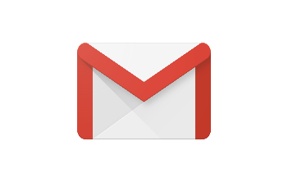

IMAGE DISCRIPTION; Get the ease & simplicity of Gmail across all your devices

The Gmail app offers real-time notifications, multiple account support, and inbox search.

Data:

**Gmail** is a free, [advertising](https://en.wikipedia.org/wiki/Advertising)-supported [email](https://en.wikipedia.org/wiki/Email) service developed by [Google](https://en.wikipedia.org/wiki/Google). Users can access Gmail on the [web](https://en.wikipedia.org/wiki/Web_application) and using third-party programs that synchronize email content through [POP](https://en.wikipedia.org/wiki/Post_Office_Protocol) or [IMAP](https://en.wikipedia.org/wiki/Internet_Message_Access_Protocol) protocols. Gmail started as a limited [beta release](https://en.wikipedia.org/wiki/Beta_test) on April 1, 2004, and ended its testing phase on July 7, 2009.

At launch, Gmail had an initial storage capacity offer of one [gigabyte](https://en.wikipedia.org/wiki/Gigabyte) per user, a significantly higher amount than competitors offered at the time. Today, the service comes with 15 gigabytes of storage. Users can receive emails up to 50 megabytes in size, including attachments, while they can send emails up to 25 megabytes. In order to send larger files, users can insert files from [Google Drive](https://en.wikipedia.org/wiki/Google_Drive) into the message. Gmail has a [search](https://en.wikipedia.org/wiki/Search_engine)-oriented interface and a ["conversation view"](https://en.wikipedia.org/wiki/Gmail_interface#Conversation_view) similar to an [Internet forum](https://en.wikipedia.org/wiki/Internet_forum). The service is notable among website developers for its early adoption of [Ajax](https://en.wikipedia.org/wiki/Ajax_(programming)).

Google's mail servers automatically scan emails for multiple purposes, including to filter [spam](https://en.wikipedia.org/wiki/Spamming" \o "Spamming)and [malware](https://en.wikipedia.org/wiki/Malware), and to add context-sensitive advertisements next to emails. This advertising practice has been significantly criticized by privacy advocates due to concerns over unlimited data retention, ease of monitoring by third parties, users of other email providers not having agreed to the policy upon sending emails to Gmail addresses, and the potential for Google to change its policies to further decrease privacy by combining information with other Google data usage. The company has been the subject of lawsuits concerning the issues. Google has stated that email users must "necessarily expect" their emails to be subject to automated processing, and claims that the service refrains from displaying ads next to potentially sensitive messages, such as those mentioning race, religion, sexual orientation, health, or financial statements. In June 2017, Google announced the upcoming end to the use of contextual Gmail content for advertising purposes, relying instead on data gathered from use of its other services.[[3]](https://en.wikipedia.org/wiki/Gmail#cite_note-No_contextual_ads-3)

As of July 2017, Gmail has 1.2 billion active users worldwide,[[*citation needed*](https://en.wikipedia.org/wiki/Wikipedia:Citation_needed)] and was the first app on the [Google Play](https://en.wikipedia.org/wiki/Google_Play) Store to hit one billion installations on [Android](https://en.wikipedia.org/wiki/Android_(operating_system)) devices. According to a 2014 estimate, 60% of mid-sized US companies, and 92% of [startups](https://en.wikipedia.org/wiki/Startup_company), were using Gmail.

**NAME:7**

GOOGLE PHOTOS

Image:

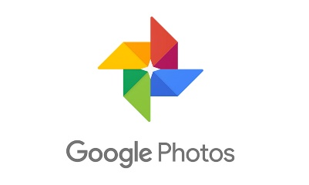

IMAGE DISCRIPTION; All your photos organized and easy to find

Get a smarter home for all your photos and videos, made for the way you take photos today.

Data:

**Google Photos** is a [photo sharing](https://en.wikipedia.org/wiki/Photo_sharing) and [storage service](https://en.wikipedia.org/wiki/Cloud_storage) developed by [Google](https://en.wikipedia.org/wiki/Google). It was announced in May 2015 and spun out from [Google+](https://en.wikipedia.org/wiki/Google%2B), the company's [social network](https://en.wikipedia.org/wiki/Social_network).

Google Photos gives users free, unlimited storage for photos up to 16 [megapixels](https://en.wikipedia.org/wiki/Megapixel) and videos up to 1080p [resolution](https://en.wikipedia.org/wiki/Display_resolution). The service automatically analyzes photos, identifying various visual features and subjects. Users can search for anything in photos, with the service returning results from three major categories: People, Places, and Things. Google Photos recognizes faces, grouping similar ones together; geographic landmarks (such as the [Eiffel Tower](https://en.wikipedia.org/wiki/Eiffel_Tower)); and subject matter, including birthdays, buildings, animals, food, and more.

Different forms of [machine learning](https://en.wikipedia.org/wiki/Machine_learning) in the Photos service allow recognition of photo contents, automatically generate albums, animate similar photos into quick videos, surface past memories at significant times, and improve the quality of photos and videos. In May 2017, Google announced several updates to Google Photos, including reminders for and suggested sharing of photos, shared photo libraries between two users, and physical albums, with Photos automatically suggesting collections based on face, location, trip, or other distinction.

Google photos acts as a back up when photos are sent or in Google terms 'Shared'. This is just a common [backup tool](https://en.wikipedia.org/wiki/Remote_backup_service) when photos are shared between social media or other platforms or apps.

Google Photos received critical acclaim after its decoupling from Google+ in 2015. Reviewers liked the updated Photos service for its recognition technology, search, apps, and loading times. Nevertheless, privacy concerns were raised, including Google's motivation for building the service, as well as its relationship to governments and possible laws requiring Google to hand over a user's entire photo history. Google Photos has seen strong user adoption. It reached 100 million users after five months, 200 million after one year, and 500 million as of May 2017, with Google announcing that over 1.2 billion photos are uploaded to the service every day, with the grand total of all uploaded content measuring over 13.7 [petabytes](https://en.wikipedia.org/wiki/Petabyte) of storage.

**NAME:8**

GOOGLE DRIVE

IMAGE:

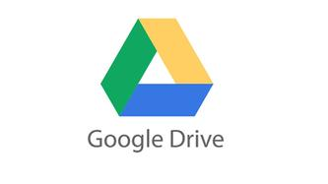

IMAGE DISCRIPTION: A safe place for all your files

Get 15 GB of free Google online storage and access files from any device.

DATA:

**Google Drive** is a [file storage](https://en.wikipedia.org/wiki/File_hosting_service) and [synchronization service](https://en.wikipedia.org/wiki/File_synchronization) developed by [Google](https://en.wikipedia.org/wiki/Google). Launched on April 24, 2012, Google Drive allows users to store files on their servers, synchronize files across devices, and [share files](https://en.wikipedia.org/wiki/File_sharing). In addition to a [website](https://en.wikipedia.org/wiki/Web_application), Google Drive offers apps with offline capabilities for [Windows](https://en.wikipedia.org/wiki/Microsoft_Windows) and [macOS](https://en.wikipedia.org/wiki/MacOS) computers, and [Android](https://en.wikipedia.org/wiki/Android_(operating_system)) and [iOS](https://en.wikipedia.org/wiki/IOS) smartphones and tablets. Google Drive encompasses [Google Docs, Sheets and Slides](https://en.wikipedia.org/wiki/Google_Docs,_Sheets_and_Slides), an [office suite](https://en.wikipedia.org/wiki/Office_suite) that permits collaborative editing of documents, spreadsheets, presentations, drawings, forms, and more. Files created and edited through the office suite are saved in Google Drive.

Google Drive offers users 15 [gigabytes](https://en.wikipedia.org/wiki/Gigabyte) of free storage, with 100 gigabytes, 1 [terabyte](https://en.wikipedia.org/wiki/Terabyte), 2 terabytes, 10 terabytes, 20 terabytes, and 30 terabytes offered through optional paid plans. Files uploaded can be up to 5 terabytes in size. Users can change privacy settings for individual files and folders, including enabling sharing with other users or making content public. On the website, users can search for an image by describing its visuals, and use [natural language](https://en.wikipedia.org/wiki/Natural_language_processing) to find specific files, such as "find my budget spreadsheet from last December".

The website and Android app offer a Backups section to see what Android devices have data backed up to the service, and a completely overhauled computer app released in July 2017 allows for backing up specific folders on the user's computer. A Quick Access feature can [intelligently predict](https://en.wikipedia.org/wiki/Machine_learning) the files users need.

Google Drive is a key component of [G Suite](https://en.wikipedia.org/wiki/G_Suite), Google's monthly subscription offering for businesses and organizations. As part of select G Suite plans, Drive offers unlimited storage, advanced file audit reporting, enhanced administration controls, and greater collaboration tools for teams.

Following the launch of the service, Google Drive privacy policy was heavily criticized by some members of the media. Google has one set of Terms of Service and Privacy Policy agreements that cover all of its services, meaning that the language in the agreements grants the company broad rights to reproduce, use, and create [derivative works](https://en.wikipedia.org/wiki/Derivative_work) from content stored on Google Drive. While the policies also confirm that users retain intellectual property rights, privacy advocates raised concerns that the licenses grant Google the rights to use the information and data to customize advertising and other services Google provides. In contrast, other members of the media noted that the agreements were no worse than those of competing cloud storage services, but that the competition uses "more artful language" in the agreements, and also stated that Google needs the rights in order to "move files around on its servers, cache your data, or make image thumbnails".

As of March 2017, Google Drive has 800 million active users, and as of September 2015, it has over one million organizational paying users. As of May 2017, there are over two trillion files stored on the service.