Stock assessment for Pacific Herring (clupea Pallasi) in British Columbia in 2017 and forecast for 2018
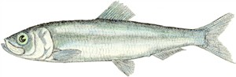  Pacific Herring (Cluepea pallasi). Image credit: Fisheries and Oceans Canada. | 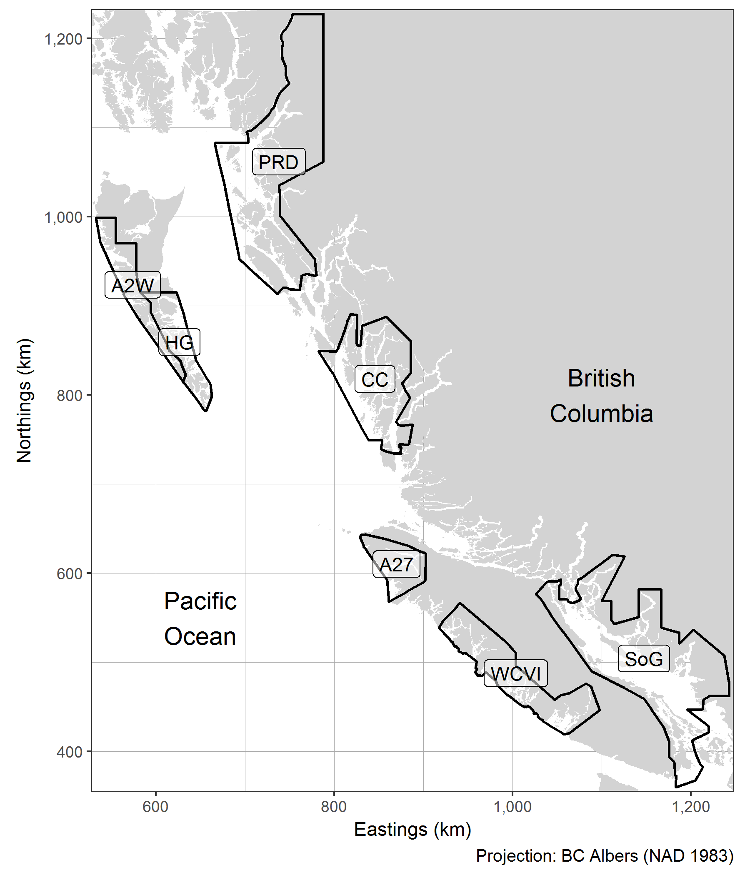  Figure 1. Boundaries for the Pacific Herring stock assessment regions (SARs) in British Columbia, Canada. The major SARs are Haida Gwaii (HG), Prince Rupert District (PRD), Central Coast (CC), Strait of Georgia (SoG), and West Coast of Vancouver Island (WCVI). The minor SARs are Area 27 (A27) and Area 2 West (A2W). Units: kilometres (km).
Context: Style “Context-Heading”: Arial, size 12, bold, aligned left, paragraph spacing 6 pt (0.08 in, 0.21 cm) before and 3 pt (0.04 in, 0.10 cm) after
Context text – Style “Context-text”: Arial, size 10, italicized, left aligned, paragraph spacing 3 pt (0.04 in, 0.10 cm) before and after.
[The following paragraph is optional for the Context section and mandatory for the Sources of Information section. The meeting date and title must be exactly as they appear on the Fisheries and Oceans Canada (DFO) Science Advisory Schedule. Be sure to use the default text in the French template for the translation as well as the meeting information on the French version of the schedule.]
This Science Advisory Report is from the [meeting date and title (e.g., January 25, 2011 Assessment of Quebec inshore waters softshell clam)]. Additional publications from this meeting will be posted on the Fisheries and Oceans Canada (DFO) Science Advisory Schedule as they become available.

WEB ACCESSIBILITY NOTES
Web accessibility standards are to be used for new documents posted on the CSAS website. (See Treasury Board Secretariat Standard on Web Accessibility for details).
Please refer to the checklist in the CSAS Publications Toolkit located on the CSAS Intranet site.

LAYOUT REQUIREMENTS (FORMATTING AND STYLES)

HEADING 2: ARIAL, SIZE 14, BOLD, LEFT ALIGNED, ALL CAPS, PARAGRAPH SPACING 12 PT (0.17 IN, 0.42 CM) BEFORE AND 6 PT (0.08 IN, 0.21 CM) AFTER

Heading 3: Arial, 12, bold, left-aligned, paragraph spacing 12 pt (0.17 in, 0.42 cm) before and 6 pt (0.08 in, 0.21 cm) after

Heading 4: Arial, 11, bold, left-aligned, left indentation 18 pt (0.25 in, 0.63 cm), paragraph spacing 6 pt (0.08 in, 0.21 cm) before and after
Body Text: Arial, size 11, left-aligned, paragraph spacing 6 pt (0.08 in, 0.21 cm) before and after
- List Bullet: Arial, size 11, left-aligned, hanging indentation 18 pt (0.25 in, 0.63 cm), paragraph spacing 0 pt before and 6 pt (0.08 in, 0.21 cm) after
- List Bullet 2: Arial, size 11, left-aligned, left indentation 18 pt (0.25 in, 0.64 cm), hanging indentation 18 pt (0.25 in, 0.63 cm), paragraph spacing 0 pt before and 6 pt (0.08 in, 0.21 cm) after
Examples of List number:
- List Number: Arial, size 11, left-aligned, numbering style: 1, 2, 3, hanging indentation 18 pt (0.25 in, 0.63 cm), paragraph spacing 0 pt before and 6 pt (0.08 in, 0.21 cm) after
- List Number
- List Number 2: Arial, size 11, left-aligned, numbering style: a, b, c, left indentation 18 pt (0.25 in, 0.63 cm), hanging indentation 18 pt (0.25 in, 0.63 cm), paragraph spacing 0 pt before and 6 pt (0.08 in, 0.21 cm) after
- List Number 2
Caption – Table: Arial, size 10, italics, left-aligned, paragraph spacing 12 pt (0.17 in, 0.42 cm) before and 6 pt (0.08 in, 0.21 cm) after, keep with next paragraph, keep with next paragraph, keep lines together. Table caption goes above the table.
Caption – Figure: Arial, size 10, italics, left-aligned, paragraph spacing 6 pt (0.08 in, 0.21 cm) before and 12 pt (0.17 in, 0.42 cm) after, keep lines together. Figure caption goes below the figure.
citation: Arial, size 11, left aligned, hanging indentation 18 pt (0.25 in, 0.63 cm), paragraph spacing 6 pt (0.08 in, 0.21 cm) before and after, keep lines together.
Blockquote: Arial, size 11, left-aligned, left indentation 36 pt (0.5 in, 1.27 cm), paragraph spacing 6 pt (0.08 in, 0.21 cm) before and after

SUMMARY
This section will be posted in HTML format on the CSAS website followed by the link to the full PDF version of the publication.
Summary Bullets: Style – Summary Bullets (Arial 11, left aligned, recommended paragraph spacing: 6 pt before and 6 pt after, or 3 pt before and after when the list is long)

- Commercial fishing for British Columbia (BC) Pacific Herring is managed as five major stock management areas: Haida Gwaii (HG), Prince Rupert District (PRD), Central Coast (CC), Strait of Georgia (SOG), and West Coast of Vancouver Island (WCVI), and two minor stock areas: Haida Gwaii Area 2W, and WCVI Area 27 (Figure 1).
- Spawning biomass in 2017 (SB₂₀₁₇) and pre-fishery forecast spawning biomass for 2018 (SB₂₀₁₈) were assessed using the most up-to-date version of the integrated statistical catch-at-age model (ISCAM or “the assessment model”). Two base cases were implemented: AM2 and AM1, differing in the treatment of spawn survey scaling coefficients (q₁, q₂).
- SB denotes spawning biomass and all biomass results are reported in metric tonnes (t). Stock status is measured relative to equilibrium unfished spawning biomass (SB₀). Model-estimated quantities are presented as the median and 5-95% credible interval.
- Advice for each Pacific Herring stock is presented in probabilistic decision tables showing predicted status in 2018 given a range of constant catches relative to the limit reference point (LRP) of 0.30SB₀, the commercial fishery cut-offs (AM2 only), and target harvest rates of 10% and 20%.
- A bridging analysis was used…
- Four sensitivity analyses were conducted: …
- The merits of AM2 and AM1 approaches to parameterizing the spawn survey scaling coefficient, q, were examined in part through sensitivity analyses. The key concern with AM2 is the use of a highly informative prior for the dive survey time series, q₂=1. The key concern with AM1 is the lack of information in the data to update the prior for 4 of the 5 stocks: median posterior estimates of q₂ are similar to the prior value of 0.5 for all areas (except PRD), ranging from 0.547 to 0.640.
- Sensitivity analyses alone are insufficient for understanding the complex interplay between q and management parameters, and resolution between AM2 and AM1 parameterization of q will require simulation-evaluation.

HAIDA GWAII (HG)
- All herring spawning from Cumshewa Inlet in the north to Louscoone Inlet in the south are assumed to be part of the Haida Gwaii stock.
- Haida Gwaii was closed to commercial roe fisheries from 2002–2013 and 2015–2017, and commercial spawn-on-kelp (SOK) fisheries from 2004–2013 and 2015–2017. Commercial roe and SOK fishing opportunities were available in 2014, however they were not pursued following an agreement between the commercial sector and local First Nations.
- Spawn index declined from 6,888 t in 2016 to 3,016 t in 2017 and the biological samples contain a high/low proportion of age x fish and few age x fish.
- The estimated spawning biomass in 2017 (SB₂₀₁₇) is 1,980 – 8,005 t (median 3,963 t) under AM2, and 3,434 – 15,433 t (median 7,336 t) under AM1. SB₂₀₁₇ is estimated to be 17% (median) of SB₀ under AM2, and 25% (median) of SB₀ under AM1.
- There is no apparent recruitment predicted to be entering the spawning population in 2017 and number of age-2 recruits per number of spawners is near the origin of the Beverton-Holt stock recruit curve.
- Although model estimates of current natural mortality remain highly uncertain, there is an increasing trend in the median estimates of natural mortality since 2012.
- Both AM2 and AM1 models estimated SB₂₀₁₇ to be BELOW the LRP of 0.3·SB₀ with greater than a 50% probability.
- The projected pre-fishery spawning biomass in 2018 is 3,270 t (AM2, median estimate) or 6,090 t (AM1, median estimate), similar to SB2017 levels, consisting of 34% (median) age-3 fish and 38% (median) age-4 and older fish.
- The median estimate of stock biomass is projected to remain near historic low levels in 2018, with 81% (AM2) and 65% (AM1) probability the stock will be below the LRP of 0.3·SB₀ in the absence of fishing.
- Others?

PRINCE RUPERT DISTRICT (PRD)
- All herring spawning in Statistical Areas 3 to 5 are assumed to belong to the Prince Rupert District stock.
- The combined total validated catch for the seine roe, the gillnet roe, and the food and bait fisheries was xxx t for the 2016/17 herring season. Commercial spawn-on-kelp operations also occurred in 2017.
- Spawn index…
- The estimated spawning biomass in 2017 ...
- Recruitment…
- Natural mortality…
- Both AM2 and AM1 models estimated SB2017 to be ABOVE the LRP of 0.3 · SB0 with greater than a 50% probability and less than a 95% probability
- Both AM2 and AM1 predict a continued stable trend in spawning biomass, with projected pre-fishery spawning biomass in 2018 of 21,553 t (AM2) and 22,590 t (AM1, median estimate), consisting of 23% (median) age-3 fish and 68% (median) age-4 and older fish.
- In 2018, there is a 27% (AM2) and 26% (AM1) probability the stock will be below the LRP of 0.3·SB₀ in the absence of fishing.
- Others?

CENRTAL COAST (CC)
- All herring spawning in Kitasu Bay (a portion of Statistical Area 6), Statistical Area 7, and part of Statistical Area 8 (Kwakshua Channel and Fitzhugh Sound) are assumed to be part of the Central Coast stock.
- CC: Both AM2 and AM1 models estimated SB2017 to be ABOVE the LRP of 0.3 · SB0 with greater than a 95% probability

STRAIT OF GEORGIA (SoG)
- All herring spawning in Statistical Areas 14 to 19, 28 and 29 (excluding Section 293), and part of 13 (Herring Sections 132 and 135, Deepwater Bay area south) are assumed to belong to the Strait of Georgia herring stock.
- SOG: Both AM2 and AM1 models estimated SB2017 to be ABOVE the LRP of 0.3 · SB0 by greater than 95% probability

WEST COAST VANCOUVER ISLAND (WCVI)
- All herring spawning in Statistical Areas 23 to 25 are assumed to belong to the west coast of Vancouver Island herring stock.
- WCVI: Both AM2 and AM1 models estimated SB2017 to be ABOVE the LRP of 0.3 · SB0, by greater than 50% probability but less than 95% probability
- This area was closed to commercial fisheries last occurred in this area in 20xx.

MINOR STOCK: AREA 2W
- All herring spawning in Statistical Area 2W (except Herring Section 006) are assumed to belong to this Haida Gwaii minor stock.
- Commercial fisheries last occurred in this area in 20xx.

MINOR STOCK: AREA 27
- All herring spawning in Statistical Area 27 are assumed to belong to this West Coast of Vancouver Island minor stock.
- A commercial spawn-on-kelp fishery last occurred in this area in 2014.

INTRODUCTION (or BACKGROUND)
(Heading 2, mandatory)
to-do: add/modify text from 2014 SAR, 2015 SR and 2016 SR
-need further instructions on how long/ what to include – ask Linnea/ Lesley…

ASSESSMENT

Stock Assessment Modeling for 2017
ISCAM (Integrated Statistical Catch-Age Model) was first reviewed and implemented for the assessment of Pacific Herring in 2011 (Martell et al. 2012). For the 2017 assessment, an updated version of ISCAM was applied to assess each of the 5 Pacific Herring stocks. This combined-sex, catch-at-age model was applied independently to each stock area and tuned to fishery-independent spawn index data, annual estimates of commercial catch since 1951, and age composition data from the commercial fishery and the test fishery charter program. The key results from stock assessments of Pacific Herring in the five major stock areas are summarized as stock reconstructions, status of spawning stock in 2017 relative to the LRP of 0.30SB₀, and projected spawning biomass in 2018.
A bridging analysis was used to move from an older version of ISCAM to the most updated version. Between-version adjustments made to some of the analytical procedures within ISCAM are also documented. The most significant update was to the estimation of the variance structure. In Martell et al. (2012) the errors-in-variables approach (partitioning of variance between observation and process error) parameterized varphi as the total standard deviation of the process error, rather than the total variance. Given the recommendation of the reviewers in 2011 and to bring the assessment in line with best practices, the current assessment includes updates to the errors-in-variables approach to represent partitioning of the total precision (Appendix A). This change to partitioning of the total variance impacts model estimates of leading parameters and unfished biomass (SB₀).
ISCAM estimates stock-recruitment parameters (recruitment is modelled as age-2 fish, while recruitment to the spawning biomass occurs at age-3), time-varying natural mortality, spawn survey scaling parameters for the survey time series (q1, q2), and selectivity parameters for three main commercial fisheries, generating time series estimates of spawning biomass and unfished biomass. One-year projections for 2018 were performed for each major stock area, over a range of constant catches, to estimate the predicted status in 2018 given a range of constant catches relative to the limit reference point (LRP) of 0.30SB₀, the commercial fishery cut-offs (AM2 only), and target harvest rates of 10% and 20%. All projections were generated from posterior distributions developed from a Bayesian Markov Chain Monte Carlo (MCMC) search to quantify the uncertainty associated with parameter estimation. Estimates of various quantities were calculated from these samples, and are presented as median values and 5-95% credible intervals.
The 2017 assessment implemented two base stock assessment models that differ in the treatment of spawn survey scaling parameters (q₁ and q₂) for the surface survey period (1951 to 1987) and dive survey period (1988 to 2017), respectively. The two models are labelled AM1 (q₁ and q₂ estimated with prior probability distributions) and AM2 (q₁ estimated, q₂ = 1).
Four sensitivity cases were included, testing the sensitivity of results from both base case models to: assumed natural mortality (time varying vs. constant), assumed initial values for variance parameters, prior probabilities on survey scaling parameters, and assumed fixed values of maturity at age. [more here?]
The merits of AM2 and AM1 approaches to parameterizing the spawn survey scaling parameter, q, were examined in part through sensitivity analyses. The key concern with AM2 is the use of a highly informative prior for the dive survey time series, q₂=1. The key concern with AM1 is that there is a lack of information in the data to update the prior for 4 of the 5 stocks: median posterior estimates of q₂ are similar to the prior value of 0.5 for all areas (except PRD), ranging from 0.547 to 0.640. Thus under AM1, the choice of prior for HG, PRD, CC and WCVI effectively defines the posterior estimates of q1 and q2.
Both the bridging analysis and the sensitivity analyses support continued use of these two base case models for each of the 5 major herring stocks. Sensitivity analyses alone are insufficient for understanding the complex interplay between q and management parameters, and resolution between AM1 and AM2 parameterization of q, beyond conclusions identified in the previous paragraph, will require simulation-evaluation.
Advice to managers on estimated (current) spawning biomass, SB₂₀₁₇, estimated unfished equilibrium spawning biomass, SB₀, stock status relative to the unfished biomass: SB₂₀₁₇/SB₀, stock status relative to the LRP of 0.30*SB₀, trends in age-2 recruitment and instantaneous natural mortality is presented in Figures x through xx. Tables 1 and ? give estimates of spawning biomass in recent years (SB_{t}), SB₀, 0.25 SB₀, and the ratio SB₂₀₁₇/SB₀…
To-do: determine what tabular information to include in the SAR

Reference Points
Describe application of LRP
Describe candidate USR- emphasizing that both Kronlund et al. (2017) and analyses presented herein continue to support non-use of MSY-based reference points.

Sources of Uncertainty
Recruitment and natural mortality are considered to be the most important processes determining the productivity of BC Pacific Herring stocks. Factors driving age-3 recruitment to the spawning biomass, forecasted by the assessment model, are not fully understood. Instantaneous natural mortality (M) is estimated to be increasing for HG, decreasing for PRD and CC, and possibly increasing for SOG and WCVI stocks. The reasons for these changes are not clear at present, but are under investigation as natural mortality is an important parameter in the stock assessment model because it affects current stock biomass and also the estimate of the unfished biomass. Long term declines in body size (weight at age) have been observed for all BC herring stocks from the early 1980s-2010, with a levelling off at the low end of the range in most recent years. Factors causing these changes are not understood.
Modelling results reflect only the structural assumptions specified in the model and weights assigned to the various data components, representing a minimum estimate of uncertainty. While uncertainty in the estimated parameters and derived quantities is explicitly addressed using a Bayesian approach, alternative model and stock structure assumptions - including alternative forecasting methods - would illustrate greater levels of uncertainty. Finally, for some stock areas (HG, WCVI), small sample sizes of age-composition samples are a concern in recent years.

Projection Results and Decision Tables

To-do: Describe columns in the decision tables

To-do: Include plain language example of how to read the decision tables

CONCLUSIONS AND ADVICE
To-do: what goes here…?

Recommendations for future work follow:
- Simulation-testing of management procedures
- SOK/SOB: quantify mortality and removed spawn
- Quantify uncertainty in the spawn index (annual estimates of variance)
- Potential for stock-specific prior distribution on q
- Investigate appropriateness of stock-specific maturity ogive
- Anything else about M?

OTHER CONSIDERATIONS
(Heading 2, when applicable, title may vary)

SOURCES OF INFORMATION
(Heading 2, mandatory)
[The following paragraph is optional for the Context and mandatory for the Sources of Information. The meeting process, date and title must be exactly as they appear for the meeting on the Science Advisory Schedule. Be sure to use the default text in the French template for the translation as well as the meeting information on the French version of the schedule.]
This Science Advisory Report is from the [meeting date and title (e.g., January 25, 2011 Assessment of Quebec inshore waters softshell clam)]. Additional publications from this meeting will be posted on the Fisheries and Oceans Canada (DFO) Science Advisory Schedule as they become available.
[References must be formatted according to the Guide for the Production of Fisheries and Oceans Canada Reports.]
[References listed in the References Cited section should be publically available when the report is posted on the website. The only exception is for books or articles that have been accepted for publication (page proof stage or where there is an acceptance letter). These can be listed followed by the notation “in press”. All others should be included in the text as unpublished data.]
Citations - Style “Citation”: Arial, size 11, left aligned, hanging indentation 18 pt (0.25 in, 0.63 cm), paragraph spacing 6 pt (0.08 in, 0.21 cm) before and after, keep lines together.

Hall et al 1988
Kronlund et al 2017
Martell, S.J., Schweigert, J.F., Haist, V., and Cleary, J.S. 2012. Moving towards the sustainable fisheries framework for Pacific herring: data, models, and alternative assumptions; Stock Assessment and Management Advice for the British Columbia Pacific Herring Stocks: 2011 Assessment and 2012 Forecasts. DFO Can. Sci. Advis. Sec. Res. Doc. 2011/136. xii + 151 p. (Accessed November 26, 2014)

APPENDIX OR APPENDICES
(Heading 2, optional)
All appendices must be formatted using styles. Tables and figures should also have captions.

Tables
To-do: Identify what tabular information is needed for the SAR
-Decision tables
-other suggestions:
-SB_2017, SB0, SB_2017/SB0, SB_2018
-SB_2010 to SB_2017

Figures
To-do: Decide whether we include AM2 and AM1 versions of each figure.

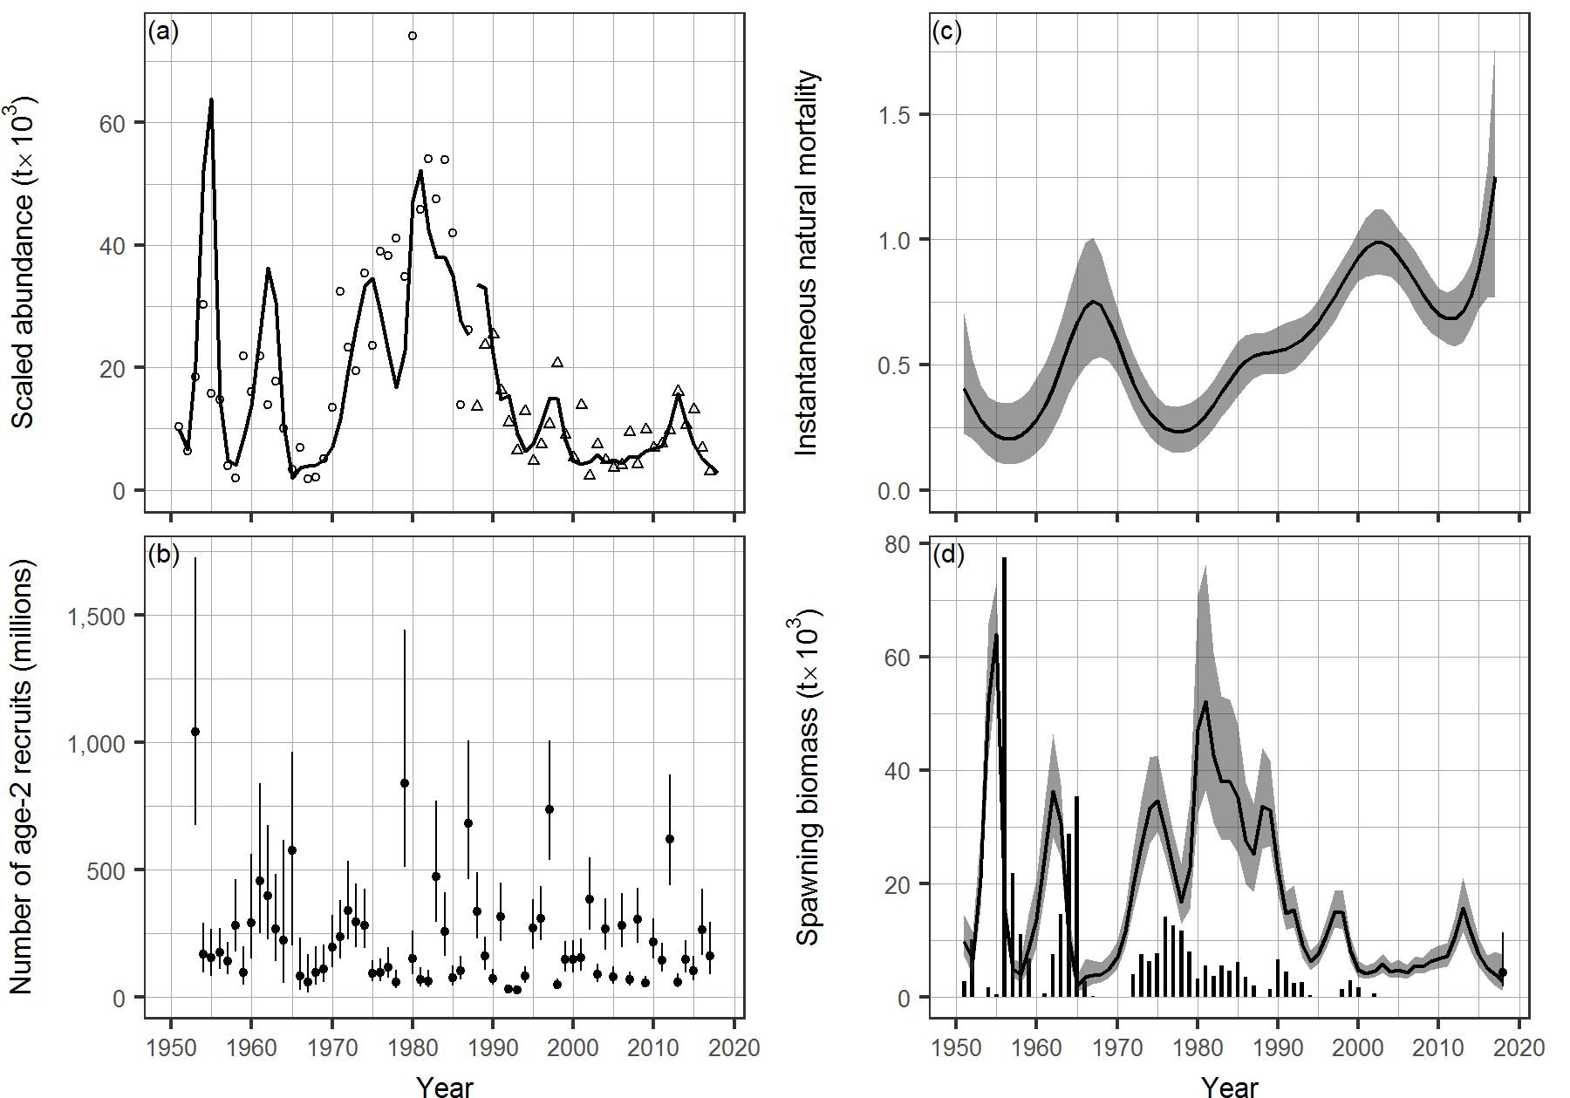
Figure 1. Model output for Pacific Herring in the HG major stock assessment region (SAR) for AM2. Panel (a): model fit to time series of scaled spawn survey data in thousands of metric tonnes (t x 10³). The spawn index has two distinct periods defined by the dominant survey method: surface surveys (1951 to 1987), and dive surveys (1988 to 2017). The spawn survey data (i.e., spawn index) is scaled to abundance via the spawn survey scaling parameter q. Panel (b): reconstructed number of age-2 recruits in millions. Circles with vertical lines indicate medians and 90% credible intervals, respectively. Panel (c): posterior estimates of instantaneous natural mortality. Line and shaded area indicate the median and 90% credible interval, respectively. Panel (d): posterior estimate of spawning biomass (SB_{t}) for each year t in thousands of metric tonnes (t x 10³). Line and shaded area indicate median and 90% credible interval, respectively. Also shown is projected spawning biomass assuming no fishing (SB₂₀₁₈) at the far right: the circle and vertical line indicates the median and 90% credible interval, respectively. Time series of vertical lines indicates commercial catch, excluding spawn on kelp (SOK).
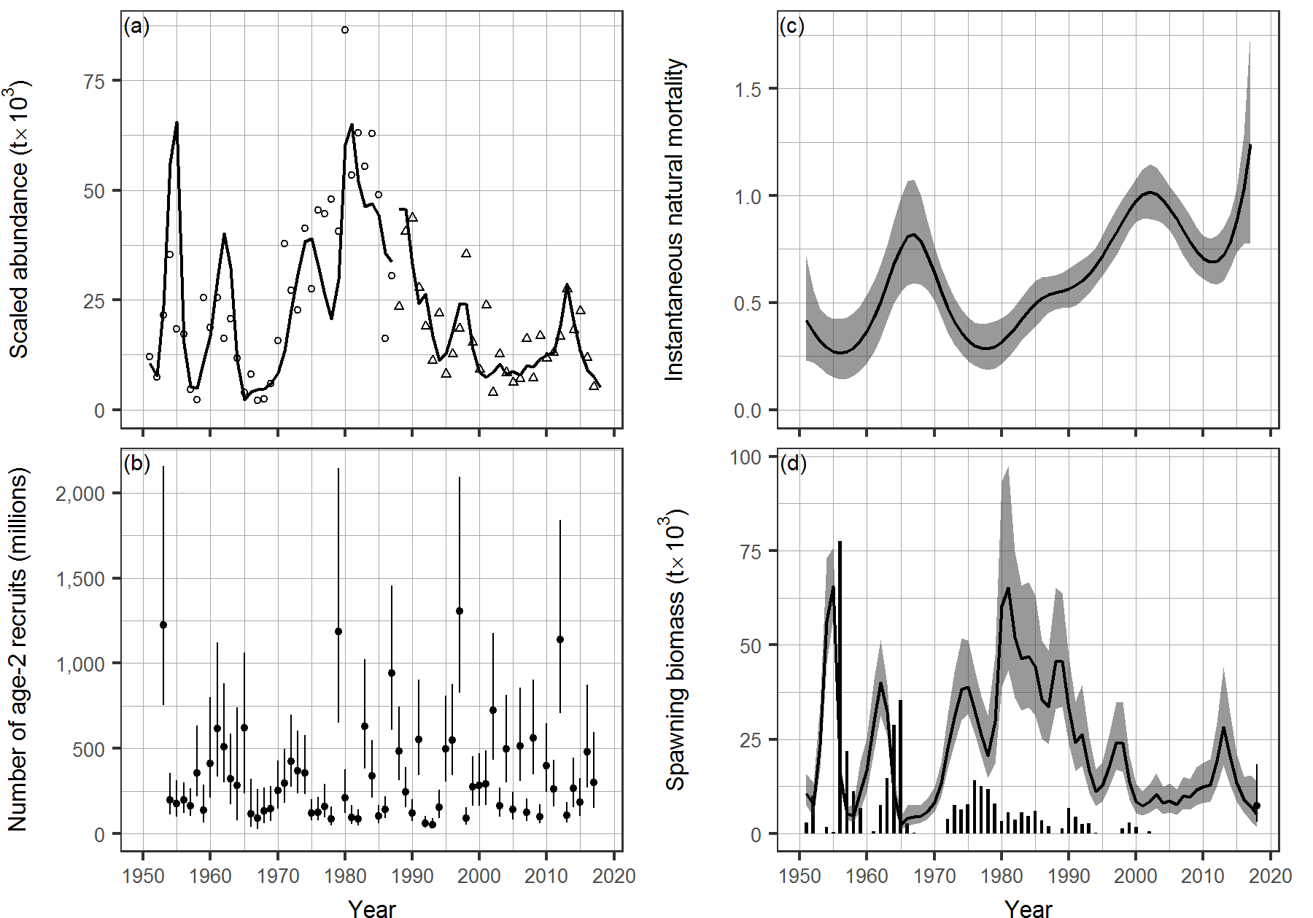
Figure 2. Model output for Pacific Herring in the HG major stock assessment region (SAR) for AM1. See Figure 1 for description.
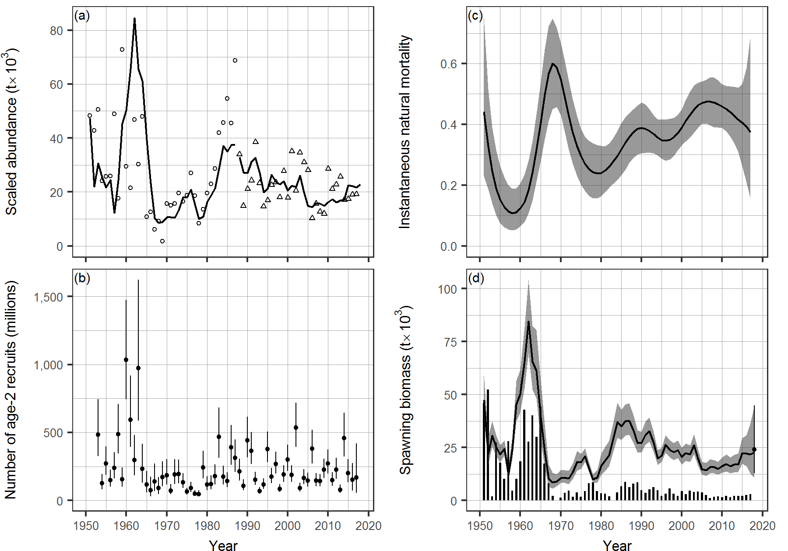
Figure 3. Model output for Pacific Herring in the PRD major stock assessment region (SAR) for AM2. See Figure 1 for description.
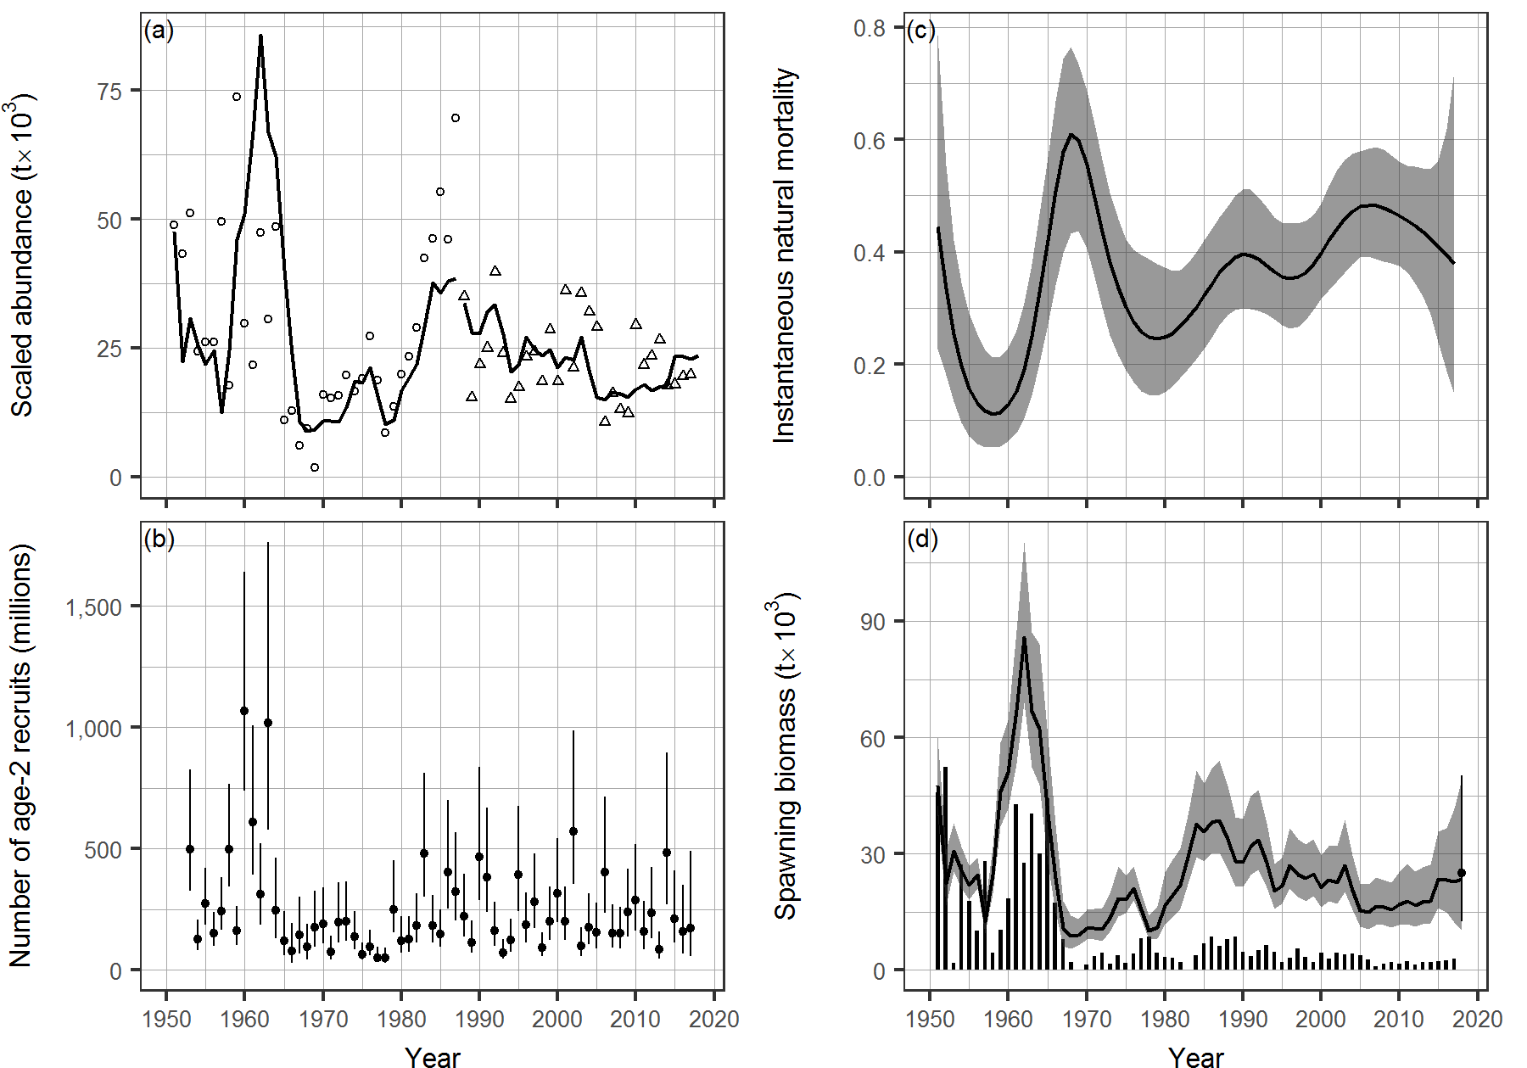
Figure 4. Model output for Pacific Herring in the PRD major stock assessment region (SAR) for AM1. See Figure 1 for description.
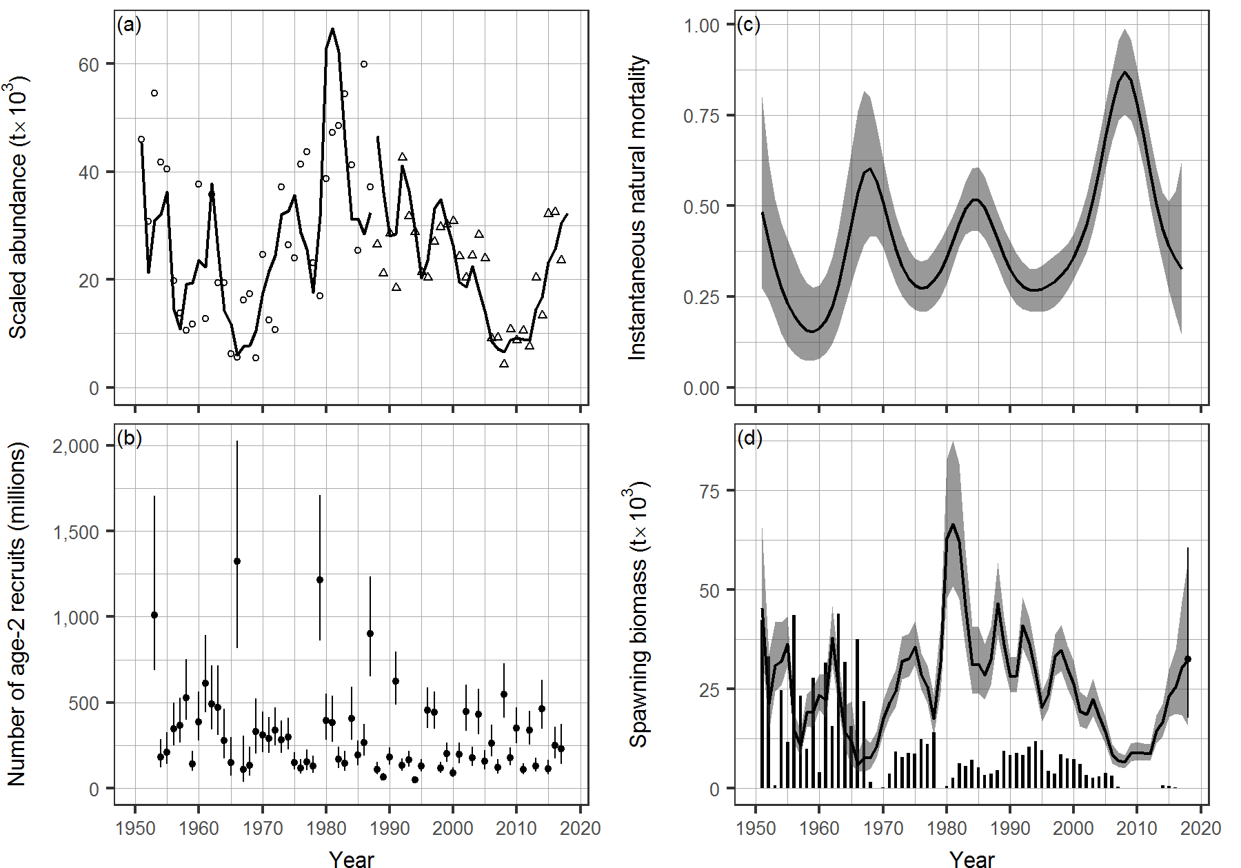
Figure 5. Model output for Pacific Herring in the CC major stock assessment region (SAR) for AM2. See Figure 1 for description.
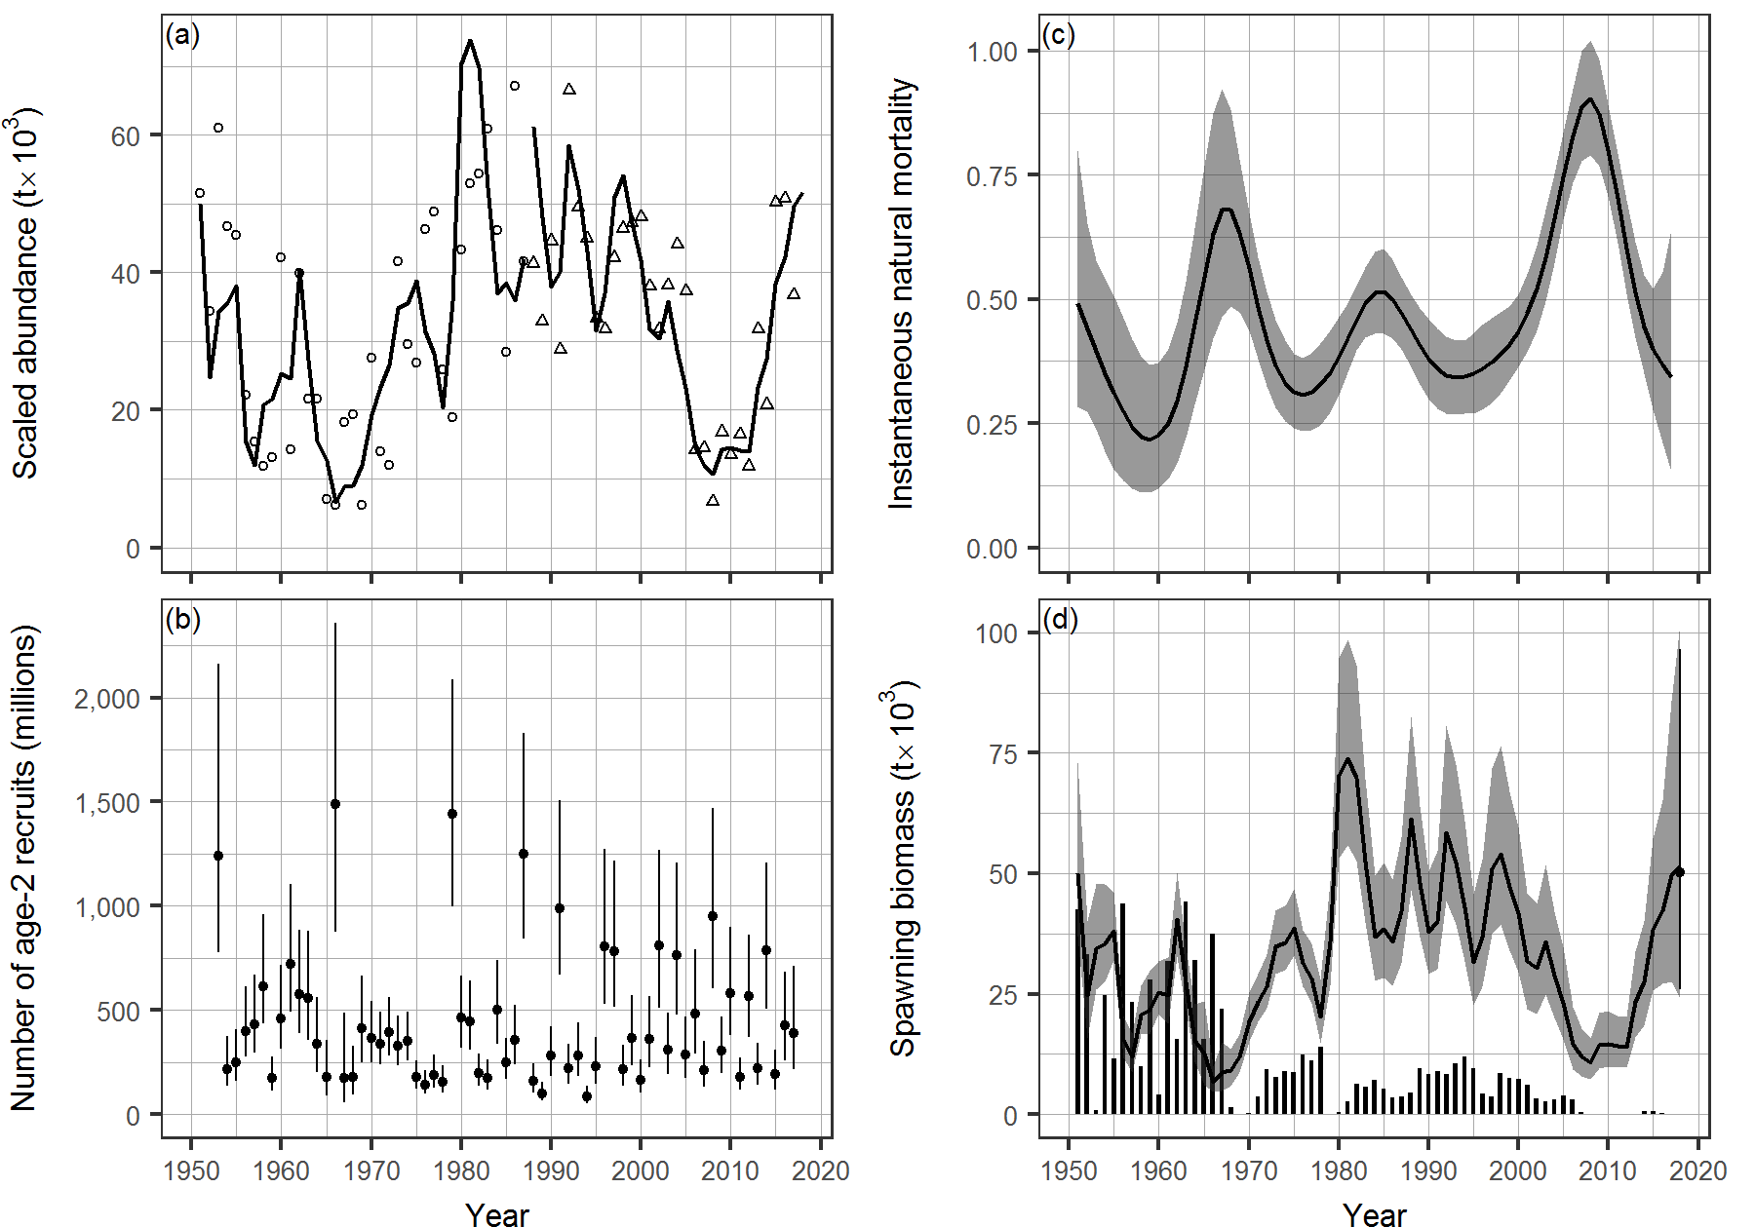
Figure 6. Model output for Pacific Herring in the CC major stock assessment region (SAR) for AM1. See Figure 1 for description.
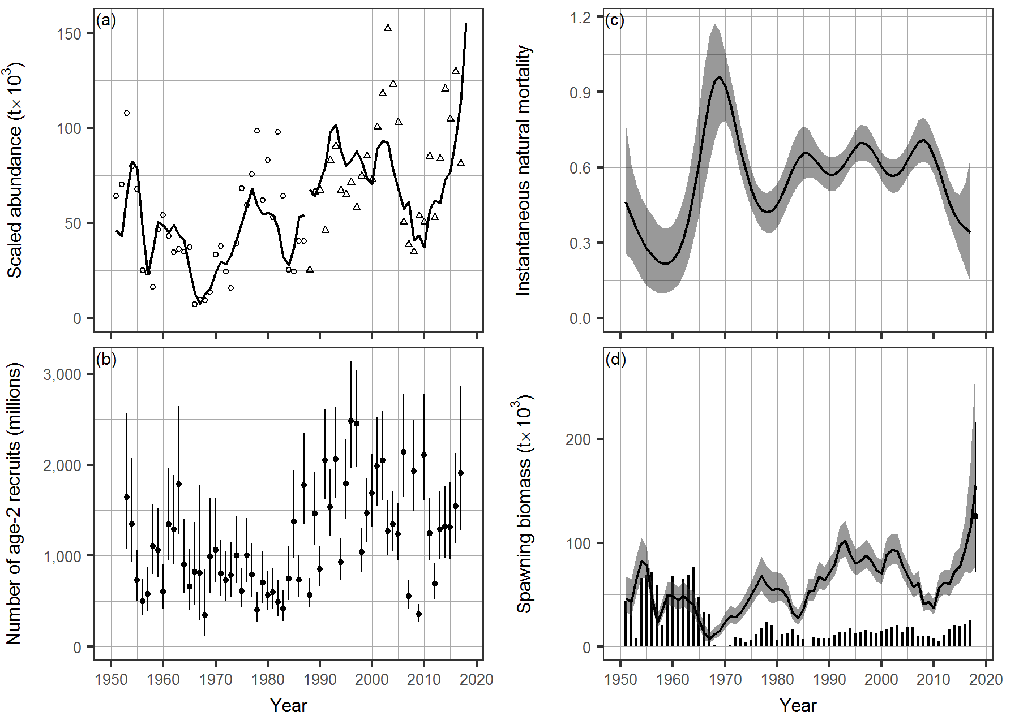
Figure 7. Model output for Pacific Herring in the SoG major stock assessment region (SAR) for AM2. See Figure 1 for description.
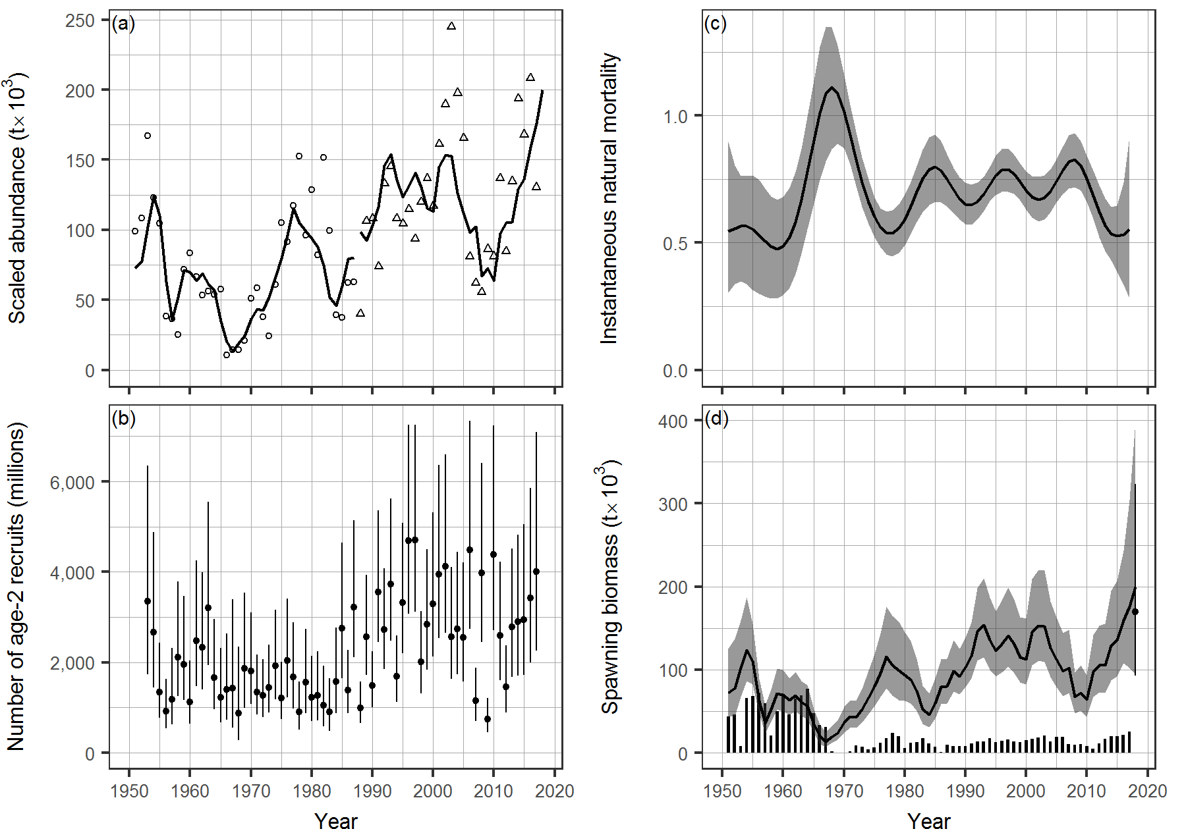
Figure 8. Model output for Pacific Herring in the SoG major stock assessment region (SAR) for AM1. See Figure 1 for description.
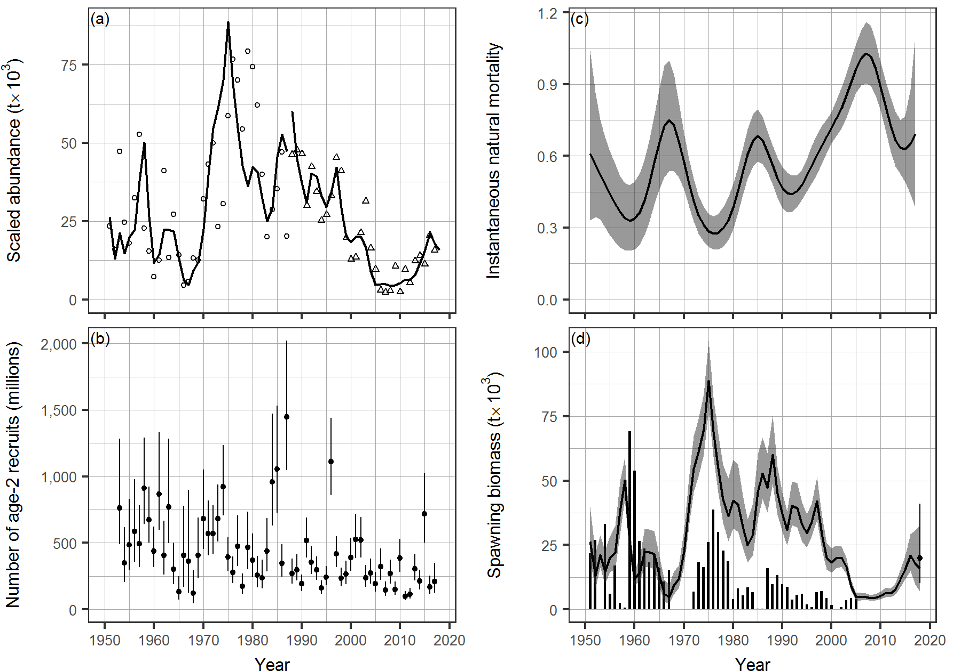
Figure 9. Model output for Pacific Herring in the WCVI major stock assessment region (SAR) for AM2. See Figure 1 for description.
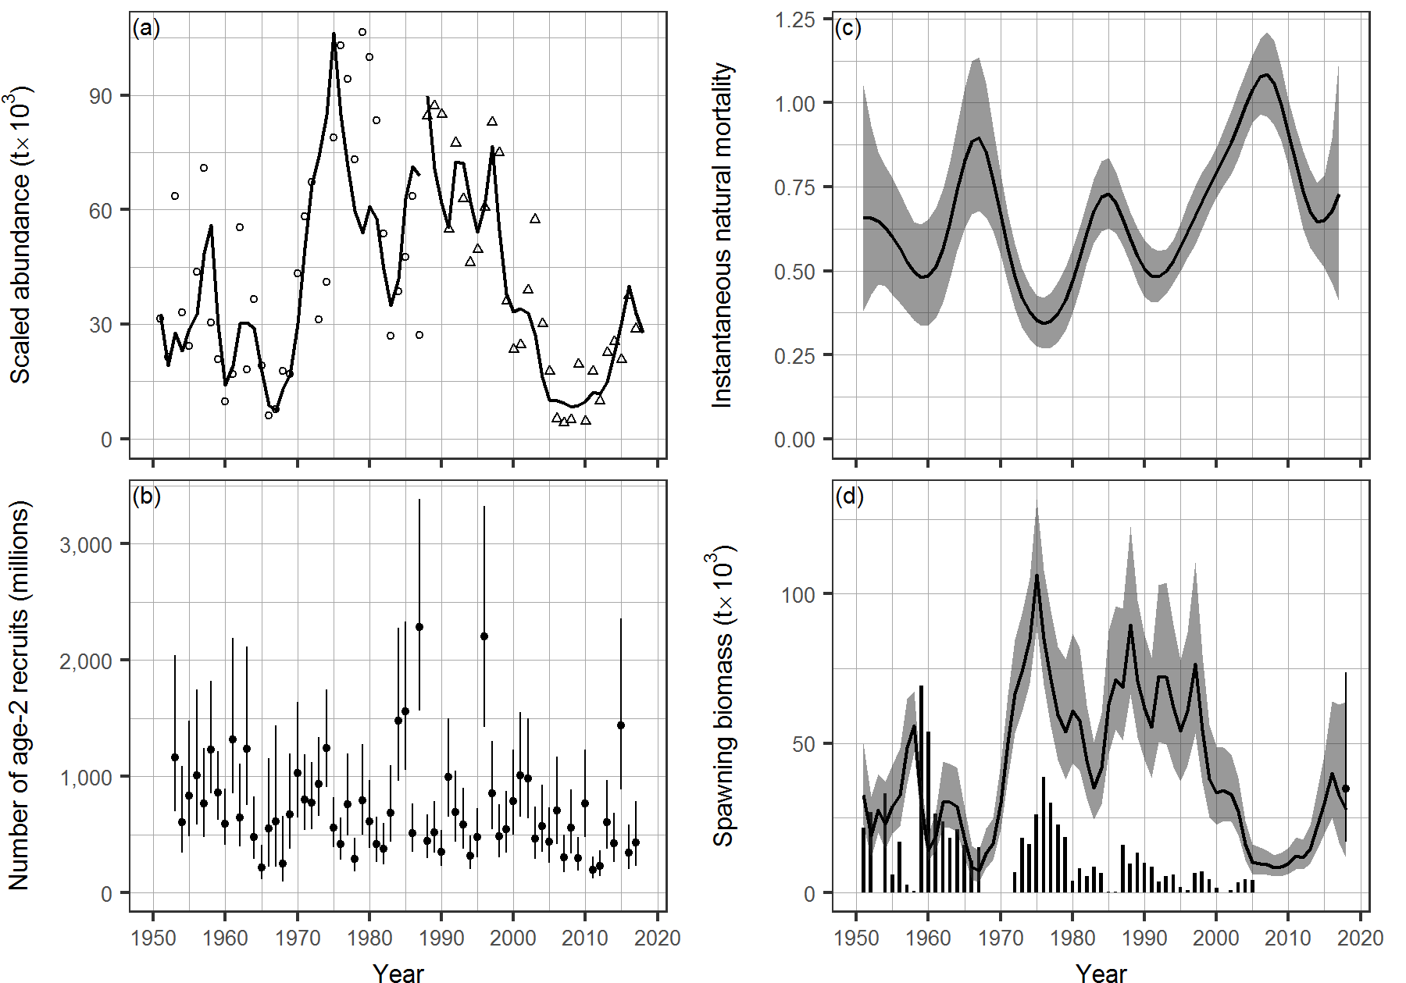
Figure 10. Model output for Pacific Herring in the WCVI major stock assessment region (SAR) for AM1. See Figure 1 for description.
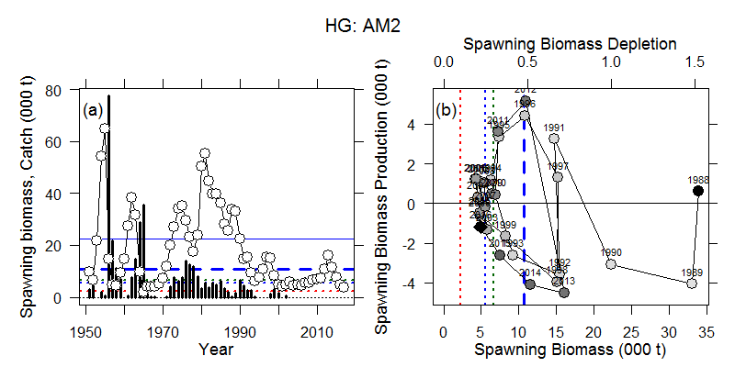
Figure 11. Production analysis for Pacific Herring in the HG major stock assessment region (SAR) for AM2. Panel (a): time series of estimated spawning biomass (circles) and catch (vertical bars). Reference lines are shown at estimates of 0:1B₀, (red dashed line) 0:25B₀ (blue dashed line), 0:3B₀ (green dashed line), the 1996 fixed cutoff value (thick blue long dashed line), and unfished spawning biomass (solid blue line). Panel (b): phase plot of spawning biomass production against spawning biomass for the Dive survey period, from 1988 (black circle) to 2016 (black diamond). Grey shading of the circles becomes darker in chronological order. Calendar years are indicated above each symbol. The axis scale at the top of the panel is in units of spawning biomass depletion (i.e., spawn biomass divided by the estimated unfished spawning biomass from the assessment model). Reference lines are the same as those in panel (a). All estimates quantities are based on maximum likelihood estimates (DFO 2016).
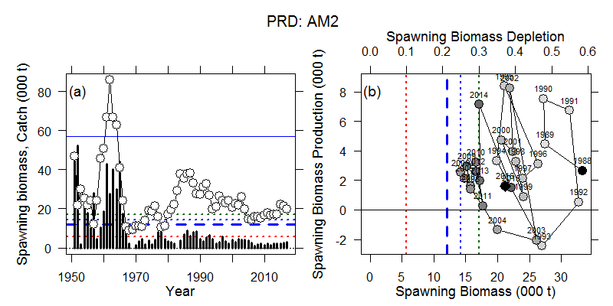Figure 12. Production analysis for Pacific Herring in the PRD major stock assessment region (SAR) for AM2. See Figure 11 for description.
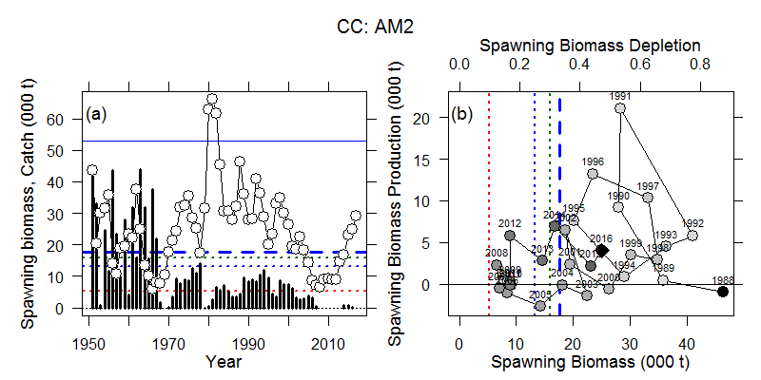Figure 13. Production analysis for Pacific Herring in the CC major stock assessment region (SAR) for AM2. See Figure 11 for description.
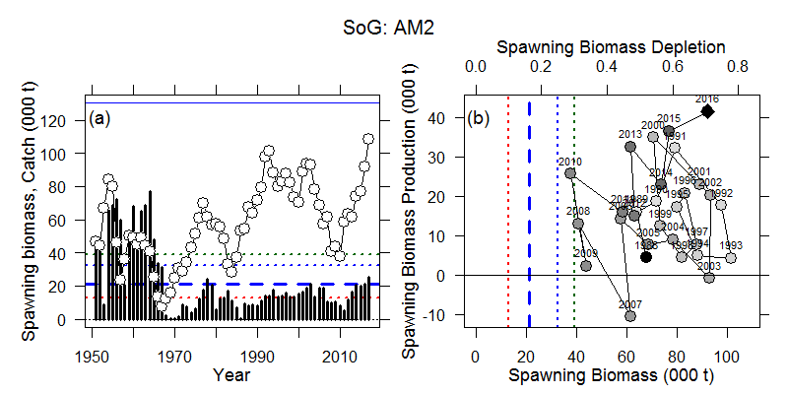Figure 14. Production analysis for Pacific Herring in the SoG major stock assessment region (SAR) for AM2. See Figure 11 for description.
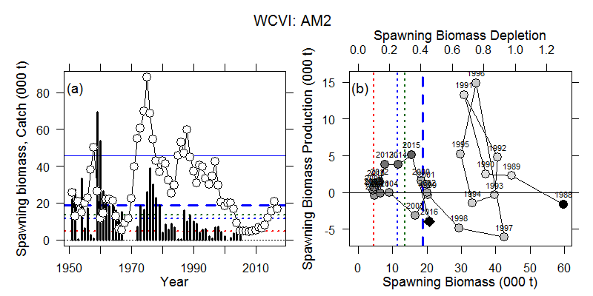Figure 15. Production analysis for Pacific Herring in the WCVI major stock assessment region (SAR) for AM2. See Figure 11 for description.
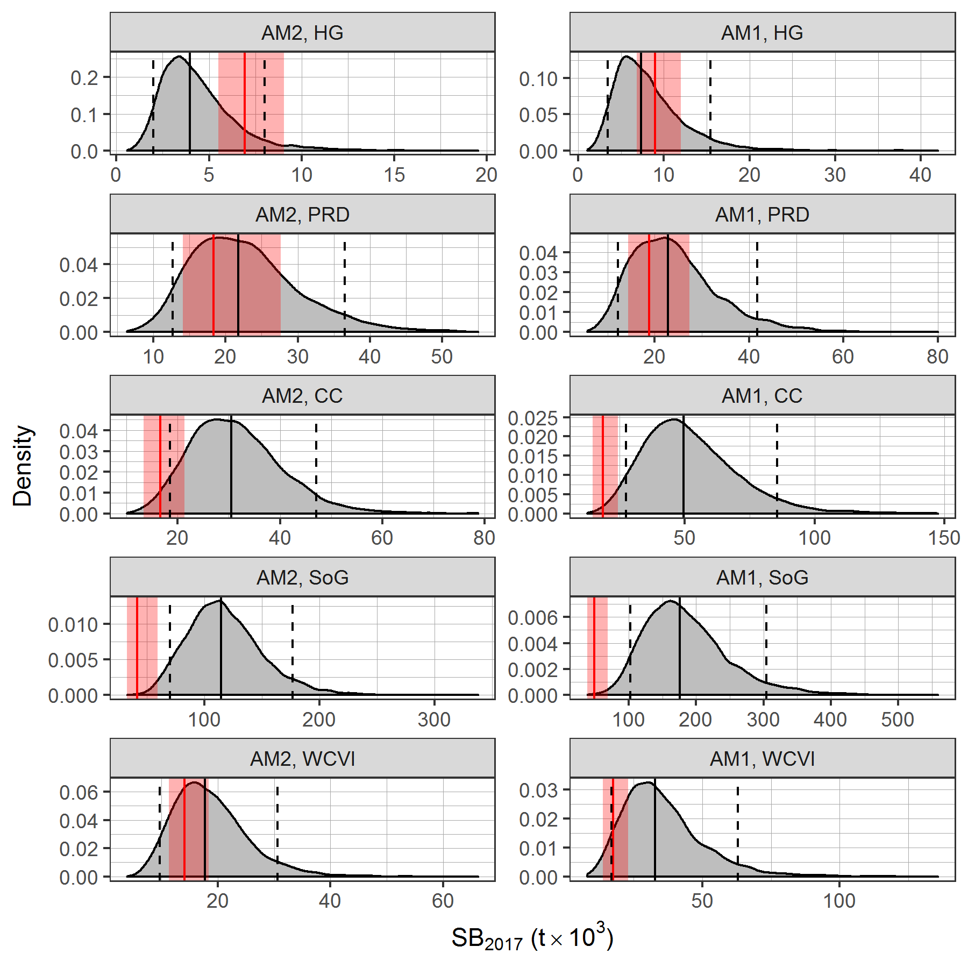
Figure 16. Estimated spawning biomass in 2017, SB₂₀₁₇ in thousands of tonnes, t for Pacific Herring in the major stock assessment regions (SARs) for models AM2 and AM1. Vertical black lines indicate medians (solid) and 90% confidence intervals (dashed) for SB₂₀₁₇. Vertical red lines indicate medians, and shaded red rectangles indicate 90% confidence intervals for the limit reference point (LRP), 0:3SB₀, where SB₀ is estimated unfished biomass.
We could add something like Tables 2 & 3 from the 2014 Pacific Herring SAR (http://waves-vagues.dfo-mpo.gc.ca/Library/364435.pdf):
- Median and 90% CI of SB for the major SARs for 2017 and the previous few years.
- Median and 90% CI of SB₀, LRP, and depletion for the major SARs.

THIS REPORT IS AVAILABLE FROM THE:
Centre for Science Advice
Pacific Region
Fisheries and Oceans Canada
3190 Hammond Bay Road
Nanaimo, BC V9T 6N7
Telephone: (250) 756-7208
E-Mail: csap@dfo-mpo.gc.ca
Internet address: www.dfo-mpo.gc.ca/csas-sccs/
ISSN 1919-5087
© Her Majesty the Queen in Right of Canada, 2017
Correct Citation for this Publication:
DFO. 2017. <<insert title here – title must be exactly as it appears on the cover page, but in title case>>. DFO Can. Sci. Advis. Sec. Sci. Advis. Rep. 2017/nnn. (Style: citation)
Aussi disponible en français :
MPO. 2017. << insérez le titre ici – il doit correspondre exactement à celui de la page couverture, mais en lettres minuscules >>. Secr. can. de consult. sci. du MPO, Avis sci. 2017/nnn. (Style: citation – other language)

