Air Quality in Cyprus - An Evaluation based on Kriging

John Dow, Jane Wod

13 Juni 2019

## Introduction

This paper provides an assessment of air quality in Cyprus based on Kriging interpolation. Air quality is a relevant indicator in the context of quality of life that gained importance over the past decades. Mapping air quality supports the analysis of areas that are more or less strongly affected by air pollution and therefore provides a basis for decision making about potential counter measures.

## Background and Related Work

Kriging is an interpolation method from the 1950s that has been widely applied. It constitutes an important approach for the interpolation of samples that represent continuous phenomena.

## Methodology

The methodology builds on data provided by the European Environment Agency (EEA): air quality data and metadata about air quality stations in Europe. The analysis is done with R - following the kriging procedure presented in: <https://keen-swartz-3146c4.netlify.com/interpolation.html>

The first step is to load the required data and perform data preprocessing. The result of data posting for available air quality stations in Cyprus is displayed in Figure 1.

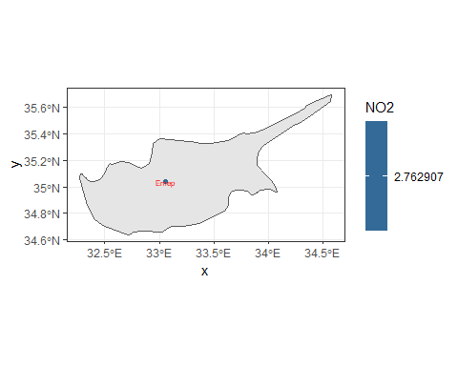

Figure 1: Air quality stations in Cyprus and the respective nitrogen dioxide (NO2) values.