Curtis Gribben
ConvFinQA Agent Write-up

Abstract

ConvFinQA is a conversational numerical-reasoning benchmark over earnings filings: each record is a data table plus surrounding prose, and later questions often depend on earlier answers (for example, looking up two years of a metric and then asking for the change). Some values sit in footnotes rather than cells; tables use messy headers, duplicate columns, and accounting sign conventions. We created a custom tool-calling LLM agent to attempt to answer these questions. Here, each filing is ingested into SQLite (one table per document, with a mapping from original headers to SQL names). An LLM model then answers one turn at a time with three tools: a read-only SQL SELECT, a restricted Python sandbox for arithmetic, and a forced structured final-answer call. Later turns see the model's own previous predictions, not gold labels. On a 100-conversation sample of the development set, our solution achieved 78.2% execution accuracy - versus the human-expert benchmark of 89.4% - at approximately $0.0036 and 1.5–2 seconds per conversation. This is a significant improvement over the 68.9% execution accuracy reported for FinQANet, the prior state of the art on this benchmark. Ablations, turn-level accuracy, and failure modes are reported in the sections below.

- Background

ConvFinQA (Chen et al., 2022) is a benchmark for conversational numerical reasoning over real financial filings. Each example is an earnings-report table plus the prose around it, followed by a multi-turn dialogue: later questions often depend on earlier answers (look up two years of a metric, then ask for the change). The released data has 3,892 conversations and 14,115 questions (train/dev/test = 3,037/421/434). Type I conversations decompose one multi-hop question into successive turns; Type II (hybrid) weave two related questions about the same report, so the model must keep a longer chain and more often mix table cells with footnote text.

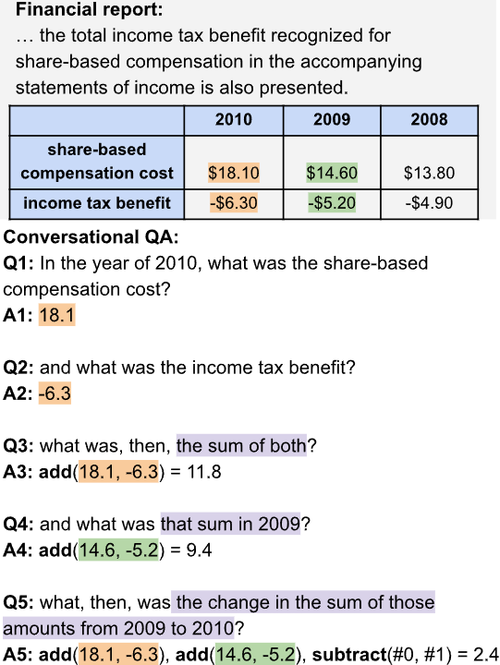 ← Fig. 1 An example ConvFinQA Question.

The original paper treated this mainly as retrieve-then-program. Their strongest reported system, FinQANet (RoBERTa-large with a learned retriever and a DSL program generator), reached 68.9% execution accuracy. Prompting GPT-3 without that pipeline did much worse: 40.6% with chain-of-thought and 24.1% answer-only. Human finance experts scored 89.4% on a 200-question sample. In short, general LLMs of that generation were poor at jointly handling table lookup, arithmetic, and conversational reference, which is why the authors pushed work onto a specialised program executor.

The task for this project is to ask whether a contemporary tool-calling agent can improve on that. Models can now call SQL and Python in a loop and hold a full filing in context, so the 2022 split of labour (fine-tuned retriever + DSL) is no longer the only option. I implement an LLM agent loop around Gemini 2.5 Flash - read-only SQL over a structured copy of each table, a restricted Python sandbox for arithmetic, and a forced structured final answer - and measure execution accuracy against the ConvFinQA development set, with the paper's FinQANet and GPT-3 numbers as the reference points.

- Methods

The solution developed here is a tool-calling agent loop built on Gemini 2.5 Flash via the OpenAI-compatible endpoint. Each conversation turn sends the full document context (pre-text, table, post-text) plus structured conversation history to the model as a system prompt, along with three tools: query_table (SQL SELECT against a SQLite table), execute_python (sandboxed arithmetic), and convfinqa_answer (structured final answer). The model loops up to 6 rounds per turn, calling tools as needed, and is forced to call convfinqa_answer on the last round via tool_choice. Each prior question and the model's own predicted answer (not the gold answer) are injected as conversation history. This mirrors how a real user would interact and forces the model to chain its own reasoning rather than re-deriving from scratch each turn. SQL queries are enforced as read-only and a pre-execution regex guard blocks any non-SELECT statements. Conversations are evaluated concurrently using Python's asyncio, with a semaphore capped at 3 to avoid hitting API rate limits while still meaningfully reducing total run time. API calls are also wrapped with exponential backoff retry (via tenacity) to handle transient API errors, which proved necessary during high-concurrency runs. All agent activity is logged via Python's standard logging module - including turn-level outcomes, token counts, tool calls, and errors - with structured output routed to ‘stdout’ for easy inspection during runs. Note that the OpenAI-compatible Gemini endpoint supports structured outputs natively, so Pydantic-enforced structured outputs work without any additional parsing layer. *Also Note that the endpoint used here carries out automatic caching for repeated token prefixes, therefore, the price given above in key results is likely lower than stated, as cached input tokens cost considerably less than uncached ones.

Fig. 2 Flow diagram showing how the agent answers a question.

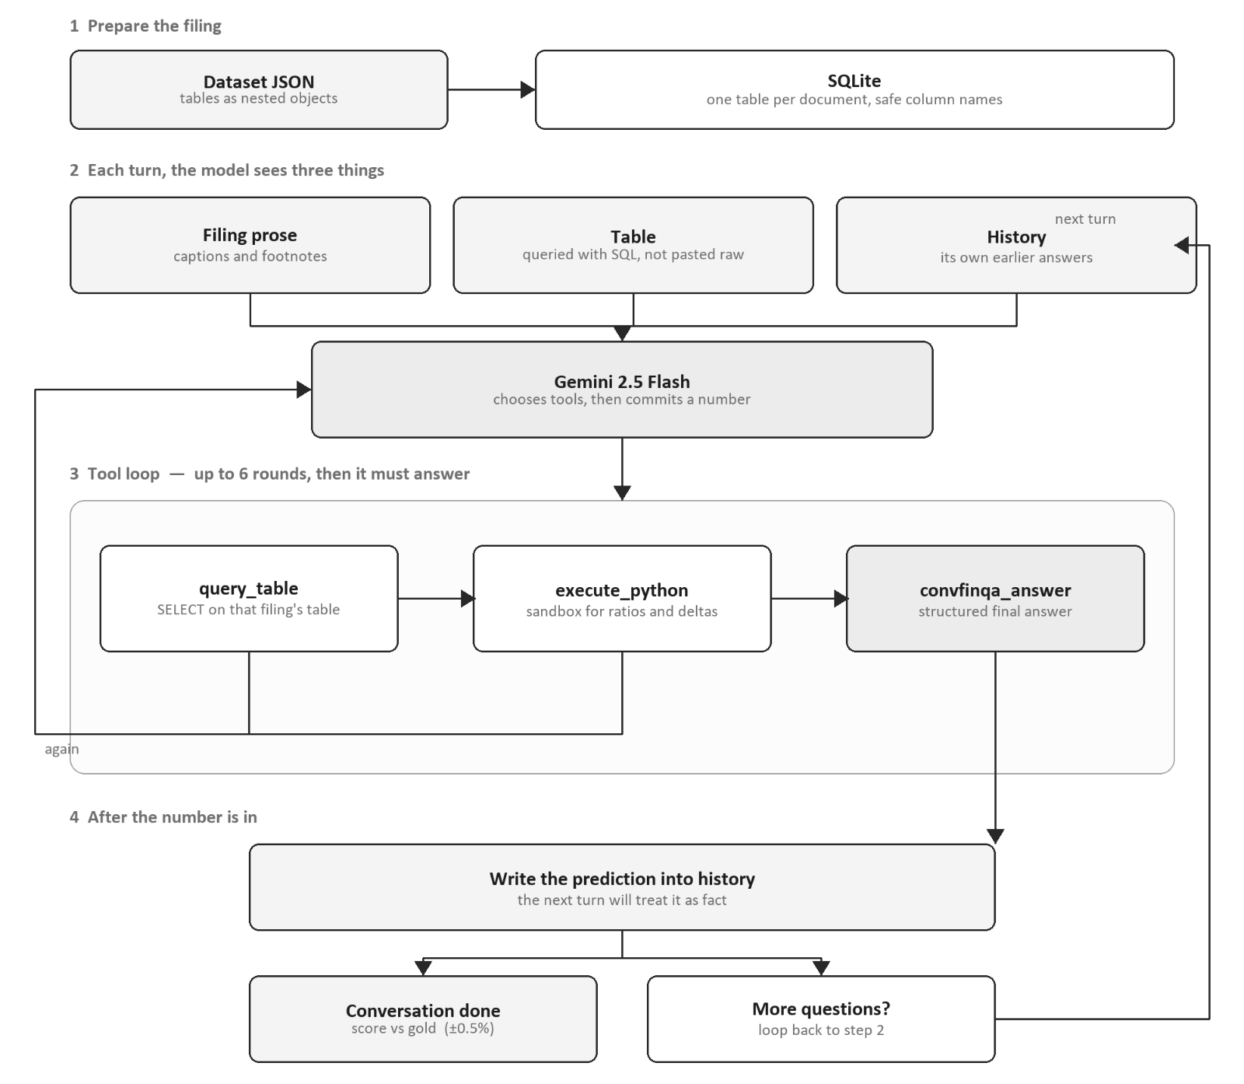

The original ConvFinQA paper used a fine-tuned retriever and reader pipeline, where it would retrieve relevant table cells, and then generate an answer program. This architecture was advisable in 2022 when LLMs weren’t able to reliably carry out multi-step reasoning such as that required by this task. The paper also tested a GPT-3 few-shot baseline, asking a single model to handle table parsing, retrieval, arithmetic, and answering all at once. It performed poorly - these are precisely the kinds of tasks that LLMs struggle with when asked to do everything themselves, and which are much better handled by delegating to specific tools.

Our approach leverages the benefits of several key steps:

Table storage - structured SQLite (as opposed to raw text input)
Retrieval - deterministic SQL (as opposed to a fine-tuned ‘retriever’)
Arithmetic - Python sandbox executor (as opposed to a DSL approach)
Output - enforced JSON schema (as opposed to simple chat completion)

Why this approach?

SQL over raw table text: The tables provided in the raw dataset come in nested JSON format, with improperly-formatted natural-language column names - we converted each to a SQLLite table with formatted column names (linked to the original names via a mapping). This allowed the agent to instead leverage SQL to more reliably query the table for the correct data.
No need for RAG: RAG was not required due to the conversation context being trivial in comparison to modern LLM context windows (Gemini 2.5 Flash context window = 1 million tokens). Such a retrieval approach would merely open up the door for loss of information, hence RAG was not implemented.
Python sandbox for arithmetic: LLMs aren’t well-suited to the multi-hop questions tackled here, as they generally require complex chaining of operations. By offloading this component to a sandboxed Python executor, we eliminate errors from the model try to carry out arithmetic itself. This approach also makes the computation auditable, as it is tracked in the code generated by the agent.
Structured output via tool forcing: The convfinqa_answer schema (answer, source, confidence, reasoning) guarantees we always get a parseable response without the need for regex or free-text parsing. The confidence and reasoning fields also make failures diagnosable.

i. Key Gain Areas

- Domain-specific prompting: adding explicit rules around accounting conventions that the model consistently got wrong out of the box. For example, losses stored as negative values in tables would cause the model to return -10,000 when asked for annual losses, rather than 10,000. Similarly, off-by-one errors were common when extracting year references from roll-forward tables. Encoding these conventions directly into the prompt addressed both.

- Model choice: Gemini 2.5 Flash proved to be particularly well-suited to this type of task, appearing to have stronger numerical reasoning capabilities than alternatives tested at a similar price point - including its own newer successor, 3.5 Flash.

- Document metadata: a secondary prompting improvement involved injecting contextual reminders based on document metadata - flagging to the model when a conversation is hybrid (requiring reasoning across both prose and table), and when a table contains duplicate or missing columns.

ii. Model exploration

I tested several different models across the major providers (OpenAI, Anthropic, Google, and DeepSeek), covering a range from lightweight options through to frontier models. Simpler, faster models unsurprisingly underperformed, presumably lacking the multi-step reasoning needed to reliably chain answers across turns. However at the other end, more capable models like Gemini 2.5 Pro, GPT-4o, and Claude Opus didn't show meaningful accuracy gains and in some cases actually dropped - likely a result of them ‘overthinking’ and second-guessing their answers.

Claude Sonnet 4.6 showed arguably the strongest performance during early testing, slightly exceeding Gemini 2.5 Flash on small-to-mid-sized samples. However, at roughly 10x the cost per record of Gemini Flash 2.5, I deemed this as too expensive, against the minor percentage gains displayed. Also worth mentioning is DeepSeek’s V4 Flash. Although achieving a lower accuracy score than Gemini 2.5 Flash, the cost is also much lower - roughly 5x less per record. Thus, I chose Gemini 2.5 Flash as it represents something of a mid-point along the performance/cost tradeoff of these models.

The performance of Gemini 2.5 Flash over 3.5 Flash was also surprising result. Despite being an older release, 2.5 Flash consistently outperformed its successor on this task. This, I suspect, is because 2.5 Flash simply happens to be better optimized for numerical reasoning tasks such as in this specific case.

3. Evaluation & Results

The final solution achieved an overall execution accuracy of 78.2% using Gemini 2.5 Flash, at a cost of $0.0036 per conversation and approximately 1.5–2 seconds per conversation. This is a significant improvement upon the FinQANet benchmark score of 68.9%, and is much closer to the human-expert benchmark execution accuracy of 89.4%.

Simple conversations achieved 77.6% accuracy against 66.4% for hybrid conversations, an 11% gap reflecting the added difficulty of questions that require reasoning across both table and prose content. Accuracy by turn declined gradually from 79.1% at turn 0 to 65.0% by turn 5 - roughly 2% per turn.

In comparison with FinQANet's reported execution accuracy of 68.9%, our solution represents an improvement of approximately 9% (again, this is based on our run of 100 conversations, not the full dev set). The GPT-3 few-shot baseline reported in the paper scored significantly lower at around 37%, highlighting both the limitations of asking a general LLM to handle retrieval and arithmetic without dedicated tools, and the substantial gains that come from a tool-calling agent approach.

Answers were scored using execution accuracy with a 0.5% relative tolerance - a predicted answer is marked correct if it falls within 0.5% of the gold answer. This allows for trivial floating-point differences without permitting meaningful errors. For yes/no questions, scoring is exact match after normalisation.

Also note that we evaluated using execution accuracy rather than program accuracy. The latter requires the model to produce a structured program trace matching the gold annotations in the dataset - however our approach uses SQL queries and a Python sandbox to retrieve and compute values, so there is no real equivalent program trace to compare against. Therefore, I have deemed execution accuracy to be the best fit for evaluation, as it only concerns whether the final answer is correct, not the path taken to get there.

Accuracy by Turn

Accuracy drops steadily across turns, from 79.1% at turn 0 down to 65% by turn 5. This is expected - each turn builds on the previous answer, so errors compound. What's notable is that the drop is actually fairly gradual at around 2% per turn, which suggests the model holds its reasoning together reasonably well across a conversation. The bigger story is turn 0: getting that first answer wrong accounts for 39% of all failures, as the model then confidently builds on a bad foundation for the rest of the conversation.

Simple vs Hybrid

Simple conversations came in at 77.6%, hybrid at 66.4% - an 11% gap. Hybrid questions require reasoning across both table and prose content, which is where performance drops. The clearest illustration of this is prose inference accuracy sitting at just 42.4%, compared to 82.2% for direct table lookups. When the answer is in the table, the model is generally fine. However when it has to piece information together from the surrounding text, it struggles.

Failure Modes

Below is a table of the failure types identified by the ‘analyse_failures.py’ module:

Failure type | Count | % of failures
Cascade from turn 0 | 150 | 39.20%
String mismatch | 99 | 25.80%
Wrong value | 63 | 16.40%
Close miss | 37 | 9.70%
Sign error | 15 | 3.90%
Unit scale | 12 | 3.10%
Pct vs decimal | 6 | 1.60%

Cascade failures are the dominant category - nearly 4 in 10 failures come back to a single wrong answer at turn 0. String mismatches are the second biggest issue, and are mostly cases where the model returned an empty string or "unknown" rather than a number - it simply gave up instead of digging further. Wrong values and close misses together make up another 26%, typically down to the model picking the wrong row in a table or making an off-by-one error on a roll-forward calculation.

Ablation Studies

Ablation | Accuracy | Delta
Full (baseline) | 76.80% | -
No Python sandbox | 75.10% | -1.7%
Truncated history | 71.40% | -5.4%
No SQL | 43.20% | -33.6%
No history | 31.40% | -45.4%

Four components were ablated across 50 conversations to understand their individual contribution to overall accuracy. Note that ablations were kept to 50 conversations due to time constraints, and therefore might not be as stable as the baseline accuracy. However, the key trends are quite visible and align with expectations.

History is by far the most critical component - removing it entirely drops accuracy by 45%, which makes sense given that the whole task depends heavily on chaining answers across turns. Without history, the model isn’t aware of its previous answers, and therefore cannot use this information when it is needed to answer the current question.

SQL is the second biggest contributor - a 34% drop without it shows the model can't reliably extract values from raw table text - this aligns with our expectations and our reasoning for using structured data querying.

Truncated history costs 5%, which is worth noting - even limiting how much prior context the model sees has a meaningful impact. We can see that the model genuinely benefits from the full conversation window.

The Python sandbox is the most surprising result - accuracy only drops by -1.7% without it. Presumably, then, most of the benefit is coming from the use of SQL rather than the Python tool. It’s likely that newer LLM models are more capable at handling inline arithmetic than previous versions, which famously are quite poor.

What I’d Do Given More Time

- Further and more fine-tuned prompt engineering.

- Calibrate the confidence score returned by the model, then implement logic where if confidence falls below a certain threshold, retry at least once - potentially with a different model. This could be a more capable model, or simply a different one at the same complexity level (we've already seen that models can handle different problem types quite differently, regardless of price point). We would, however, either have to also calibrate this model’s confidence scores, and take the higher confidence answer between the two model answers, or otherwise simply take the second model’s answer automatically.

- Tackle turn 0 failures - given that in a multi-hop reasoning task like this, failures tend to cascade, it's more important to minimise failures toward the start of a conversation, since doing so minimises downstream failures too. Ideally, given no constraints on time or cost, you'd simply use a more performant model like Sonnet 4.6 across all questions. But given the considerable variation in cost between models, it might make more sense to reserve a stronger model just for the most critical questions - those at turn-0, or as suggested above, those returning low confidence scores.

4. Appendix

Structured output schema (from ConvFinQAAnswer):

Field | Type | Purpose
answer | float | str | The final answer returned to the user
answer_source | AnswerSource | How the answer was derived (e.g. table_direct, prose_inferred)
confidence | float | Model's self-reported confidence (0–1)
confidence_reason | str | Brief justification for the confidence score
code_executed | str | None | Python code run in the sandbox, if any
sql_executed | str | None | SQL query issued, if any
depends_on_turns | list[int] | Which prior turn indices this answer depends on
reasoning | str | Chain-of-thought before the final answer

The model is required to populate this schema on every turn via structured outputs - there is no post-hoc parsing step.

Failure Taxonomy:

Category | Description
cascade_from_t0 | Error in turn 0 propagates through subsequent turns via history
string_mismatch | Correct numeric value but wrong surface form (e.g. "14.1%" vs 14.1)
wrong_value | Substantively incorrect answer with no clear pattern
close_miss | Numerically close but outside the 0.5% tolerance threshold
sign_error | Correct magnitude, wrong sign (e.g. positive vs negative)
unit_scale | Off by a consistent factor (e.g. millions vs thousands)
pct_vs_decimal | Percentage returned as decimal or vice versa (e.g. 0.141 vs 14.1)

How I used AI

When using AI with my work, I take a pragmatic approach: I use it where it’s useful and time-saving - including exploring POCs, and writing most code, but I make sure not to move forward until I understand exactly what’s been done and why it’s worked.

