Radar Statistical Reconnaissance with the Cassini RADAR: Roughness of Titan's Seas. C. Grima¹ , M. Mastrogiuseppe², A. Hayes², S. Wall³, B. Stiles³, C. Elachi³. ¹University of Texas Institute for Geophysics, J.J. Pickle Research Campus, Bldg. 196, 10100 Burnet Rd. (R2200), Austin, TX 78758, ²Cornell University, Ithaca, NY 14853, ³Jet Propulsion Laboratory, Pasadena, CA 91109. Email: cyril.grima@gmail.com

Introduction: Titan's landforms are similar to those on Earth, shaped by aeolian, pluvial, fluvial, lacustrine, tectonic, impact and possibly cryovolcanic processes [1]. In that respect, investigating the properties of Titan's surface is a key to better understanding surface-atmosphere interactions, climate dynamics, and internal activity. The surface is being probed by NASA's Cassini spacecraft with an imager, a spectrometer and a Radar. The Radar has a nadir-looking altimeter mode at high sampling rate compatible with the application of the novel Radar Statistical Reconnaissance (RSR) technique that has been recently validated in Antarctica and on Mars with radar sounders at VHF frequencies (20-60 MHz) [2, 3, 4]. RSR utilizes the surface signal randomness to constraint the observed terrains in terms of surface permittivity and vertical/horizontal roughness. The purpose of this work is to evaluate the feasibility of the RSR technique with the Cassini RADAR specificities with some applications over the Titan's seas.
The Cassini RADAR: The Cassini RADAR is an active 13.8 GHz (2.2-cm wavelength) multiple-beam instrument with observation angles arranged across-track [5, 6]. It is a part of the science payload for the NASA's Cassini spacecraft touring the Saturn's system and it's icy moons since 2004 [7]. The Cassini RADAR can operate sequentially in several modes: Radiometer (Receive-only), scatterometer (off-nadir transmission/reception), altimeter (nadir transmission/reception), and imager (synthetic aperture radar). The transmission sequence is a packet (a.k.a. burst) of ~15 consecutive chirps at fix rate. The burst repetition frequency is adjustable to adapt the instrument to various targets and observation configurations.
Radar Statistical Reconnaissance (RSR): The RSR is a systematic method to constrain quantitative surface properties from the radar surface return. It has been recently demonstrated with the High Capability Radar Sounder (HiCARS, 60-MHz central frequency, 15-MHz bandwidth) airborne radar data in Antarctica [3, 4]. The RSR relies on a physical description of the surface echo assuming a stochastic behavior for the surface geometry. Analytically, the surface echo strength detected by the radar antenna is the summation of two fundamental components, the signalreflectance and scattering [e.g. 8]. The contribution of surface permittivity and deterministic structure (e.g. thin deposit or layering) is dominant in the reflectance, while scattering is mainly a function of the surface roughness and random internal geometries of the near-surface (e.g. a pile of blocks from a collapsed terrain). Firstly, the RSR aims to extract the reflected and scattered components of the signal by best-fitting the histogram of a set of surface echo amplitudes with a theoretical stochastic model (homodyne K-statistics [9]). The correlation coefficient of this fit is a confidence factor to estimate the terrain compliance to the model assumptions. The scattering, reflectance and correlation coefficient give a first qualitative insight into the surface properties. Once deduced from the fit, they can be used in a backscattering model to constrain the surface properties: Root mean square (RMS) heights, correlation length, and permittivity.

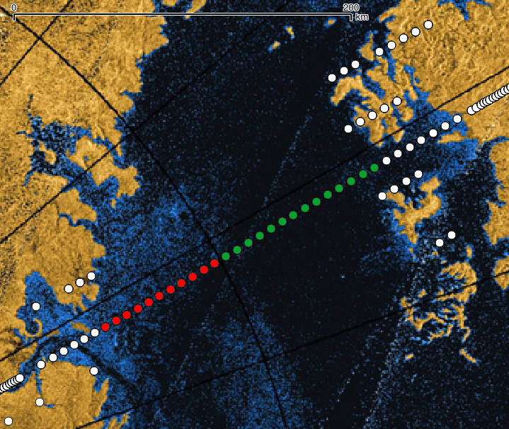
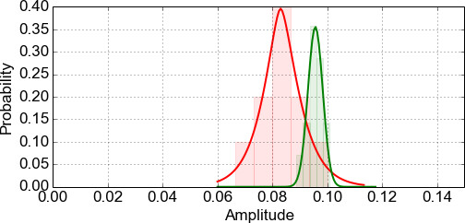
Fig. 1. (top) Location of the Cassini RADAR burst's footprints over Ligeia mare (background from the imaging mode) for Flyby T91. The red and green color coding indicates the samples used to obtain the surface echo amplitude histograms (bottom). The red (resp. green) fit is consistent with a coherent power of -21.6 dB (resp. -20.4 dB) and a coherent/incoherent power ratio of +16.4 dB (resp. +28.0 dB) at an altitude of 4150 km. The two histograms correspond to a slightly different roll angle of the spacecraft but are also coincident with different scattering properties for the sea's surface.
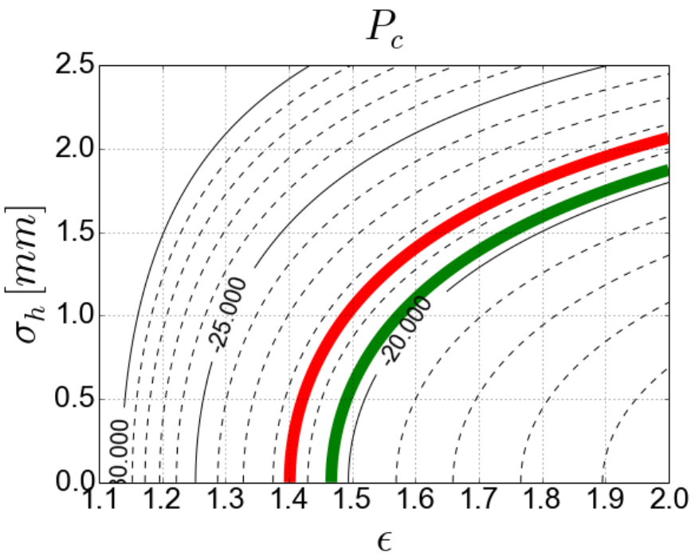
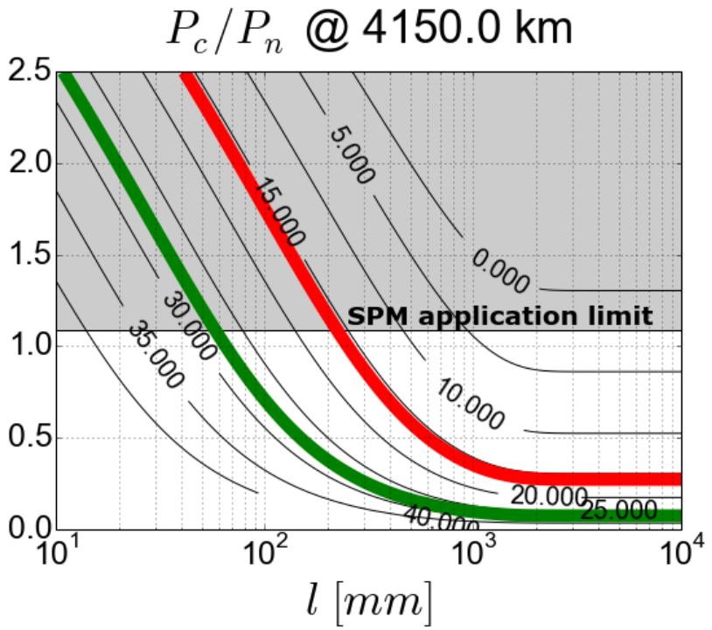
Fig. 2. Range of surface properties solutions for the signal components derived from the RSR for both the red and green data set over Ligeia (Fig. 1). (top) Coherent power (P_{c}) in function of surface RMS height (σ_{h}) and permittivity (ε). (bottom) Coherent/Incoherent power ratio(P_{c}/P_{n}) in function of the surface correlation length (l) by application of the SPM.

RSR application to the Cassini RADAR: The RSR is applied to the altimeter mode of the Cassini Radar where the signal is transmitted in the nadir direction. In that configuration the received surface signal holds both the coherent and incoherent part of the backscattered power, thus bringing more information about the surface than an off-specular signal (incoherent only). We study the signal statistics for both pulse- and burst-derived amplitude histograms. The Titan's seas are favored targets for application of the RSR. Their supposed homogeneity in terms of roughness /composition at the scale of the radar footprint provides a more suitable configuration for application of theoretical stochastic models. The Cassini RADAR obtained valid data in altimetry-mode over three Titan seas: Ligeia, Punga, and Kraken.
Preliminary results: The highly overlapping footprint of the contiguous pulses could violate the assumption of statistically independent signal returns that is needed to apply the RSR. However, the pulse-derived and burst-derived (weak overlapping footprint) surface amplitude histograms do not show significant differences. The gain pattern of the Cassini RADAR has a 3-dB beamwidth of 7 mrad (0.35°). Observations tend to show that slight variations of the spacecraft roll affect the power components and surface properties extracted by the RSR. However, those variations are also coincident with different scattering properties of the surface as highlighted by the imaging mode of the Cassini RADAR (Fig. 1). Even if the the Mares appear as the more specular surfaces on Titan at 2.2-cm wavelength, the extracted coherent and incoherent components do not comply with the application domain of the Small Perturbation back-scattering Model (SPM) for very smooth surfaces. Despite that, the roughness properties at Ligeia can be constrained. If the permittivity of the surface is assumed to equal ~1.7 (Methane-dominant) [10, 11], the RSR technique converges to an RMS height of ~1.5 mm, in agreement with [12] and [13], and a correlation length probably in the order of ~100 mm at the scale of the radar wavelength and footprint, respectively (Fig. 2). The application of more generic back-scattering models (e.g., the integral equation method) will constrain those results in the future.
References:
[1] Aharonson O., et al. (2014), in Titan, Cambridge Planetary Science. [2] Grima C., et al. (2012), Icarus 220, 84–99. [3] Grima, C., et al. (2014), Planet. and Space Science 103, 191-204. [4] Grima, et al. (2014), Geophys.. Res. Lett. 41(19), 6787-94. [5] Elachi C., et al., (2004), Space Science Reviews 115, 71-110. [6] West R.D., et al. (2009), IEEE Trans. On Geosc. and Remote Sens. 47(6), 1777-1795. [7] Matson D.L., (2002) Space Science Reviews 104, 1-58. [8] Ishimaru A. (1999) Wiley-IEEE Press. [9] Destrempes F. and Cloutier G., (2010) Ultrasound Med Biol, 36(7), 1037-1051. [10] Mastrogiuseppe M., et al. (2014) Geophys. Res. Lett. 42, 1432-1437. [11] Mitchell K.L., et al. (2015) Geophys. Res. Lett. 42, 1340-1345. [12] Paillou, et al. (2008) Geophys. Res. Lett. 35, L05202. [13] Wye et al. (2009), Geophys. Res. Lett. 36, L16201.

