List of the assembly code files:

average.asm

To implement this project I had to create a file that took a user’s input, in integer form, and then take X more inputs, in float form, where X equals the user’s first input. Then I averaged the floating number inputs by dividing their sum by the first integer received. To accomplish this goal I prompted the user for an integer. Next, I used a while loop to ask for a float number X times and in the same while loop I summed the float inputs thus far. After exiting the while loop I converted the original integer input to a float and then averaged the float inputs and returned the average.

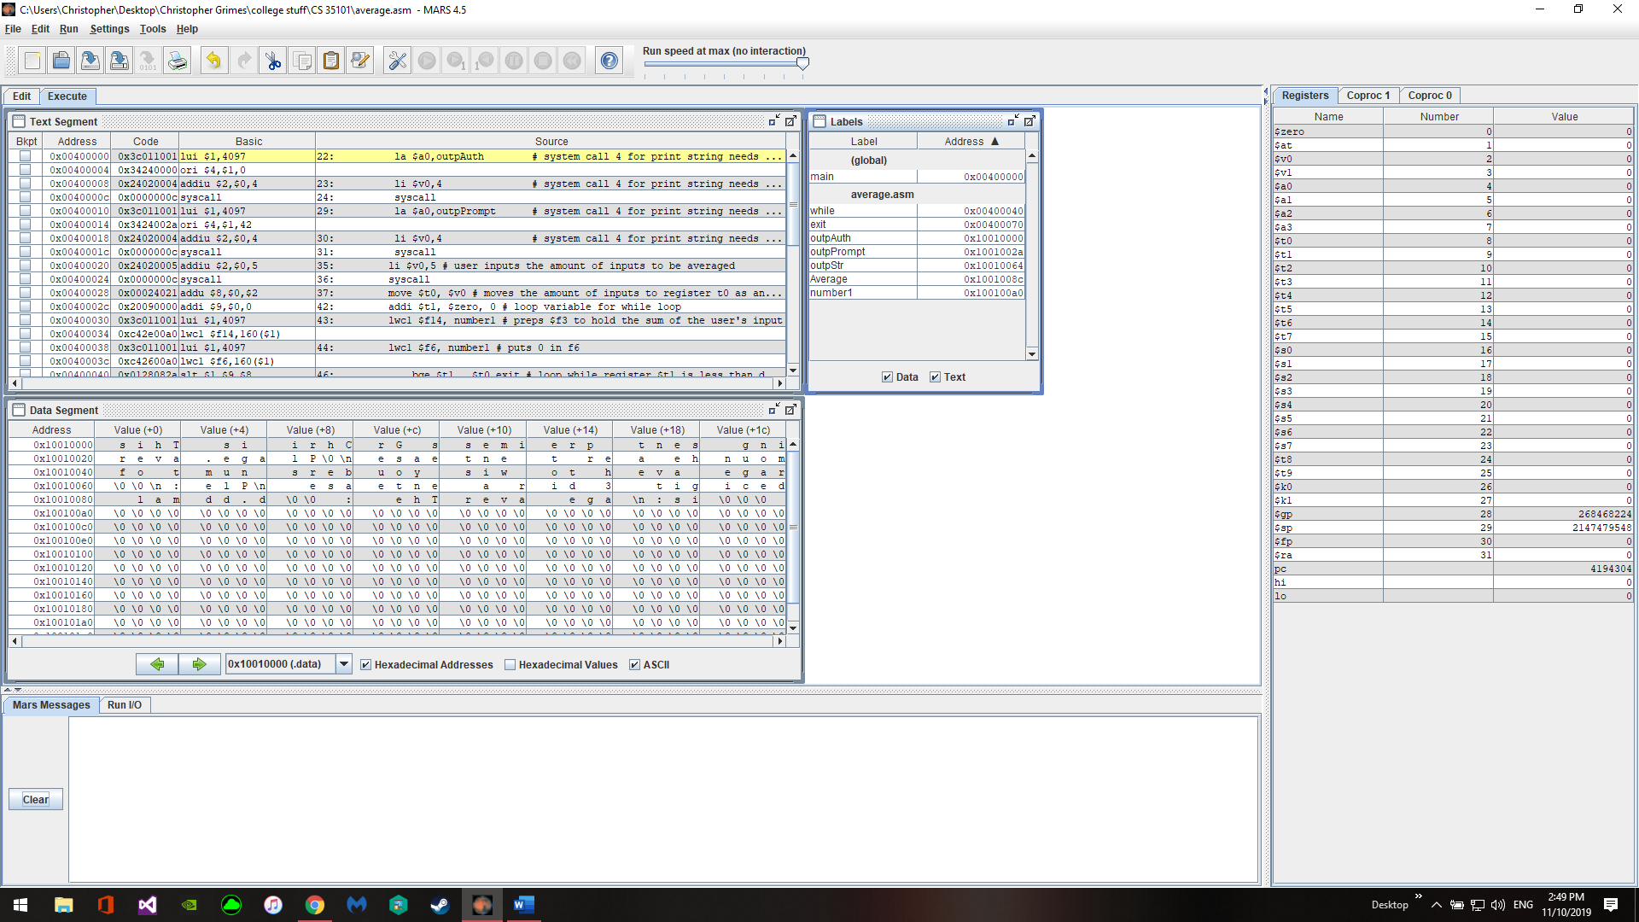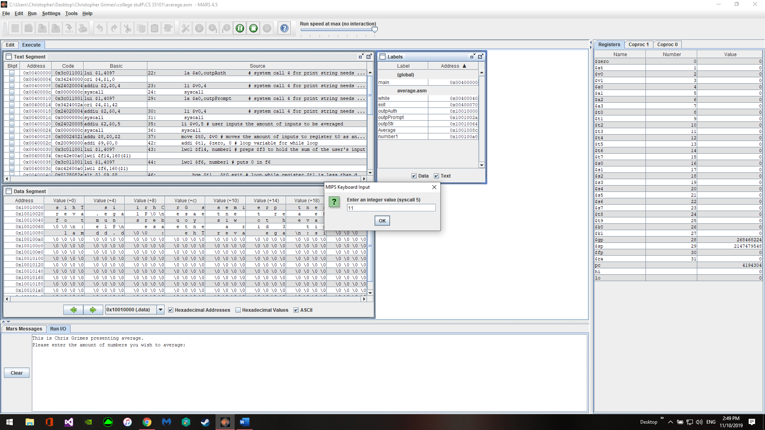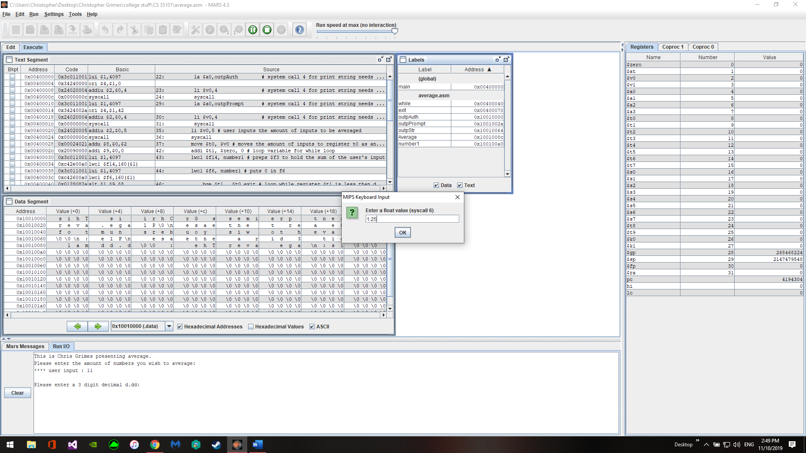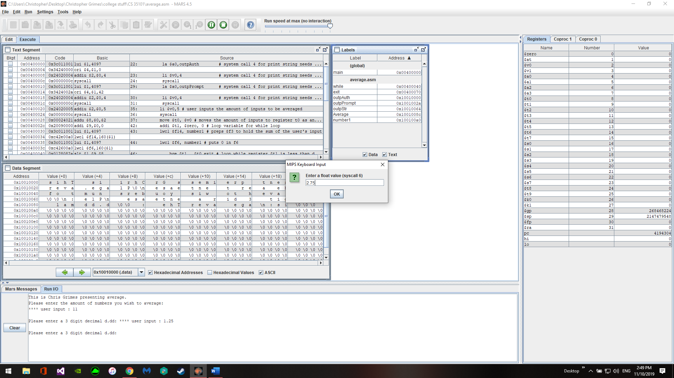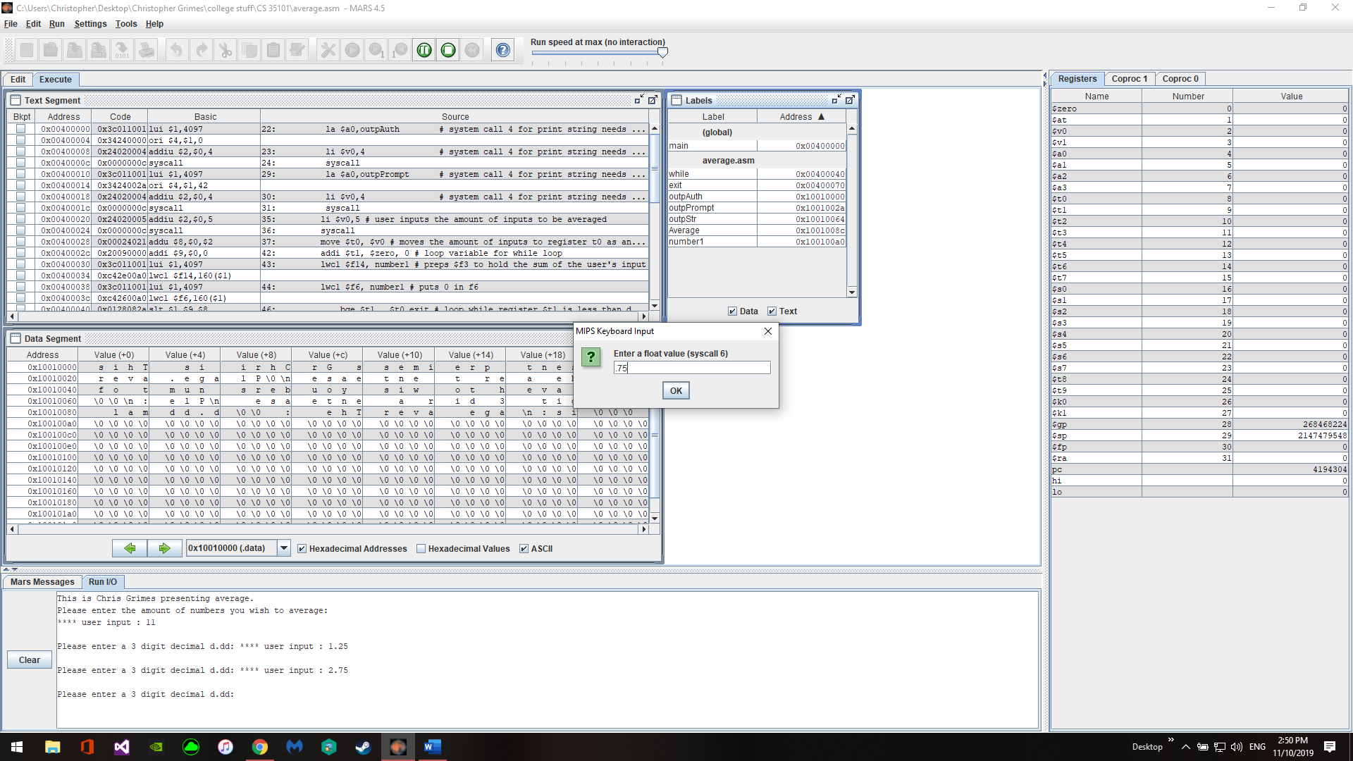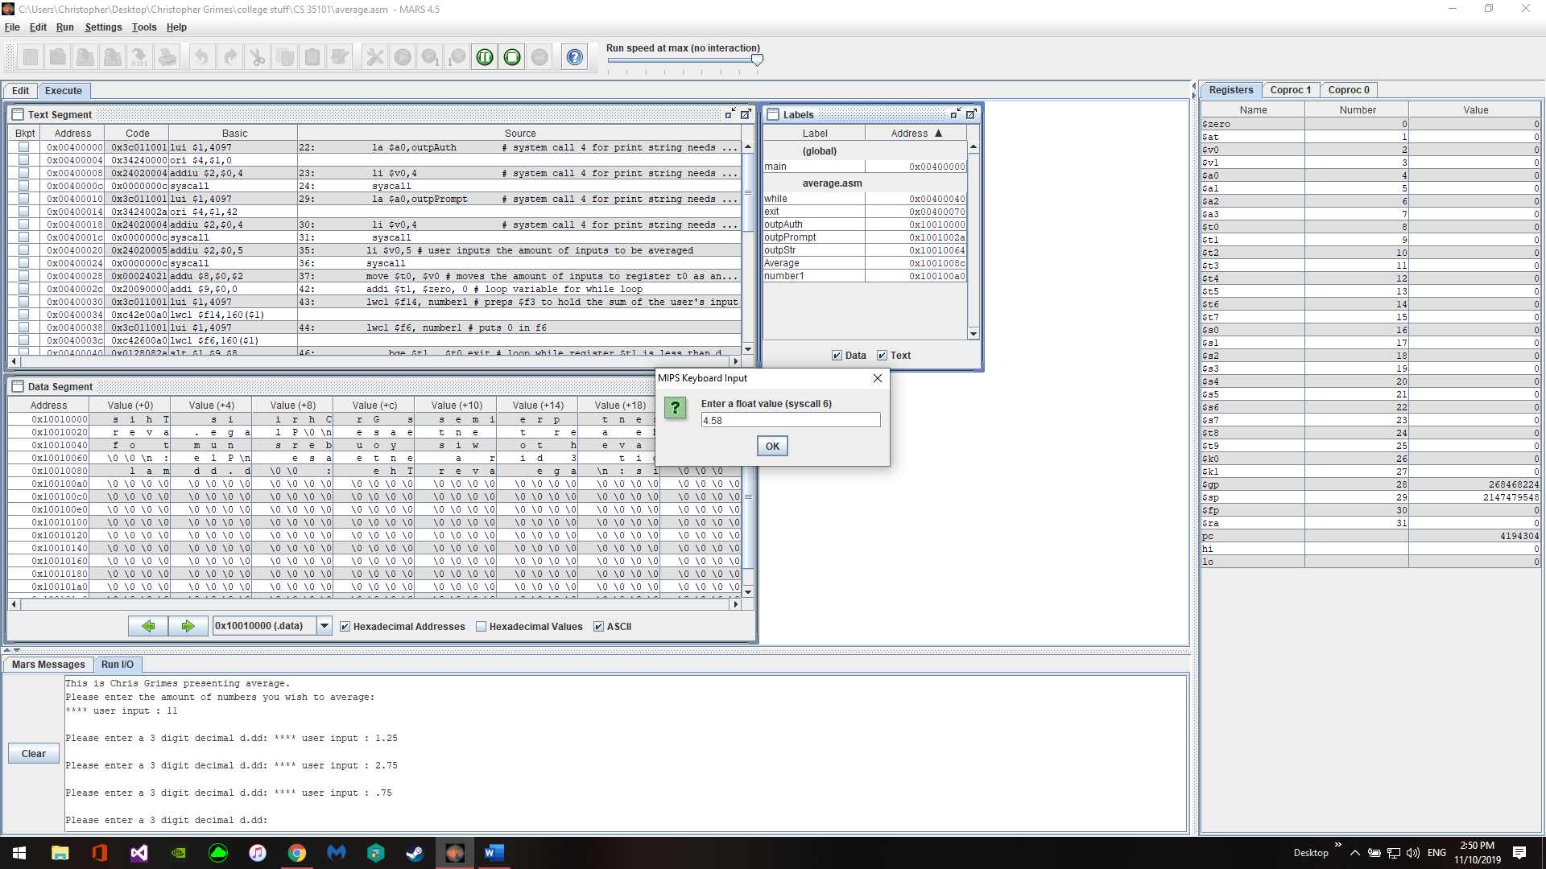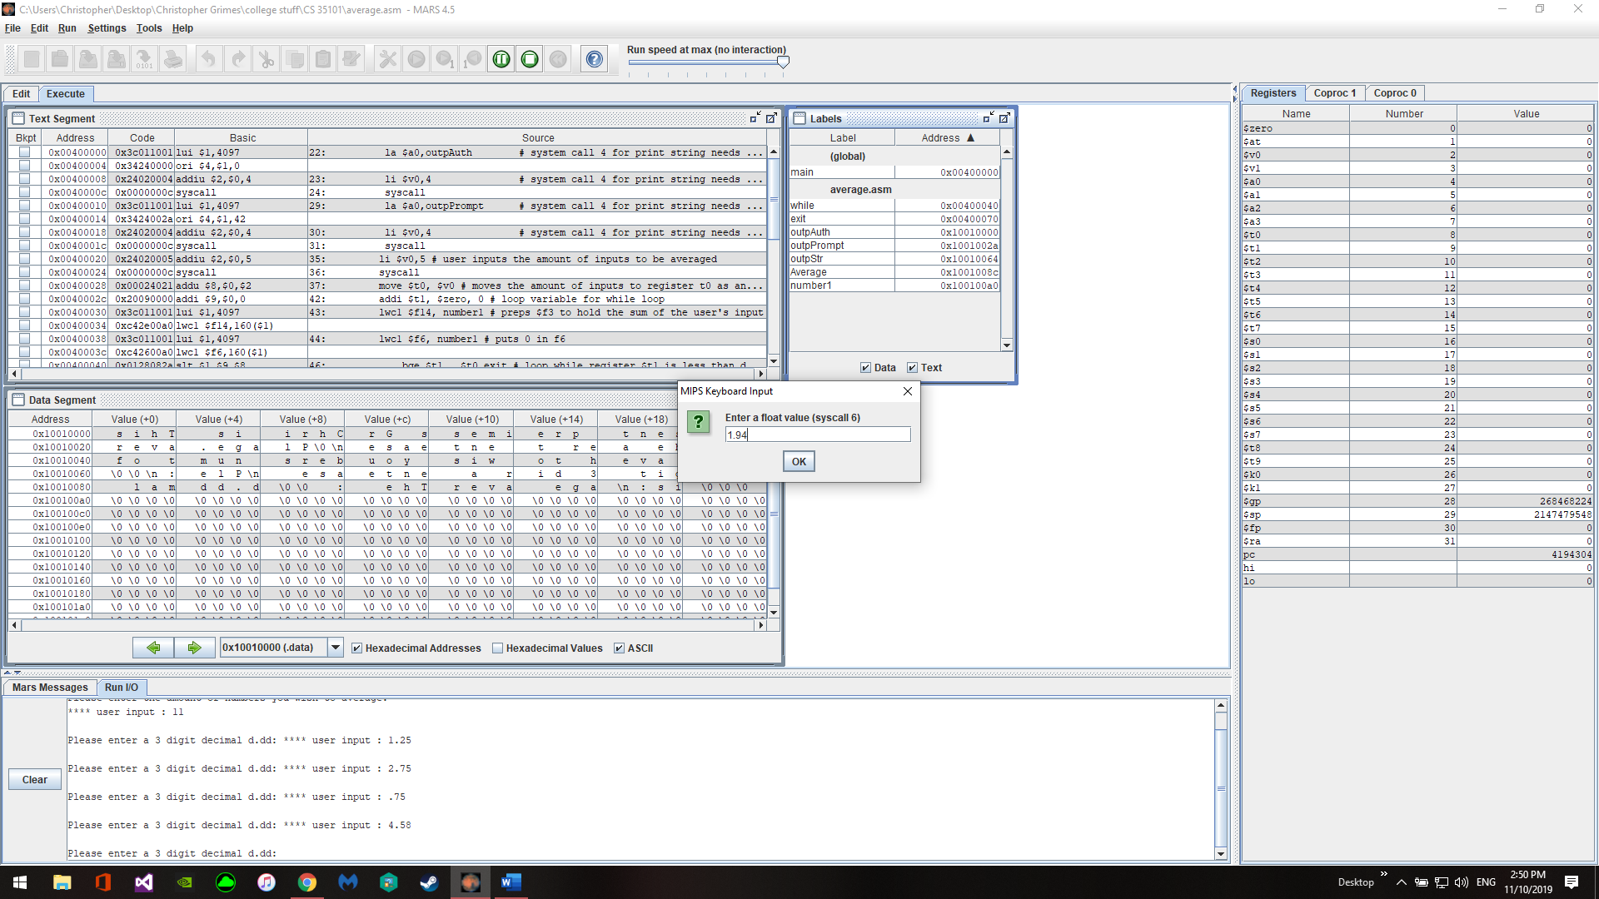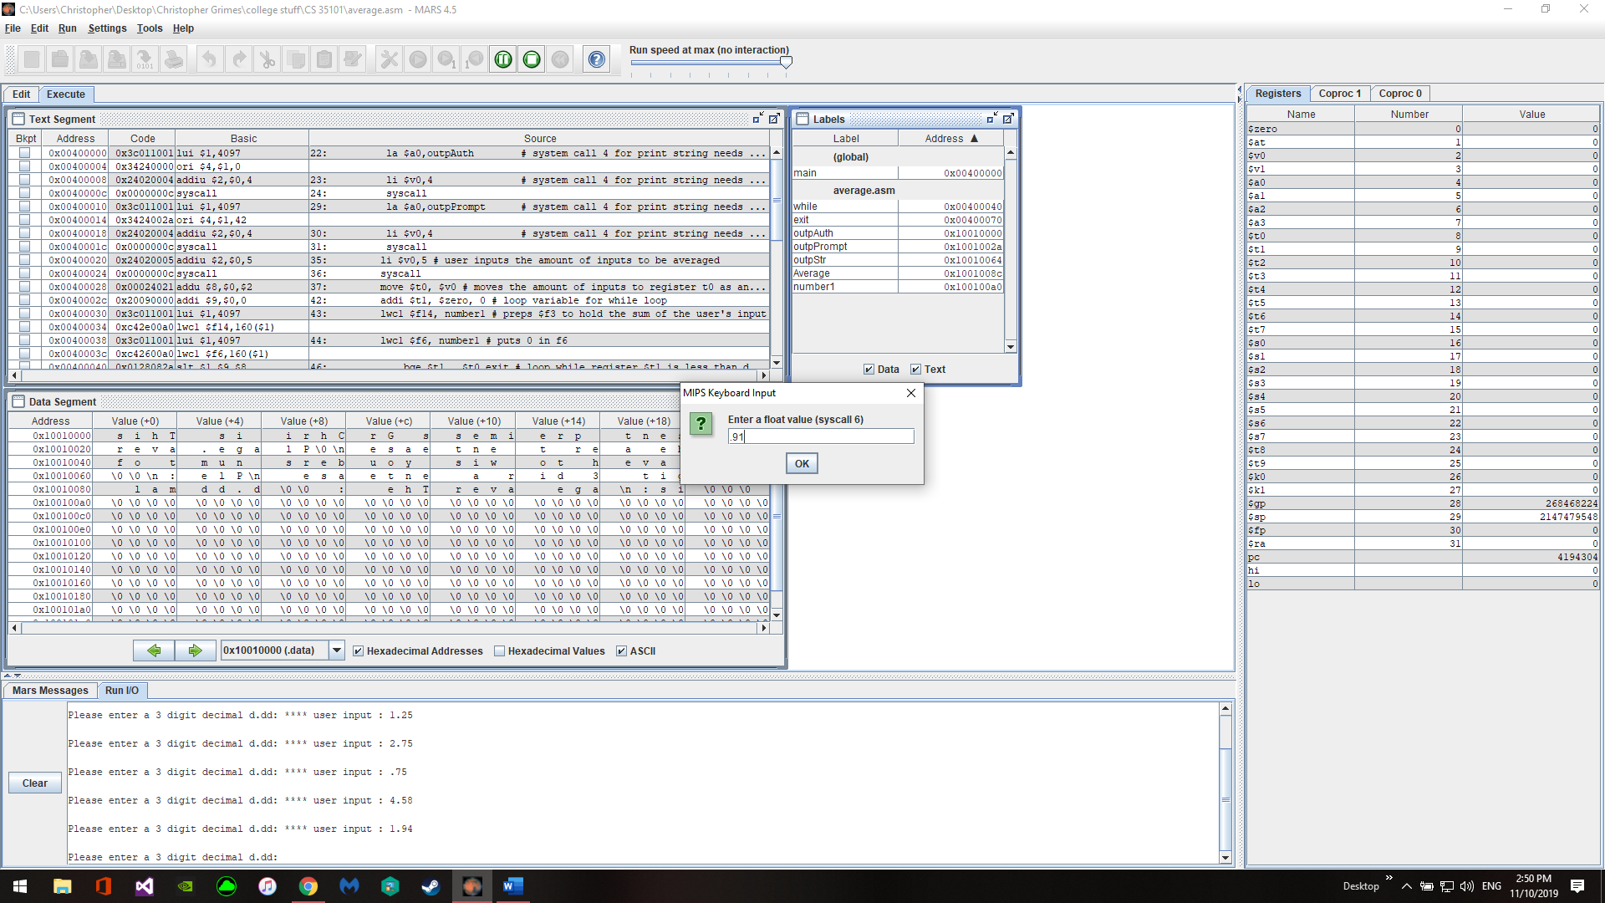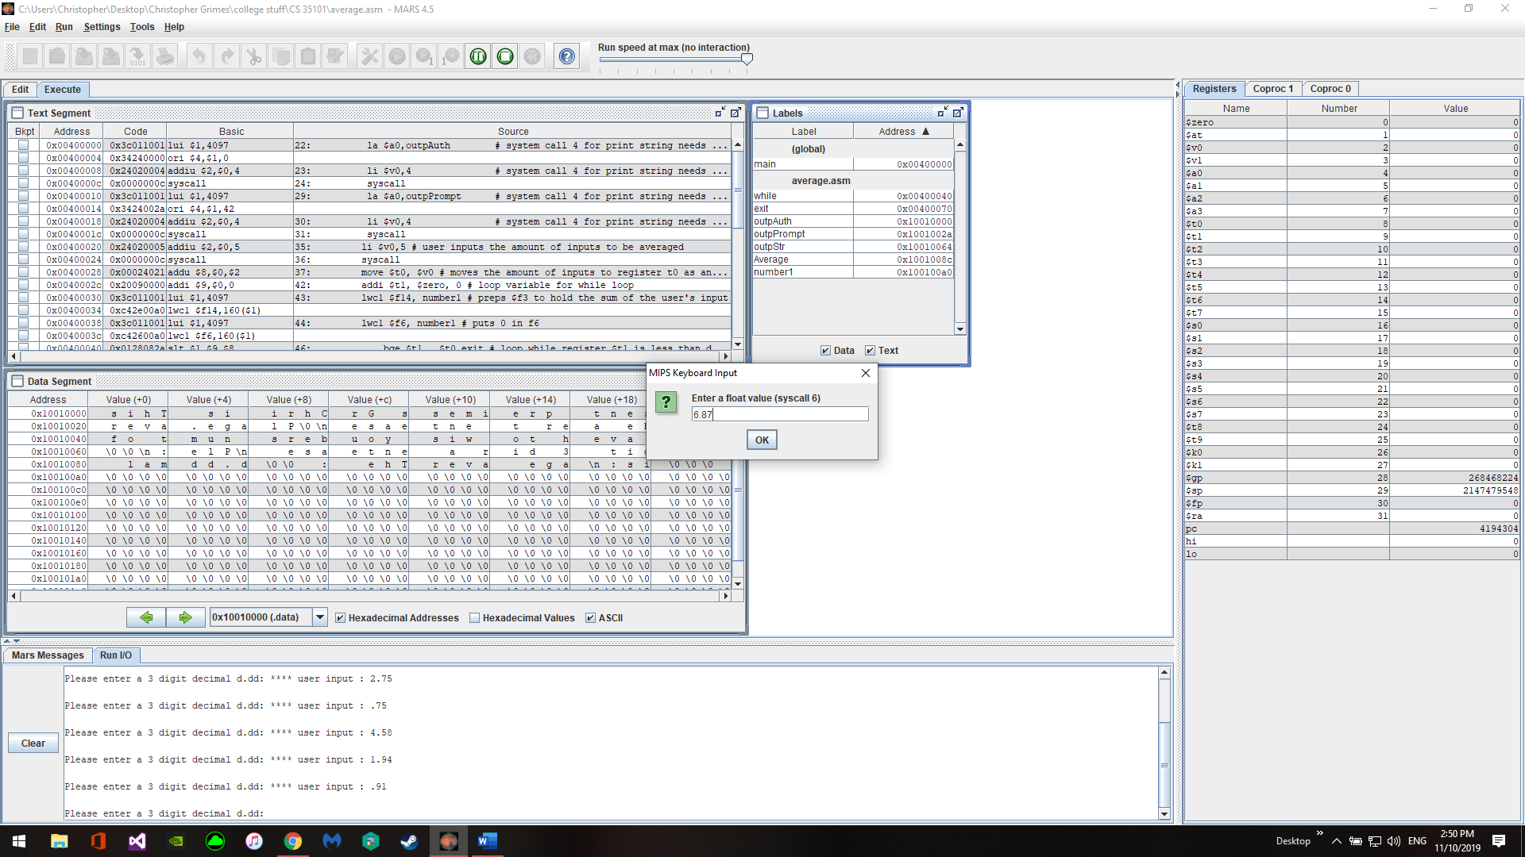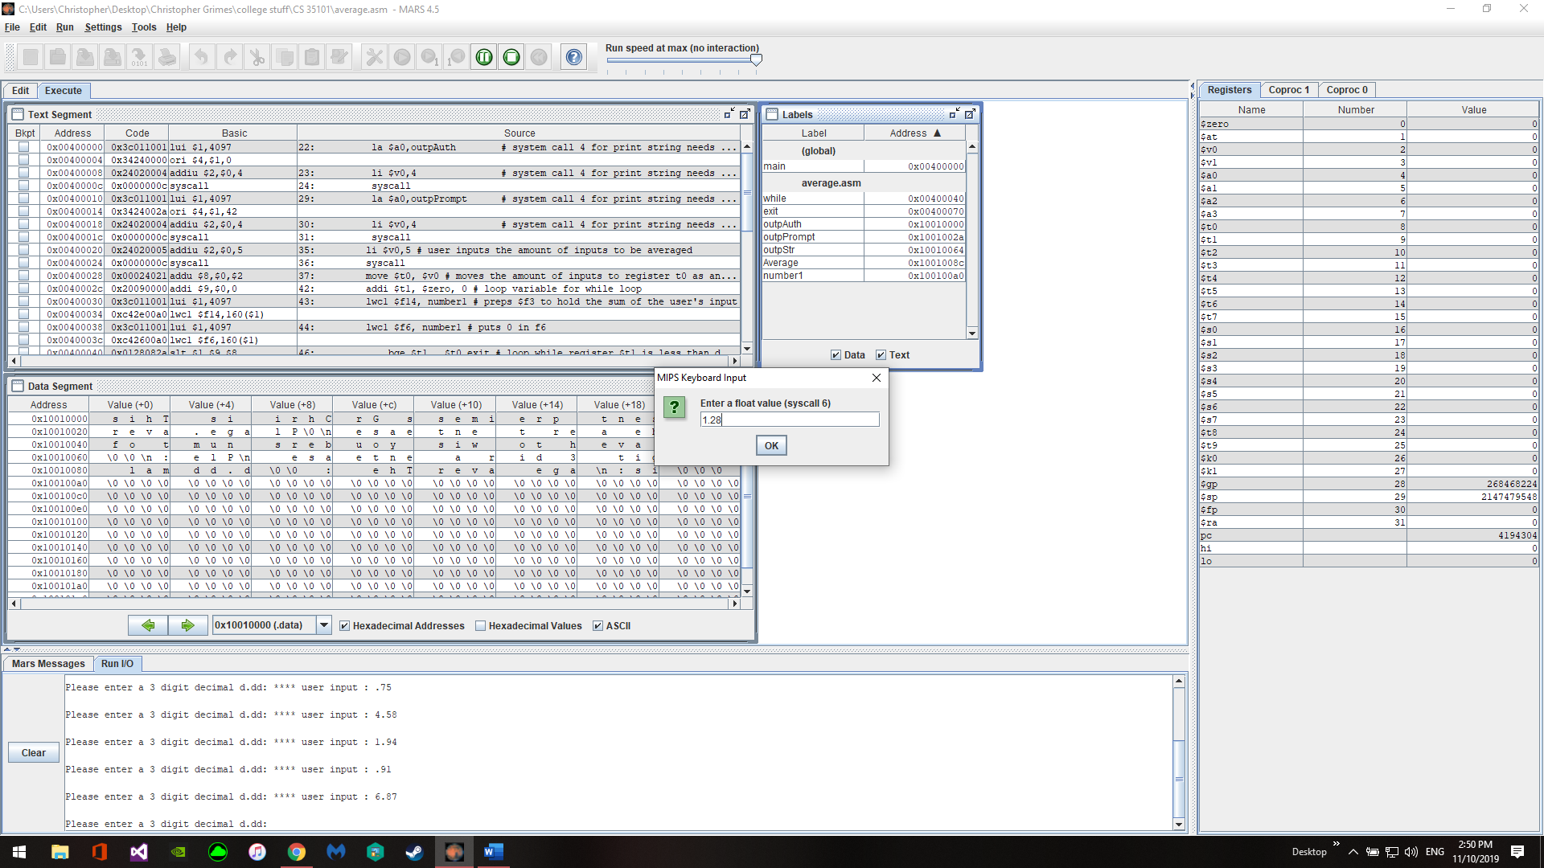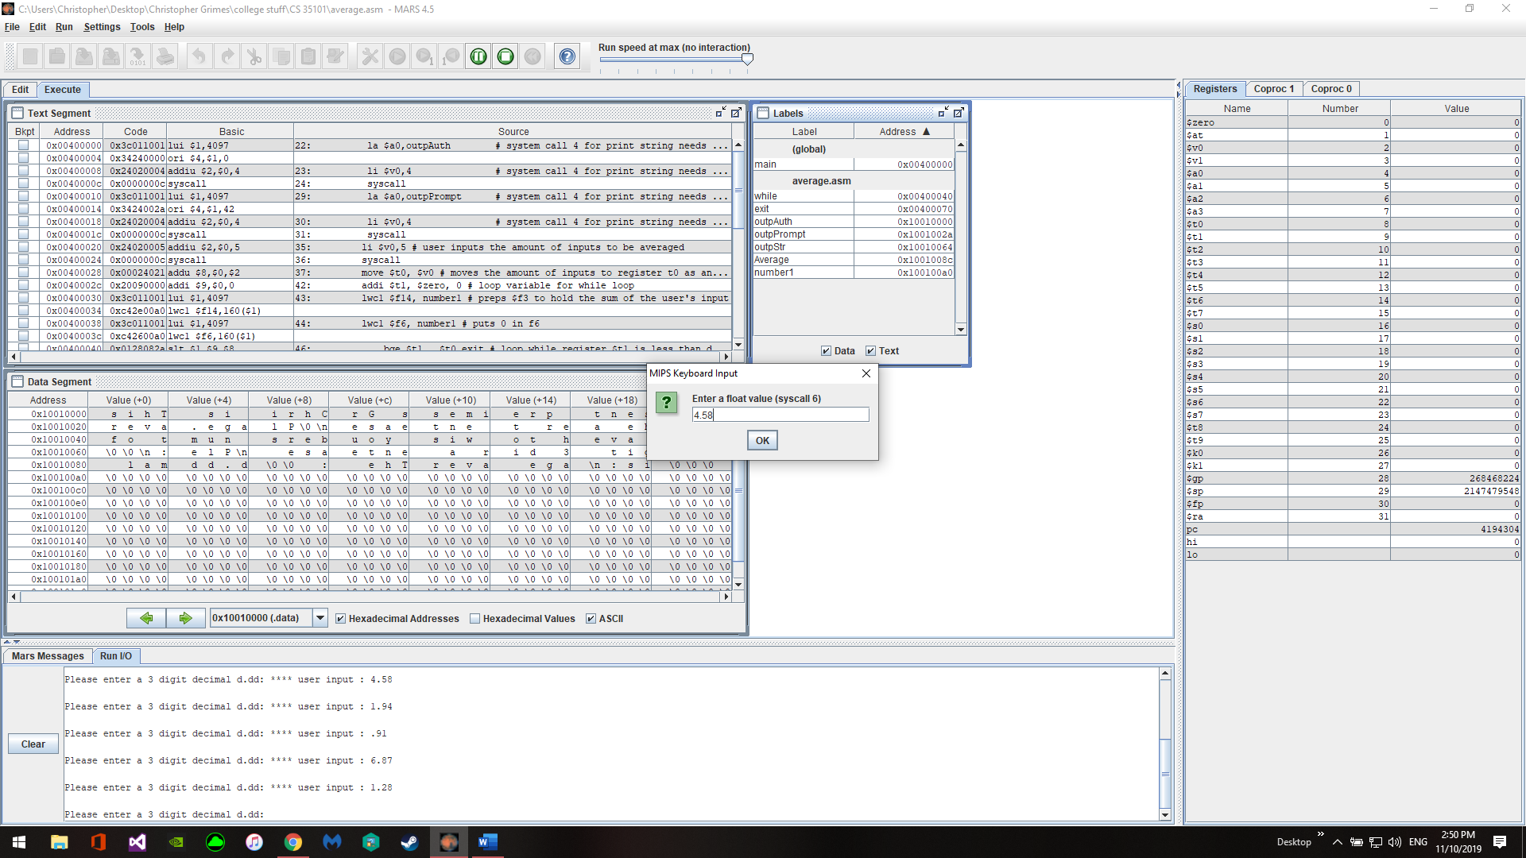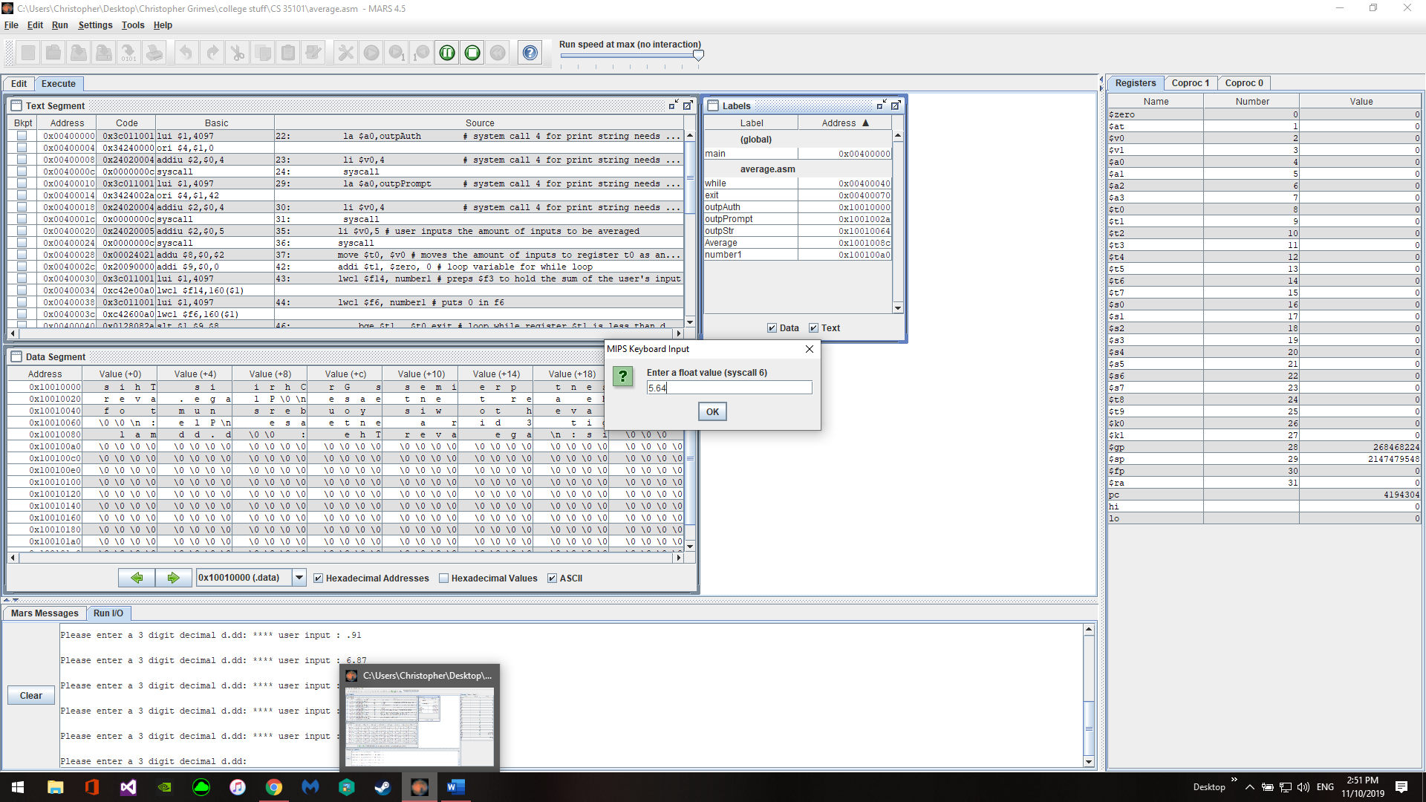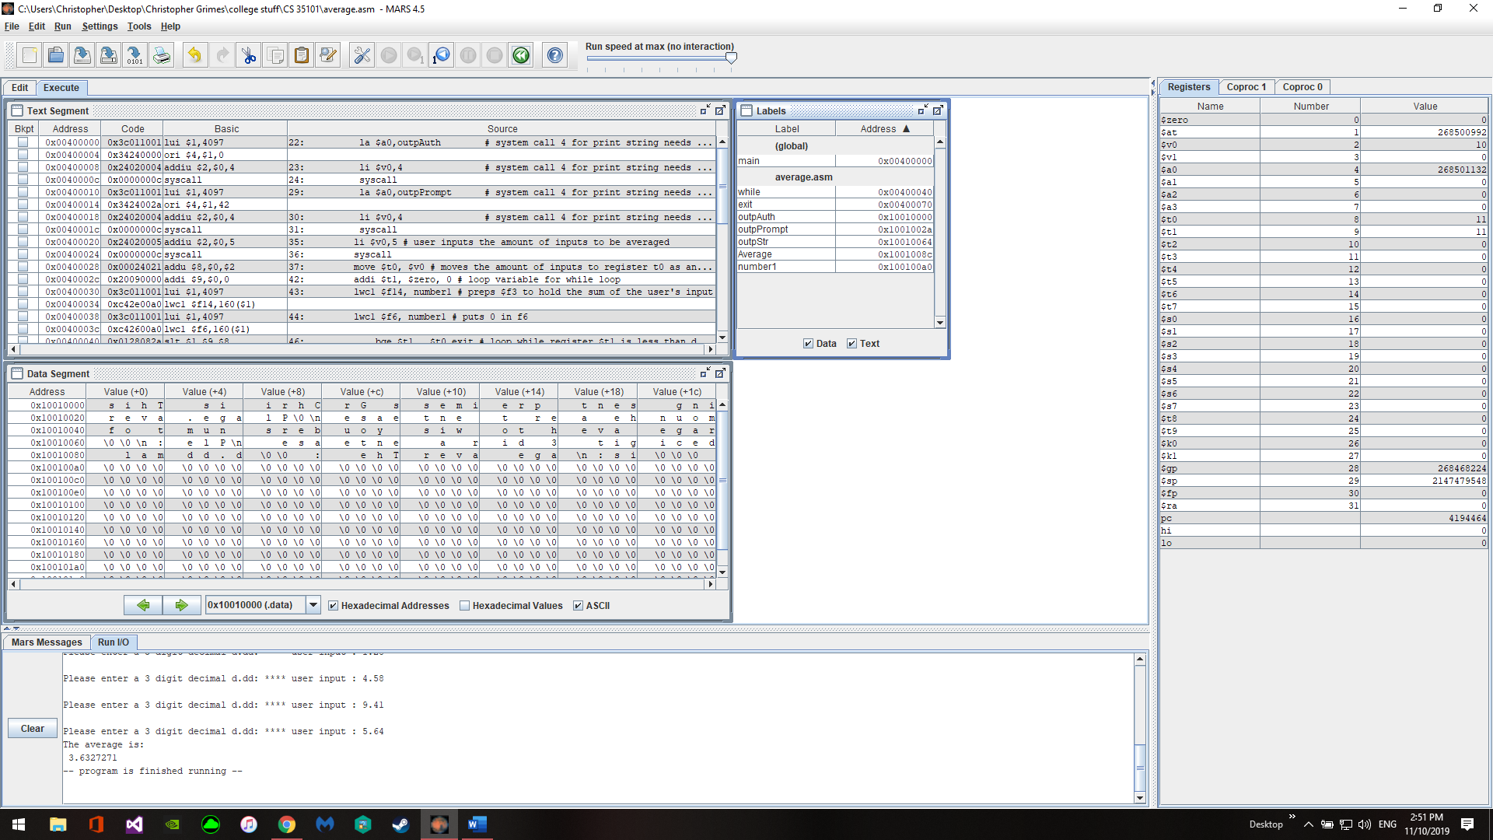

This project showed me how to manipulate float numbers both from the registers and taking input form the user.